PURPOSE:

To provide instruction for processing requests for restoration declaration received from the MS Outlook Public Folders Restorations mailbox.

GENERAL INFORMATION:

Pursuant to Arizona Supreme Court Rule 123 (a) through (h), and A.R.S. 13-910, the customer may request the Clerk’s Office to provide certification that a particular document is not contained within the court file. The Restoration Declaration is provided upon request from the Maricopa County Attorney’s Office.

OBJECTIVE:

- To provide a declaration regarding the existence of filed documents pertaining to restoration of civil and/or gun rights after conducting the appropriate research of an existing Maricopa County criminal case.

EVENT DRIVER:

- A request for a restoration declaration is received in the Restorations email box.

PROCEDURES:
- Outlook:
- Open Outlook – Go to the COC Restorations Inbox.
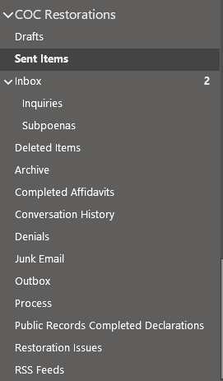
- Open the oldest email request and verify the following is provided:
- Defendant Name.
- Defendant’s Date of Birth (DOB).
- Maricopa County Criminal Case number.
  - You may be provided with multiple numbers, some for current ongoing cases and some for (priors) completed cases. The declaration will be attesting to the research conducted in the completed prior case.

- Research the case in iCIS:
- Open iCIS – COC CR COC Staff or COC CR Supervisor
- Search for the case in iCIS; when possible start in the most current case
- From the main page, verify the following:
  - Defendant name.
  - Date of Birth (DOB).
    - If information does not match skip to IV, 2, A.
    - If information matches the request, proceed to the next step.
- Return to the Main Page; right click and select Main Page or use the drop-down menu under tasks.
- Locate the “prior” completed case by clicking on Related Cases icon or using the drop-down menu under tasks.
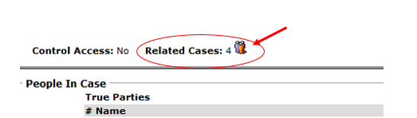
- Select the most recent case first.
- Reconfirm the defendant’s name and DOB.
- Go to the Hearings and Events screen; right click and select Hearing and Events or use the drop-down menu under Tasks.
  - Identify that the sentencing is annotated.
- Return to the Docket screen; right click and select Docket or use the drop-down menu under Tasks.
- Research case docket.
  - Confirm that the sentencing information was indeed a felony.
  - Start at the Complaint/Indictment filing, note the earliest file date
  - Review the docket to see if there have been any ASJ, APL, ORD, or MFR documents filed where the defendant has applied to Set Aside and/or Restore Gun Rights. Notate the file dates if applicable.
  - Notate the file dates of the oldest and most recent documents filed.

- Restoration Folder and Form:
- Go to Share drive: S:\Customer Service\CSC\Public Records\Restoration of Rights Declarations\Declaration Forms.
- Start a new declaration by opening the blank declaration that applies to your findings:
  - If applicable documents are found, use “Declaration RE – Restoration of Rights Research-Disclosed” document.
  - If applicable documents are Not found, use “Declaration RE – Restoration of Rights Research-Failed to disclose” document.
- Open the form, save as, with the last name of the defendant, first name, MI.
  - Save the form in your personal (H:) drive.
- Fill in the applicable information on the form:
  - Enter Employee Name (twice).
  - Enter Job Title.
  - Use drop-down menu to select the applicable findings.
  - File dates of applicable documents, if found.
  - Fill in the following information using the data from the case research:
  - Enter defendant name.
    - Enter the name as it appears from the prior case.
  - Enter date of birth.
  - Enter the case number.
  - Enter the date range of search.
    - These are the dates previously noted from the docket research (oldest and most recent file dates).
  - Enter the case number.
  - Enter Clerk’s name.
  - Enter Current date.
- Save completed declaration as an Adobe document; save in the “Restoration of Rights Declarations” folder.

- Reply to requestor by email: Send “on behalf of” the COC Restorations mailbox.
- Forward completed declarations to the requestor by email.
- For those requests that are unable to be completed, send email and include the following reason:
  - Information is missing or does not match:

Example:
A Maricopa County Superior Court Felony conviction that matches the provided case criteria could not be located. The following criteria does not match:
- Defendant DOB
- Defendant name
Please verify all information provided and resubmit your request.

- Place applicable email(s) in the Public Records Completed Declarations Folder.
      - Emails should be in date order.

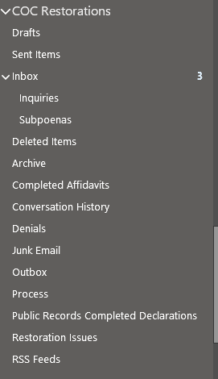

POLICIES / RELATED DOCUMENTS:

N/A

OTHER PARTIES INVOLVED:

- Prosecuting Agency

TIME / VOLUME:

- Varied

FREQUENCY:

- Weekly

PERFORMANCE MEASURE:

- N/A

SYSTEM ACCESS REQUIRED:

- iCIS
- MS Outlook e-mail inbox
- S:\

REPORTS / FORMS:

- Affidavit Form - Civil and Gun Rights

DEFINITIONS:

APPLICABILITY:

This procedure applies to all employees of the Clerk of the Court.

REVISION HISTORY:

Revision Number | Revision Author | Summary of Changes | Approval Date
- | Ana Namauleg | Document Origination
A | Ken Shipley | Procedural Content Updated | 07/22/2022
B
C

