PURPOSE:

To provide instructions for remitting a telex to Maricopa County Sheriff Office for purge payments.

OBJECTIVE:

To ensure the telex remittance of purge payments are handled consistently and accurately over time.

EVENT DRIVER:

Purge Payments are paid to the Clerk of Superior Court.

PROCEDURES:
- Receiving a Purge Payment Form
- The payor is given an F-FSS-1001: Cash Purge Payment form to complete.
- The cashier will ensure the form is legible and filled out in its entirety.
- The cashier is responsible for verifying the information provided by the payor and completing the “Clerk’s Office Only” box on the Cash Purge Payment form.
- In-Jail payments need to be verified with MCSO.
- In-Jail
- A charge needs to be marked whether In-Custody or not. See Figure 1.

Figure 1
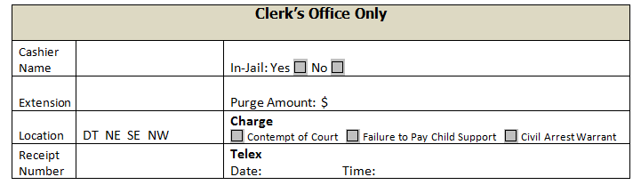

- Funds are receipted in the Cash Receipting System under service code 779 – C/S Release & Civil Arrest Funds.
- Forms are immediately sent to TrustResponse@mail.maricopa.gov.
- All forms are re-sent at close of business to COCFSS-InJailPurgePayment@mail. maricopa.gov, this supports the report process that is completed the next business day by Family Support Services.

- Cash Purge Payment forms are received via Trust Response.
- Open the Trust Response Public eMail.
- Open the Purge Payment form.

- Verify Purge Payment.
- Open ICIS.
- Select Family, FS View Only COC.
- Enter the Case number in the Case # field.
- Click Search. The case record will open.
- Verify the information on the Purge Payment form matches the information in ICIS.
- Click Entry>Docket.
- Review Docket for active Warrant.
- Only purge payment with Active Warrant that are paid in full are sent to MCSO.
- If there is no Active Warrant and/or the payment doesn’t pay the purge amount in full save the purge payment form in S:\Fin_Svc\Trust System\Cash Purge Payments\(current year)\(current month)\(current date)\(case number). Note the form No Warrant.
- If there is an Active Warrant and the payment pays the purge in full print the form and fax to MCSO at 602-379-0088.
- Save the form S:\Fin_Svc\Trust System\Cash Purge Payments\(current year)\(current month)\(current date)\(case number). Note the form Warrant Faxed and time.

POLICIES / RELATED DOCUMENTS:

- N/A

OTHER PARTIES INVOLVED:

- Filing Counter Staff
- Accounting Unit
- Maricopa County Sheriff Office
- Family Support Services

TIME / VOLUME:

- Varied

FREQUENCY:
- Daily

PERFORMANCE MEASURE:

- N/A

SYSTEM ACCESS REQUIRED:

- Cash Receipting System
- MS Outlook
- Trust Response Public eMail Folder
- iCIS Application
- TrustResponse@mail.maricopa.gov.
- COCFSS-InJailPurgePayment@mail. maricopa.gov

REPORTS / FORMS:

- F-FSS-1001: Cash Purge Payment form

DEFINITIONS:

- N/A

APPLICABILITY:

This procedure applies to all employees of the Clerk of the Court.

REVISION HISTORY:

Revision Number | Revision Author | Summary of Changes | Approval Date
- | Diana Hoover | Document Origination | 11/23/2015
A | Diana Hoover | Reformatted to accepted office procedure format | 11/24/2015
B | Edie Friss | Updated with current process | 05/25/2021

