PURPOSE:

- To provide instructions for providing certified copies of court documents to the Attorney General’s Office.

OBJECTIVE:

- To provide the necessary direction to ensure that the Attorney General’s Office is provided with official court records for cases they are associated with.

GENERAL INFORMATION:

Pursuant to A.R.S. §12-282 and AZ Rules of Supreme Court, Rule 123 (a)-(h), the Clerk of the Court shall maintain and provide access to court records in accordance with applicable law. Rule 123 is adopted to govern public access to the records of all courts and administrative offices of the judicial department of the State of Arizona.

EVENT DRIVER:

A request for certified copies is received from the Attorney General’s Office.

PROCEDURES:
- Log into OnBase/Thin Client. You can also use Thick Client, but your settings must be in the “core based” setting (see step 7). From the main page under the “Document” drop- down menu, click on the “workflow” icon in the tool bar.


- Once the queue is open, expand the “AG Request for Certified Copies” queue.
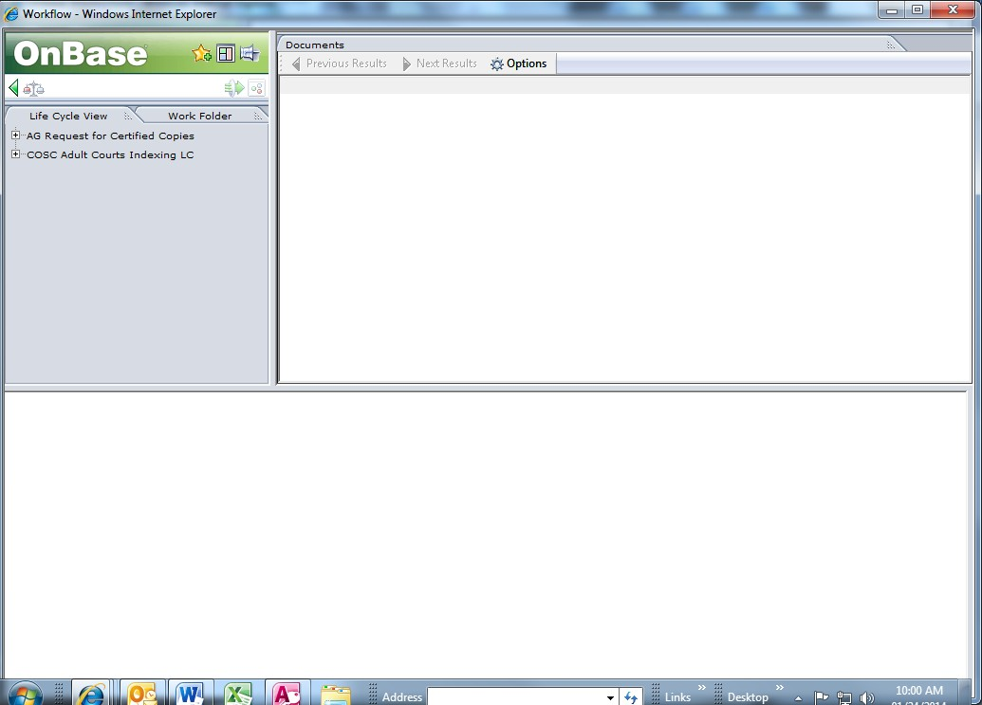

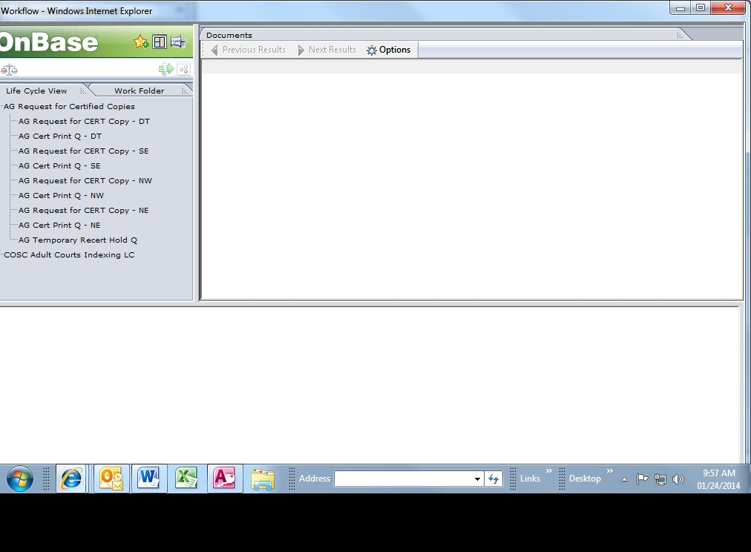
- Open each of the sub-queues individually, click on the first listed document.

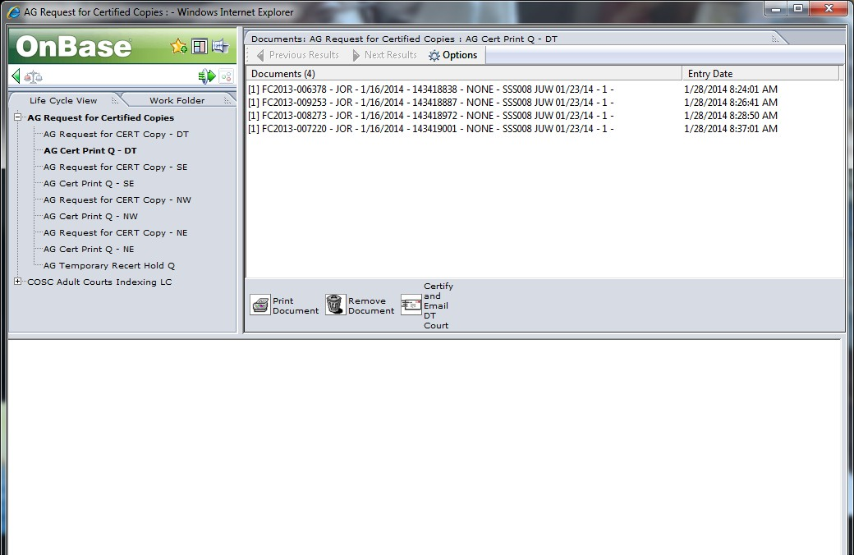
- The document will open at the bottom of the screen. In the grey “tasks” column on the right or at the bottom, click on the “certify and email” icon. If you are in thin client click once; if you are in thick client, click twice.
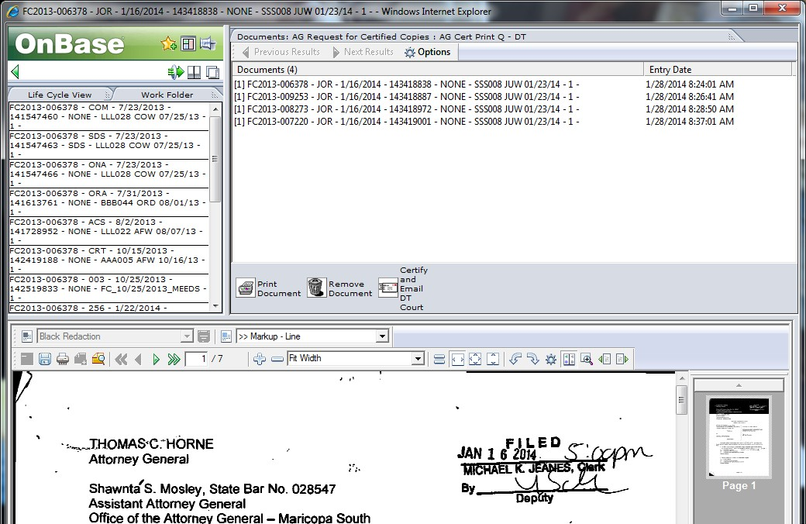

- Once this is done, the certified document has been sent to the AGs office. If you are in thin client, once you have clicked on the “certify and e-mail” icon, the document will automatically remove itself from the queue. If you are in thick client, you must double click on the “remove document” icon to remove it from the queue.
- Repeat this process for each document in each of the queues (DT, SE, NE, & NW).

Access with Thick Client:

- Enter Thick Client with individual login:
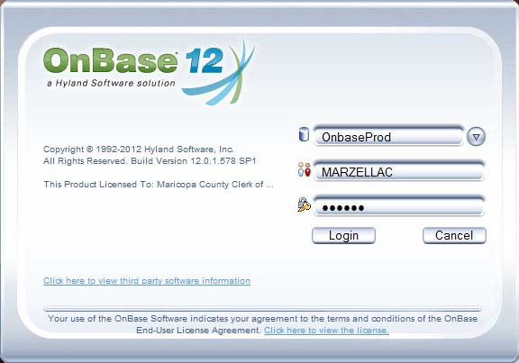

- Click on “User”
- Click on “Workstation Options”
- Click on “Workflow Display Options”
- On the bottom of the screen, under “user interface”, select “Core-based” from drop down menu.
- Click “Save”
- Click the workflow icon
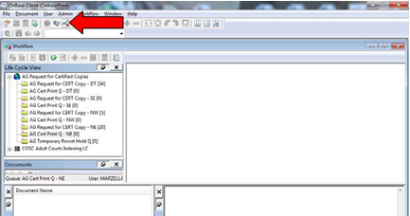

- Once the queue is open, expand the “AG Request for Certified Copies” queue.

- Proceed with steps 3-6.

POLICIES / RELATED DOCUMENTS:

N/A

OTHER PARTIES INVOLVED:

- The Attorney General’s Office

TIME / VOLUME:

- Varied

FREQUENCY:

- Daily

SYSTEM ACCESS REQUIRED:

- OnBase

APPLICABILITY:

This procedure applies to all employees of the Clerk of the Court.

REVISION HISTORY:

Revision Number | Revision Author | Summary of Changes | Approval Date
- | Melanie Fay | Document Origination | 01/23/2014
A | Melanie Fay | Process Revisions | 7/17/2014
B
C

