PURPOSE:

- To provide instructions for providing certified copies of court documents to the Maricopa County Attorney’s Office-Criminal Division.

OBJECTIVE:

- To provide the necessary direction to ensure that MCAO-Criminal Division is provided with official court records for cases they are associated with.

GENERAL INFORMATION:

Pursuant to A.R.S. §12-282 and AZ Rules of Supreme Court, Rule 123 (a)-(h), the Clerk of the Court shall maintain and provide access to court records in accordance with applicable law. Rule 123 is adopted to govern public access to the records of all courts and administrative offices of the judicial department of the State of Arizona.

EVENT DRIVER:

A request for certified copies is received from MCAO-Criminal Division.

PROCEDURES:
- Requests for certified copies of criminal records will be received by Support Service staff via interoffice mail, fax and emails sent to the governmentdesk@cosc.maricopa.gov public folder in Outlook.
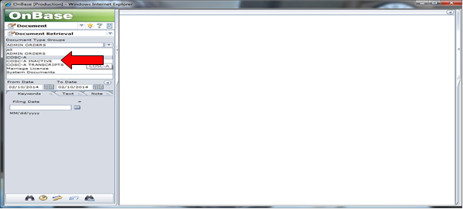
- Log into OnBase/Thin Client with individual login. From the main page under the “Document type groups” drop-down menu, click on either COSC-A (for active cases) or COSC-A Inactive.

- Under “Document Types”, select COSC-A CR-Criminal.
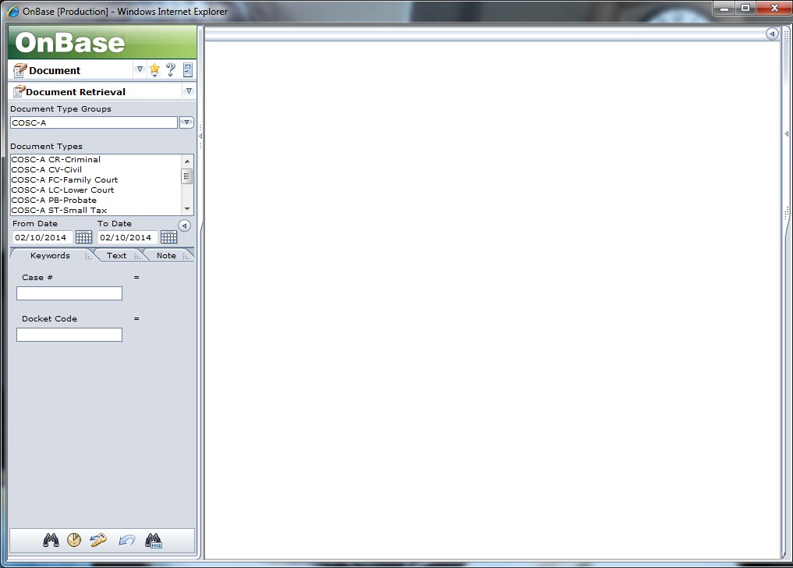
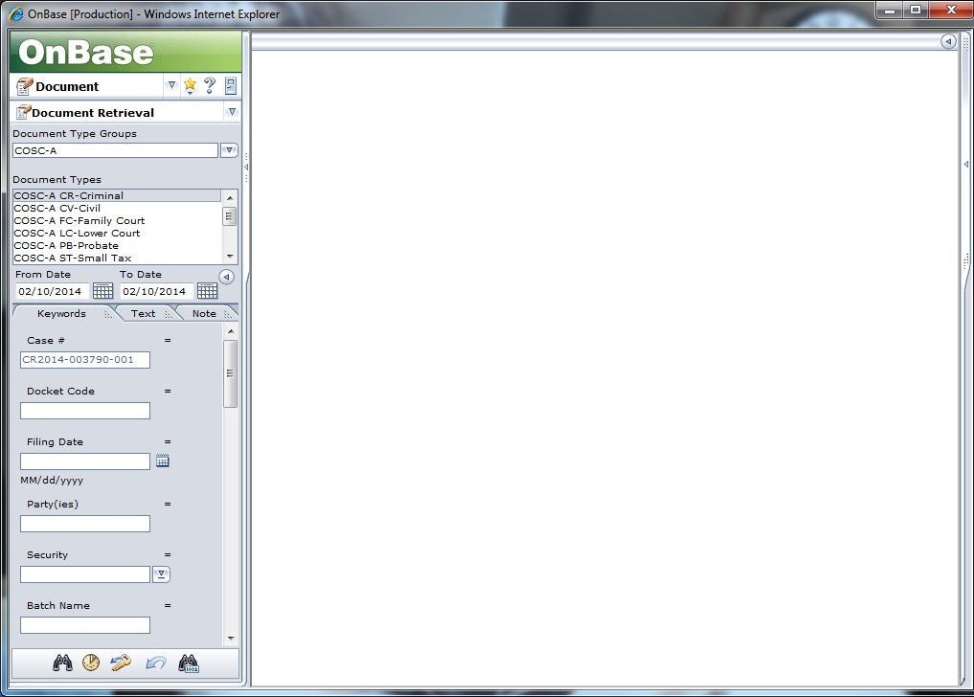
- Enter your case number and click “search”.
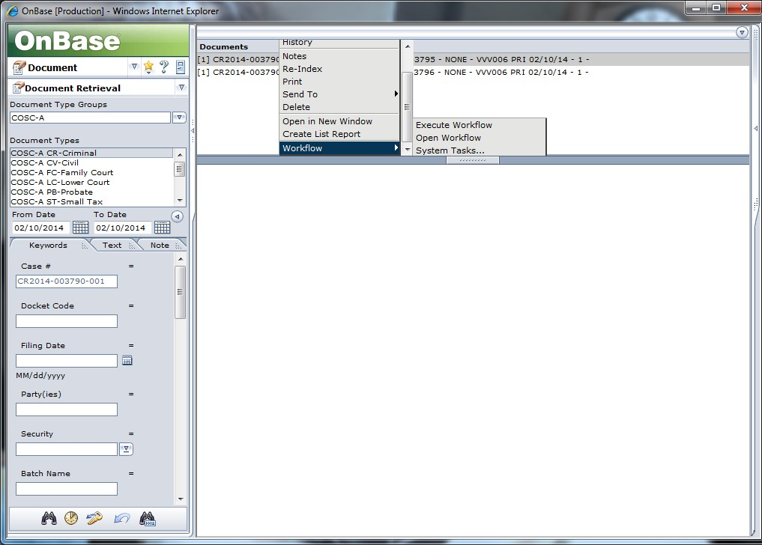
- Once the queue is open, right click on the document requested. A drop-down menu will appear. Select “workflow”, “system tasks”.
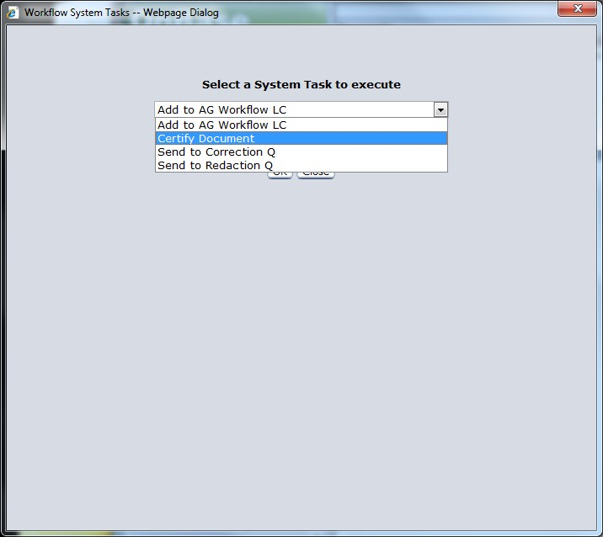
- Select “certify document” from the drop down screen and click “OK”.

- The document will appear on your screen. Notice at the bottom of each page of the document is a certified document-file locator number. This will appear on every page of the document.

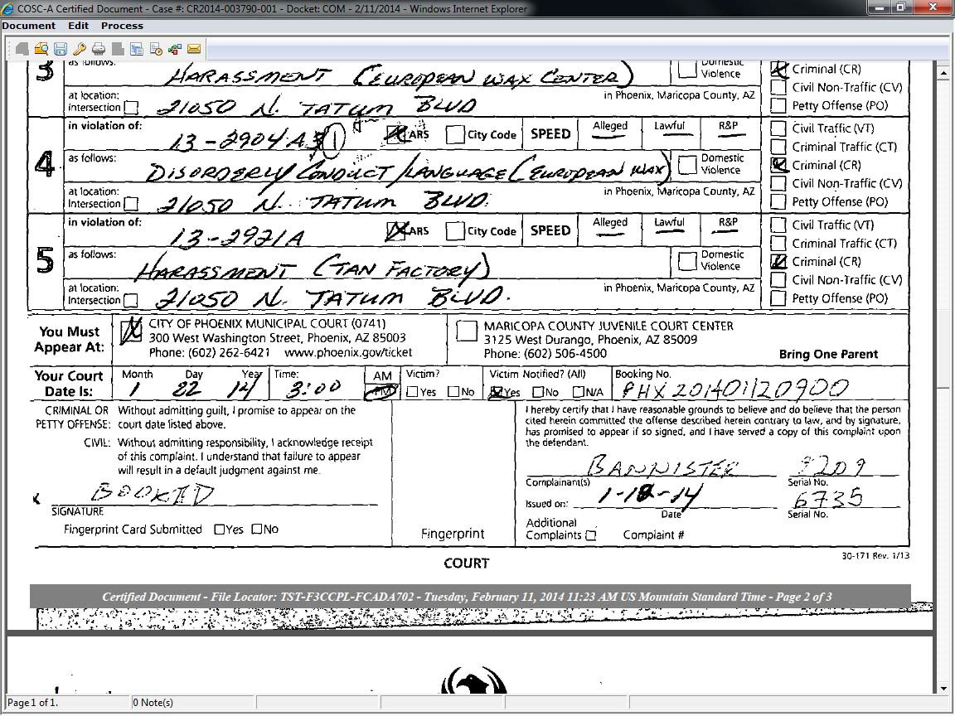
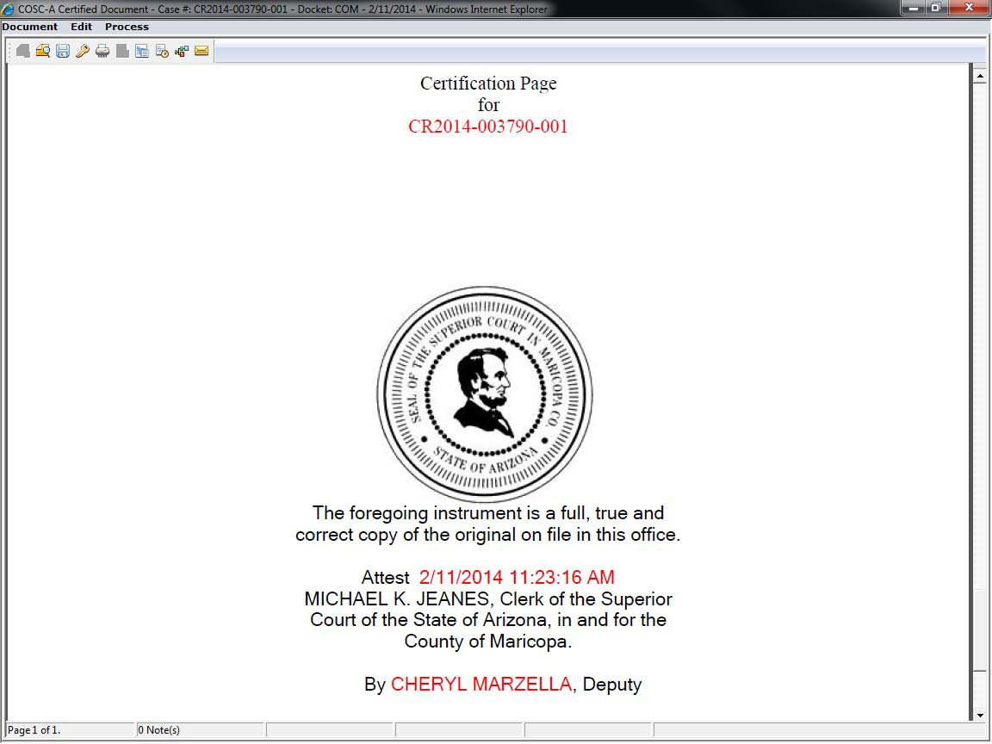
- The last page of the document is the “Certification Page” which will contain the case number, date and time of certification, and the name of the deputy clerk that certified the document.

- To print the certified copy, click the print icon on the top left of your screen and then click “ok”. Staple document if necessary and place in pick-up area downstairs in Public Records for MCAO to retrieve.

- Close screen and repeat steps 5-9 for additional documents.

POLICIES / RELATED DOCUMENTS:

N/A

OTHER PARTIES INVOLVED:

- MCAO

TIME / VOLUME:

- Varied

FREQUENCY:

- Daily

SYSTEM ACCESS REQUIRED:

- OnBase

APPLICABILITY:

This procedure applies to all employees of the Clerk of the Court.

REVISION HISTORY:

Revision Number | Revision Author | Summary of Changes | Approval Date
- | Melanie Fay | Document Origination | 02/11/2014
A | Melanie Fay | Process Revisions | 7/14/2014
B
C

