PURPOSE:

- To provide instructions for providing electronic certified copies of court documents to the Maricopa County Attorney’s Office-Civil Division.

OBJECTIVE:

- To provide the necessary direction to ensure that MCAO-Civil is provided with official court records for cases they are associated with.

GENERAL INFORMATION:

Pursuant to A.R.S. §12-282 and AZ Rules of Supreme Court, Rule 123 (a)-(h), the Clerk of the Court shall maintain and provide access to court records in accordance with applicable law. Rule 123 is adopted to govern public access to the records of all courts and administrative offices of the judicial department of the State of Arizona.

EVENT DRIVER:

A request for certified copies is received from MCAO-Civil Division.

PROCEDURES:
- Log into OnBase/Thin Client. You can also use Thick Client, but your settings must be in the “core based” setting (contact ITG).
- From the main page, click on the down arrow next to “document” in the tool bar and select “workflow”.


- Once the queue is open, expand the “MCAO Civil Division Request for Certified Copies” queue.
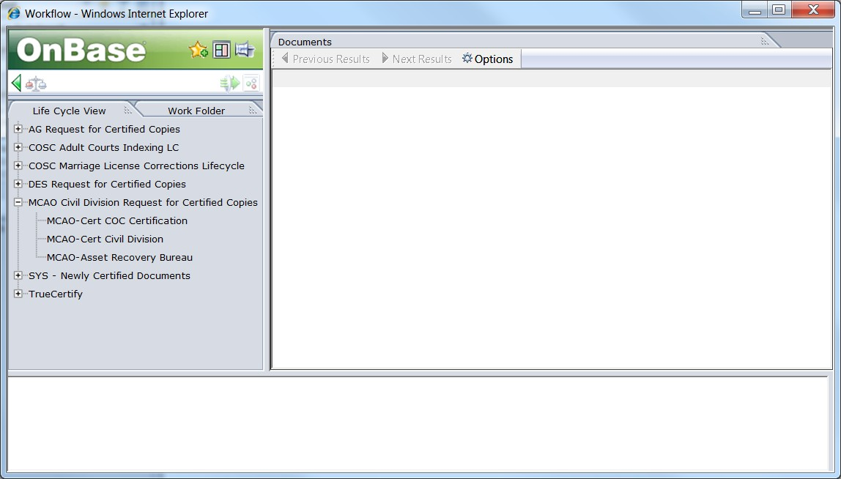
- Open the MCAO-Cert COC Certification.
- Documents that need to be certified will appear in the queue.
  - Left click on the document and click “certify and return”.
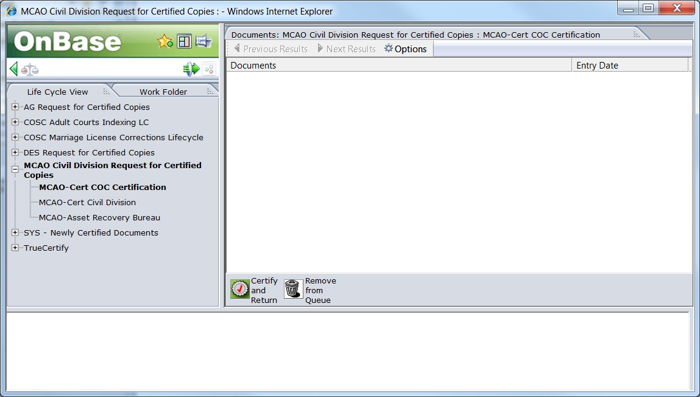

- Once this is done, the certified document has been returned to the MCAO-Civil Division.
  - If you are in thin client, once you have clicked on the “certify and return” icon, the document will automatically remove itself from the queue.
  - If you are in thick client, you must double click on the “remove document” icon to remove it from the queue.
- Repeat this process for each document.

POLICIES / RELATED DOCUMENTS:

N/A

OTHER PARTIES INVOLVED:

- MCAO

TIME / VOLUME:

- Varied

FREQUENCY:

- Daily

PERFORMANCE MEASURE:

- N/A

SYSTEM ACCESS REQUIRED:

- OnBase

APPLICABILITY:

This procedure applies to all employees of the Clerk of the Court.

REVISION HISTORY:

Revision Number | Revision Author | Summary of Changes | Approval Date
- | Melanie Fay | Document Origination | 12/09/2014
A
B
C

