PURPOSE:

- To provide instructions for recording replacement Marriage Licenses.

GENERAL INFORMATION:

Pursuant to ARS §25-123(a) and (d) the Clerk of Superior Court shall maintain a record of all marriage licenses issued, to include replacement and duplicate endorsed licenses. After replacement licenses are issued, forward the unsigned top portion and new unsigned affidavit to Recording Services.

PROCEDURES:
- Retrieve the original affidavit.
- Annotate the replacement license number just below the original license number on the lower right corner of the affidavit and draw a line through the original license number.
- Access ML2000 and enter the original license number into the field labeled “Enter License Number”. Click the “Search” button.
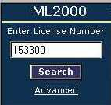

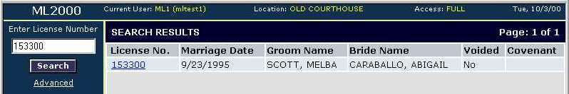
- ML2000 will display a search results screen (similar to below).

- Verify that the license information displayed matches the license requested. Click on the license number.
- The “Initial Entry” screen will now display. Click on the “Issue/Record” button to move to that screen.
  - Depending on the user’s access, the “Issue/Record” screen may display first versus the “Initial Entry” screen. If this occurs, proceed to step 7.
- Type a note in the “Recording Information” area, under the “Notes” section concerning the replacement license (e.g., “See new replacement license # 123456”).

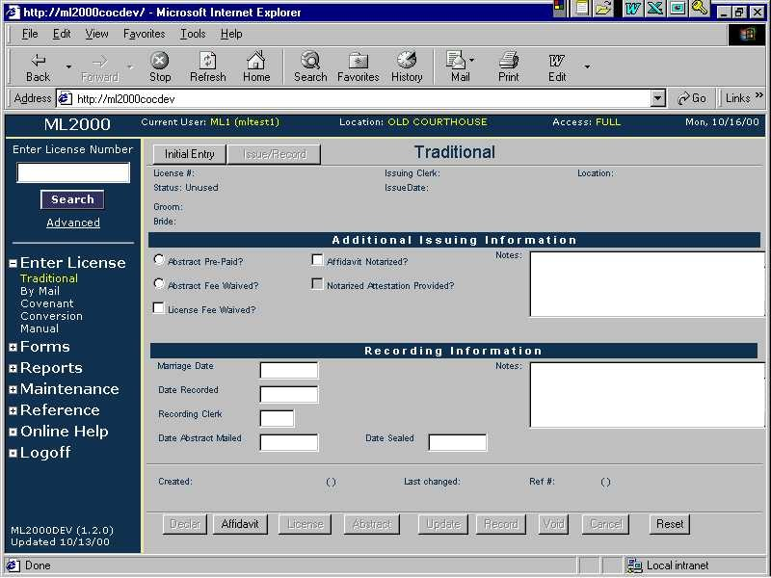

- Click on the “Update” button.
- Enter the replacement license number in the “Enter License Number” field and click “Search”.
- Verify the license information displayed and click on the license number.
- The “Initial Entry” screen will now display. Click on the “Issue/Record” button to move to that screen.
  - Depending on the user’s access, the “Issue/Record” screen may display first versus the “Initial Entry” screen. If this occurs, proceed to step 12.
- Type a note in the “Recording Information” area, under the “Notes” section concerning the replacement of the original marriage license number (e.g., “This is a replacement license to old
# 123456”). Then click “Update” button.
- Discard the old affidavit and top portion of the license in a confidential manner.
- If any of the signatures are missing, retain the old affidavit and attach it to the new affidavit. Both affidavits will be scanned.
- Upon receipt of fully executed replacement certificate, match with the original affidavit and the new license number. Record using same procedure as recording marriage licenses.
- If the original affidavit is unavailable, record the “Affidavit of Marriage Ceremony” in its place, along with a “No Affidavit at Time of Recordation” form.
- Annotate the license number on the lower right corner of all documents recorded.
- Court Ordered Recordation of Duplicate Endorsed Marriage License.
- Upon receipt of an order/minute entry, record a duplicate endorsed marriage license. Contact the issuing judge for clarification, if necessary.
- Annotate the license number on the lower right corner of all accompanying support documentation. All accompanying documents become part of the recorded license.
- If the minute entry order requires the top portion of the marriage license be recorded as the duplicate endorsed license, record it along with an “Affidavit of Marriage Ceremony”, the original affidavit, and the minute entry order.
- If the minute entry order requires that a new certificate be issued, type in all appropriate names and data and stamp the new certificate with the “Duplicate Endorsed License” stamp.

POLICIES / RELATED DOCUMENTS:

N/A

OTHER PARTIES INVOLVED:

- The Public

TIME / VOLUME:

- Varied

FREQUENCY:

- Daily

PERFORMANCE MEASURE:

- N/A

SYSTEM ACCESS REQUIRED:

- N/A

APPLICABILITY:

This procedure applies to all employees of the Clerk of the Court.

REVISION HISTORY:

Revision Number | Revision Author | Summary of Changes | Approval Date
- | Melanie Fay | Document Origination | 06/06/2003
A | Melanie Fay | Process Revision | 07/17/2014
B
C

