PURPOSE:

- To provide instructions for retrieving an unused ML affidavit.

GENERAL INFORMATION:

Pursuant to A.R.S §25-123, marriage license affidavits are received from all issuing offices and must be processed accordingly. If a license has not been used by the expiration date, the affidavit will be maintained as an unused affidavit.

PROCEDURES:
- Clerk will access the S drive under S:\Cust_Svc\CSC\Unused Marriage Affidavits.
- Unused marriage license affidavits are listed alphabetically by year.
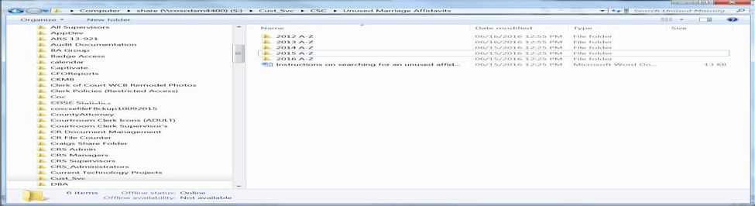
- In years 2012, 2013 and 2014, unused affidavits are listed alphabetically by the groom’s last name. In year 2015 and forward, unused affidavits are listed by the last name of applicant 1 on the marriage license application.
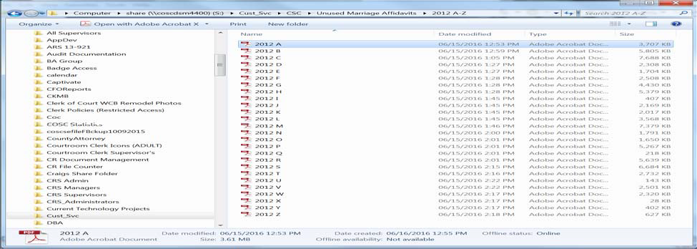

- Scroll to locate the affidavit needed, select File-Print-Current Page or Page number that coincides with the affidavit you need.
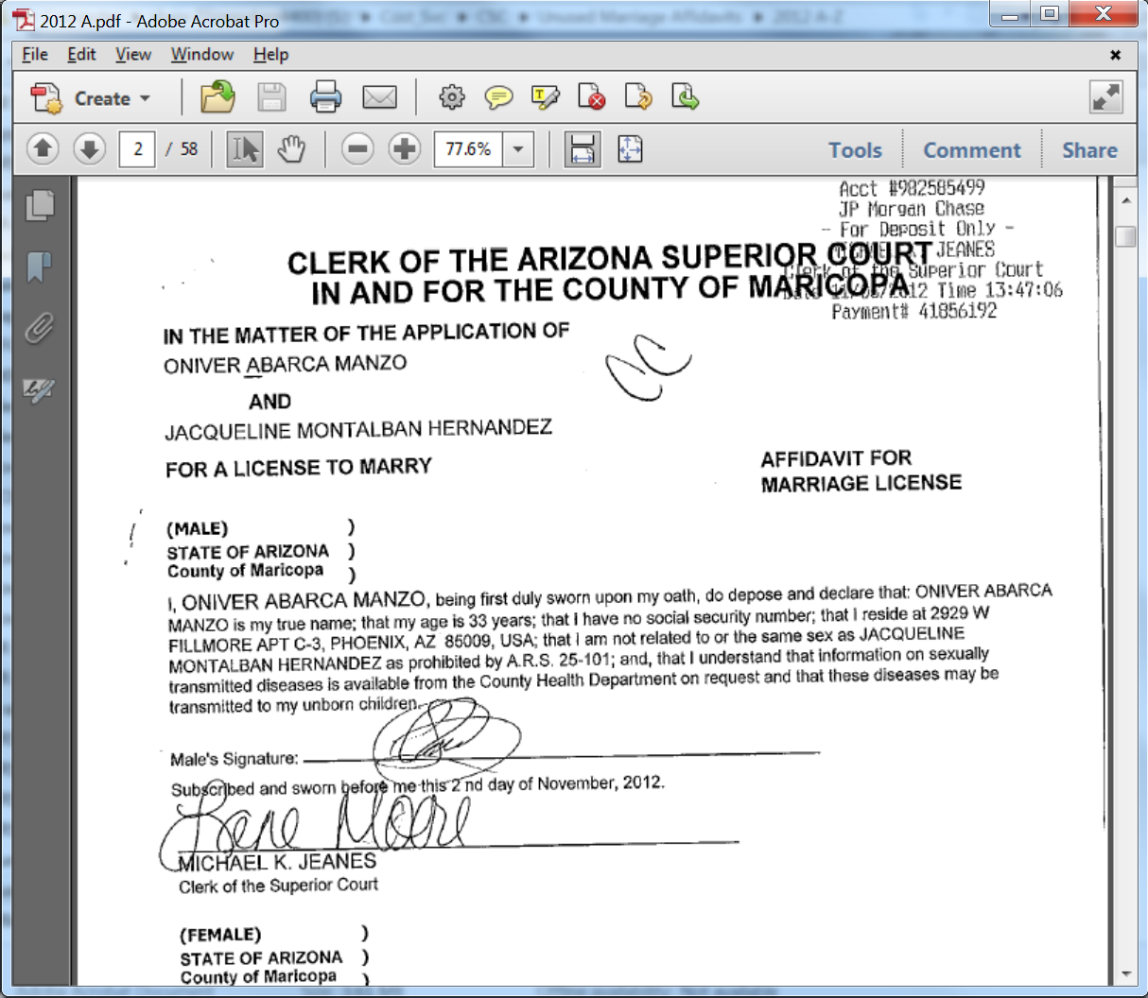
- Unused affidavits prior to 2012 are located on microfilm in the Film Alcove at CSC.

POLICIES / RELATED DOCUMENTS:

N/A

OTHER PARTIES INVOLVED:

- The Public

TIME / VOLUME:

- Varied

FREQUENCY:

- Daily

PERFORMANCE MEASURE:

- N/A

SYSTEM ACCESS REQUIRED:

- N/A

APPLICABILITY:

This procedure applies to all employees of the Clerk of the Court.

REVISION HISTORY:

Revision Number | Revision Author | Summary of Changes | Approval Date
- | Melanie Fay | Document Origination | 06/16/2016
A
B
C

