PURPOSE:

To provide instruction for employee’s access to Inactive Case Files.

OBJECTIVE:

To inform and direct staff of their responsibilities for accessing the inactive case files via OnBase Thick Client.

EVENT DRIVER:

Having the need to access OnBase Thick Client to provide customer assistance with an inactive case file.

PROCEDURES:
- Access OnBase (Thick Client) utilizing your Login ID and password. (see Figure 1)

(Figure 1)
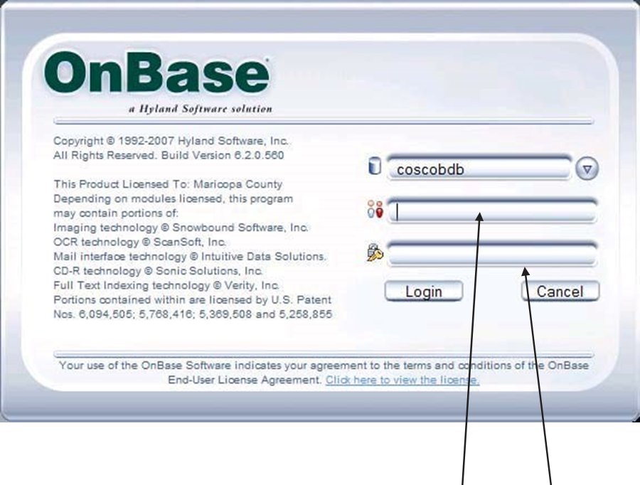
Access OnBase (Thick Client) utilizing your Login ID and password

- Click on “COSC-A INACTIVE”. (see Figure 2)

(FIGURE 2)

- At this screen (Document Retrieval), click on the required case category (Document Types). (see Figure 3)

(FIGURE 3)

- Input case number (use ten digits with dash in-between). (see Figure 4)

(FIGURE 4)

- A listing of documents will display. (see Figure 5)

(FIGURE 5)

- To access a single document, click on that document. (see Figure 6)
- To highlight all listed documents, click the left mouse button and drag the mouse down until all documents are highlighted.

(FIGURE 6)
- Documents will display in “cascade” effect with the first document displayed on top. (see Figure 7)
- To view documents one at a time, click the “Maximize” button which will “pile” the documents. (see Figure 7)
(FIGURE 7)
- Click the bottom “X” to view the next document. (see Figure 8)

(FIGURE 8)
- To access another inactive case, click the “Retrieve Documents” button (first button on the toolbar). (see Figure 9)

(FIGURE 9)

- The Document Retrieval screen will display once again. Input case number and follow previous steps. (see Figure 10)

(FIGURE 10)

- To exit OnBase, click the top “X”. (see Figure 10)

SYSTEM ACCESS REQUIRED:

OnBase Thick Client

APPLICABILITY:

This procedure applies to all employees of the Clerk of the Court.

REVISION HISTORY:

Revision Number | Revision Author | Summary of Changes | Approval Date
- | Melanie Fay | Document Origination – transferred from Guide to Procedure | 01/22/2021
A
B
C

