PURPOSE:

To provide instructions for adding records to the Case History Index.

GENERAL INFORMATION:

Pursuant to A.R.S. §12-283, A.R.S. §39-121.01 and Rules of the Supreme Court of Arizona, Rule 94, the Clerk of the Court is responsible for preparing statistical and such other reports and maintaining Court Case Files, Marriage Licenses and other records. The Case History Index details a brief history of the Clerk’s Office cases, provides historical information and provides location and access information for each case category.

PROCEDURES:
- Access the iCIS New Case Filings Report to obtain the previous year’s last case number used per filing location for corresponding Adult filing categories.
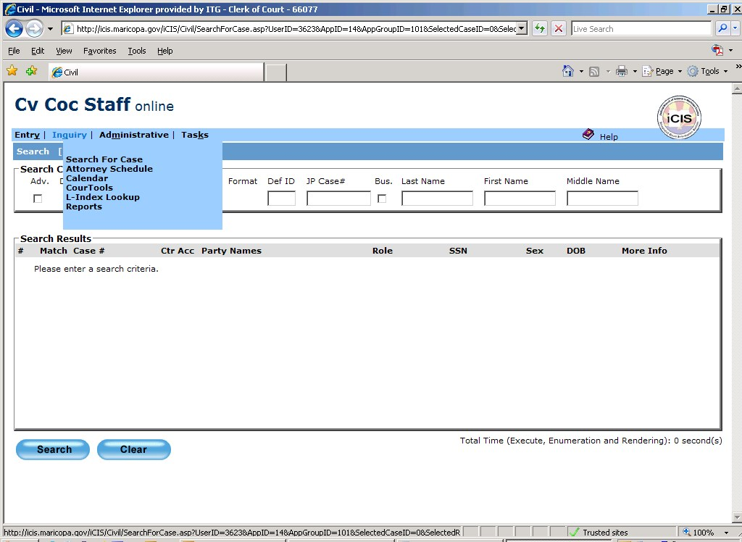
  - Click on “Inquiry” and then “Reports”.

After accessing iCIS and
the specific filing category,
click on “Inquiry” and then
click on “Reports”.
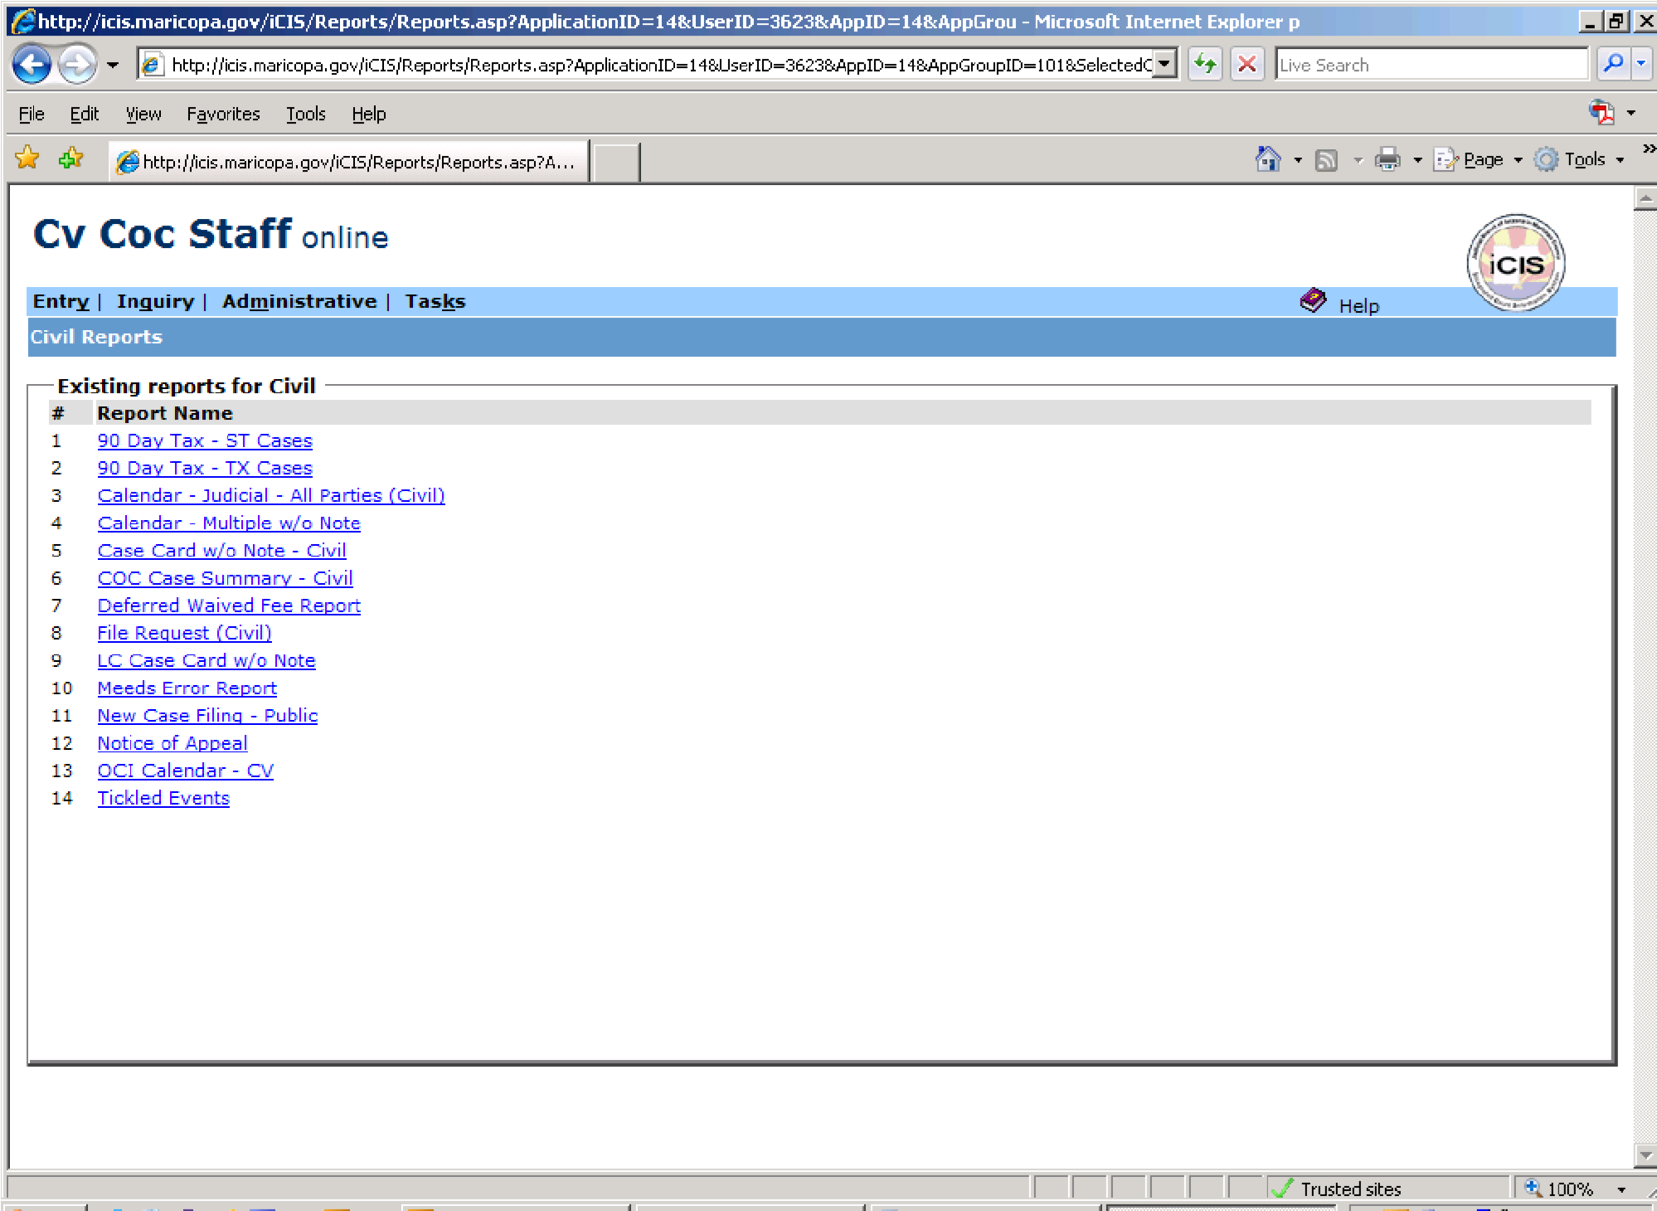
  - Click on “New Case Filings

Click on “New
Case Filing –
Public”.

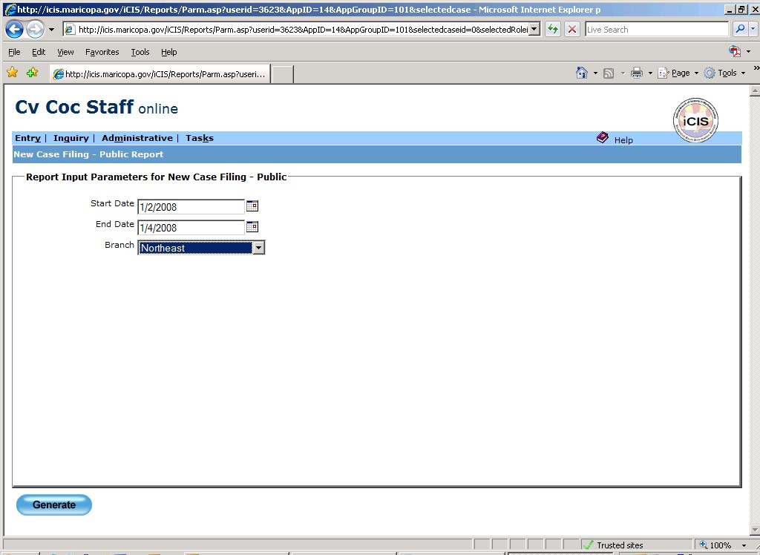
  - Generate report.

Click on the drop
down menu to
select the specific
location needed.
Enter a three day period for the start and
end date, usually the first three days of
the current year.

  - Scan through report to locate the last case number used for the previous year. In many instances, the case numbers will not be listed in numerical order.
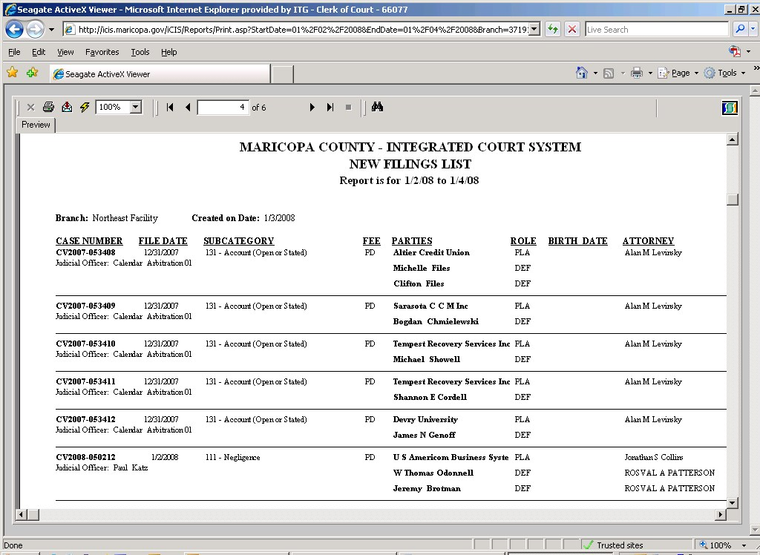

Scroll through the
pages to find the
last case number
for the past year.

- Obtain the total of new cases filed by Adult category per location by accessing the COSC Statistics folder located on the S-drive (S:\Metrics\Statistics\COSC Stats\1-Adult New Cases [requires pre-approval for access]).
- Contact the Juvenile Administrator to obtain the data for all Juvenile filing categories.
- Contact the Public records Administrator to request the case number information (first and last case number used for the year per category). The Public Records Administrator will contact the Court to obtain this data.

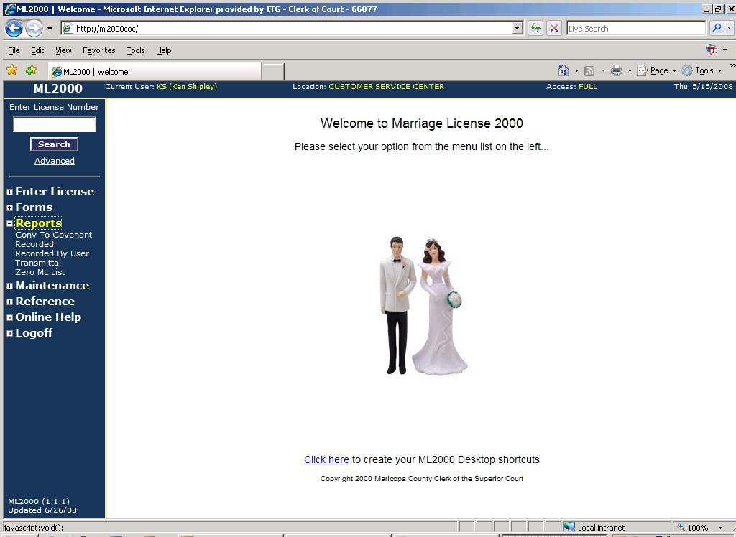
- Access ML2000 to obtain the recorded marriage licenses data.

After accessing
ML2000, click on
“Reports” and then click
on “Recorded”.
- Access the “Reports” category.

- Input the report parameters needed to generate report.
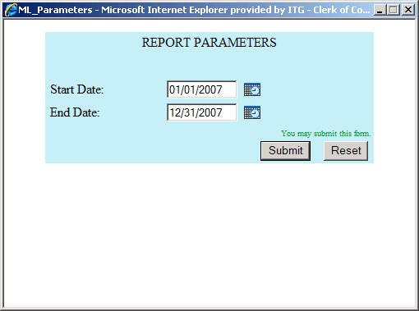

Input the start and
end dates of the
required period.
Click “Submit”
to generate the
report.

- Click the last page button.
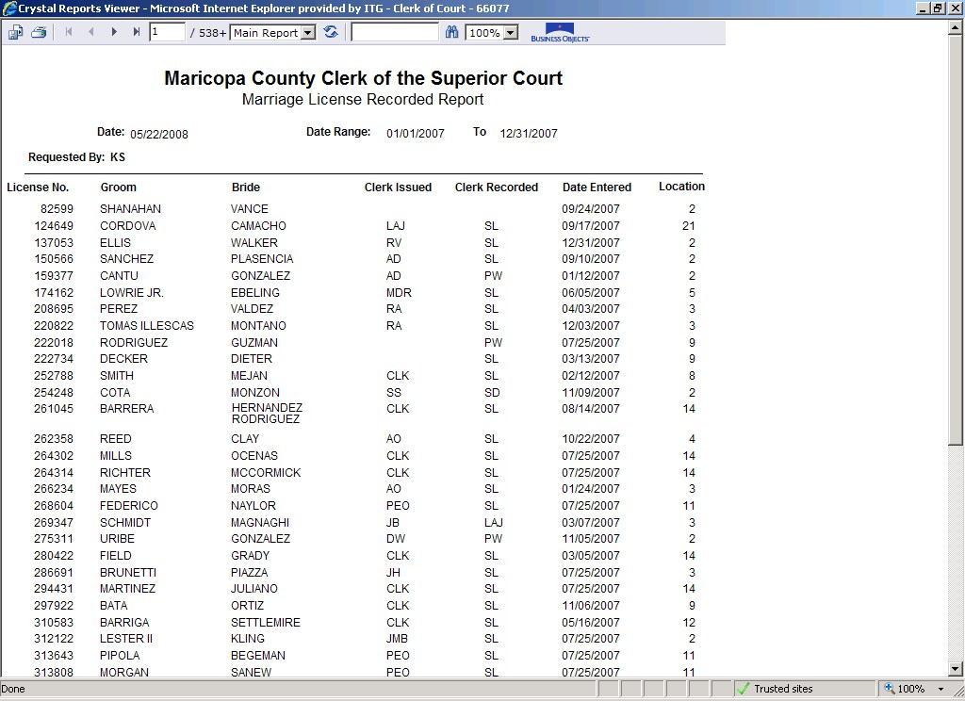

Click the “last
page” button to
forward to the last
page of the report.

- Post the total recorded onto the Marriage License Index section of the CHI.
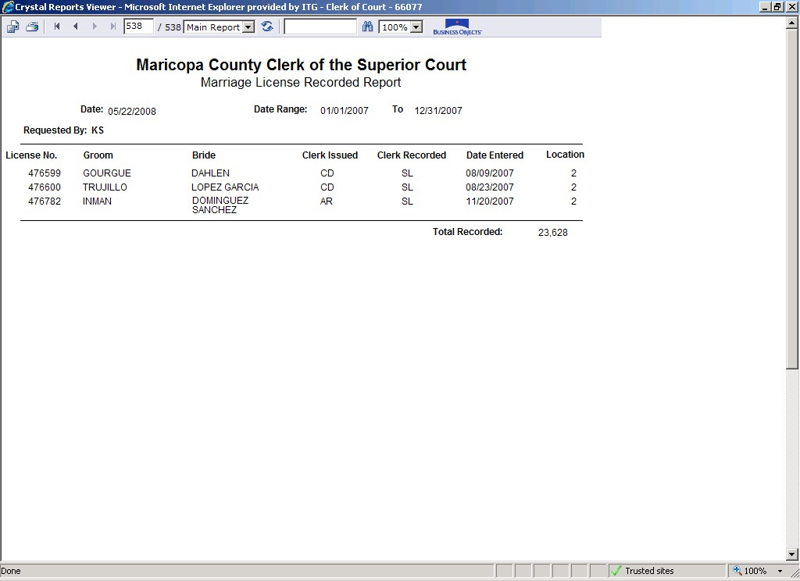

The total recorded
for the requested
period – post this
number onto the
Marriage License
Index section of
the CHI.

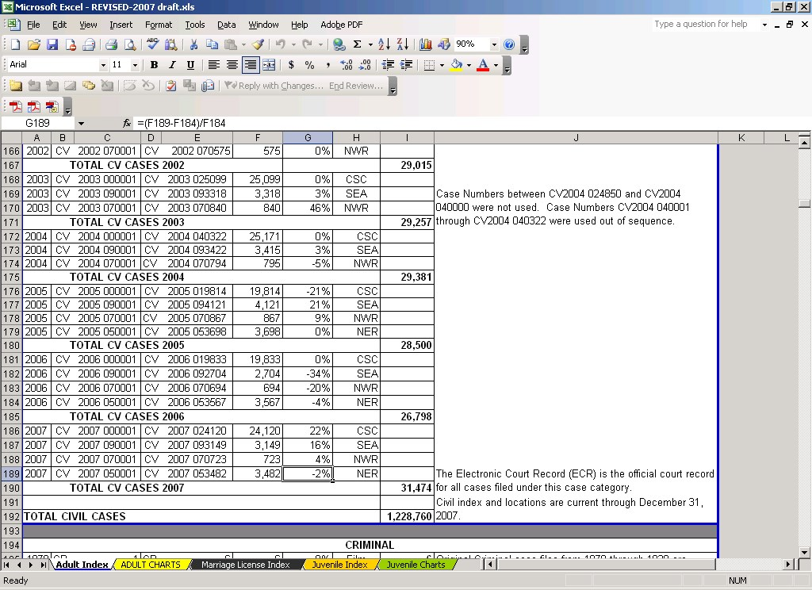
Cut and paste formula – total will auto calculate from previous year’s data

- Insert blank rows – input data for specific filing categories for applicable locations.

- Contact the Water Case Specialist or Public Records Supervisor to obtain information on the Water Case.
- Update the Case History Index glossary as required (input will be provided by the Public Records Administrator and/or the Deputy Director[s]).
- Input collected data into the applicable sections (Adult Index, Marriage License Index, and Juvenile Index) of the draft (Excel spreadsheet).
  - Copy and paste the formulas from the previous years into the blank rows. Excel will auto-calculate the formula.
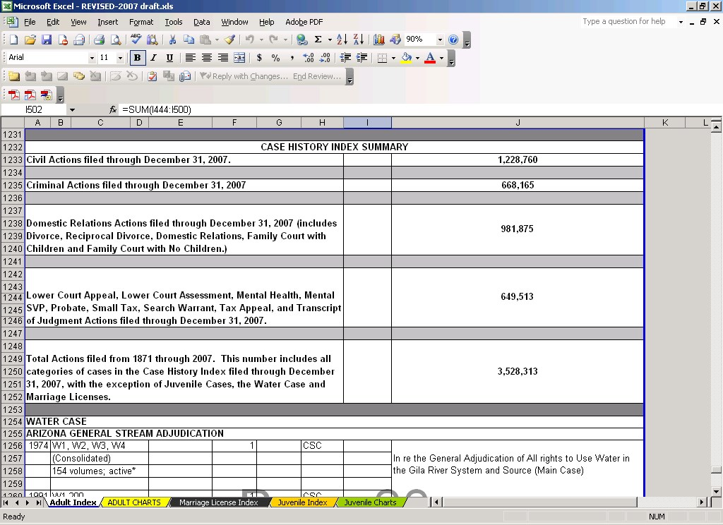
- Review the Case History Index Summary and verify that the totals listed equal the combined totals from the respective sections.

Verify that the totals
listed here match the
totals (including
combined totals) of
the respective
sections.
- Update the charts.
- Once all data has been entered (including updating the charts) and the final draft has been reviewed and approved, convert the final draft, glossary and cover page into .PDF format (requires full access to interactive Adobe Acrobat).
  - Convert each worksheet (tab) of the spreadsheet into .PDF format.
    - Click “File” and then “Print” to bring up the Print dialog box.
    - When the dialog box appears, click the dropdown menu and select “Adobe PDF”.
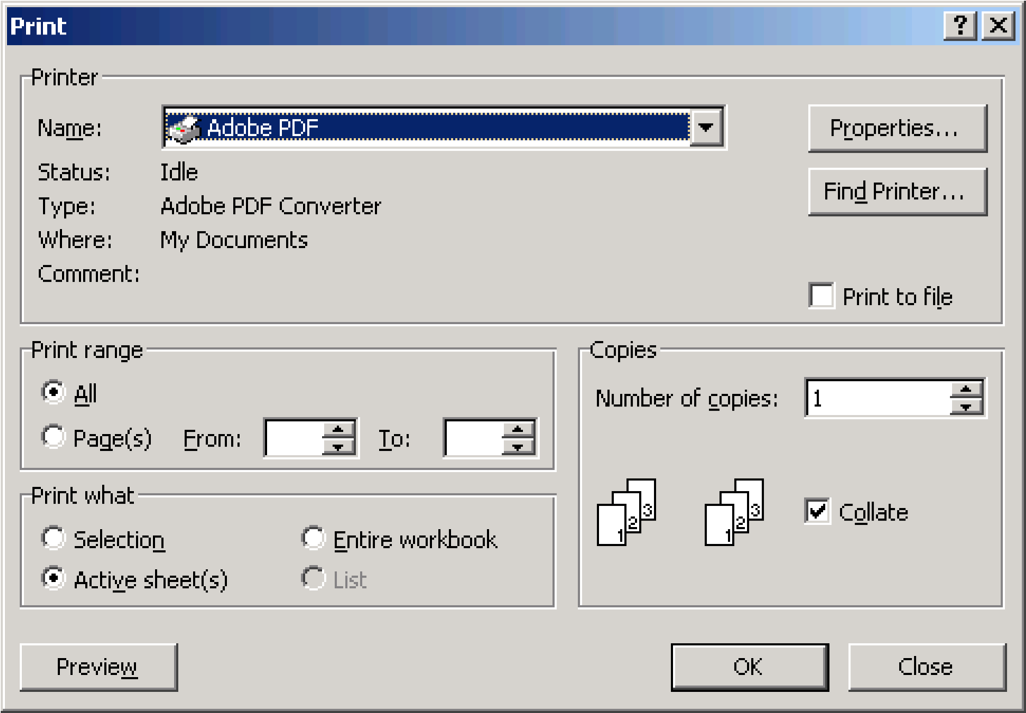

    - When the next dialog box appears, select the appropriate folder to save the file and rename the file (rename the file the same name as the worksheet (tab) name).

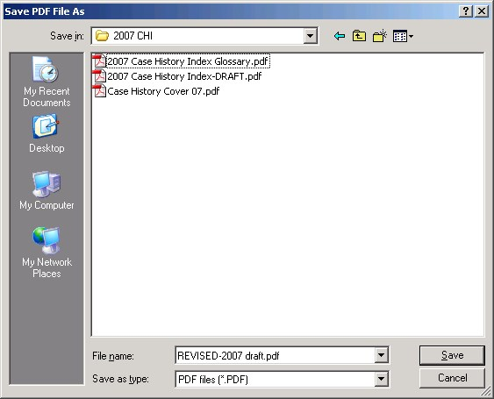

    - Continue this process until all worksheets (tabs) have been saved as PDF files.
- After the final review, make approximately 15 hard copies for distribution. Check with the appropriate Deputy Director for the distribution list.
- After delivering the copies to the Deputy Director for distribution, send an RFS to ITG to update the COC website with the updated CHI.
- Once the new CHI has been posted, send a Memorandum via e-mail to the Court Judiciary staff, Special Water Master, and State Archives to inform these offices that the new CHI is now available for review on the COC website.
- Send an e-mail to inform all COC staff that the new CHI is now available on the COC website.

POLICIES / RELATED DOCUMENTS:

- ARS 12-283: Powers and Duties
- ARS 39-121.01: Definitions; maintenance of records; copies, printouts or photographs of public records; examination by mail; index
- Rules of the Supreme Court of Arizona, Rule 94: Superior Court Clerks

OTHER PARTIES INVOLVED:

- N/A

SYSTEM ACCESS REQUIRED:

- ML2000

REPORTS / FORMS:

- N/A

APPLICABILITY:

This procedure applies to all employees of the Clerk of the Court.

REVISION HISTORY:

Revision Number | Revision Author | Summary of Changes | Approval Date
- | Melanie Fay | Document Origination | 07/14/2008
A | Melanie Fay | Process Revision | 08/18/2014
B | Ken Shipley | Procedural Contents Updated | 12/31/2020
C

