PURPOSE:

To provide instruction for Exporting Documents (OnBase Publishing and C2C Modules).

OBJECTIVE:

- To provide necessary direction to ensure that Exporting Documents (OnBase Publishing and C2C Modules) are processed properly and consistently over time.

GENERAL INFORMATION:

Pursuant to Supreme Court Rules, Rule 123 Arizona Rules of Court, A.R.S. § 12-284, A.R.S. § 39-121.03(D), the Clerk of the Court shall maintain and provide access to court records in accordance with applicable law, and shall promptly furnish copies of such records. Case files are maintained at the Customer Service Center (CSC) and are subject to review by the general public and various outside agencies.

EVENT DRIVER:

- Exporting Documents (OnBase Publishing and CSC Modules) is required.

PROCEDURES:
- OnBase Publishing: Insert blank writable CD into the CD drive.
- Access OnBase Thick Client.
- Click the applicable Document Type Group and then input the case number into the Keywords section (located at the bottom left of the screen--example: PB2001-000234).
- If placing multiple cases on a CD, an Envelope must be created to export the cases:
  - Click User.
  - Click Envelope, then New Envelope.
  - When the pop-up box appears, name the new Envelope (i.e., John Doe Envelope, or use case number).
  - Click OK. This will return to the Documents Search Results screen.
  - Select (highlight) those documents to be copied to the CD.
  - Once documents are highlighted, right click on the highlighted documents.
  - Click Send To.
  - Click Envelope.
  - When the pop-up menu appears, double-click on the just named Envelope. Those selected documents will be transferred to the Envelope.
- To transfer the Envelope to a writable CD:
  - Ensure the Envelope is open.
  - Place the cursor inside the box and right click to bring up pop-up menu.
  - Click Export Envelope.
  - When the pop-up box appears:
    - In the Description box, type in the case number.
    - In the Export Format box, select Production Exports from the drop-down menu.
    - In the Envelope (Optional) box, select the appropriate Envelope from the drop-down menu (i.e., John Doe Envelope).
    - Click the Create button to export the envelope to the writable CD.
  - Once the data are transferred, a prompt will appear to inquire if an additional copy of the same CD is to be made.
    - If a second copy of the same data is needed, insert a new blank writable CD, select Yes, and follow the instructions on the screen.
    - If another copy is not needed, select No and remove the CD from the CD ROM drive.
- If copying a single case to a CD:
  - Follow steps 2 and 3 above to access OnBase and the applicable case type and case number.
  - Select (highlight) the entire range of documents.
  - Once documents are highlighted, right click on the highlighted documents.
  - Scroll to and then click on Export All.
  - Under Description, input the case number.
  - Under Export Format, click on the dropdown menu and select Production Exports.
  - Click Create to export the highlighted documents to the CD. If a message appears to overwrite CD, click Yes.
  - Once the data are transferred to the CD, remove the CD.
- Verify that the documents are viewable on the CD.
  - Reinsert the CD to view the documents.
  - A version of OnBase will automatically open up.
  - The customer will need to accept "disclaimer" to be able to view the documents.
  - Type in the case number.
  - Click Find. All documents will then appear.
  - Verify that all documents requested were transferred to the CD.
- Once the information has been transferred to the CD, that CD cannot be used for future copying.
- C2C Module Disk Burning Steps.
    - Click on C2C icon (on the desktop screen).
    - Enter your OnBase Username and Password.
    - Click on the Connect button (icon that looks like a key).
    - Enter the case number exactly the way you in OnBase (example, FC2008-050083, CR2008-119506-001). YOU MUST USE THE DASH.
    - Press the “Tab” key.
    - Click on the Export Documents button (it looks like a running man). You will then be prompted to select a group. Group _01 should be highlighted.
    - Click on “Use Selected Group”.
    - Choose an Extract Option. There should only be one (Recreate) when this is the first time to extract documents for this case.
    - NOTE: Recreate will start from scratch and re-export all documents. If this is the first time you are extracting documents for this case, this will be the only option you can choose. Use this option only.
    - Click on “Recreate”, then click “OK”.
    - When the extraction process is completed, you will see a message similar to below (the message box may appear more compact than displayed below):

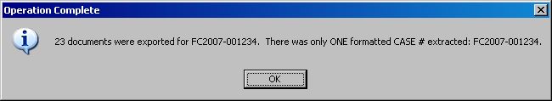

    - View the Index by clicking on the Main Menu>View>Index of Record File.
    - Insert blank disk into the drive.
    - Click on the “Home” tab (if you are not already there) and click the “Repackage” button (button under the Running Man) to build the HTML Index of Record

Repackage button
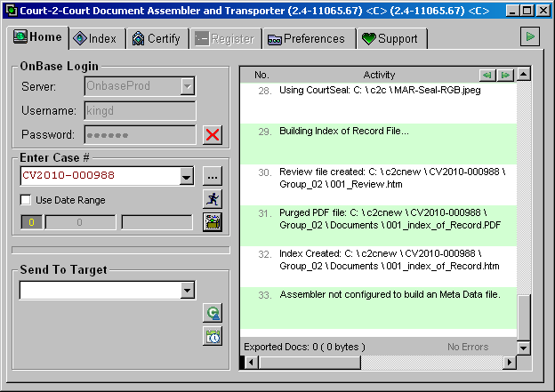

    - Select the appropriate Target – CD Drive.
    - Click on “Send to Target”.
    - Select the correct group (as you did in the beginning of this process).
    - Click “OK” to confirm sending. The documents are being copied to a folder: C:\CD Publishing.
    - To burn the documents to a CD, you must open the C:\CD Publishing folder and locate the folder (by case number) to be burned to the CD
- Click on “Start” (lower left hand corner of screen).
- Click on “My Computer/Computer”.
- Double click on the C drive to open it.
- Double click on the CD Publishing folder.
- Locate the folder with your case number; double click to open.
    - Delete the MetaData document (ooo_MetaData.XMS, or something similar) from the folder.
    - Go back (arrow up) to the folder with the case number).
    - Right click on the folder.
    - Left click on “Send To”.
    - Select the appropriate CD/DVD drive (“E” or “F”).
    - Insert the disk (if not previously done).
    - Enter a disk title (preferably the case number).
    - Click Next to continue.

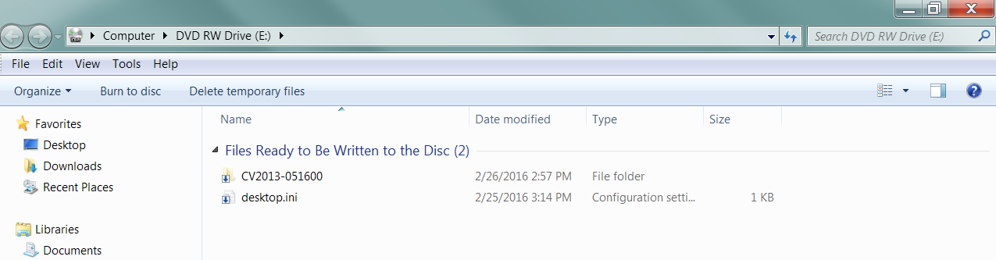

- Delete the desktop.ini file from the folder.

- Click on “Burn to disc” (located on the task bar).

    - Enter a Disc Title is not previously done.
    - Click “Next”. The documents are now being copied to the CD.
    - If you want to create another CD with the same files, click on “Yes”. If not, click
Finish”.
- REMOVING FILES FROM THE C AND K DRIVES (C2C Module)
    - In downloading the documents from OnBase and in preparation of burning the documents to CD, copies of the documents are placed and the C and K drives. Endless storage of these documents on the drives can quickly consume disk space. It is important that once the contents of the documents are burned to a CD and the contents of the CD has been verified, the copies of the documents on the c and K drives are to be removed.
    - To remove files from the C drive:
- Go to Computer and click on your ‘C’ drive
- On the “C” drive, locate the “CD Publishing” folder.
- Locate the case number that has been copied and delete it.
    - To remove from the K Drive:
- Go to “Computer” and click on “K” drive.
- On the “K” Drive, locate the “M” number of the PC used to burn the CD.
- Locate the case number completed and delete.

POLICIES / RELATED DOCUMENTS:

- 17A A.R.S. Supreme Ct.Rules: Rule 123: Access to the Judicial Records of the State of Arizona
- ARS 12-284: Fees
- ARS 39-121.03: Request for copies, printouts or photographs; statement of purpose; commercial purpose as abuse of public record; determination by governor; civil penalty; definition

OTHER PARTIES INVOLVED:

- The Public

TIME / VOLUME:

- Varied

FREQUENCY:

- Daily

PERFORMANCE MEASURE:

- N/A

SYSTEM ACCESS REQUIRED:

- OnBase Thick Client

REPORTS / FORMS:

- N/A

DEFINITIONS:

- N/A

APPLICABILITY:

This procedure applies to all employees of the Clerk of the Court.

REVISION HISTORY:

Revision Number | Revision Author | Summary of Changes | Approval Date
- | N/A | Document Origination | 12/03/2008
A | N/A | N/A | 07/14/2014
B | Larry Urewicz | Reformatted for the CDI | 04/28/2017
C | Ken Shipley | Procedural Contents Updated | 10/29/2020

