PURPOSE:

To provide instructions for handling a facility outage.

OBJECTIVE:

- To provide the necessary direction to ensure that the proper COSC staff are advised of a facility outage affecting their work area(s).
- To provide contact information of personnel involved in facilities outages.

EVENT DRIVER:

- A facility outage notification is received from County.

PROCEDURES:
- Review if outage is occurring in COSC space.
  - In order to know if the work is impacting COSC space, read through notification to see what floors or areas are impacted. If it is not clear, contact the FMD Project Manager listed in the notification and request specifics related to the outage.
  - The locations identified in the Applicability section below would be impacted at the Clerk’s office.
- If no impact, send email to ITG Help Desk and ITG Management advising them there is no impact to COSC spaces.
- If impacted, a separate email and pre-shutdown meeting invite should have been received from the FMD Project Manager.
  - If not received, contact FMD Project Manager for that information.
  - If received, review the scope and impact.
    - Forward the outage information to the ITG Help Desk and ITG Management
    - Forward the pre-shutdown meeting invite to the ITG Tech Support Manager. If an out of office notice is received, forward the pre-shutdown meeting invite to his out of office designee.
- An electrical outage will require contacting the FMD Project Manager via email and require the card reader vendor to do the following:
  - Ensure all back up batteries in the card reader panels are replaced.
  - Be onsite during the outage if the batteries fail.

- An electrical outage in the following locations will require a Sheriff deputy (Protective Services for CSC) to be posted outside the door during an outage:
  - SCT Exhibits (Sheriff)
  - 1 W. Madison Grand Jury (Sheriff)
  - CSC Exhibits/Vaults/Grand Jury/D&C (Protective Services)
- Water outages will occur after hours except in an emergency. If occurring during business hours, contact the Clerk of the Superior Court or the COSC Chief Deputy as they have the authority to decide whether or not to send staff home.
- HVAC (heat/cooling) outages will occur after hours except in an emergency. If occurring during business hours, contact the Clerk of the Superior Court or the COSC Chief Deputy as they have the authority to decide whether or not to send staff home.
- Once all outage information is identified, ITG Help Desk will send an email out to staff. The email will include both IT equipment shutdown information as well as other impacted information, for example: remove all items from refrigerators and power down copiers.
- Follow up to ensure the email notification from ITG Help Desk was sent to staff at least once but preferably twice prior to the outage.

PROCESS SUMMARY:
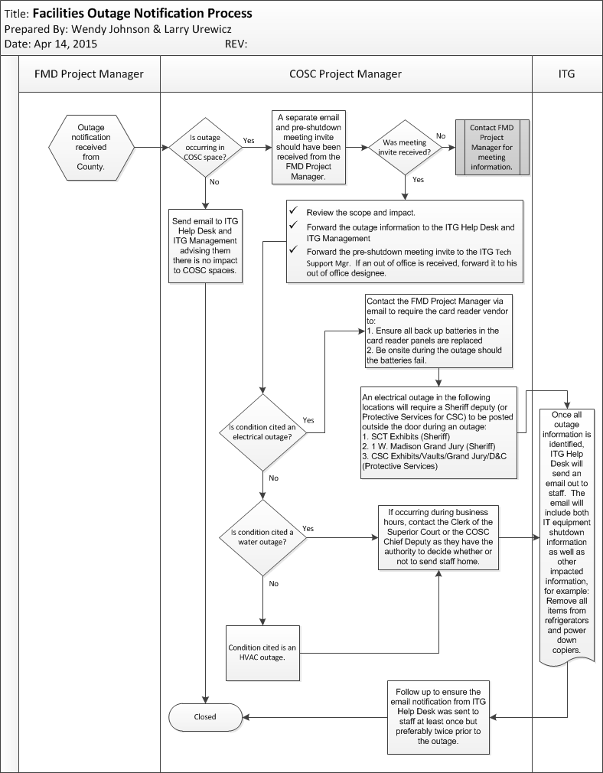
POLICIES / RELATED DOCUMENTS:

- N/A

OTHER PARTIES INVOLVED:

- FMD Boiler Room (506-3310)
- FMD Project Manager / Building Contacts
  - 1W Madison/CCB/CSC/DJC/OCH/ECB/WCB – Tim Rosenow (506-1237 / 393-6829)
  - DUR/NW – Linda James (506-7966 / 723-7182)
  - NE – Brian Spoon (506-1477 / 397-2827)
  - SCT/SEA/SEJ – Brad Koos (506-4157 / 723-5609)
- ITG Tech Support Manager (or designee)
  - Scott Hensel (506-7616 / 722-6749)
- Sheriff’s Office
  - Jonathan Knapp (876-8842 / 527-1188)
- Protective Services
  - Brad Cutliffe (506-5773 / 296-9607)
  - Andy Tooke (506-0995 / 882-9720)
- Clerk of the Superior Court
- COSC Chief Deputy
  - Christine Kelly (506-5728)
- Card reader vendor
  - ESI: 800-377-5017 (Project Manager: Dave Calhoun 480-223-7236)

TIME / VOLUME:

- Varied

FREQUENCY:

- As needed

PERFORMANCE MEASURE:

- N/A

SYSTEM ACCESS REQUIRED:

- email

REPORTS / FORMS:

- N/A

DEFINITIONS:

- N/A

APPLICABILITY:

This procedure applies to all employees of the Clerk of the Court. Facilities affected are as follows:
    - 1 West Madison (1st floor)
    - Central Court (1st floor and 3-12 Courtroom Clerks)
    - Customer Service Center (Jackson Garage)
    - Downtown Justice Center (3rd floor)
    - Durango (1st floor)
    - East Court Building (4-5,7 Courtroom Clerks)
    - Northeast (1st floor)
    - Northwest (1st floor)
    - Old Courthouse (1st floor)
    - South Court Tower (4th and 12th floors)
    - Southeast Adult (1st floor and 2-4 Courtroom Clerks)
    - Southeast Juvenile (1st floor)
    - West Court Building (1st floor)
REVISION HISTORY:

Revision Number | Revision Author | Summary of Changes | Approval Date
- | Wendy Johnson | Document Origination | 04/17/2015
A
B
C

