PURPOSE:

To provide the process for a Quality audit within the Clerk’s Office.

OBJECTIVE:

- To provide the necessary direction to ensure that Quality audits are correctly and accurately conducted in accordance with Management approved methods;
- To ensure that Quality audits are consistently done over time.

EVENT DRIVER:

- A Quality audit is required.

PROCEDURE: (refer to Figure 1)
- Each batch is sequestered until the audit of the batch is completed and acceptance or rejection is determined.
- Quality Audit history will be maintained (to include at least: Date Batch Received, Date Audit Completed, Case Type, Batch Number, Batch Size, Sample Size, Number of Defectives Found, and Number of Defects Found & Nature of the Defects. This information is gathered on a Quality Audit Record form (F-ODIR-1005), which upon completion of the audit is entered into the F-ODIR-1006: COSC Audit Log for Quality History maintenance and subsequent reporting.
- All rejected batches will be reported on form F-ODIR-1007: Non-Conforming Batch Notice and dispositioned by the COSC Management Review Board. Disposition will consist of the batch being sorted, corrected, and re-submitted for re-inspection as separate batches.
- Any new or major changes to the production process (e.g.: change of Case Type), batches should be audited at 100% inspection level for the first few batches in order to establish an audit level history before implementing sampling.
- Batch numbering for different Case Types for example should start over.
- Sampling may be conducted; contact the Management Analyst for appropriate sampling plans.

Figure 1
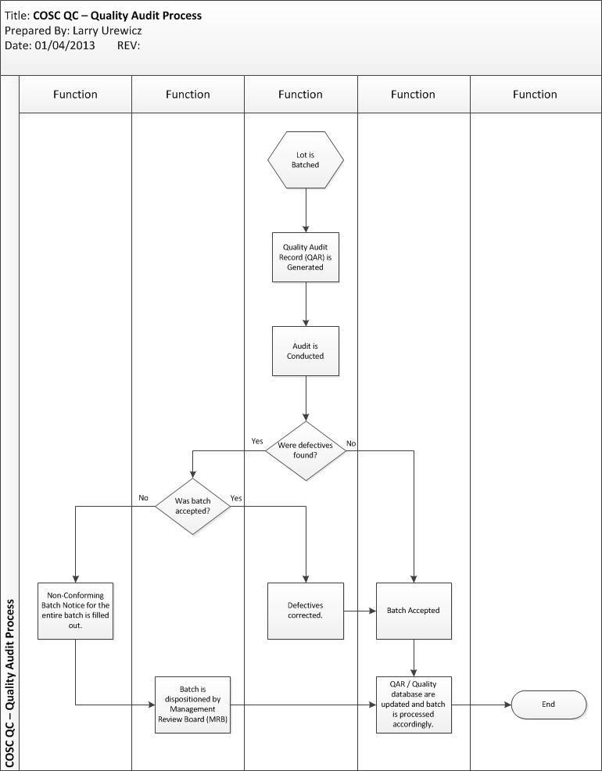
POLICIES / RELATED DOCUMENTS:

- ANSI/ASQ Z1.4-2008: Sampling Procedures and Tables for Inspection by Attributes
- TABLE-ODIR-1003: Document Defect Classification & Characteristics (Cr/Ma/Mi)

OTHER PARTIES INVOLVED:

The COSC Management Review Board (MRB) consists of:
- Initiating Dept. Manager
- Project Manager
- Management Analyst

TIME / VOLUME:

- Varies

FREQUENCY:

- Daily

PERFORMANCE MEASURE:

- N/A

SYSTEM ACCESS REQUIRED:

- OnBase
- The Document Control System

REPORTS / FORMS:

- F-ODIR-1005: Quality Audit Record
- TABLE-ODIR-1006: COSC Audit Log
- F-ODIR-1006: Non-Conforming Batch Notice

DEFINITIONS:

- Homogeneous Group: Of the same kind or nature; essentially alike; having come from the same source.
- Random Sample: Each sample drawn from the batch must have had an equal opportunity to have been chosen.
- Defect (a.k.a.: Error): A single instance of a departure from standard, or requirements, or expectations.
- Defective: A unit of product (i.e.: a document, for example) that contains at least one, but could contain more than one, Defect.
- Product: A tangible or virtual “unit” (Examples include but are not limited to: end items, components or raw materials, operations, materials in process, supplies in storage, maintenance operations, data or records, administrative procedures, etc.).

APPLICABILITY:

This procedure applies to all employees of the Clerk of the Court.

REVISION HISTORY:

Revision Number | Revision Author | Summary of Changes | Approval Date
- | Larry Urewicz | Document Origination | 01/15/2013
A
B
C

