PURPOSE:

To provide instructions for processing and issuing Marriage License requests received from a visually impaired customer.

OBJECTIVE:

- To provide the necessary direction to ensure that marriage license requests are correctly and accurately initiated,
- To ensure consistent processing of marriage license requests over time.

GENERAL INFORMATION:

Pursuant to A.R.S. §25-121, persons shall not be joined in marriage in this state until a license has been obtained for that purpose from the clerk of the superior court in any county of this state. Pursuant to Maricopa County Superior Court Notice of Court Access Information for Persons with Disabilities, Title II of the Americans with Disabilities Act and other applicable laws, the Clerk’s Office will make reasonable accommodations to qualified individuals with disabilities who require accommodation to fully and equally participate in court services, programs and activities.

EVENT DRIVER:

- A visually impaired customer requests the issuance of a Marriage License.

PROCEDURES:
- Identification Requirements
- Effective 2/1/2010, all marriage license applicants are required to provide identification. The Matricula Consular ID will no longer be accepted effective 7/20/11. The following items are acceptable forms of identification:
- Any valid government issued picture ID with date of birth included: driver’s license, passport, foreign passport, foreign driver’s license, Certificate of Naturalization, Mexican voter cards with copy of birth certificate, Visa Border Crossing card (US issued).
- Any valid picture ID with a copy of their birth certificate, to include: student ID, bank card, Costco card, etc.
- If no valid picture ID is available, a copy of their birth certificate and an Affidavit of Identifying Witness (this is similar to what is used in accepting passport applications) along with 3 separate documents (electric/water/phone bill, apartment lease or mortgage note, tax returns, credit card/bank statements, etc.) that are in that person’s name.

- If no copy of their birth certificate is available, a valid picture ID and an Affidavit of Identifying Witness along with 3 separate documents (see section I.1.C above), PLUS review and approval by the supervisor, manager or administrator.
- The four options stated above are to be followed in order with option C and D only being used as a last resort, and with review and approval as stated in option D until proper identification is obtained. If there are any questions as to the appropriateness of the document for identification purposes, please seek the assistance of a supervisor, manager, or administrator.

- Age Requirements

NOTE: Effective August 3, 2018 per Arizona law, persons under 16 years of age are prohibited from marrying.

- For those individuals age 16-17, the following is required:
- A copy of their birth certificate…AND
- One of the following government issued picture IDs to show proof of age and confirm identity: a current driver’s license, a state or military ID card, current passport, Certificate of Naturalization, or other valid government-issued picture ID…AND
- Either a certified copy of an Emancipation Order, OR a notarized Clerk’s Office parental consent form along with copies of the front and back of the parent(s) or legal custodian’s identification, or have your parent(s) or legal custodian accompany you and present proper identification and sign the parental consent form in the presence of the clerk issuing the marriage license.....AND
- The younger applicant’s prospective spouse cannot be more than 3 years older than the younger applicant.

NOTE: Per the AG, there is no statutory requirement that the person providing the consent have "legal custody" of the minor; the statute only says "consent". There is no obligation that the Clerk requires independent proof of custody; the Clerk can rely on the written affidavit unless there is reason to question any of the statements in the affidavit. If there is reason to question any of the statements in the affidavit, seek clarification/ guidance from the ML&PP/PR supervisor, manager or Administrator.

- ML Age Calculator

NOTE: For applicants at least 16 years of age and under 18 years of age, the clerk will utilize the “ML Age Calculator” (See Figure 1).

FIGURE 1

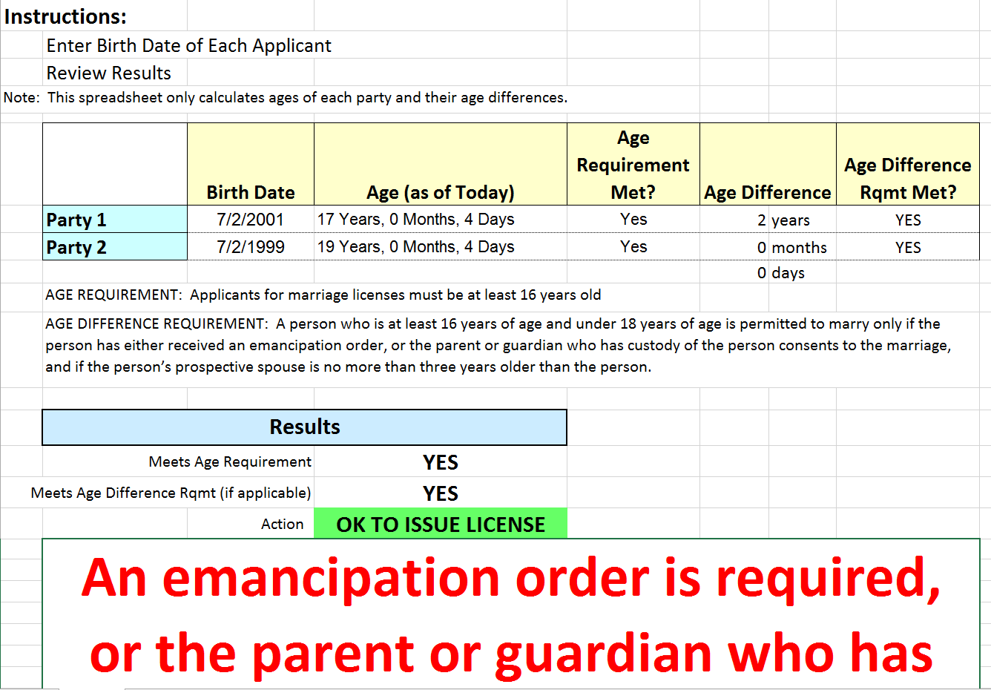


- The clerk inputs the date of birth for each party (input is not dependent on who is older or younger), and the calculator performs calculations, presenting the results after checking for :
A. Meeting the minimum age requirement
B. Meeting the age difference requirement for parties greater than 16 years old,
but less than 18 years old with an age difference of 3 years or less
C. Birth dates of both applicants shall be entered in, Party 1 and Party 2; then, hit
“tab” for the results
- The calculator will display results as to whether the marriage license can or cannot be issued.
- If the results indicate “YES”, a second verification from another clerk will be required. Notes regarding this second verification will be entered in ML2000 under the notes section for “additional issuing information” (See Figure 2).

FIGURE 2
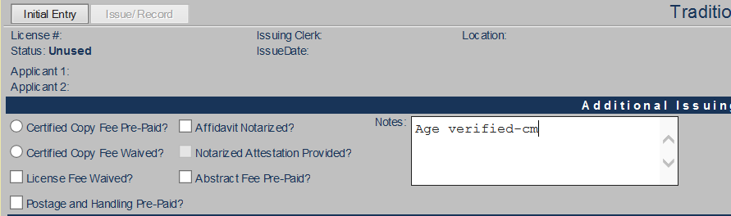

- Issuance of the License
- Upon request from a customer (applicant) for accommodated assistance due to visual impairment, Marriage License staff will:
  - Retrieve a blank Marriage License Application Form from the License Services front counter.
  - Inform the applicants that staff will assist them with completing the application.
  - Request the applicant’s government/photo identification (ID) cards in order to prepare the application.
    - Photocopy the ID cards for our files as proof of the signature of the customer. Prior to scanning this document with the affidavit and marriage license, redact the social security number and driver’s license number.
    - Annotate the appropriate information from the government/ID card onto the marriage license application.
    - The legal name on the parties’ identification is the only name that can be used to apply for a marriage license.
- Escort the applicants to the issuing clerk’s desk to prepare the affidavit.
  - Discreetly re-read the information from the marriage license application to the customer to verify the annotated personal information. If the customer indicates a change to that information, annotate correct information on the application form.
  - Access ML2000 and input the applicants’ information from the application into the affidavit as instructed in the PRO-ML&PP-1011, Issuing Traditional marriage Licenses procedure.
  - Print Affidavit VI (visually impaired).
  - Ensure two (2) License Services clerks are available for the verification of the affidavit process; the issuing clerk and a witnessing clerk.
  - Inform the applicants that the affidavit will be read verbatim for accuracy and verification.
  - Read affidavit very clearly. Be sure to spell out names and addresses.
  - Once the affidavit has been read, inquire if any further clarification is needed. If so, provide clarification until the information provided has been verified as true and correct by the applicants.
- Inquire if the applicants are able to provide signatures or other form of written acknowledgments on the affidavit.
  - If they can, have them “sign” in the appropriate locations.
  - If the applicants are unable to provide written acknowledgment, note this on the affidavit using a typewriter or hand-written documentation, along with their verbal acknowledgment as follows:
    - “Verbal acknowledgement was given by [name], as he/she said, “____________”. And/or, “Verbal acknowledgement was given by [name], as he/she said,“_____________”.
    - The two (2) License Services staff, the issuing clerk and the witnessing clerk, will then sign underneath the statement above as witnesses to the verbal acknowledgment.
- Collect fees and print marriage license.
- If the applicant(s) request other accommodations, contact the appropriate Administrator for consideration. Inform the applicants that all requests require at least 72 hours prior notification.

POLICIES / RELATED DOCUMENTS:

- ARS 25-121: Marriage License, Application & Affidavit
- Maricopa County Superior Court: Notice of Court Access Information for Persons with Disabilities
- Americans with Disabilities Act: Title II

OTHER PARTIES INVOLVED:

- The Public
- Recording Services

TIME / VOLUME:

- Varied

FREQUENCY:

- Daily

PERFORMANCE MEASURE:

- N/A

SYSTEM ACCESS REQUIRED:

- Marriage License application (ML2000)
- The Cash Receipting System

REPORTS / FORMS:

- Affidavit of Identifying Witness
- Marriage License Application form

DEFINITIONS:

- N/A

APPLICABILITY:

This procedure applies to all employees of the Clerk of the Court.

REVISION HISTORY:

Revision Number | Revision Author | Summary of Changes | Approval Date
- | N/A | Document Origination | 03/03/2009
A | N/A | N/A | 08/22/2014
B | Larry Urewicz | Reformatted for the CDI | 10/28/2016
C | Melanie Fay | Added Age Requirement Updates | 10/31/2018
D

