PURPOSE:

To provide instructions for processing and issuing Traditional Marriage License requests received from the general public.

OBJECTIVE:

- To provide the necessary direction to ensure that marriage license requests are correctly and accurately initiated,
- To ensure consistent processing of marriage license requests over time.

GENERAL INFORMATION:

Pursuant to ARS 25-121 persons wishing to enter into a traditional marriage shall apply to the Clerk of Superior Court, complete and sign, under oath, the required affidavit. The clerk shall then issue a marriage license to the applicants, and collect the fees pursuant to ARS 12-284 A. Marriage licenses once solemnized and recorded may not be changed unless by court order.

EVENT DRIVER:

- Customer requests the issuance of a Traditional Marriage License.

PROCEDURES:
- Identification Requirements
- Effective 2/1/2010, all marriage license applicants are required to provide identification. The Matricula Consular ID is no longer accepted effective 7/20/11. The following items are acceptable forms of identification:
- Any valid government issued picture ID with date of birth included: driver’s license, passport, foreign passport, foreign driver’s license, Certificate of Naturalization, Mexican voter cards with copy of birth certificate, Visa Border Crossing card (US issued).
- Any valid picture ID with a copy of their birth certificate, to include: student ID, bank card, Costco card, etc.
- If no valid picture ID is available, a copy of their birth certificate and an Affidavit of Identifying Witness (this is similar to what is used in accepting passport applications) along with 3 separate documents (electric/water/phone bill, apartment lease or mortgage note, tax returns, credit card/bank statements, etc.) that are in that person’s name.
- If no copy of their birth certificate is available, a valid picture ID and an Affidavit of Identifying Witness along with 3 separate documents (see section I.1.C above), PLUS review and approval by the supervisor, manager or administrator.
- The four options stated above are to be followed in order with option C and D only being used as a last resort, and with review and approval as stated in option D until proper identification is obtained. If there are any questions as to the appropriateness of the document for identification purposes, please seek the assistance of a supervisor, manager, or administrator.

- Age Requirements

NOTE: Effective August 3, 2018 per Arizona law, persons under 16 years of age are prohibited from marrying.

- For those individuals age 16-17, the following is required:
- A copy of their birth certificate…AND
- One of the following government issued picture IDs to show proof of age and confirm identity: a current driver’s license, a state or military ID card, current passport, Certificate of Naturalization, or other valid government-issued picture ID…AND
- Either a certified copy of an Emancipation Order, OR a notarized Clerk’s Office parental consent form along with copies of the front and back of the parent(s) or legal custodian’s identification, or have your parent(s) or legal custodian accompany you and present proper identification and sign the parental consent form in the presence of the clerk issuing the marriage license.....AND
- The younger applicant’s prospective spouse cannot be more than 3 years older than the younger applicant.

NOTE: Per the AG, there is no statutory requirement that the person providing the consent have "legal custody" of the minor; the statute only says "consent". There is no obligation that the Clerk requires independent proof of custody; the Clerk can rely on the written affidavit unless there is reason to question any of the statements in the affidavit. If there is reason to question any of the statements in the affidavit, seek clarification/ guidance from the ML&PP/PR supervisor, manager or Administrator.

- ML Age Calculator

NOTE: For applicants at least 16 years of age and under 18 years of age, the clerk will utilize the “ML Age Calculator” (See Figure 1).

FIGURE 1

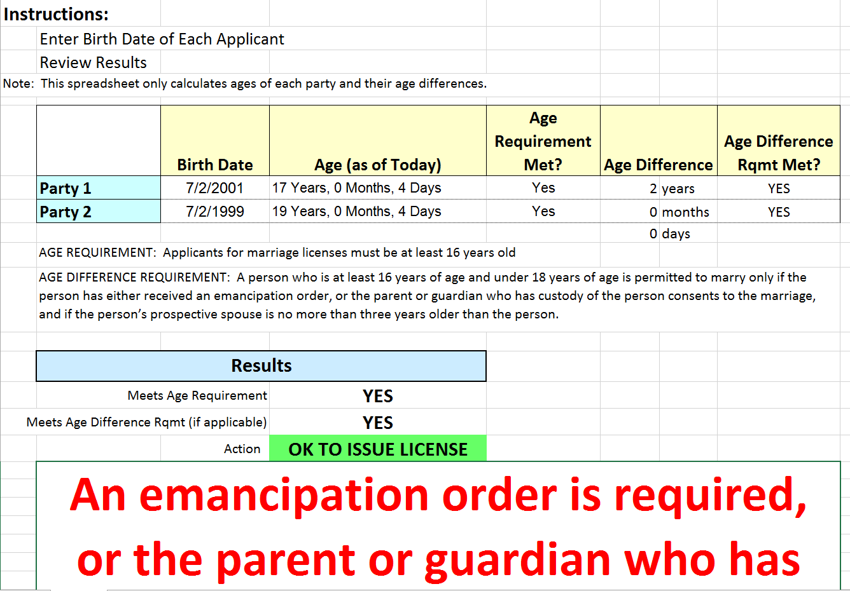


- The clerk inputs the date of birth for each party (input is not dependent on who is older or younger), and the calculator performs calculations, presenting the results after checking for :
- Meeting the minimum age requirement
- Meeting the age difference requirement for parties greater than 16 years old,
but less than 18 years old with an age difference of 3 years or less
- Birth dates of both applicants shall be entered in, Party 1 and Party 2; then, hit
“tab” for the results
- The calculator will display results as to whether the marriage license can or cannot be issued.
- If the results indicate “YES”, a second verification from another clerk will be required. Notes regarding this second verification will be entered in ML2000 under the notes section for “additional issuing information” (See Figure 2).

FIGURE 2
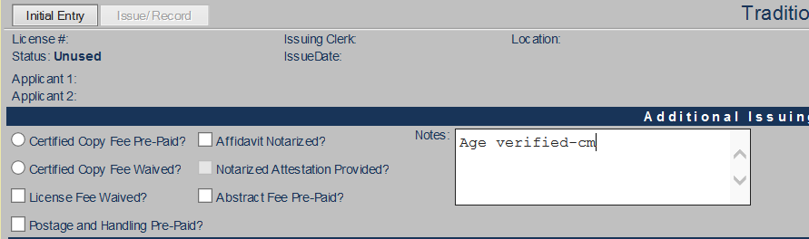

- Issuance of the License
- The couple wishing to enter into a Traditional marriage shall complete the Marriage License Application form selecting the block “Traditional”. The legal name on the parties’ identification is the only name that can be used to apply for a marriage license.
- Access ML2000 program using individual login code. The issuing clerk will complete the data entry portion from the information provided on the application and the ID’s. The clerk entering this information into ML2000 must be the same clerk that prints the affidavit, accepts the fee, and issues the license while the customers are present at the clerk’s workstation, unless otherwise directed by the Administrator.
- The Welcome to Marriage License 2000 screen will appear (See Figure 3). Select Enter License>Traditional.

Figure 3

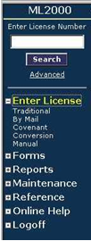

- The following two options will be prompted:
  - A message box will display asking if the couple has pre-paid for a certified copy. If so, click “Yes” or type a capital “Y”. If not, click “No” or type a capital “N”. (See Figure 4)
Figure 4

NOTE: An applicant in the United States military is provided one (1) certified copy of the recorded marriage license at no charge. Click on the radio button that states “Certified Copy Fee Waived”. In the Notes section (second screen), include the following: last name of the military person whose ID was verified, branch of service and expiration date of the verified military ID (example: Smith, USAF, expires 8/14/2020)

  - A message box will display asking if the couple has pre-paid for the Postage and Handling. If so, click “Yes” or type a capital “Y”. If not, Click “No” or type a capital “N”. (See Figure 5)

Figure 5
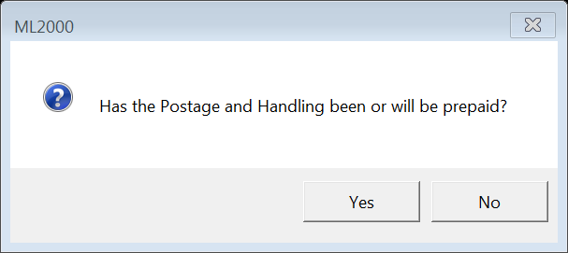

- Enter all appropriate data into the fields located on the “Initial Entry” tab of the license form. This is the screen that displays after the “Traditional” link is clicked.
  - Use the “Tab” key to move from field to field in the order listed below or use the mouse to click on a field to edit existing data. (See Figure 6)

Figure 6

  - The License Number is obtained from the license itself. Type this number into the field.
    - After entering the license number, the database will check for duplicates. A warning message will appear if a duplicate exists.
    - Up to 8 numeric characters may be entered in this field.
  - The Created Date will default to the current date.
  - The Clerk's Initials will default to the initials of the clerk who has logged into the application.
  - The Location field will default to that of the clerk who has logged into the application. Manual entry of data can also be accomplished in this field.
  - Select title: Groom, Bride, or Spouse.
  - Enter Applicant 1’s information: First Name, Middle Name, and Last Name (required). Middle name is not required. Options for a middle name are:
    - If the ID has “John A. Smith” and the party wants to include the full middle name of John Alan Smith, a copy of the birth certificate showing the full middle name is required – this is approved.
    - If the ID has “John Alan Smith” and the party wants to include the initial “A” instead of “Alan” – this is approved.
    - If the ID has no middle name, the customer must provide a copy of their Birth Certificate to verify and include the middle name.
    - If the ID has a misspelled middle name: Jamie Lynn Jones…should be Jamie Lyn Jones – the customer has the option of using the misspelling of Lynn, leaving the middle name off the license or providing a birth certificate showing the correct spelling of the middle name. OR, direct the customer to MVD to have the name corrected on the license and then return for a ML.
    - Enter up to 25 characters in either the First or Middle Name fields.
    - Enter up to 40 characters in the Last Name field.
  - Enter Applicant 1’s Address (required). There are two lines available and each accepting up to 40 characters per line.
  - Enter the City (required). Up to 20 characters may be entered in this field.
  - The State may be selected from a drop down list or using the keyboard by typing the first letter of the state which will then display the first state that has that initial. Select the two letter state code (AK, AL, AR, AZ, etc). A blank state field is available at the beginning of the alphabet drop down for out of country addresses.
  - Enter the Zip Code. This field will accept up to 9 numeric characters.
  - The Country field will default to USA. Click on this field to make corrections. Up to 20 characters may be entered in this field.
  - Enter the Social Security Number next. If the party does not have a Social Security Number, leave this field blank. When leaving this field, the clerk will be prompted to verify that the field was left blank intentionally. If anything other than a numeric value is typed, a message box will appear alerting that this is not acceptable.
(See Figure 7)
Figure 7

  - The ID Code is used to indicate the type of identification provided to the issuing clerk. (NOTE: Effective 2/1/2010, all marriage license applicants are required to provide identification.)
    - Enter the type of ID provided.
    - If further information is required, the clerk will receive a message box indicating additional identification information must be entered in the Issue Notes textbox located on the Issue/Record screen. (See Figure 8)

Figure 8

  - Enter the Age (required) in the next field. Parties whose age is less than 18 but at least 16 must provide a notarized Parental Consent form or have the parent(s) present. The parent(s) must provide the proper identification and sign the Parental Consent form in front of the issuing clerk.
    - If an age less than 18 is entered, a message box will appear requiring the clerk to verify that this mandate has been met. (See Figure 9) Identification and one of the following documents must be presented to show proof of age: a copy of a birth certificate, a current driver’s license, a state or military I.D. card, or a current passport.
Figure 9

    - If this box is answered “NO”, the process will be aborted. This field will accept up to 3 numeric characters. In the event that an age greater than 100 is entered, the clerk will receive a message box asking for age verification. (See Figure 10)

Figure 10

- The same information is then entered for Applicant 2. When entering the Address, a message box will appear asking if Applicant 2’s address is the same as Applicant 1’s.
- If the address information is the same, click “Yes” which will auto fill the address information into Applicant 2’s portion of the form.
- If “No” is clicked, enter Applicant 2’s address information. Enter all other information for Applicant 2.
- Enter the Address after Ceremony information next including a contact phone number (required). To the right of these data fields are buttons named, “Applicant 1”, “Applicant 2” and “Other”. If “Applicant 1” or “Applicant 2” buttons are clicked, the address field will auto fill. If “Other” is clicked, the address field will remain blank.
  - The name field will display the name of either Applicant 1 or Applicant 2 (whatever button) is clicked.
  - If the Address after Ceremony is the residence of someone other than the parties, enter that name into the “in care of” field. Up to 80 characters may be entered in this field.
  - The address can also be manually entered if it’s different than either of the couple’s current address.
- Enter the couple’s phone number under PH #.
- If the couple has provided an e-mail address, enter it in the next field.
- To issue the license, click on the Issue/Record tab or press “Alt + R”. (See Figure 11)

Figure11

- Press “Alt + I” to return the clerk to the Initial Entry tab of this form. (See Figure 12)

Figure 12

- If applicable, the following data will be entered in the Additional Issuing Information portion of this form. (See Figure 13)

Figure 13

  - If the License fee has been waived, click on this box.
  - If warranted, the issuing clerk may also enter any notes relative to the issuance of this license.
  - The Notarized Attestation Provided check box is used exclusively for Covenant licenses. Any issuing notes can be entered in the Notes field at this time as well.
- Upon successful entry of all appropriate data, click on the “Affidavit” button to print a formal affidavit for review by the parties. Verify the spelling of the names on the identification against the spelling of the names on the printed affidavit prior to receiving the parties’ signature. Have the parties review the affidavit and initial on the blank lines out beside their title (Bride, Groom, Spouse, etc.), their name, and their age. This will ensure they have actually read the document and noted any required changes before the marriage license is printed.

- If any mistakes are found, update the affidavit with the correct information.
  - If any required fields in the data entry form have been left blank, a message box will appear to state there are fields that still require information. (See Figure 14)

Figure 14

- Once the Marriage License is printed, the affidavit information may NOT be amended. Only a supervisor or a clerk with full access can change an affidavit.
- Once the information has been updated and the affidavit has been printed and has been signed by the petitioning parties, click on the “License” button to print the marriage license.
- A message box will appear requesting verification that a license has been loaded in the printer. (See Figure 15) DOUBLE-CHECK to make certain that the marriage license is loaded and that the “License” button is hit to print (not the “Affidavit” button).

Figure 15
- Clicking “Yes” will allow the print command to continue. This license is valid for one year following the date of issuance.
        - Prior to printing the license, if the parties determine that they are unable to proceed, click on “Cancel” which will clear all entered data.
        - If the license was printed after the parties’ inability to proceed was discovered, forward the license with attached explanation to the Public Records Administrator for voiding.
- Collect the required fees and make the appropriate entry in the Cash Management System.
- Provide the applicants with their receipt, the marriage license and Clerk’s Office approved materials which includes instructions on returning the endorsed marriage certificate after solemnization.
- The social security number(s) on the application shall be blackened out by the issuing location prior to sending to Recording Services.
- Forward the application, “Affidavit for Marriage License”, parental consent forms (when applicable), and copies of identification documents (when applicable) to Recording Services for processing along with the daily transmittal.

POLICIES / RELATED DOCUMENTS:
- ARS 12-284: Fees
- ARS 25-102: Consent Required for Marriage of Minors
- ARS 25-121: Marriage License, Application & Affidavit
- ARS 25-123: Recording licenses; endorsement of solemnization; recording return; lost licenses
- ARS 25-126: Application to justice of the peace for marriage and covenant marriage licenses; issuance; violation; classification
- ARS 25-127: Issuance of marriage license by a city or town; transfer of fees; handling fee

OTHER PARTIES INVOLVED:

- The Public
- Recording Services

TIME / VOLUME:

- Varied

FREQUENCY:

- Daily

PERFORMANCE MEASURE:
- N/A

SYSTEM ACCESS REQUIRED:

- Marriage License application (ML2000)
- The Cash Receipting System

REPORTS / FORMS:

- Affidavit of Identifying Witness
- Marriage License Application form

DEFINITIONS:

- AG: The Attorney General’s Office
- MVD: Motor Vehicle Division

APPLICABILITY:

This procedure applies to all employees of the Clerk of the Court.

REVISION HISTORY:

Revision Number | Revision Author | Summary of Changes | Approval Date
- | N/A | Document Origination | 04/08/2003
A | N/A | N/A | 09/28/2012
B | Joe Altnether | Reformatted for the Document Control System. | 12/14/2012
C | N/A | N/A | 06/26/2015
D | Larry Urewicz | Reformatted for the CDI; renumbered from PRO-DRMS-1001 to PRO-ML&PP-1011 | 10/28/2016
E | Cheryl Marzella | Updated to current process; corrected figure numbering | 11/14/2017
F | Cheryl Marzella | Updated step III.5.G.a. to require birth certificate to confirm applicant’s middle name. | 12/06/2017
G | Cheryl Marzella | Updated per State Law regarding ages of applicants, effective 8/3/2018 | 07/12/2018

