PURPOSE:

To provide instructions for printing the CARS Report.

OBJECTIVE:

- To print the CARS Report properly and consistently over time.

GENERAL INFORMATION:

Pursuant to Rule 28.1, Arizona Rules of Criminal Procedures and AZ Supreme Court Administrative Order 2006-29, the Clerk may microfilm and dispose of records. After the film has been inspected (QC’ed), a printout is generated to verify that all entries for a specific roll number are accurately entered into the CARS system.

EVENT DRIVER:

- A CARS Report is needed to verify that all entries for a specific roll number are accurately entered into the CARS system.

PROCEDURES:
- Access the Clerk of Court Internet Portal Explorer icon on your Desktop.
- At next menu, click on CARS located in the Secured Applications.
- Click on Reports (located on the CARS tool bar).
- Select the Case Data Report. The Case Data Report window will appear.
- Complete the following sections (See Figure 1):
  - Date Range.
  - Film Type
  - Case Location
  - Case Type
  - Case Year
  - Case Number

Figure 1
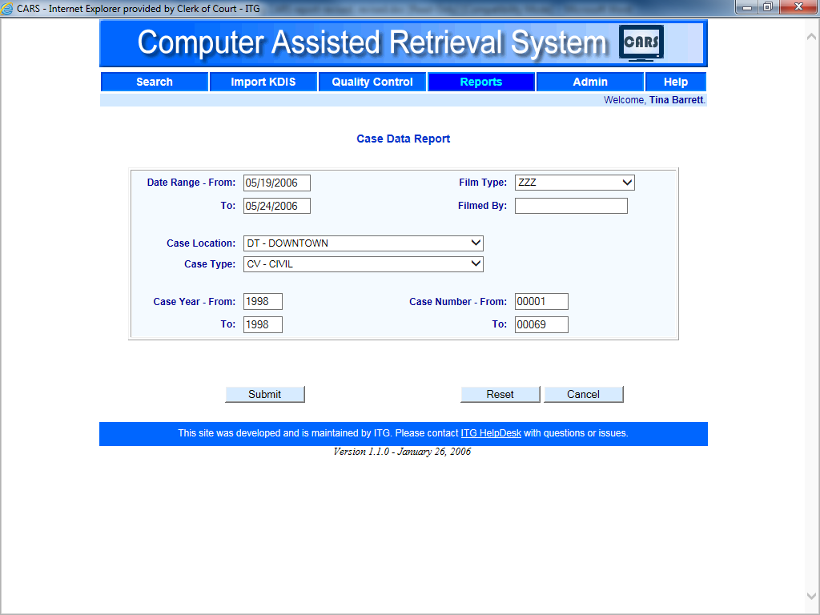

- Click the Submit button. The Case Date Report will appear.
- Click the printer icon located on the upper left hand side of the report. Click the Print button to print the report.
- If more than one printout is needed, repeat steps 1 through 6

POLICIES / RELATED DOCUMENTS:

- Rules of the Arizona Supreme Court, Rule 28.1: Rules of Criminal Procedure,Retention and Destruction of Records and Evidence, Duties of the Clerk
- AZ Supreme Court Administrative Order 2006-29: Arizona Code of Judicial Administration § 3-402: Superior Court Records Retention and Disposition

OTHER PARTIES INVOLVED:

- N/A

TIME / VOLUME:

- Varied

FREQUENCY:

- Varied

PERFORMANCE MEASURE:

- N/A

SYSTEM ACCESS REQUIRED:

- Clerk of Court Internet Portal Explorer

REPORTS / FORMS:

- N/A

DEFINITIONS:

- N/A

APPLICABILITY:

This procedure applies to all employees of the Clerk of the Court.

REVISION HISTORY:

Revision Number | Revision Author | Summary of Changes | Approval Date
- | N/A | Document Origination | 11/28/2003
A | N/A | N/A | 08/28/2012
B | N/A | N/A | 07/29/2014
C | N/A | N/A | 05/25/2016
D | Larry Urewicz | Reformatted for the CDI | 04/28/2017

