PURPOSE:

The purpose of this procedure is to provide instruction on how to duplicate existing spreadsheets or workbooks when links already exist.

OBJECTIVE:

- To provide the necessary direction to ensure all associated spreadsheets/workbooks are accurately linked.
- To ensure consistent collection of statistical data.
- To provide the necessary direction for duplicating spreadsheets/workbooks for the next year’s tracking.

EVENT DRIVER:

- A new calendar year begins.

PROCEDURES:
- Identify all spread sheets or workbooks that are currently linked.
  - This may vary depending on the area.
  - Example: Staff Stats sheets are linked to the Facility spread sheet which is linked to the Office spread sheet, etc.
- Copy, paste, and rename each spread sheet to the new desired folder location. See figure 1.
  - Right click over the selected spread sheet, select Copy.
  - Paste in desired folder location.
  - Right click again, select Rename, enter desired name.
Note: The location and name are essential when identifying the correct link to update. Be sure to choose a name and location that will be easy to identify in relation to the existing link.
Figure 1
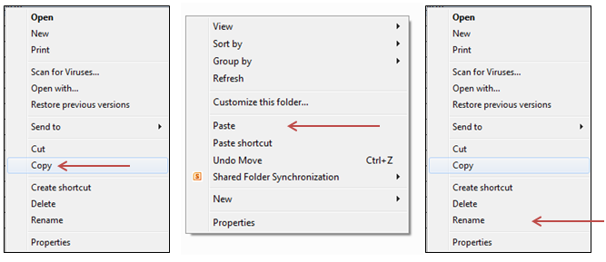

- Unprotect each sheet within each workbook. See figure 2
- Open workbook, select the File tab.
- Click Unprotect and enter password for each sheet listed.
Figure 2
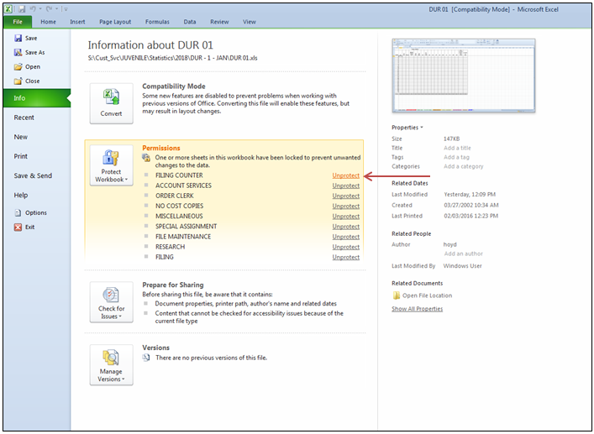
- Update the existing links found within each spread sheet or workbook to the new spread sheet. See figures 3, 4, and 5.
- Open workbook and select the Data tab.
- Select Edit Links, a list of all existing links will appear.
- Identify and click on the link you wish to update.
- When the link is highlighted, click Change Source.
    - The intent is to change the location that the data is being collected from.
- Locate and select the new spread sheet that you want to replace that link with. Click OK to complete the link
Note: It is crucial that you select the applicable sheet to match with the existing link. If not, you may have incorrect data linked to incorrect cells in the subsequent workbooks. Example: If the link is for data collected in January from the Durango Facility, be sure to select the new sheet for the Durango Facility in January. See figures 4 and 5 to compare file names.
- Repeat steps 4, C – E until all links have been updated to desired location.
- Select Close.

Figure 3
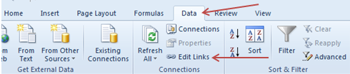
Figure 4
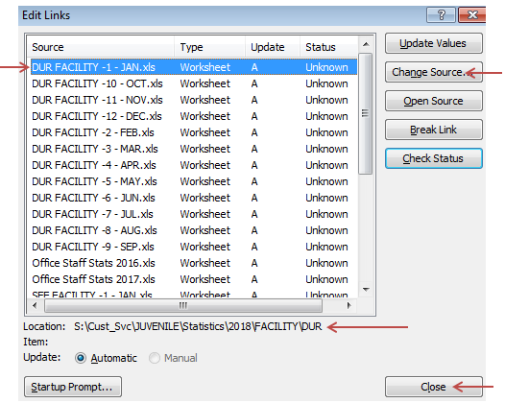
Figure 5
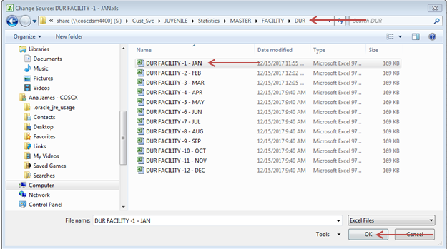
- Protect and Save each sheet within each workbook. See figures 6 and 7.
- Open each workbook
- Select the Review tab.
- Click Protect Sheet, enter password twice to confirm.
- Repeat for each sheet within each workbook.
- Save and Close.
Note: All workbooks and sheets are linked according to the saved name and location. If one is moved or renamed, the data may not link or update accurately.
Figure 6
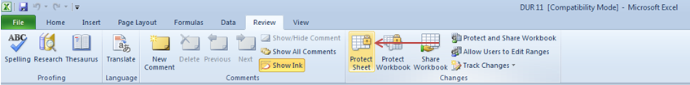
Figure 7
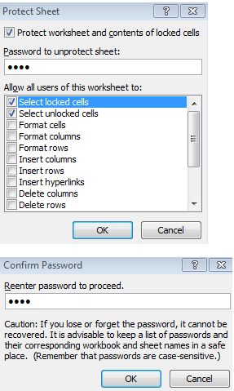

POLICIES / RELATED DOCUMENTS:

OTHER PARTIES INVOLVED:

TIME / VOLUME:

- Varied

FREQUENCY:

- Yearly

PERFORMANCE MEASURE:

- N/A

SYSTEM ACCESS REQUIRED:

REPORTS / FORMS:

- N/A

DEFINITIONS:

APPLICABILITY:

This procedure applies to all employees of the Clerk of the Court.

REVISION HISTORY:

Revision Number | Revision Author | Summary of Changes | Approval Date
- | Ana James | Document Origination
A
B
C

