PURPOSE:

To ensure all Juvenile ICIS debit adjustments have corresponding credit adjustments and to identify items resolved from Unknown suspense.

OBJECTIVE:

To verify all payment debit (PD) and payment credit (PC) adjusting entries in Juvenile ICIS balance; and to resolve Unknown suspense items in the Cash Receipting system.

EVENT DRIVER:

Juvenile Probation Finance or the COC Accounting Unit completes adjusting entries in Juvenile iCIS.

PROCEDURES:
- Open Juvenile iCIS Reports
- Place cursor over the Inquiry tab on the Juvenile Search bar.
- Move cursor down to Report, and click Report.
- From the pop-up window, select Financial Report – Debit Adjustment Detail.
- In the pop-up window, change the following criteria only:
- Cashier Group = All
- Start Date = Prior business day date
- End Date = Prior business day date
- In bottom corner of report, select the Generate button.
- In the Report Viewer pop-up window, change the following criteria only:
- Cashier Group ID = All
- Select the Maximize button to enlarge the screen.
- Select the View Report button.
- Select the Export drop-down box to export the report as a CSV (comma delimited) file.
- From the pop-up window, select the Open button.
- Select the Minimize button to minimize the CSV file.
- Close the iCIS report window.
- Place the cursor over the Inquiry tab on the Juvenile Search bar.
- Move cursor down to Report, and click Report.
- From the pop-up window, select Financial Report – Credit Adjustment Detail.
- Repeat steps I.4 through I.12 to create a CSV file for the Credit Adjustment Detail report.

- Create Reconciliation Spreadsheet
- Maximize the Debit Adjustment Detail CSV file.
- Rename the tab as “PD” (Debit Adjustment Detail).
- Click the tab to insert a new worksheet in the file.
- Rename the tab as “PC” (Credit Adjustment Detail).
- Maximize the Credit Adjustment Detail CSV file.
- Highlight the entire worksheet by clicking the square in the upper right hand corner between row 1 and column A.
- Right click in the worksheet and from the pop-up list select copy.
- Return to the Debit Adjustment Detail CSV file.
- On the “PC” tab, right click in the worksheet and from the pop-up list select paste.
- Click the tab to insert a new worksheet in the file.
- Rename the tab as “Recon”.
- On the “PD” tab, highlight columns B through K with the headings: Fee Code, Obligation Number and Type, F Number, JV Formatted Name, Assessed Party Name, TextBox18, Transaction Type, Total Payment, Payment Category, and Cashier Display Name.
- Right click in the highlighted area and from the pop-up list select copy.
- On the Recon tab, right click in cell A1 and from the pop-up list select paste.
- Highlight the data and sort by the column titled “F Number”.
- Highlight columns A through C; right click in the highlighted area and from the pop-up list select cut.
- Highlight column K, right click and from the pop-up list select insert cut cells.
- Highlight column E; right click in the highlighted area and from the pop-up list select cut.
- Highlight column K, right click and from the pop-up list select insert cut cells.
- On the “PC” tab, highlight columns B through K with the headings: Fee Code, Obligation Number and Type, F Number, JV Formatted Name, Assessed Party Name, TextBox18, Transaction Type, Total Payment, Payment Category, and Cashier Display Name.
- Right click in the highlighted area and from the pop-up list select copy.
- On the Recon tab, right click in cell N1 and from the pop-up list select paste.
- Highlight the data and sort by the column titled “F Number”.
- Highlight column U; right click in the highlighted area and from the pop-up list select cut.
- Highlight column N, right click and from the pop-up list select insert cut cells.
- Highlight column Q; right click in the highlighted area and from the pop-up list select cut.
- Highlight column N, right click and from the pop-up list select insert cut cells.
- In cell K1, type the title “Fee Code”.
- In cell L1, type the title “F Number”.
- In cell M1, type the title “Amount”.
- Review columns D and U entitled “Transaction Types” for PR or PV transactions.
- Highlight and delete these lines from the Recon tab. These transaction types may appear on the report, but are not reconciled on this particular report.

- Reconcile Debit Adjustments to the Credit Adjustments
- Review the CSV file to verify the Fee Code, F Number and Amounts are the same on both the PD and PC reports.
Note: Typically there will be one transaction line on the PC report while there may be one or more transactions lines on the PD report for the same F Number; this is dependent on how the payment allocates to obligations within Juvenile iCIS.
- If multiple transactions lines exist for the same F Number, insert blank lines in the file to separate cases – see example 1.
Note: Highlighting the transaction lines for the same F Number on the PD and PC reports may be useful in distinguishing between transactions.

Example 1
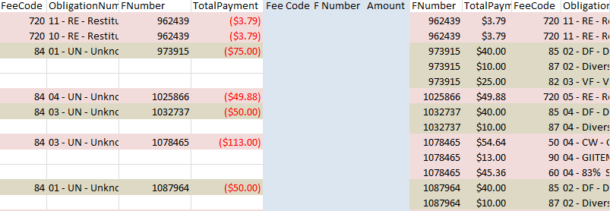

- To verify the Fee Code, F Number and Amounts are the same on both reports, write a formula in cells K2, L2 and M2 comparing the two: i.e. cell K2 = cell G2 (PD Fee Code) minus cell P2 (PC Fee Code):
- If the amount equals zero, then the service codes are the same and no additional research is needed.
- If the amount equals anything other than zero, additional research is needed to identify and resolve the difference.
- Continue to individually check each F Number with the formulas until the report is complete.

- Research to identify and Resolve Differences to an Unknown Obligation
- In Juvenile iCIS, enter the F Number in the Legal Number field and hit enter.
- Select to highlight the Juvenile’s name (if there is a blank line, select the blank line).
- Place the cursor over the Financial tab on the Juvenile Search bar.
- Move cursor to Obligation List and select Obligation List.
- Find all the Unknown obligations.
- Under the Action column, select Transaction History.
- Look for the Transaction Date and the Amount of the PD to verify both match the reconciliation report.
- Select the Cancel button.
- In the CSV file on the Recon tab, note the fee code(s) the payment allocated to (See Fee Code and Obligation Number Type – columns P and Q respectively).
- In Juvenile iCIS, locate the obligation(s) corresponding to the fee codes found on the CSV Recon tab in Step 9.
- Under the Action column, select Transaction History.
- View to verify the Transaction Date and Amount match the reconciliation report.
- In the CSV file on the Recon tab, verify the Total Payment Amount and Obligation Code for the PC report matches the Amount and Assessment ID fields respectively in Juvenile iCIS.
- Find the Transaction Date of the original entry of the Unknown payment entered into Juvenile iCIS, open the appropriate Unknown MS Excel file (i.e. the start date of the Unknown obligation is 01/21/2016, open the January December 2016 MS Excel file). Unknown files are located at: S:\Cust_Svc\Juvenile\Accountant\Year\Unknown\January December [Year].xlsx.
- Find the F Number on the Unknown spreadsheet.
- Under the Status column, if status is noted as:
- Susp – the funds are in Unknown Suspense and need to be resolved to the service codes listed in Juvenile iCIS.
- Paid – the funds are in Unknown Fee and a general ledger adjustment will need to be completed and submitted to the Accounting Unit.
- Update the Unknown spreadsheet with the resolution details.
- Place an “x” in the X column to indicate the item has been resolved.
- If the payment allocated to multiple obligations, insert additional lines into the spreadsheet.
- Copy and paste the Unknown line into the additional lines inserted.
- Change the UNK AMT to match the dollar amount of the obligations.
- Complete all fields to the right of the X column:
- In the Credit To field, enter the name of the obligation the payment allocated to.
- In the Line # field, enter the Assessment ID number from Obligation code on the Recon tab.
- In the Fee Code field, enter the Fee Code from the Recon tab.
- In the Date Corrected on iCIS field, enter the Transaction Date from Juvenile iCIS.
- Depending on how the item was resolved: Resolved in Suspense, Manual Refund, or Manual GL ADJ - - enter the Dollar Amount in the appropriate field.
- In the Comment field, enter pertinent comments relating to the transaction.

- Research to identify and Resolve Other Differences
- If the service code different from Unknown:
- Verify a general ledger adjustment has not been completed:
- Look for the F Number in the following location: S:\Cust_Svc\Juvenile\Accountant\2016\GL Adjustments.
- If an adjustment can’t be found, a general ledger adjustment will need to be completed and submitted to the Accounting Unit.
- Update the Unknown spreadsheet with the resolution details by following the steps outlined in IV.15.A-E.a-f.
- If the F Number is not the same:
- Research to find the case in iCIS, read case notes for a reason why the case number is different.
- Cashier error – send email notification to the cashier supervisor for a “9999” receipt correction.
- Misapplied – to a wrong case number.
- Move – to a sibling account
- Once the issue is identified, notate the F Number field on the recon tab (column L).
- If the Dollar Amount is different:
- The transaction may have allocated to multiple obligations within Juvenile iCIS.

- Saving the Document
- On the Recon tab, ensure all transactions balance and are explained.
- AutoSum the Total Payment columns for the PD and PC sides – see example 2.
- Save the CSV file as a MS Excel document:
- Select the File tab
- From the drop-down list, select Save As
- In the File Name field, enter the report date being reconciled.
- In the pop-up window, change the Save as type to Excel Workbook
- Save to: S:\Cust_Svc\Juvenile\Accountant\Year\PD_PC\File Name.xlsx.

Example 2
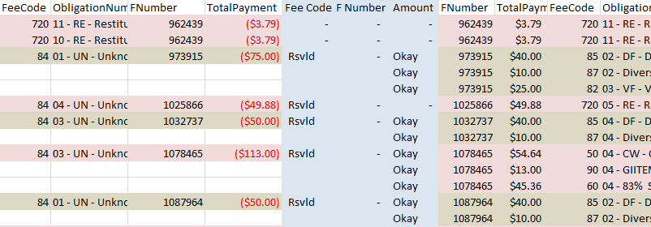

POLICIES / RELATED DOCUMENTS:

- N/A

OTHER PARTIES INVOLVED:

- N/A

TIME / VOLUME:

- Varied

FREQUENCY:

- Daily

PERFORMANCE MEASURE:

- N/A

SYSTEM ACCESS REQUIRED:

- Cash Receipting System
- Juvenile ICIS
- MS Excel

REPORTS / FORMS:

- Juvenile Unknown Spreadsheet

DEFINITIONS:

- N/A

APPLICABILITY:

This procedure applies to all employees of the Clerk of the Court.

REVISION HISTORY:

Revision Number | Revision Author | Summary of Changes | Approval Date
- | Becky Fimbres | Document Origination | 01/15/2016
A | Diana Hoover | Reviewed, reformatted for CDI | 01/25/2016
B | Diana Hoover | Updated procedure to reflect current processing | 04/09/2019
C

