**PURPOSE:**

To provide instruction for processing Exparte Income Withholding Orders, Exparte Income Withholding Orders are issued when one of the parties come in to file wanting an IWO to be issued to the employer. The reason for the Exparte Income Withholding Order is that the original Order or Decree does not state that the Child Support or Spousal Maintenance is to be paid by IWO. The Order usually states that the NCP is to pay directly to the CP or it could state to be paid through Clearinghouse only.

**OBJECTIVE:**

* To provide the necessary direction to ensure that an IWO is completed and mailed out the employer.

**EVENT DRIVER:**

**PROCEDURES:**

1. **Exparte Orders:**
2. A Petition for Exparte IWO Order is received interoffice mail and is not signed by a Judge/Commissioner. An IWO is created from the copy received. (See sample of Page 2) Two IWO’s are mailed to the Employer. Employer will give Employee one copy. Process of Exparte IWO Orders is treated like a Sealed Case. We receive N4D and 4D Exparte IWO Order’s.
3. Atlas case may need to be loaded, depending on the Case scenario. Load the case as when loading a new Atlas case. When loading Suod and Debts use the begin date from the original Order ordering C/S or Spousal Maintenance and use the month we are in for the effective date. The reason that we use the effective date the month we are in is that we do not know for sure what payments have been made to the payee.

**Sample of Petition for Exparte Income Withholding Order**

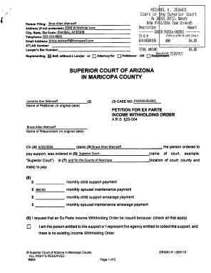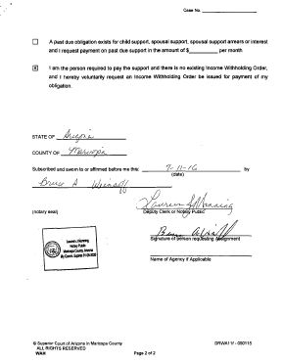

1. Caal note to use on N4D: When sending IWO to employer use E9644, when sending IWO to NCP use E9663.

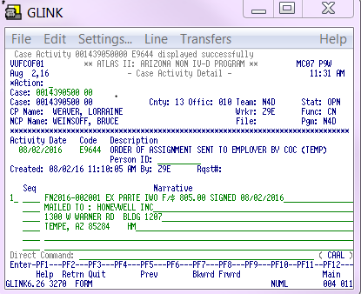

On 4D we enter 2 Caal notes. See below: Use A0253 to show what order we used.

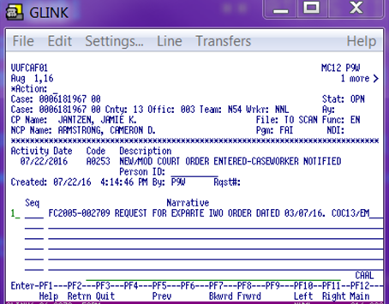

Use E9644 when sending IWO to employer and E9663 when sending IWO to NCP.

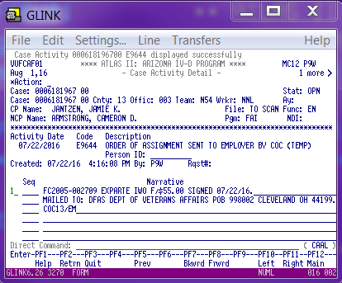

Completing the OnBase Form:

1. Double check that all the information in the OnBase form has been added correctly.
2. Names
3. SSN
4. Employer information
5. Termination dates
6. Order dates
7. Atlas number added

Once all the information has been confirmed on the IWO, click on **Preview PDF** on the bottom of the OnBase Form. Edit title of IWO to say (**Exparte IWO**) like the sample below by typing it in while in Preview PDF:

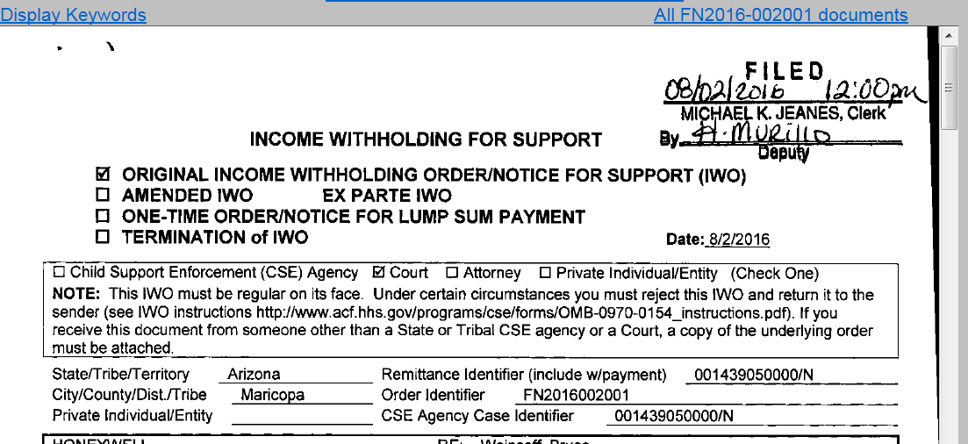

Print 1 copy. **X** out of the document to close the IWO and click on **Close** on the Onbase form, send IWO to Supervisor Queue. (in the note enter “please delete, exparte”) Exparte Order’s are processed like Sealed cases.

1. File stamp the IWO and sign page 2 of the IWO. See below:

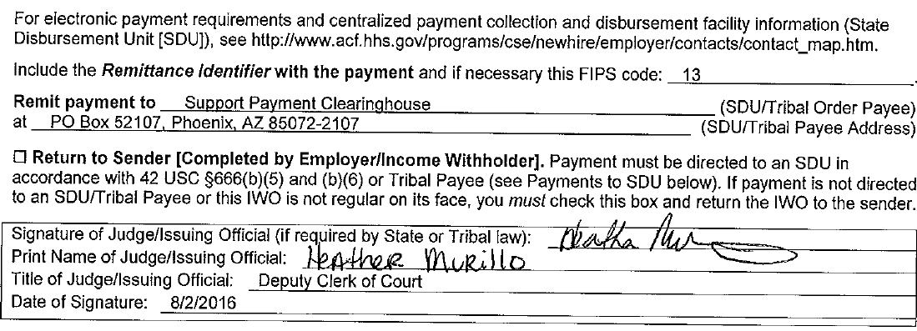

1. Make 2 copies of the IWO.
2. Exparte IWO will be mailed to the employer. (if no employer is given send both copies to the NCP)
3. Go to **FSS Staff Folder**, then **Forms** and print the forms below.
4. 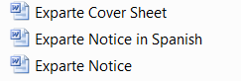
5. Print a copy of the Petition of Exparte filed by the party in ICIS.

**Getting ready to mail out the Exparte:**

1. The 1st set of mailing will have the Cover Sheet for Employer and copy of IWO.

2nd set of mailing will have the Cover Sheet for Employee, Notice to Employee (English and Spanish required), copy of Exparte Petition from ICIS and copy of IWO.

Address envelope to the Employer.

**POLICIES / RELATED DOCUMENTS:**

**OTHER PARTIES INVOLVED:**

**TIME / VOLUME:**

* Varied

**FREQUENCY:**

**PERFORMANCE MEASURE:**

* N/A

**SYSTEM ACCESS REQUIRED:**

**REPORTS / FORMS:**

* N/A

**DEFINITIONS:**

**APPLICABILITY:**

**REVISION HISTORY:**

|  |  |  |  |
| --- | --- | --- | --- |
| **Revision Number** | **Revision Author** | **Summary of Changes** | **Approval Date** |
| - | Elisa McGrath | Document Origination | 06/02/2020 |
| A |  |  |  |
| B |  |  |  |