PURPOSE:

To provide instruction for creating IWO’s from Minute Entries (M/E’s) and IWO Judgement Order Queue for N4D and 4D.

OBJECTIVE:

- To provide the necessary direction to Create IWO’s.

EVENT DRIVER:

- Support Services Mailbox and OnBase Workflow.

PROCEDURES:

- Support Services Mailbox:
For M/E’s go to Public Folders, then click on favorites in Outlook and you should see the Support Services folder, click folder. See example below:

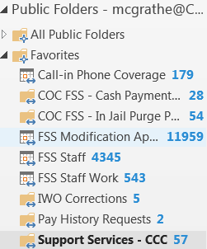

Click on the email and open PDF document. Example below:

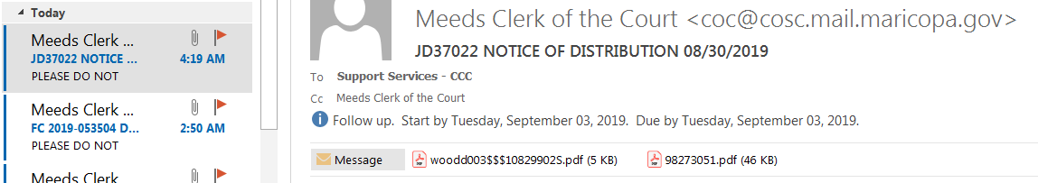

Read the M/E all the way to the last page, some M/E’s will have headings like the following: Temporary Orders, Decree of Dissolution of Marriage these are our main headings and occasionally you will come across a different heading.

You will be reading Orders for New cases, Modification cases, Stops and miscellaneous entries.

Pay attention to phrases such as;

It is Therefore Ordered or It is Ordered and the Court Finds, this is where the Judge/Commissioner is ordering Child Support, Spousal Maintenance or Past Child Support/Spousal Maintenance. Under those Orders it should state the phrase Child Support/Spousal Maintenance is to be paid by income withholding order.

See possible scenarios below:

Or

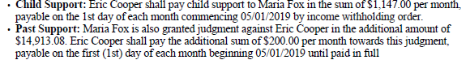

Or

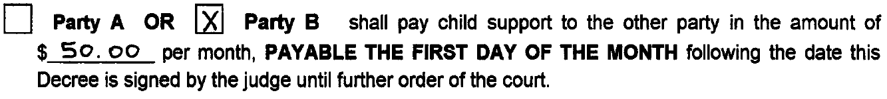

(pay attention to whom is Party A and Party B from your caption)

Or

Each M/E will be different and at times you will come across where no Child Support or Spousal Maintenance is ordered. When you come across an Order where nothing is ordered go on to the next M/E.

Creating IWO’s

After reading through the M/E, and if Child Support or Spousal Maintenance is ordered you will go to the COC WEB Home page and click on Income Withholding Orders Program under Secured Applications, see example below:

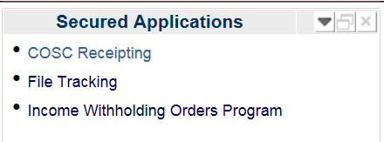

You will see the following, click on Audit History

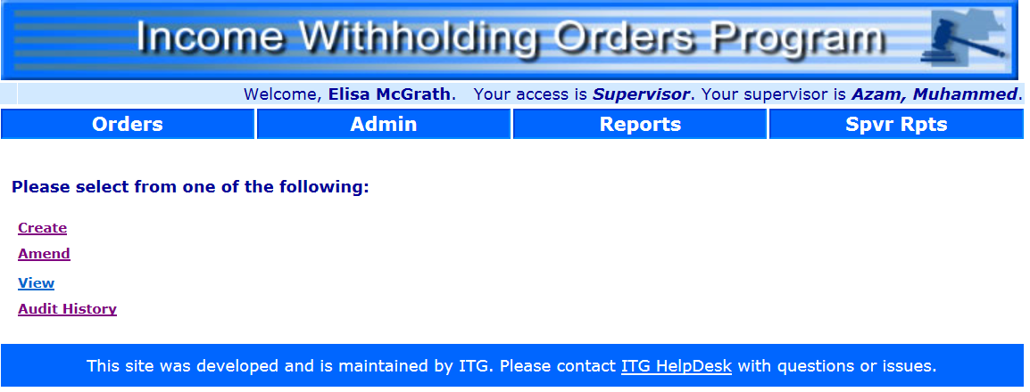

You will see the following, enter the Case number you are working on, no dash.

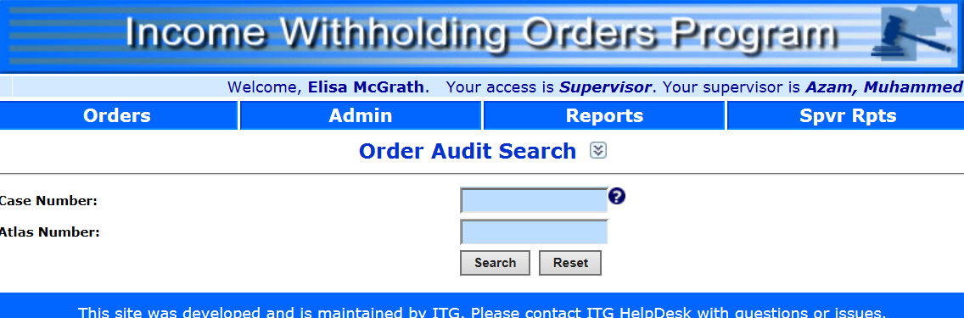

If you get the message No Orders Found click on “Orders” tab

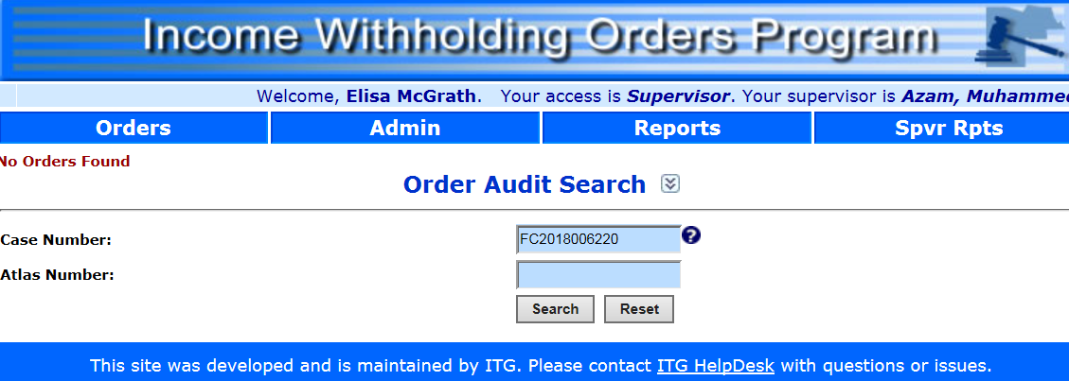

After clicking on Orders click on Create

Type in the Case Number, click on the Search button

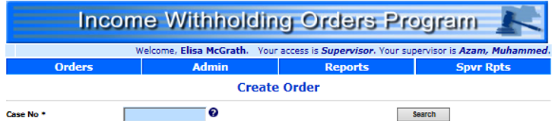

Parties’ names will populate along with their SS#’s, DOB and addresses.
Under Pay Type select whether party is Payor or Payee
***In certain cases parties do not provide all of their information***

Next enter the following:

Underlying Order Date: underlying order date is the date the Judge/Commissioner has signed the order, if there is no signature use the file stamp date, (applies only to M/E’s). When working the J/O queue you will always find a signature. If there is no signature ask your Lead.

Amount for Child Support: you will find under it is Ordered.

Amount for Spousal Maintenance/Support (if ordered): same as above

Payments on Arrears/Interest (if ordered): same as above

Effective Date: you will find the effective date usually right after they have ordered the Child Support or Spousal Maintenance. If there is no mention of a start date, then use the following month of the signed order. (For example: Judge signs an order May 25, 2019, so effective date would be 06/01/19., the effective date should always be the first of the month)

See sample on next page.
Effective date
Effective date

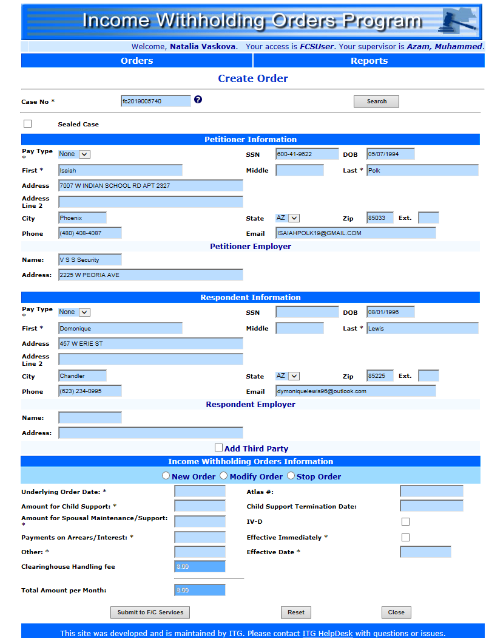
You will select New Order, Modify Order or Stop Order

When creating an IWO for a 4D case you will see the example below that will come up at times (Department of Economic Security in the first Pay Type) when you come across this check the “Add Third Party” box and type in the CP’s first and last name Only. Pay Type for Third Party will automatically come up as Payee. Respondent will be Payor

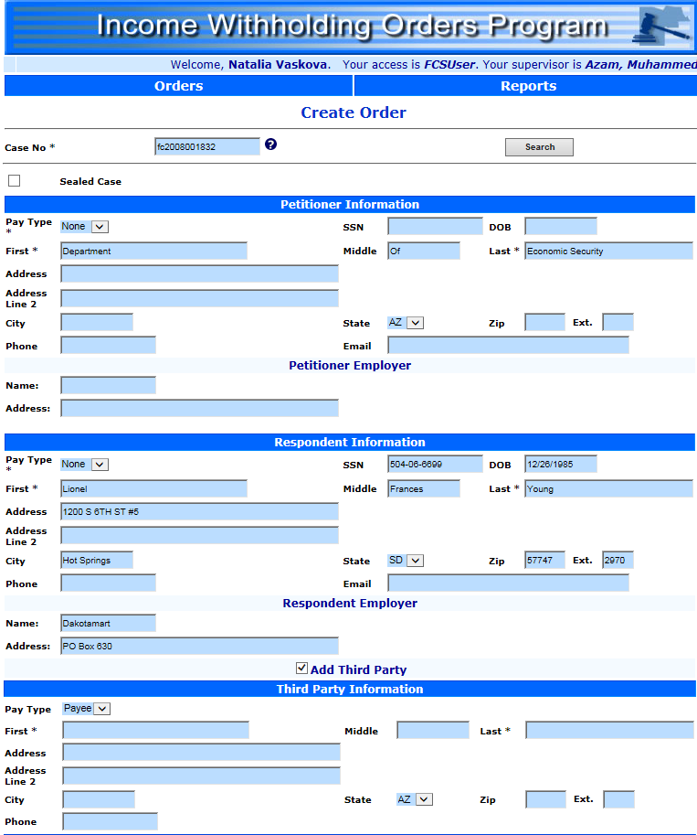

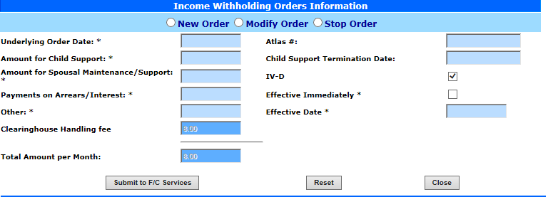

Judgment Orders Queue sign into OnBase:
Click on OnBase from Applications from the COCWEB site or from your Icon Desktop

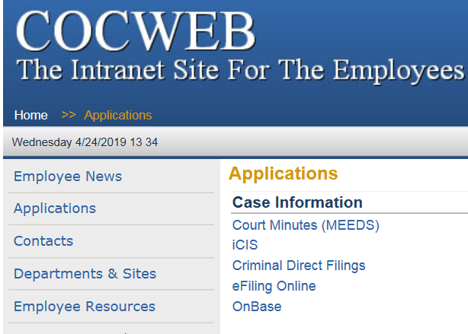


Icon
Desktop

Screen shot below shall appear and you will type in your User Name and Password



Click on the Document Retrieval

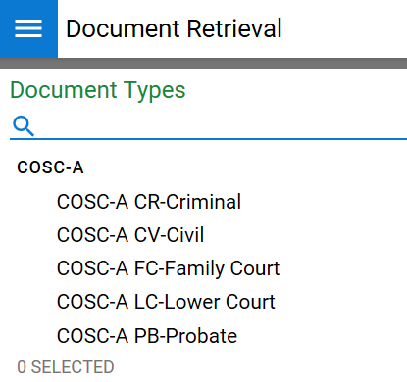

Click on Open Workflow

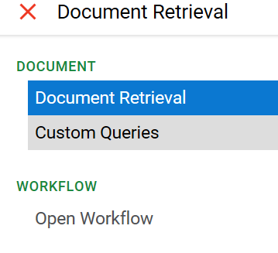

It should take you to the following screen, double click on COSC Income Withholding Order, multiple Queue’s will appear.

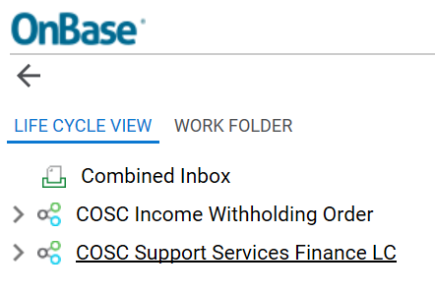

Scroll down until you see IWO Judgment Order Queue.

In the IWO Judgment Order Queue you will come across Child Support Orders, Decree of Dissolution of Marriage, Stipulated Orders, Judgment and Orders.

You will look for the same information as the M/E’s. Reading the Orders to the end, looking for Child Support or Spousal to be paid.
Follow the steps starting on Page 2 and 3.

POLICIES / RELATED DOCUMENTS:

OTHER PARTIES INVOLVED:

TIME / VOLUME:

- Varied

FREQUENCY:

- Daily

PERFORMANCE MEASURE:

- N/A

SYSTEM ACCESS REQUIRED:

- OnBase
- Income Withholding Orders Program

REPORTS / FORMS:

- N/A

DEFINITIONS:

APPLICABILITY:

This procedure applies to all FSS employees of the Clerk of the Court.

REVISION HISTORY:

Revision Number | Revision Author | Summary of Changes | Approval Date
- | Elisa McGrath |  | 04/22/2020
A
B

