**PURPOSE:**

To ensure that all staff enter CAAL notes using the same format and include relevant information to the case.

**OBJECTIVE:**

* Notes created on the Case_ Activity_Listing to have timeline to reference all case activity in the ATLAS System.

**EVENT DRIVER:**

* A Customer inquiry regarding child support payment and clearinghouse fees.

**PROCEDURES:**

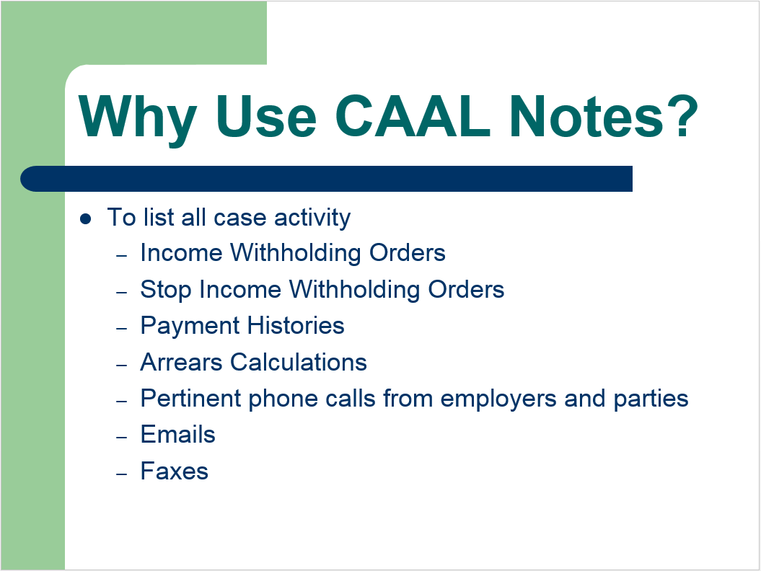

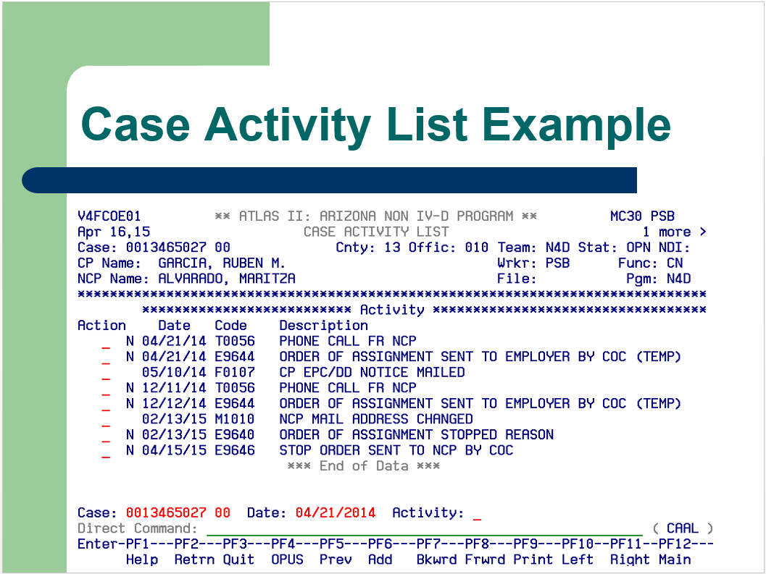

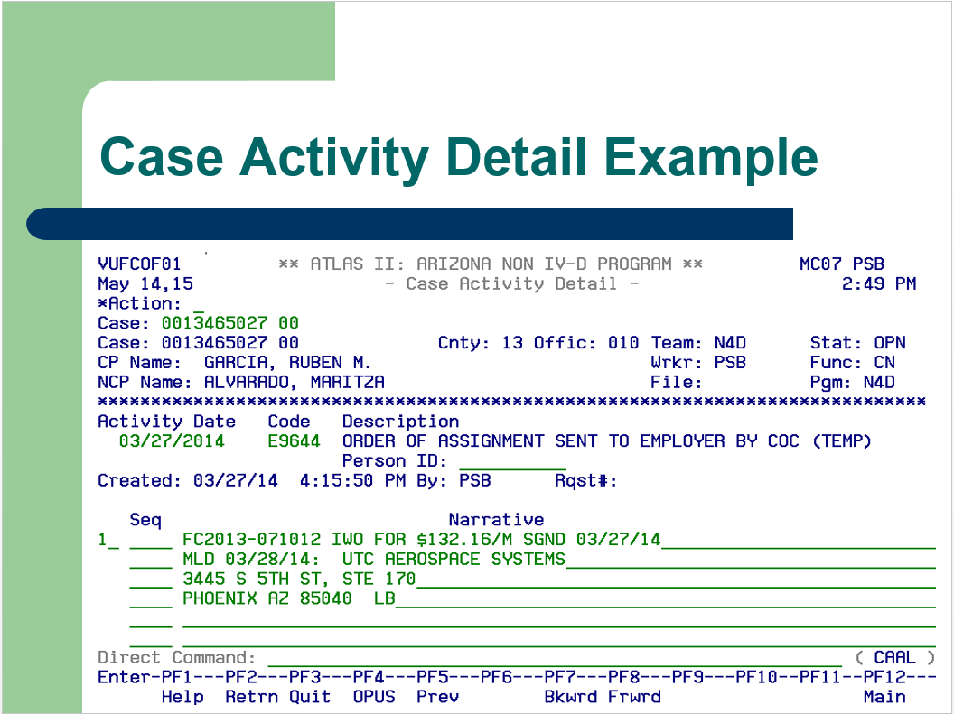

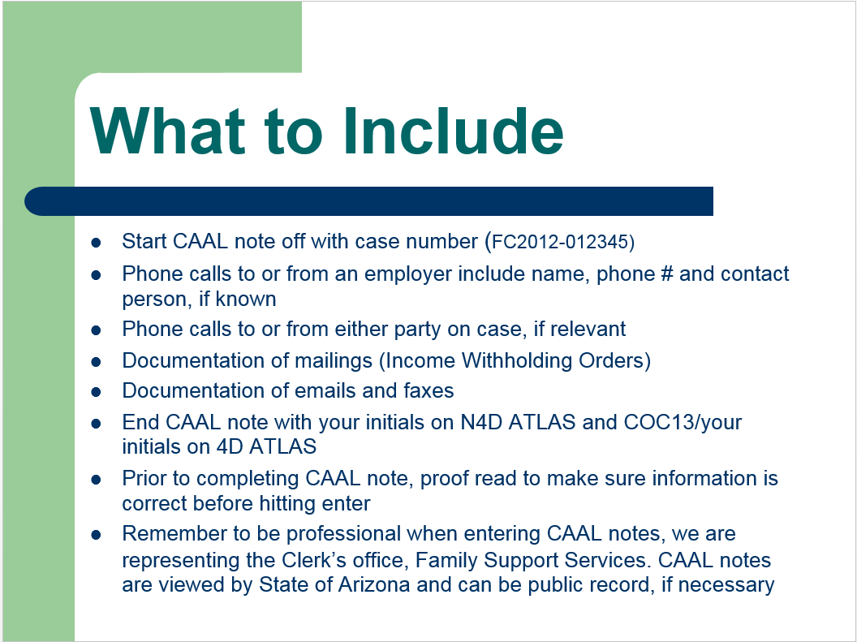

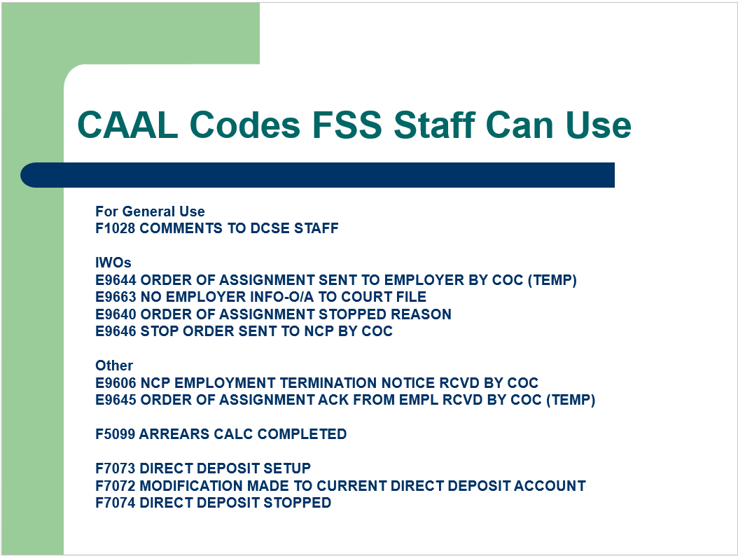

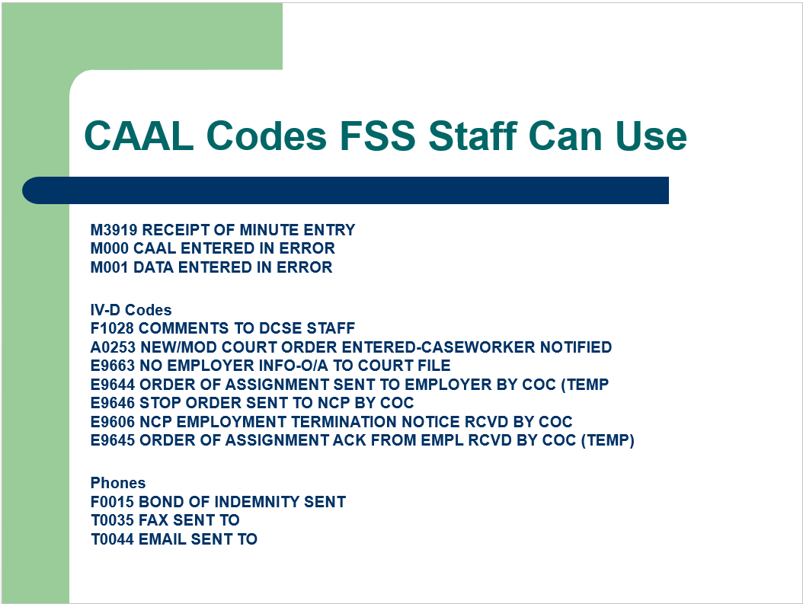

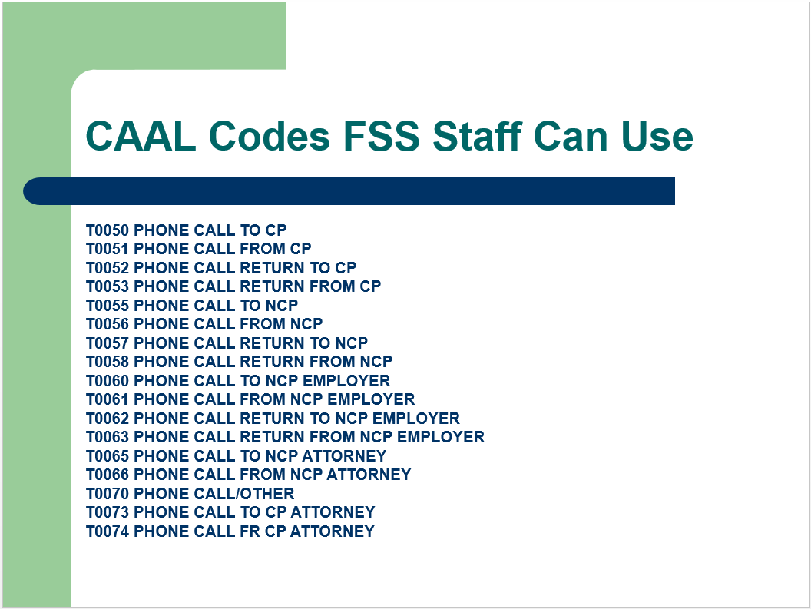

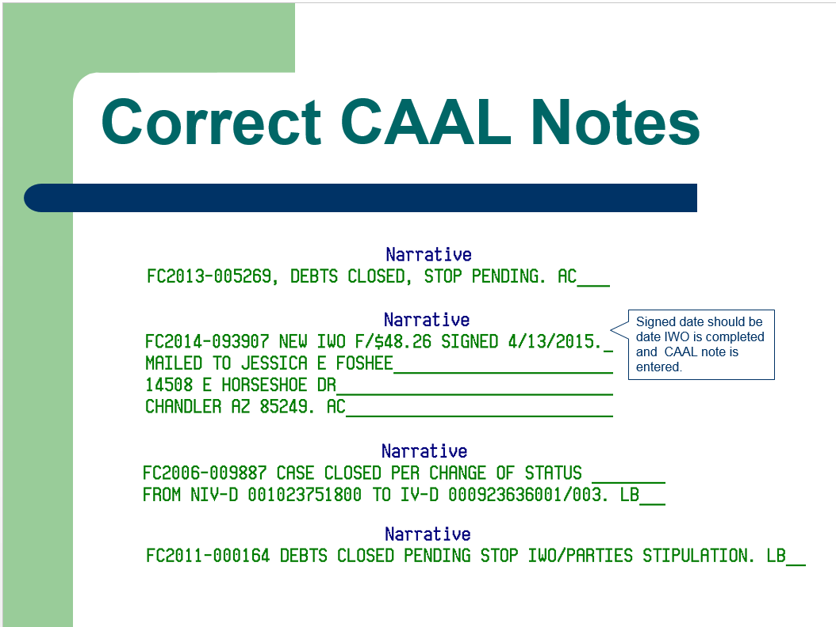

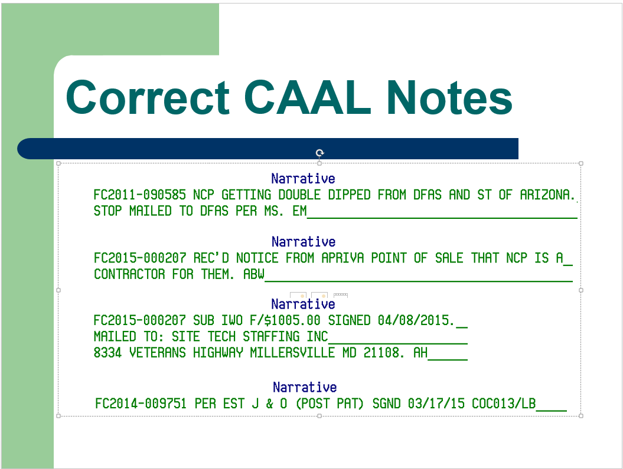

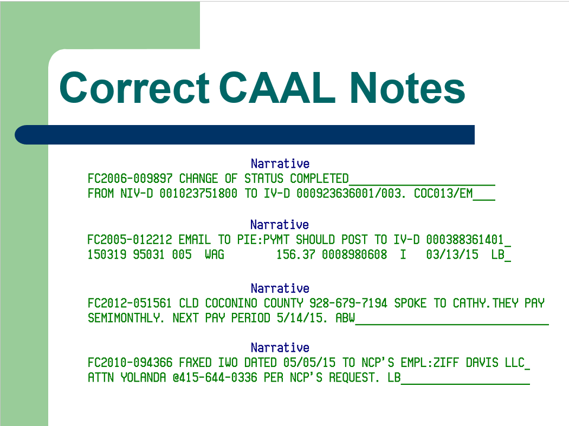

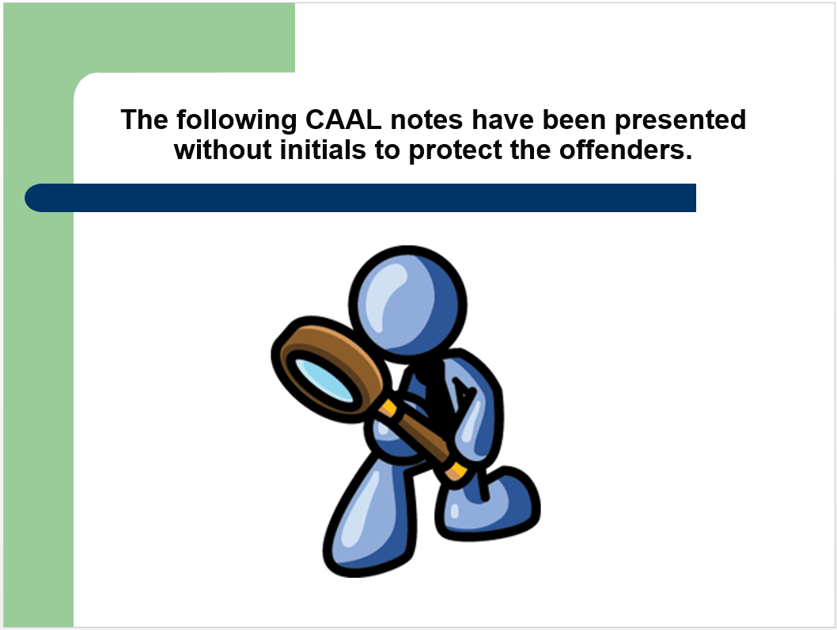

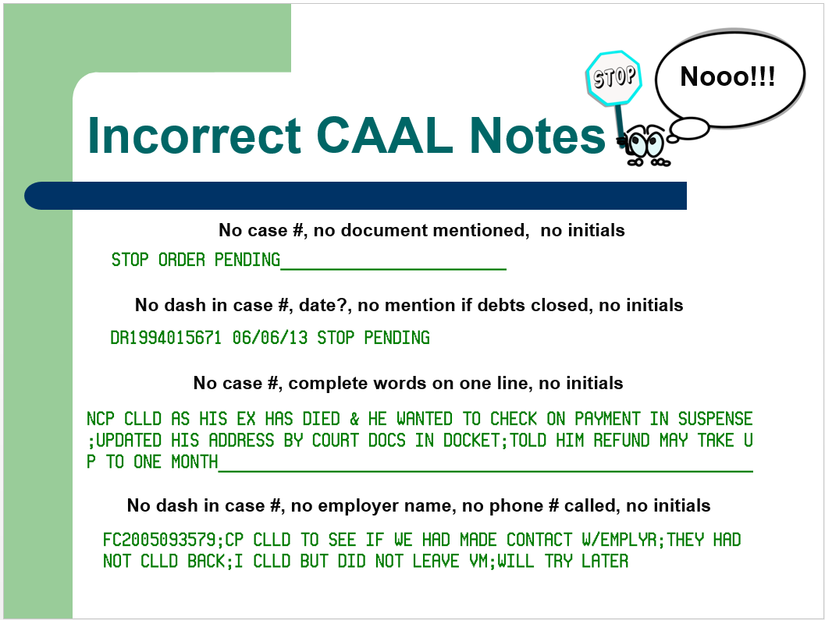

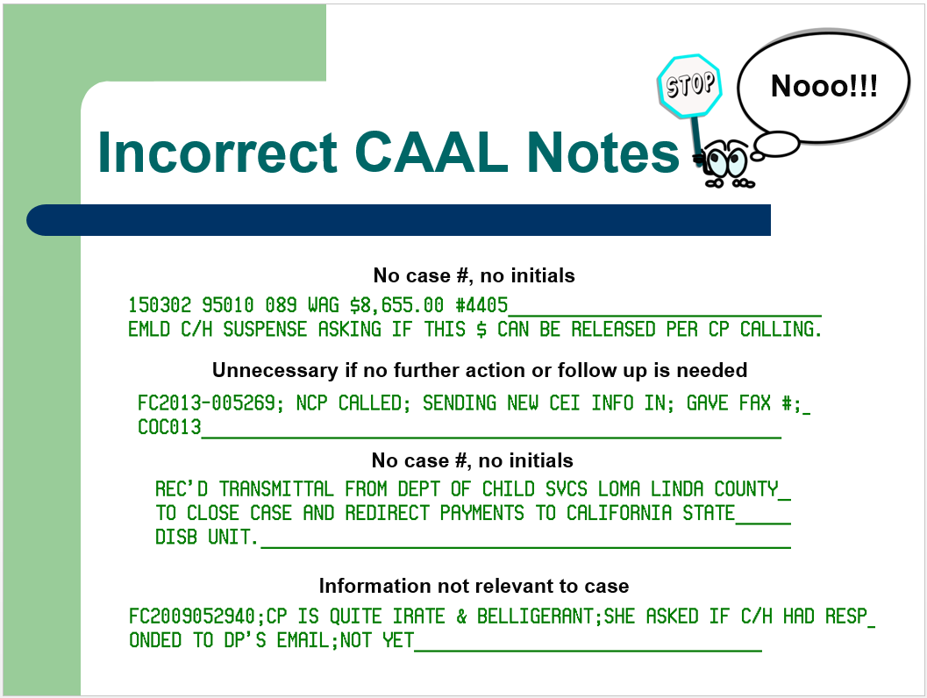

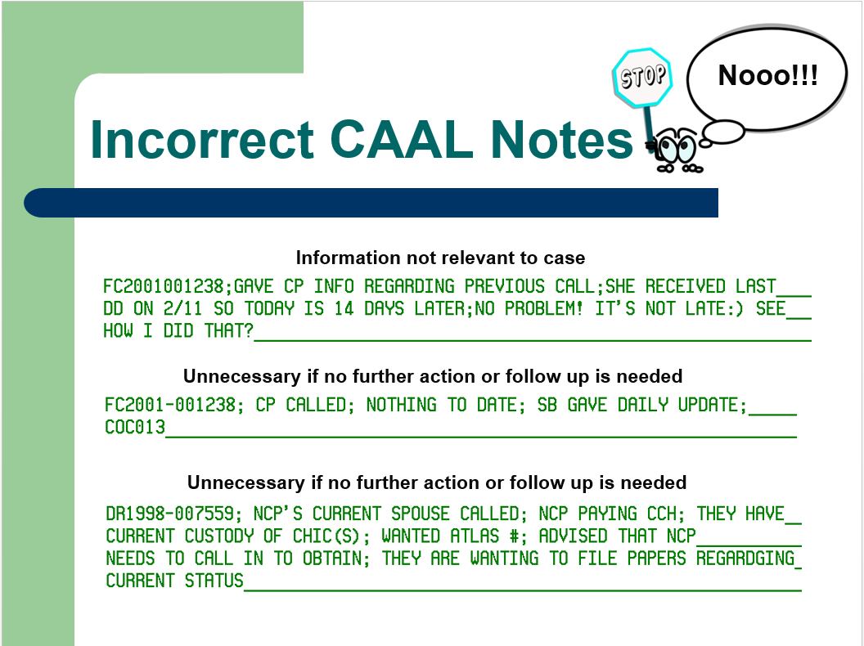

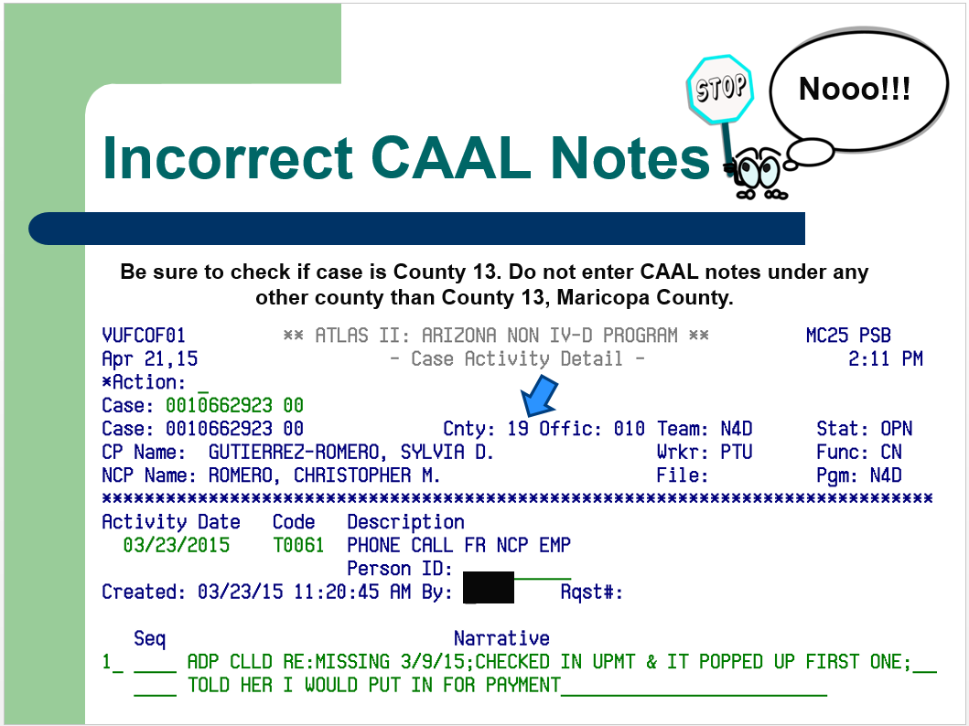

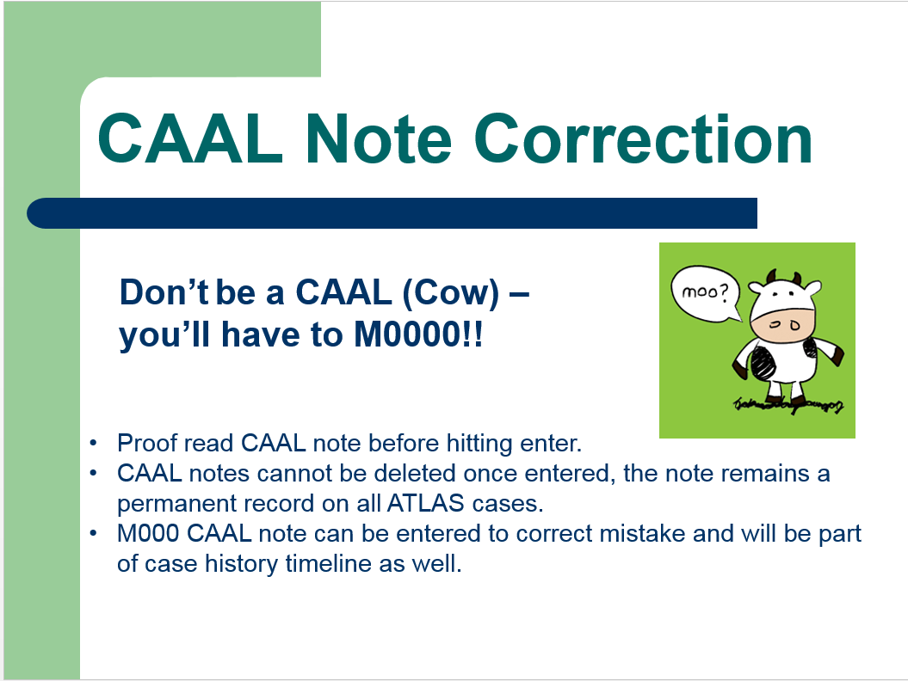

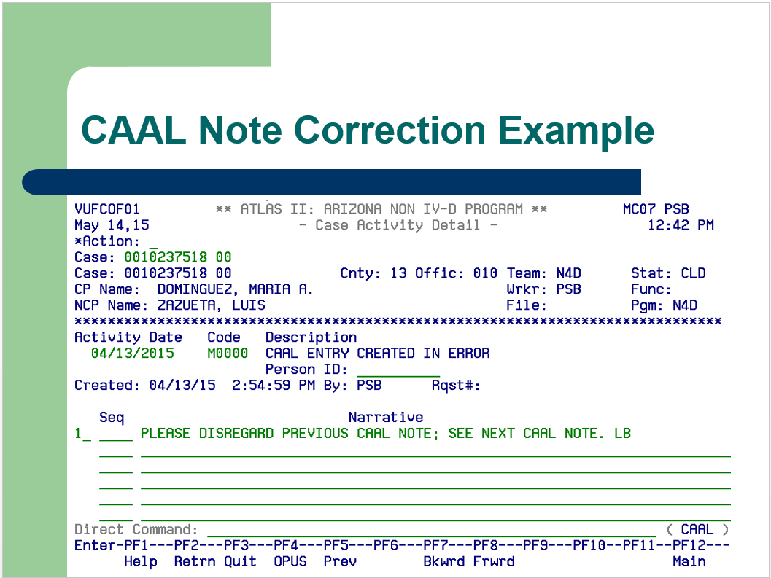

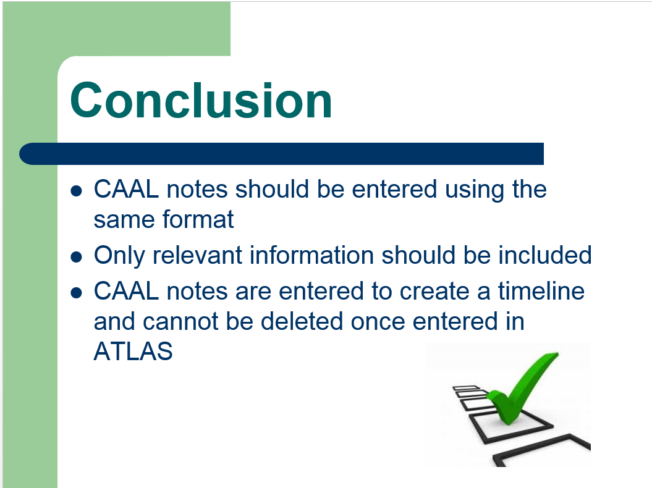

**POLICIES / RELATED DOCUMENTS:**

* N/A

**OTHER PARTIES INVOLVED:**

* N/A

**TIME / VOLUME:**

* N/A

**FREQUENCY:**

* Daily

**PERFORMANCE MEASURE:**

* N/A

**SYSTEM ACCESS REQUIRED:**

* ATLAS

**REPORTS / FORMS:**

* *N/A*

**DEFINITIONS:**

* N/A

**REVISION HISTORY:**

|  |  |  |  |
| --- | --- | --- | --- |
| **Revision Number** | **Revision Author** | **Summary of Changes** | **Approval Date** |
| A |  |  |  |
| B |  |  |  |
| C |  |  |  |