**PURPOSE:**

To provide instructions on when and how to issue a Bond of Indemnity

**OBJECTIVE:**

* To provide the necessary direction to ensure that Bond of Indemnities are issued correctly and consistently and
* To correctly notate case history on ATLAS case whenever a check becomes lost and needs to be replaced.

**EVENT DRIVER:**

* A check(s) has become lost and needs to be replaced.

**PROCEDURES:**

When a check is issued to one of the parties on a case, either the Custodial Parent (CP) or the Noncustodial Parent (NCP) and the check becomes lost or stolen, the check then needs to be voided and reissued. In order to reissue the check, the payee needs to complete a Bond of Indemnity.

A Bond of Indemnity (BOI) is an agreement to compensate for lost checks. A BOI may be issued and mailed, faxed or emailed to a payee when a payee reports a lost or stolen check. The BOI must be notarized, witnessed and signed by the payee who has requested a replacement check. The original BOI must be sent back to Division of Child Support Services, Attn: Accounting, Unit: PEU2451, PO Box 36626, Phoenix, AZ 85067-6626, which is included on the BOI Instruction Letter.

A request for a replacement check is received by way of a phone call from the payee to Family Support Services.

The criteria that needs to be met in order to issue a BOI to payee:

1. 10 business days have occurred since the check has been issued and is still in “ISSUED” status.
2. A current address needs to be entered onto ATLAS case for the payee.

* If an address update is necessary, the payee may fax an address update in to FSS to process immediately.

After the address has been updated, the BOI can be prepared to issue to payee.

The lost check information can be obtained by going to CHPL on ATLAS, if payee is the CP or CHNC, if the payee is the NCP.

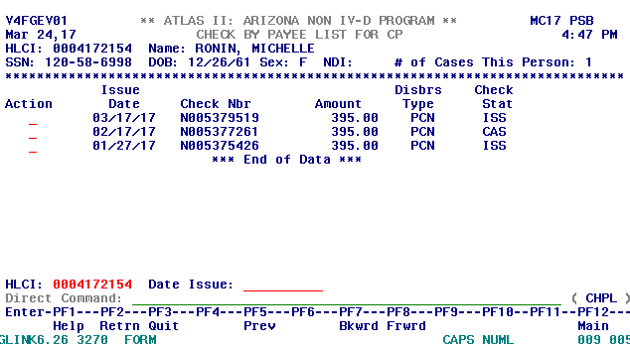

The BOI can be accessed via the FSS Staff folder under Forms and then BOI forms.

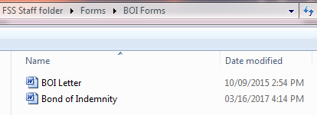

If you do not have access to the FSS Staff folder, you can access the forms through the Share drive. See below:



Double click on Bond of Indemnity to open it. See sample BOI:

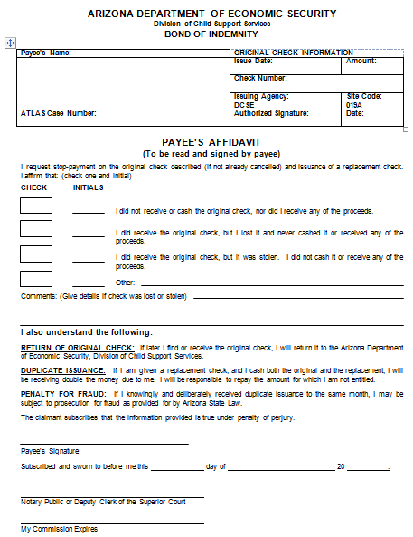

Fill in the **Payee’s Name**, **Address**, **ATLAS Case Number** on the left side of the BOI. Then on the right side top of the BOI, fill in the **Issue Date**, **Amount**, **Check Number** and the **Date**, which is today’s date.

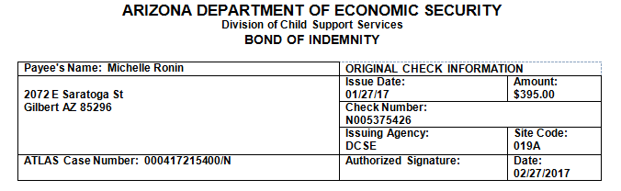

Sample BOI Letter:

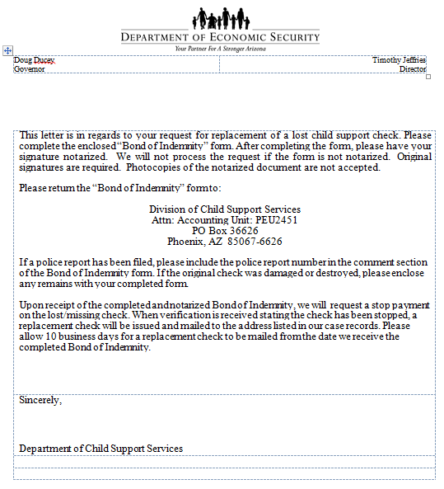

**Emailing BOI**

If the payee is requesting the BOI to be emailed to them, you can save the completed BOI to your desktop to email as an attachment in the email.

Click on File, and then click on Save As

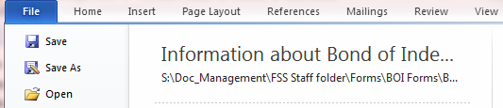

Then Desktop and rename, File name to BOI (Payee’s last name)

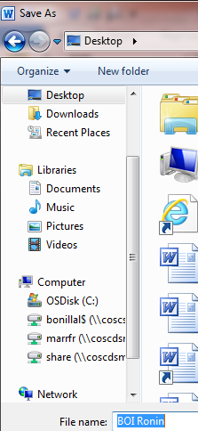

This will enable you to drag the BOI to the email you will be sending to the payee along with attaching the BOI Letter as well. You can drag the BOI Letter into your email from the FSS folder and it will become an attachment. Then drag and drop the BOI from your desktop to your email. Be sure to copy the FSS Research, [fssresearch@mail.maricopa.gov](mailto:fssresearch@mail.maricopa.gov) to ensure that all staff has access to the BOI if another needs to be sent to the customer. See example of email:

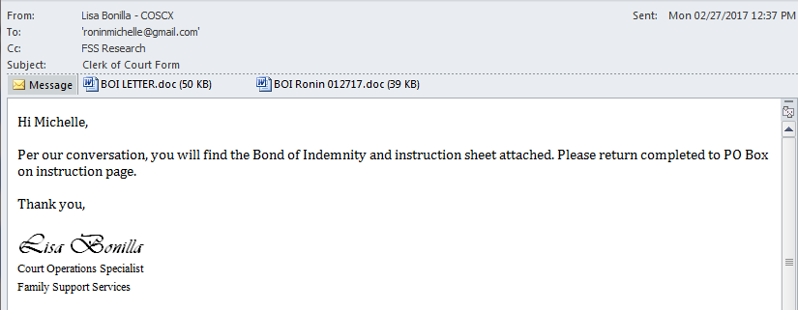

**Mailing BOI**

If the payee is requesting the BOI be mailed to them, you can now print it off and prepare for mailing. Be sure to include a copy of the BOI Letter which is the instruction page for the payee to follow. This is also located under FSS Staff folder/Forms/BOI forms

A CAAL (Case Activity List) note will need to be created on the parties’ ATLAS case with the check information and how the BOI was sent, by way of email, mailed or faxed. The CAAL note code used is F0015 (Bond of Indemnity Sent). See examples:

CAAL Note for Emailing BOI:

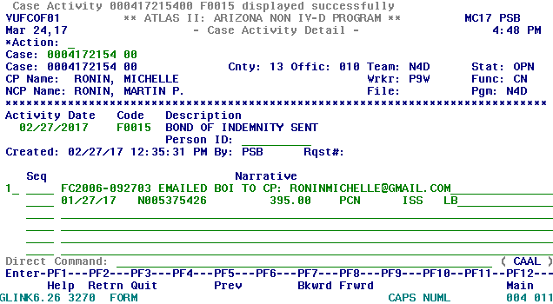

CAAL Note for Mailing BOI:

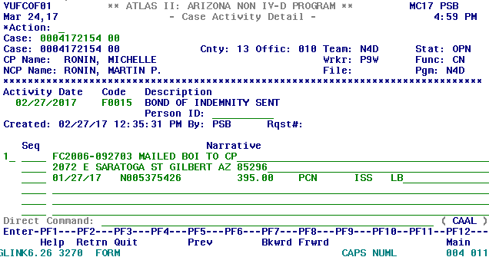

Once the Clearinghouse received a completed BOI from payee, they will enter an F0033 (Check Stopped) CAAL note notating that the BOI has been received. The check is stopped and a processing time occurs. See CAAL note example:

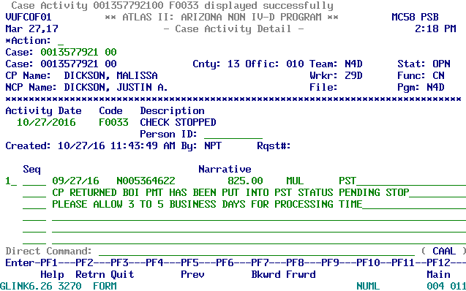

When the processing time of 3-5 business days have passed, an F0032 (Check Stopped and Reissued) will be entered to note that the check that been reissued to payee. See CAAL note example:

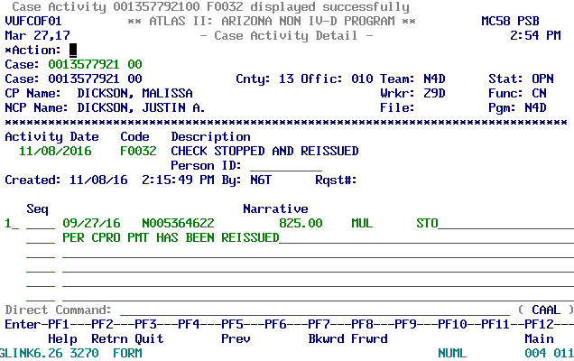

Once the BOI is received at the Clearinghouse, it can take approximately 10 business days for a replacement check to be mailed from the date the Clearinghouse receives the completed BOI. FSS can email CPRO, [dcsscpro@azdes.gov](mailto:dcsscpro@azdes.gov), with any customers inquiring about their BOIs. Be sure that copy FSS Research on any inquiries as well.

**POLICIES / RELATED DOCUMENTS:**

* N/A

**OTHER PARTIES INVOLVED:**

* N/A

**TIME / VOLUME:**

* Varied

**FREQUENCY:**

* Daily

**PERFORMANCE MEASURE:**

* N/A

**SYSTEM ACCESS REQUIRED:**

* ATLAS
* On Base Workflow
* iCIS

**REPORTS / FORMS:**

* N/A

**DEFINITIONS:**

* N/A

**REVISION HISTORY:**

|  |  |  |  |
| --- | --- | --- | --- |
| **Revision Number** | **Revision Author** | **Summary of Changes** | **Approval Date** |
| A |  |  |  |
| B |  |  |  |
| C |  |  |  |