PURPOSE:

To provide instruction on how to complete N4D IWO Stops and 4D IWO Stops.

OBJECTIVE:

- To provide the necessary direction to ensure that an IWO Stop is completed.

EVENT DRIVER:

PROCEDURES:
- N4D IWO Stops:
- Open OnBase and do the following:
- In OnBase, click on Document to open the pull-down menu.
- Click on Workflow. The Workflow window will open.

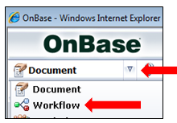

- Click on the + icon to the left of COSC Income Withholding Order Lifecycle to open the workflow.
- Click on IWO Stop Queue.

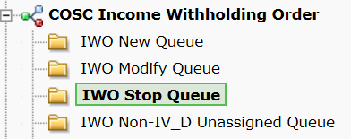

- A list of all the IWO Stops will be displayed in the Queue. Select case from Queue. Highlight the order by clicking on the line. Click on Click Here to edit this order.

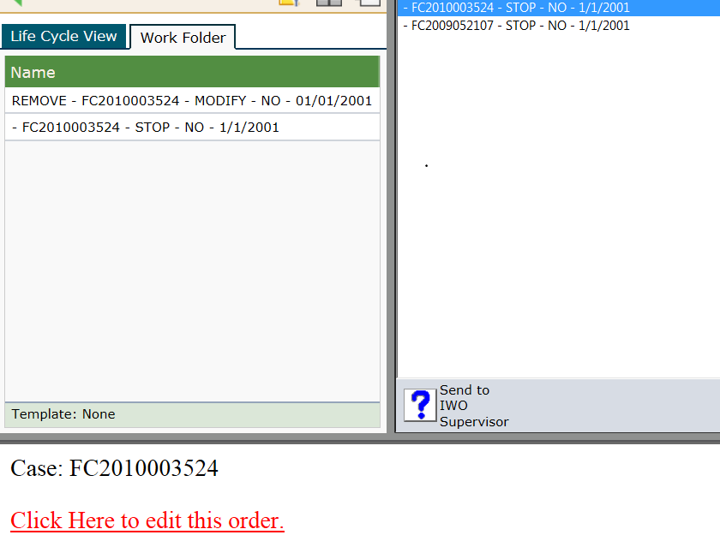

The Edit Order/Update OnBase form window will open.

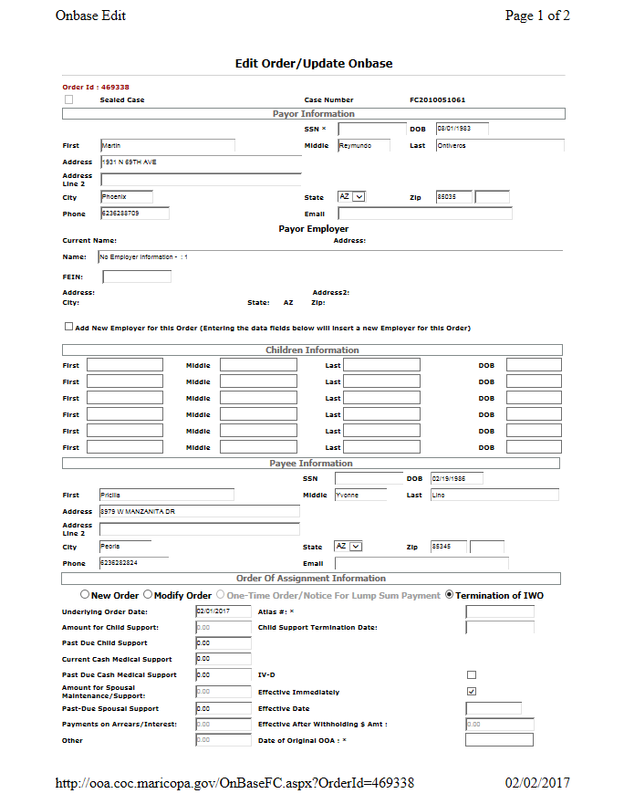

- Go to ICIS to research for the “Order Stopping Income Withholding Order” signed by Judge/Commissioner.
- Verify that names match on the “Order Stopping Income Withholding Order” and look for when IWO is to stop. (immediately or future date)
- Bring Atlas case up, if you have the Atlas #, go to the CAST screen and enter the Atlas #. If you have the Case #, go to SUOC and enter the case # and tab and delete any numbers following.
- Once you are in the Atlas case, verify that Names match the IWO Stop and update IWO Stop with Employer, Atlas #, SS# if needed and Date of Original IWO. (Check ICIS for last IWO mailed) Anywhere there is a * on the IWO Stop information needs to be filled in.
- Go to DELN in Atlas to close each Debt. Select first Debt by entering an “S” and hit enter; this will take you to the DEDN screen. Once there you will deactivate each debt. On the Action Line enter an “M” and tab to Deact Reason and enter CAC and hit enter. Do this for each open Debt. If you come across a NSF Debt and there is balance do not close the Debt. (Clearinghouse will try to recoup money for NSF) see Example A and B below:

Example A:

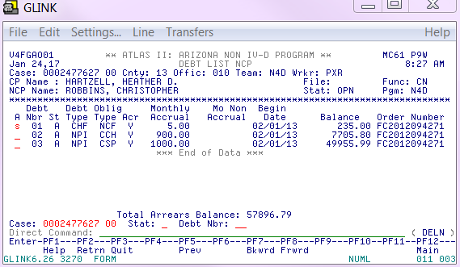

Example B:

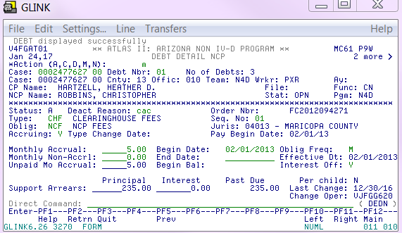

After selecting each Debt on DELN and closing each Debt on DEDN enter DELN on direct command line to make sure you have closed all debts except for the NSF Debts. DELN should look like the Example C or Example D below: (not all cases will have NSF Debts loaded)

Example C:

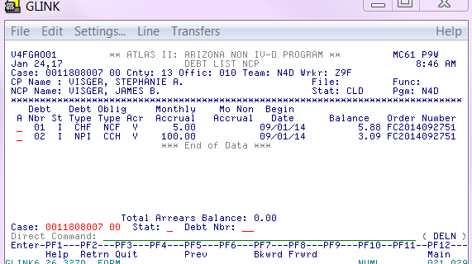

Example D:

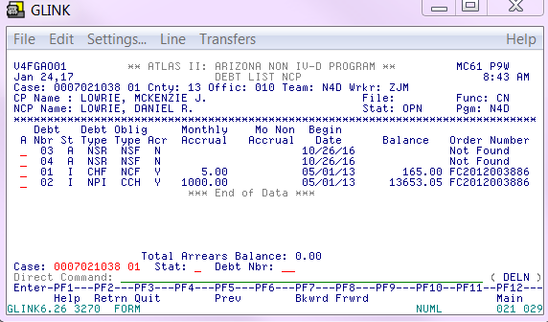

- Next go to CAAL screen and enter the following Caal Note using E9640 as your code. This CAAL note will let everyone know the reason the Debts and Case was closed. See Example E below:

Example E:

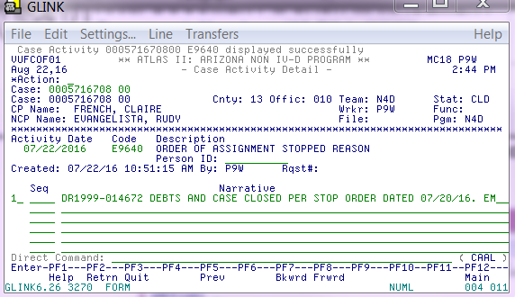

Next enter the following CAAL note using E9646 as your code. This CAAL note will let everyone know where the IWO Stop is being mailed to. See Example F below:

Example F:

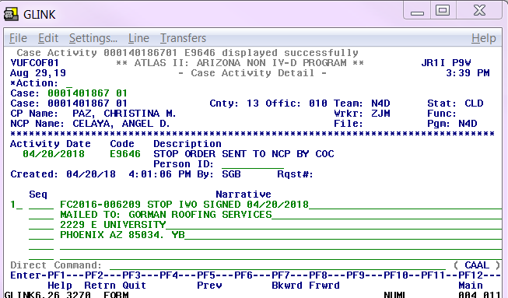

Next go to Direct Command and enter PALC to check if money is in suspense. See Example G.

Example G:

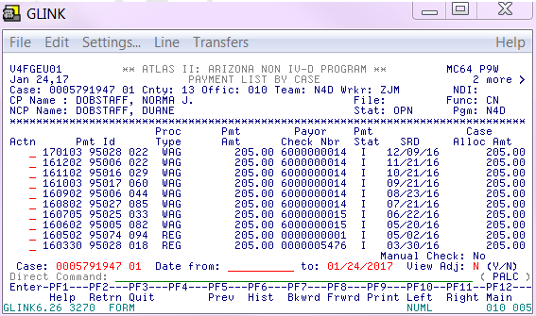
Once in the PALC screen hit F11, see Example H.

Example H:

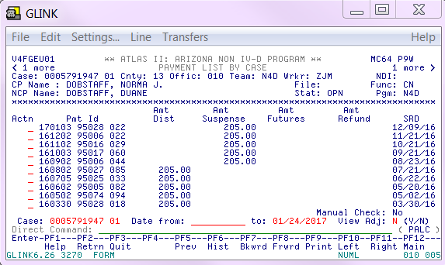

If the PALC screen shows money in suspense like Example H, print a copy of the PALC screen and put it in the Suspense in Box.
If there is no money showing in suspense in PALC continue to the Cast screen and enter “M” in the Action Line and tab down to Reas:, Codes for REAS: will be 402, 416 or 422. Example I below has the Reas code 402.
Example I:

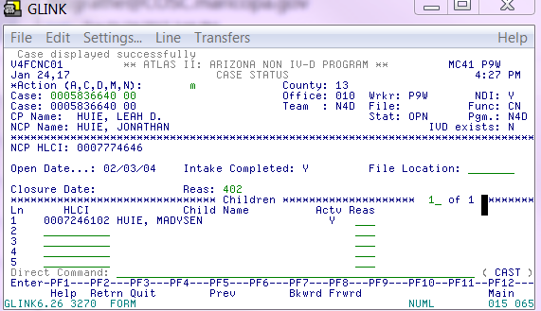

Description for 402: Case dismissed by court
Description for 416: Child emancipation
Description for 422: Change of Custody
Description for 451: IVD Status transfer, this code you will use when working on Change of Status closures.

FYI: You can also put the cursor on the REAS: line and hit F1 to get a list of codes and reasons for Stops.

At the end CAST screen should look like this. See Example J.

Example J:

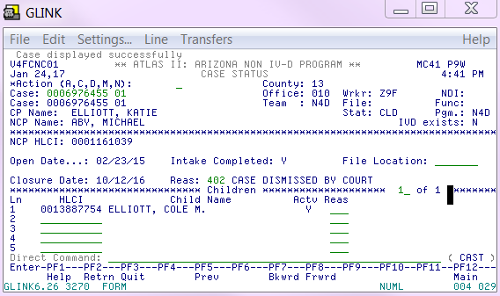

Then go back to IWO Stop and hit Complete, then hit Close.

Below are the procedures on what to do when there is no Underlying Order:

- If all you see in ICIS is the “Petition to Stop” filed by one of the parties do the following:
- Bring Atlas case up. If you have the Atlas #, go to the CAST screen and enter the Atlas #. If you have the Case #, go to SUOC and enter the case # and tab and delete any numbers following.
- Once you are in the Atlas case, verify that Names match and update IWO Stop with Employer, Atlas #, SS# if needed and Date of Original IWO. (Check ICIS for last IWO mailed) Anywhere there is a * on the IWO Stop something needs to be filled in.
- Go to DELN to close each Debt. Select first Debt by entering an “S” and hit enter; this will take you to the DEDN screen. Once there you will deactivate each debt. On the Action Line enter an “M” and tab to Deact Reason and enter CAC and hit enter. Do this for each open Debt. If you come across a NSF Debt and there is balance do not close the Debt. (Clearinghouse will try to recoup money for NSF)
- Go to CAAL and enter the following caal note, using E9640. See Example K.

Example K:

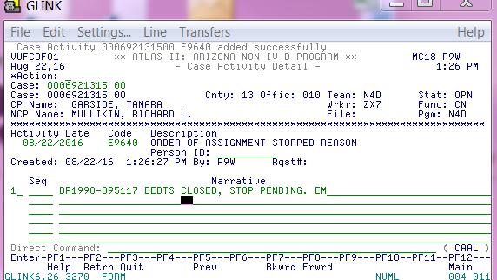

  - Going back to the IWO Stop in Onbase, on one of the blank lines you may enter something to this effect “no underlying order as of today’s date” followed by your initials. (this way you know why you Saved it for later). After checking IWO Stop and it has been updated as mentioned in “I” click on the “Save for Later” tab.
  - The next day or so when you go back to check your “Save for Later’s and the “Order Stopping Income Withholding Order” is in ICIS follow steps “M through P”.

SPECIAL NOTES:
1. Ocassionaly we receive Stop Orders with a Future date. On those cases after checking the Underlying Order, we mail out the IWO with the future date and enter a Caal note with Code #9646, see Example L below:

Example L

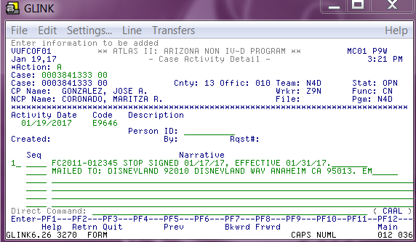

Debts are kept open until the Future date arrives. Keep a copy of the IWO Stop or Underlying Order with the Future date so that you can go back and at that time to close the Debts.

To Print the IWO Stop for your Future date, do the following:
Right click on the screen and select Print Preview.
  - Select Shrink to Fit size print so the screen can be printed on one page. Roughly 70% will allow the screen to print on one page.
  - Click on the mini printer, click on Current Page, this gives you one page. Print the OnBase Form. See below:



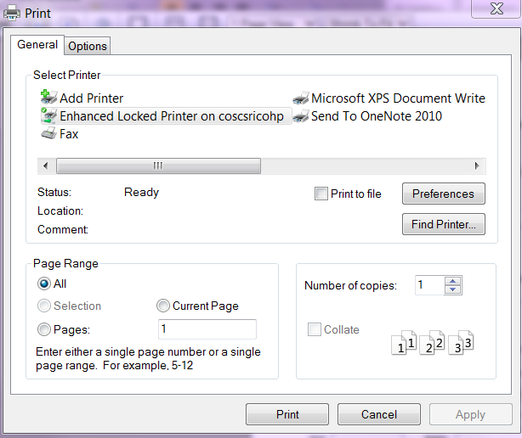

Then enter the following CAAL Note: See Example M. Atlas can now be closed.

Example M

2. Never create a Stop with out a Underlying Order or supporting document.
3. Never create a Stop because one of the parties have called stating they are changing jobs. If money is being deducted by a part-time employer and they want their full-time employer or Vice Versa to start deducting from their pay they are to file a Petition to Stop so that Judge/Commissioner can rule on it.

4D IWO Stops

1. Open OnBase and do the following:
- In OnBase, click on Document to open the pull-down menu.
- Click on Workflow. The Workflow window will open.

- Click on the + icon to the left of COSC Income Withholding Order Lifecycle to open the workflow.
- Click on IWO Stop 4D Queue.

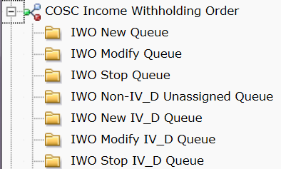

- A list of all the IWO Stops 4D will be displayed in the Queue. Select case from Queue.

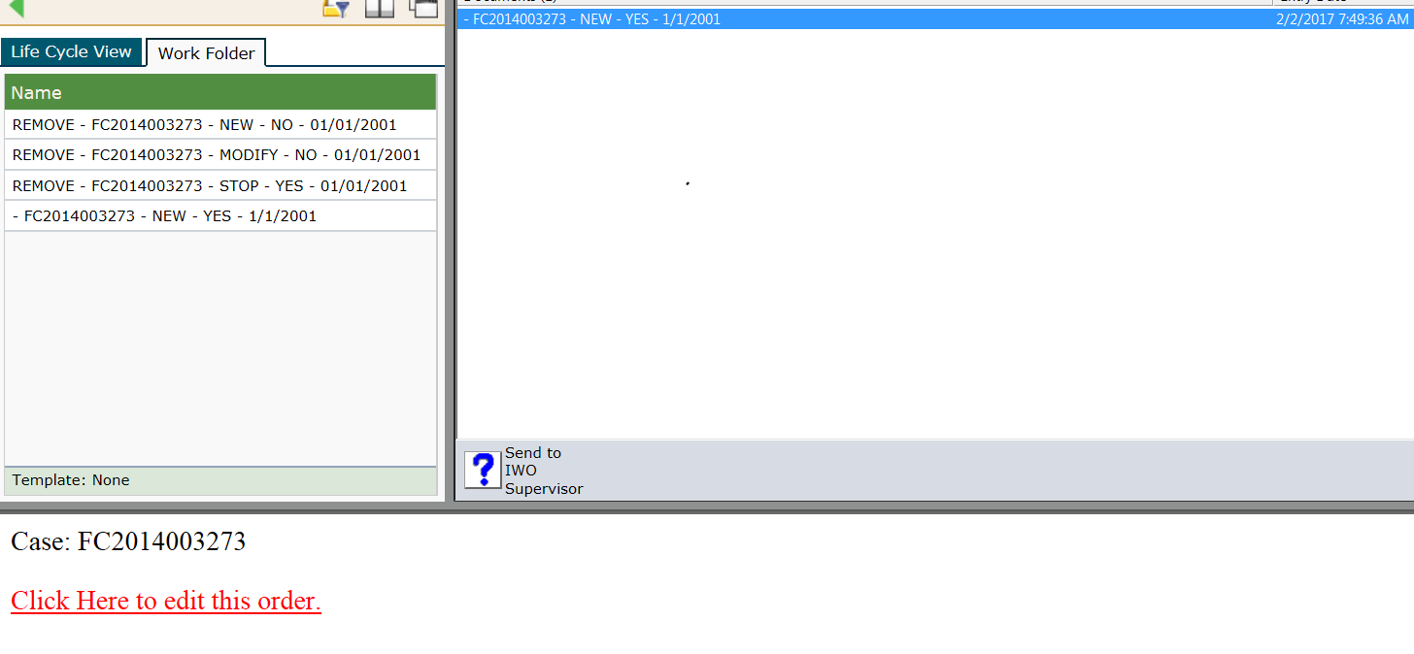

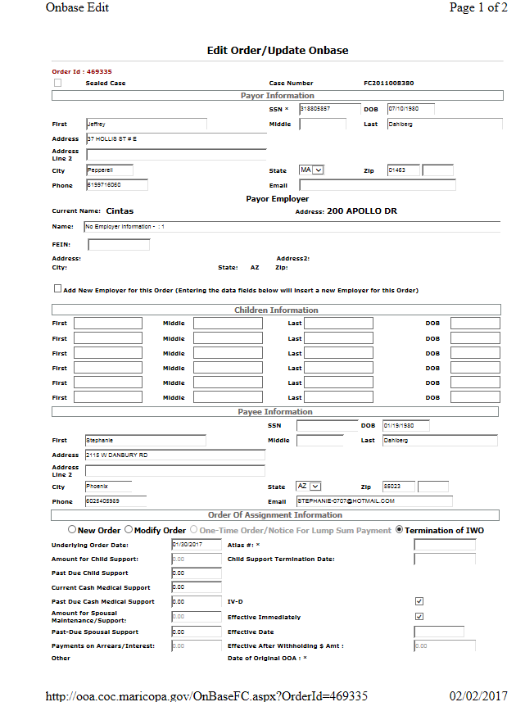

- Go to ICIS to research for the “Order Stopping Income Withholding Order” signed by Judge/Commissioner.
Very rarely will you see a Petition to Stop on a 4D case, for the most part you will be finding a J&O as your underlying order. Make sure you read to the very end of the J&O, at times they are ordering NCP to pay towards arrears. (Your 4D IWO Stop would turn into a 4D IWO Mod)
- Bring Atlas case up on 4D. If you have the Atlas #, go to the CAST screen and enter the Atlas #. If you have the Case #, go to SUOC and enter the case # with the dash (example: FC2011-012345) and tab and delete any numbers following.

Enter 2 CAAL notes, first CAAL note will be with code A0253, this lets DCSS know what the Underlying Order is. See Example A below:

Example A:

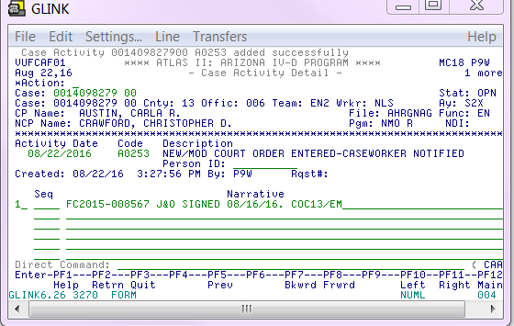

Second CAAL note will be code E9646, this lets DCSS know where the IWO Stop was mailed to. See Example B below:

Example B:

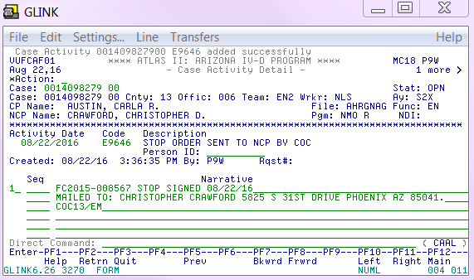

Notice: when ending your CAAL notes use, COC13/your inititals. This lets DCSS know which County has entered the CAAL note.

If no underlying order is found in ICIS for the 4D IWO Stop do the following:
- Go to the Atlas case, verify that Names match and update IWO Stop 4D with Employer, Atlas #, SS# if needed and Date of Original IWO. (Check ICIS for last IWO mailed) Anywhere there is a * on the IWO Stop 4D information needs to be filled in. On a blank line on the IWO enter something to this effect “no underlying order as of today’s date” followed by your initials. (This way you know why you saved it for later).
- Then click on “Save for Later”.

- On the 4D Atlas cases all we do is the 2 CAAL notes. We do not touch their Suod’s or Debts nor do we close their cases. The State handles all that.

POLICIES / RELATED DOCUMENTS:

- N/A

OTHER PARTIES INVOLVED:

- N/A

TIME / VOLUME:

- Varied

FREQUENCY:

- Daily

PERFORMANCE MEASURE:

- N/A

SYSTEM ACCESS REQUIRED:

- Atlas
- On Base Workflow
- iCIS

REPORTS / FORMS:

- Order to process IWO

DEFINITIONS:
- N/A

APPLICABILITY:

This procedure applies to all employees of the Clerk of the Court.

REVISION HISTORY:

Revision Number | Revision Author | Summary of Changes | Approval Date
-
A | N/A | Reviewed | 4/15/2020
B
C

