PURPOSE:

To provide instruction for processing non4D only Interstate Transmittal requests received from out of state agencies

OBJECTIVE:

Family Support Services to redirect monies to the requesting state or to close Atlas.

PROCEDURES:
We receive Interstate Transmittal forms by fax or mail. We cannot allow emails because transmittal forms have social security numbers of both parties. (Our emails are public record) See Transmittal form below:
In ATLAS, go to the CAST screen and enter the Atlas number provided on the Transmittal. After verifying the parties names go to the SEEN screen, (see sample below)

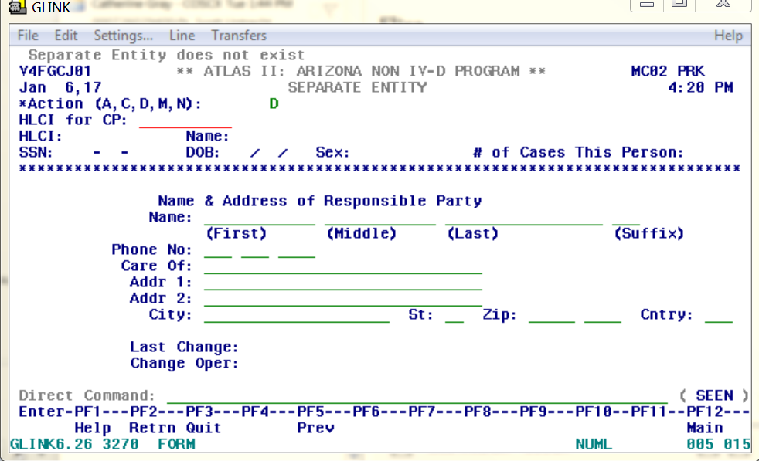

On the action line type in “A” to replace the “D” in the action line, then Tab to Name and insert information of CP. Then Tab to, Phone No. and insert the requesting agency number located on the interstate transmittal form.
DO NOT USE CARE OF (it does not print on the check) then Tab to, Addr 1: and type in the agency name and unit, then tab to Addr 2: and type address of agency and their case number, located on the interstate transmittal under Initiating IV-D Case Identifier Number. Then tab to direct command and review your work and then hit ENTER.
If any changes need to be made after hitting Enter you can modify the SEEN screen.
See Example below:
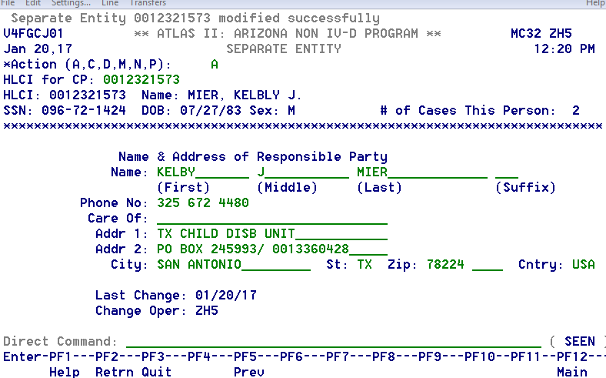

3. Tab to direct command, type in CPDD and hit ENTER, if CP has active bank information remove and clear Direct Deposit bank information by entering a M in the Action line to Modify, tab down to the “Stop Eff Date” and enter today’s date, the system will automatically take you to “Stop Originated by” enter CP, again the system will take you to “Stop Reason” enter CP, tab to “Stop Housed at” and enter 13, then hit enter to finish Mod of CPDD screen.

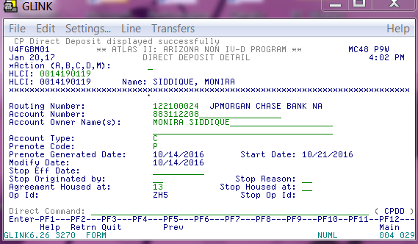

If CP has no bank activated then Tab to, Direct Command and type EPCD and hit enter to see if CP has an active account with EPCD. (EPCD stands for Electronic Pay Card Debit)

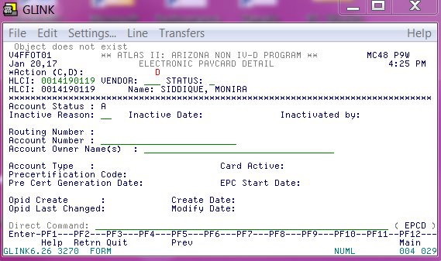

To view if CP has an active EPCD account, once in the EPCD screen tab to VENDOR line and enter “BAC”, then enter a “A” and hit Enter. The screen below is what you will see if EPC Card is active.

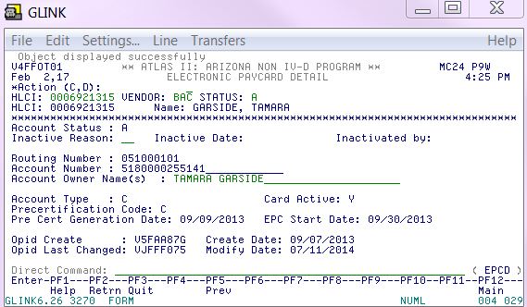

If CP has an active account with EPCD send an email to CPRO” from the FSS Research Mailbox. (Clearinghouse will only clear the EPCD screen if (SEEN) is completed first. See Example below:

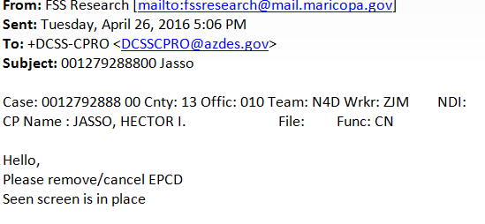

When EPC Card has been inactivated you will see the CAAL Note entered by Clearinghouse in Atlas. See Example below:

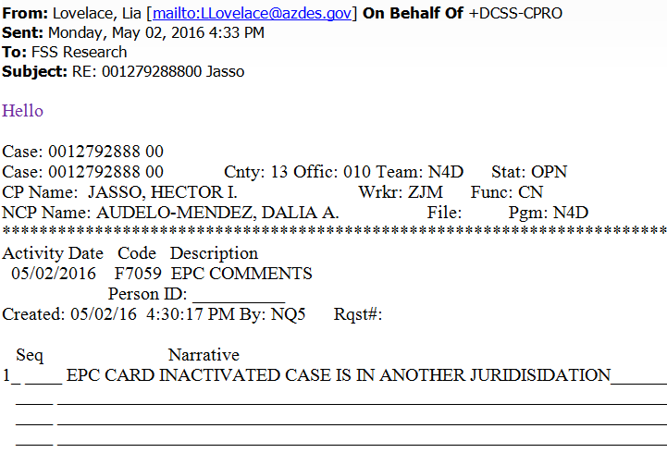

If there is no active EPC Card this is how the ECPD screen will display:

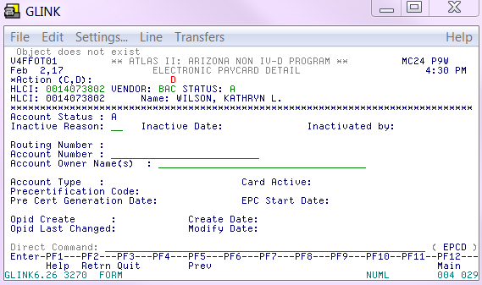

4. Complete a CAAL note using code M0560 stating (FCSS-case number) Payments redirected to (List) agency name, and unit name. Notate why they are having payments redirected to their state. And then initial your name. See Example below:

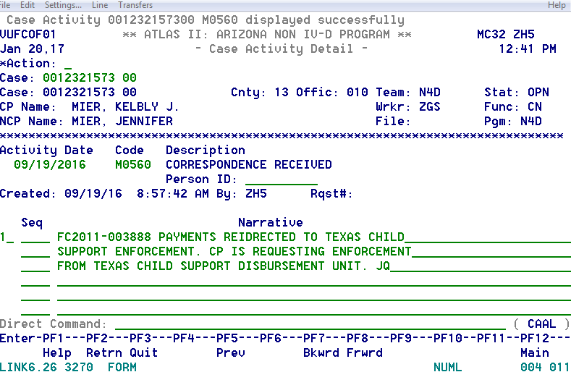

5. Complete Acknowledgments part of Transmittal form and fax back to requesting agency (with case workers name) See Example below:

6. If requested, include certified Payment History. See Procedures for Payment History is needed.

7. Save original transmittal form, file stamp it then put in docket bin.

Transmittal form requesting Arizona to stop the IWO

1. Close Atlas account per transmittal form

2. Update NCP address if necessary

3. Complete STOP IWO FOR ARIZONA ONLY and mail.

4. Complete a caal, notate case code E9640 stating agency name, phone, address and fax and contact name requesting closures

5 Complete Acknowledgments part of Transmittal form and fax back to requesting agency (with case workers name)

6. If requested, include certified Payment History

7. Send Completed Transmittal form to Docket (Back up for COC/FSS)

POLICIES / RELATED DOCUMENTS:

OTHER PARTIES INVOLVED:

Out of state agencies

TIME / VOLUME:

- Varied

FREQUENCY:

- Daily

PERFORMANCE MEASURE:

- N/A

SYSTEM ACCESS REQUIRED:

- ATLAS
- OnBase
- iCIS

REPORTS / FORMS:

- N/A

DEFINITIONS:

APPLICABILITY:

This procedure applies to all employees of the Clerk of the Court.

REVISION HISTORY:

Revision Number | Revision Author | Summary of Changes | Approval Date
A | Muhammad Azam | Document Origination | 5/29/19
B
C

