**PURPOSE:**

* The purpose of suspense is to review monies that cannot be automatically processed.

**OBJECTIVE:**

* To ensure monies are processed and disbursed to the correct parties per court order.

**EVENT DRIVER:**

* A daily list is generated from the prior day of posting at the Support Payment Clearinghouse. This list is printed to research the different suspense codes and each payment that has fallen under that code, to determine a resolution.

**PROCEDURES:**

**SUSPENSE PROCEDURES**

The job task which our department, Family Support Services or FSS refers to as ‘Suspense’ is manually reviewing monies that are on hold under the State of Arizona ATLAS system. The purpose of suspense is to review monies that cannot be automatically processed. There are several different actions that can cause payments to be held in suspense from closing debts to creating a receipt narrative or an ‘R’ narrative to hold monies which will cause payments to fall under a suspense code.

A daily list is generated from the prior day of posting at the Support Payment Clearinghouse. This list is worked to research the different suspense codes and each payment that has fallen under that code, to determine a resolution.  The suspense codes researched are **SCLS**, **SDBT**, **SNCA** and **SNSD**. Each suspense code is specific to the action that needs to be taken to either disburse or refund monies.

**Overview of Suspense Codes**

An **SCLS** suspense code is automatically generated by the ATLAS system when a case has been closed. When a payment is received after an ATLAS case has been closed, it will be held under the SCLS suspense code. A review of the CAAL (Case Activity List) notes can determine if a Stop Income Withholding Order (Stop IWO) has been signed by locating an E9640 CAAL note (Order of Assignment Stopped Reason) and an E9646 CAAL note (Stop Order Sent). The Stop IWO and any underlying orders can be located in iCIS for review of how the Judicial Officer orders monies to be disbursed. If monies are to be refunded to the NCP (Noncustodial Parent) or Obligor (person making payments), an Authorization to Release Monies is created as a Word document. It will be reviewed and digitally signed by FSS Lead or another FSS staff member trained on suspense. Once an Authorization to Release Monies has been signed, a PAAR (Payment Adjustment Request) will be initiated for each payment that is ordered to be returned.  Each PAAR entered for each payment will need to be reviewed by FSS Lead or another FSS staff member. At this point, SDU/Clearinghouse (State Distribution Unit) will complete the final approval of the PAAR and a refund check will be issued to NCP. A review of the NCP’s current address is also done to ensure that the refund check is sent out to the correct address. If monies are to be released to CP(Custodial Parent) or Obligee, a SURE (Suspense Request) and SULI (Suspense Listing) will be completed to ensure release of payment to CP.

An **SDBT** suspense code is automatically generated by the ATLAS system when debts are closed on a case. Debts may have been closed pending a Stop Income Withholding Order and monies will remain in suspense until a Judicial Officer signs off the Stop. Debts may also be closed due to a future effective date of an obligation. In these instances, monies will remain in suspense until the effective date commences and then automatically released to CP. If monies are sent in by an employer too early, monies will be refunded to NCP. Steps to complete an Authorization to Release Monies will be taken.

An **SNCA** (Court Action Is Pending) is an R Narrative that is manually created by FSS staff when a Petition to Stop an Income Withholding Order is filed. A review of iCIS is completed using the court case number for payment. If only a Petition to Stop IWO is located in iCIS, monies will remain in suspense until a Judicial Officer signs off the Stop. If the Stop IWO and any underlying order are located in iCIS, a review of how the Judicial Officer orders monies to be disbursed is done and the proper steps to complete order are taken.

An **SNSD** (Special Distribution) is an R Narrative that is manually created by FSS staff to review payment for special instructions by a court order or to monitor payments for appropriate distribution. Special instructions by court order typically require splitting monies between CP and NCP. Splitting payments may simply be completed by the refund process utilizing the Authorization to Release Monies steps and the SURE/SULI process to release monies to CP.  Some payments may require a split or a Paper PAAR that requires a BRP (Back out Reapply) PAAR request that only the SDU/Clearinghouse/Suspense department has access to perform. The Paper PAAR request is emailed to the SDU Suspense department with an attached form that lists the breakdown of how the payment should be disbursed between the parties. When cases are monitored under the SNSD code, this is used to prevent overpayment when a recent modification has taken place. This hold is only placed on a case when an NCP inquiries about possible overpayment and is not offered to all. Each payment is reviewed to release funds immediately to CP the next business day and actions are performed for refunds to NCP. The SNSD hold will be removed once the NCP’s employer has made adjustment according to the IWO and not to further delay funds distributing to CPs.

**To Work the Suspense List for the Day**

A Word document of the Suspense List will need to be created using screenshots from SULI for each screen of the suspense/Reject Codes we work: **SCLS**, **SDBT**, **SNCA** and **SNSD**. At the top of each list, the title, Suspense List for the day (04/13/20) and the count of payments on the list will be included. The legend designating highlights of how the suspense item is being worked should also be included.

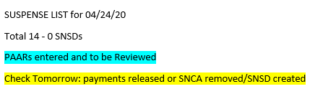

To bring up the suspense list up for the day, go the Direct Command line and type in **SULI**, and then enter. This brings you to the **SULI** screen:

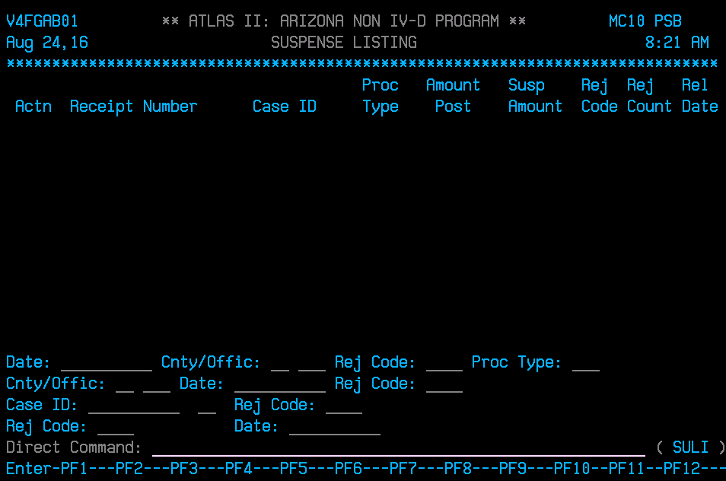

Tab to Cnty/Office and type 13 010, in Date: type in date of listing you wish to work and Enter:

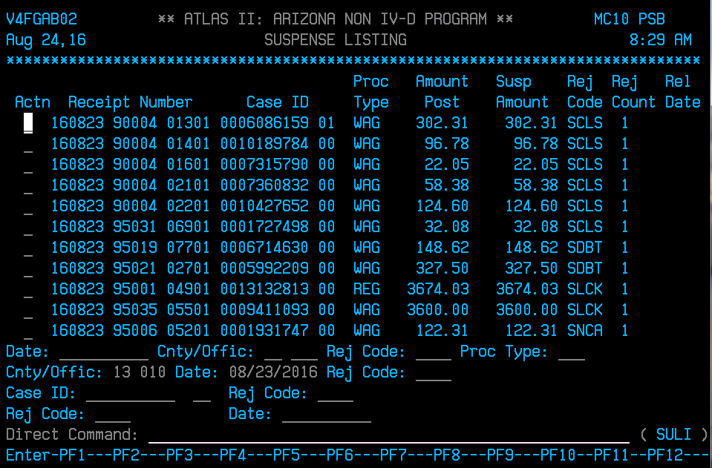

After hitting enter and the list will appear with SCLS at the top on the list. Using Word and the Snipping Tool, screenshot each page of payments with SCLS, then Press F8 to go the next page to locate SDBT, SNCA and any SNSD for the day and continue until you reach *** End of Data*** for the day of posting.

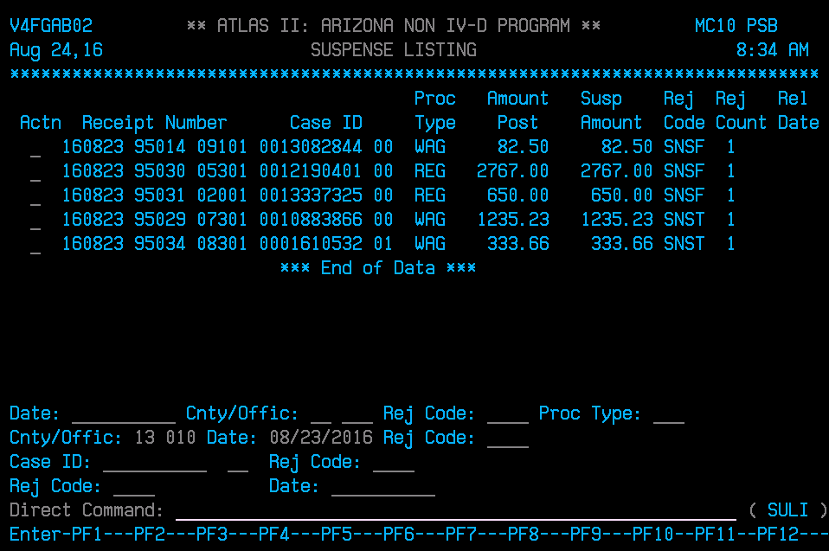

**To Create and Save the Suspense List for the Day**

Open the Word program to open a blank document; be sure to have your screenshot of SULI ready and then click on the Snipping Tool to open. Use the + as your cursor to screenshot the first page of SCLS, SDBT, SNCA and SNSD if any. Place on the blank Word document you opened. Return to SULI and copy the corresponding ATLAS numbers to the payments under SCLS, SDBT, SNCA and SNSD; then place them under the screenshot.

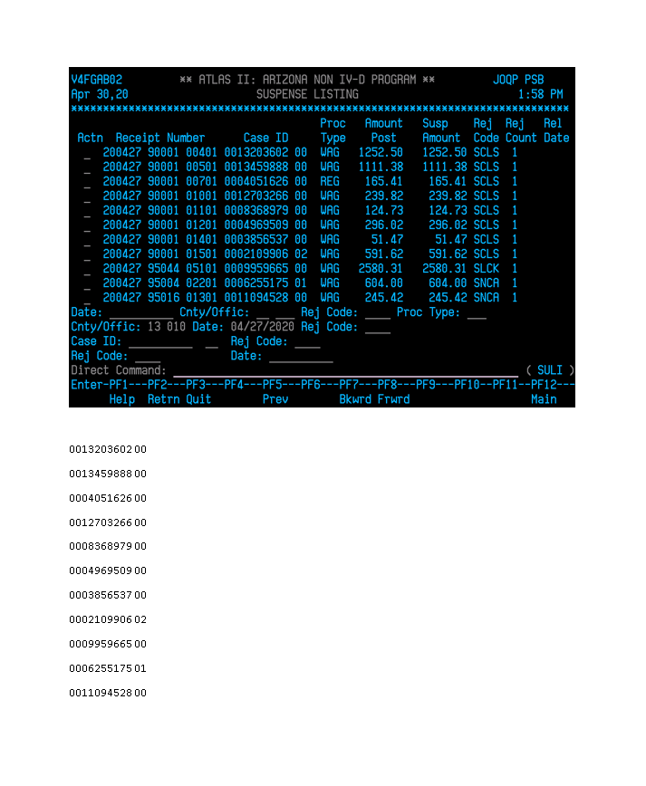

At the top of the first page, create the title ‘Suspense List for and the date you’re working’, Total payments and number of SNSDs once you’ve completed screenshotting list for the day. Along with the legend of how payments are being worked and why highlighted. Above each rejection code, title it as well for an easier reference. Continue to copy and paste each screen, then Press F8 to go the next page to SDBT, SNCA and any SNSD and continue until you reach *** End of Data*** for the day of posting. Only save the page that have those rejection codes.

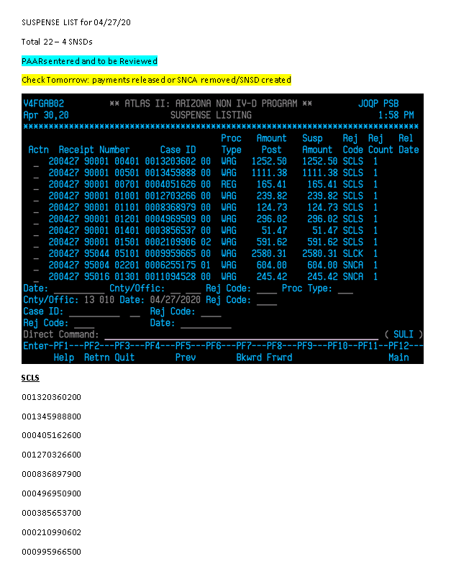

Once you’ve completed all the screenshots, save the list at this point by clicking on File, then Save As, then Browse, select the S drive, Fin_Svc, FSS Staff, Document Storage, Suspense, Suspense Lists and then the corresponding month.



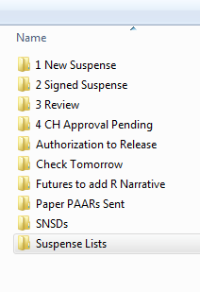 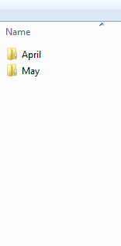 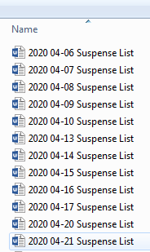

Go through each page to work each payment on the list and making notations or for any further reference as to how payment was worked (see below). Under the SNCA rejection code, if no further action was taken, place a “>” indicating the payment was reviewed.

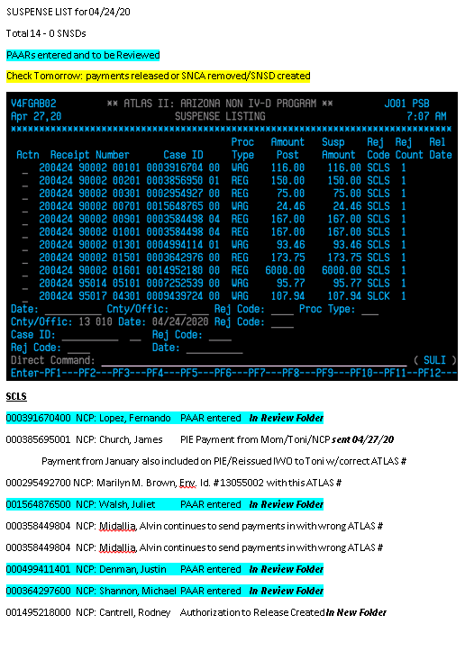

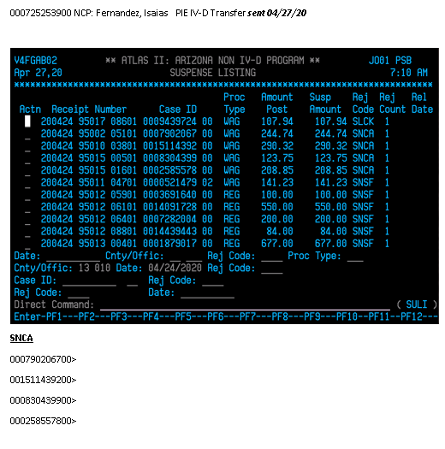

**Researching (Working) Daily Suspense List**

The first page of daily suspense will begin with **SCLS** suspense code. The payments are in suspense due to ATLAS case being closed. In ATLAS, type in PALC (Payment List By Case) on the Direct Command line and enter. Then type in the ATLAS case (Case ID on suspense listing) in Case: and enter. This will bring the payment listing for the payment.

In order to view the payment or payments in suspense, Press F11.

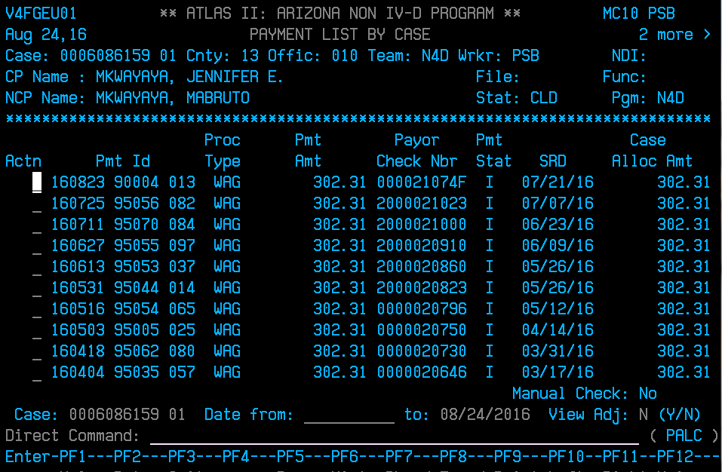

Payments listed under Amt Suspense are being held in suspense.

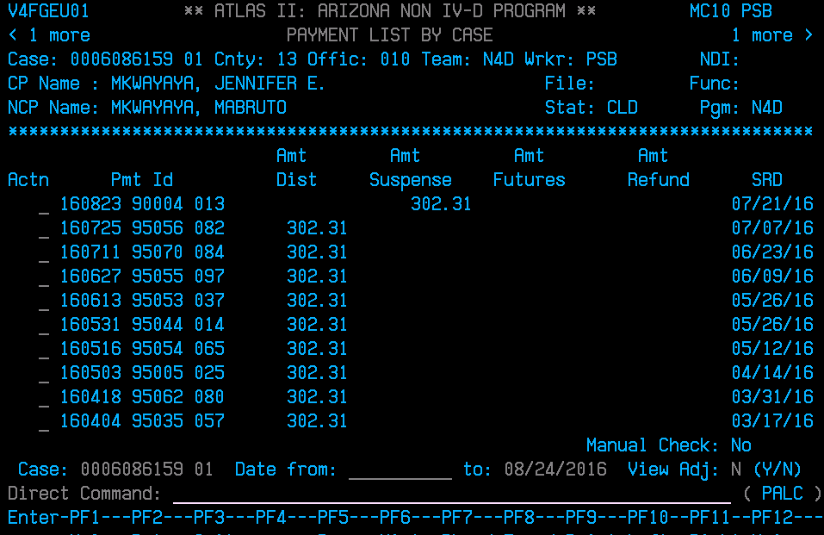

In the Direct Command, type in CAAL (Case Activity List) and Enter. Be sure to clear out any letters or dates just above the Direct Command line leaving only the ATLAS number and enter. This will adjust the CAAL notes to chronological order. A review of the CAAL (Case Activity List) notes can determine if a Stop Income Withholding Order (Stop IWO) has been signed by locating an E9640 CAAL note (Order of Assignment Stopped Reason) and an E9646 CAAL note (Stop Order Sent). The Stop IWO and any underlying orders can be located in iCIS for review of how Judicial Officer orders monies to be disbursed.

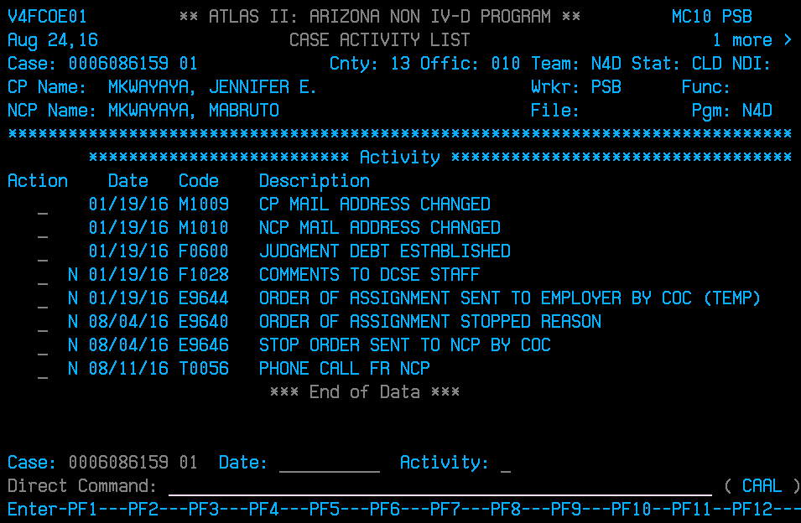

Type in a D (for Display) next to the E9640 and E9646 CAAL notes to view note which is determined by the N, the N means there is a note within the CAAL note and Enter.

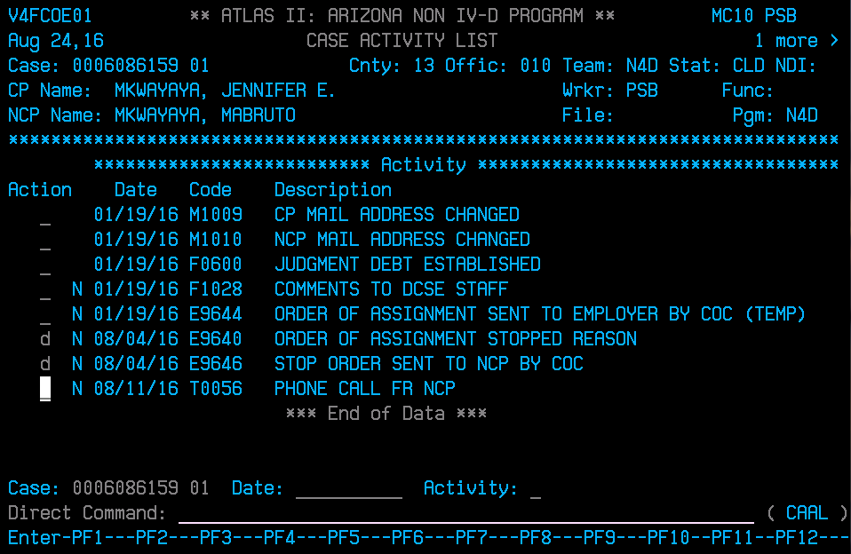

The note in the E9640 (Order of Assignment Stopped Reason) will state why the case was closed (i.e. Parties’ Agreement, Child Emancipation, CP death, Spousal Obligation terminated) along with the underlying Order title and date order was signed.

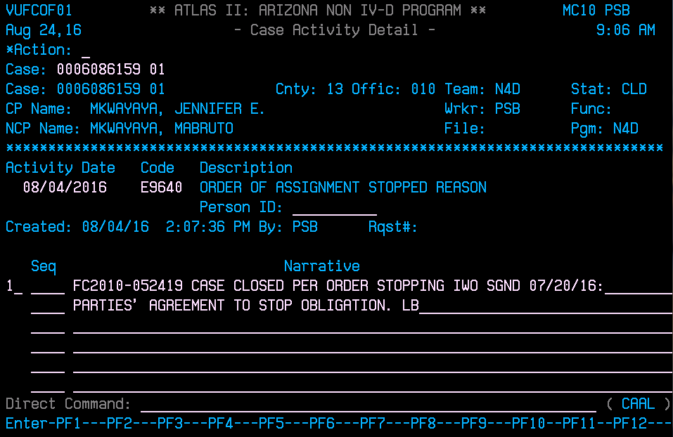

Press F2 and this will take you to the E9646 (Stop Order Sent to NCP By COC) CAAL note. This will state where the Stop Income Withholding (Stop IWO) was mailed.

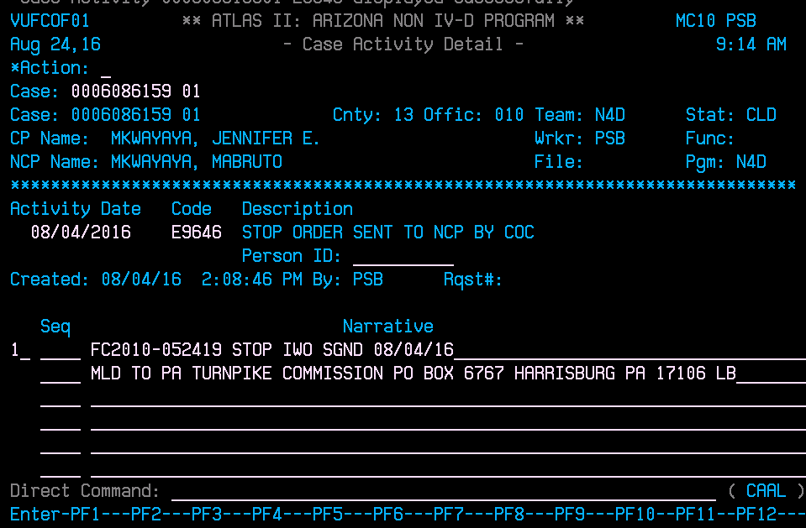

If payments are coming from NCP’s employer, the Stop IWO should have been mailed to their employer. If payments are coming from NCP, the Stop IWO should have been mailed to the NCP. We can refer back to this if payments continue to come in over a period of time. One month is long even for an employer to have received the Stop IWO. We can review if payments coming in are from the employer we mailed the Stop IWO or not. We can take further measures to resend Stop IWO if needed at that time.

**Review of iCIS (Court Case File/Docket)**

In Docket of Court Case File in iCIS, type in Court Case # and enter. This will bring up the Existing Dockets for case:

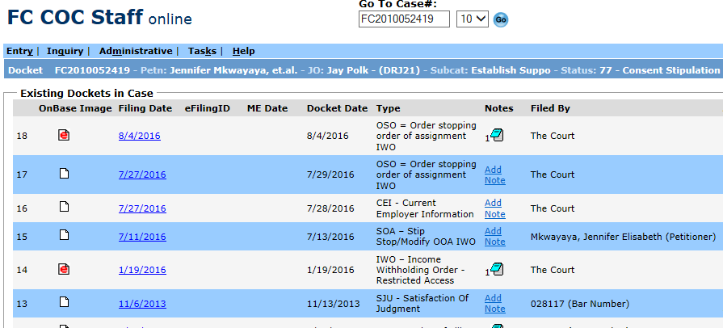

**Review of Underlying Orders and Petitions**

Reviewing the OSO – Order Stopping order of assignment IWO and the SOA – Stip/Stop/Modify OOA IWO will give us the date the Stop was signed and any instruction as far as refunding or releasing payment(s) to parties in the case. The Order Stopping IWO is the Stop that has been signed by a Judicial Officer, which gives direction of what to do with the funds; the Filing Date and Docket Date differ versus the Order Stopping IWO created and completed by FSS (Family Support Services) for mailing to employer or paying party to terminate obligation and/or any garnishment in place for NCP (Noncustodial Parent)/Obligor; the Filing Date and Docket Date are the same.

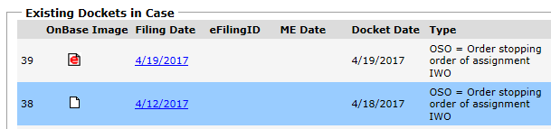

**Order Stopping Income Withholding Order signed by Judicial Officer (With Direction of Funds):**

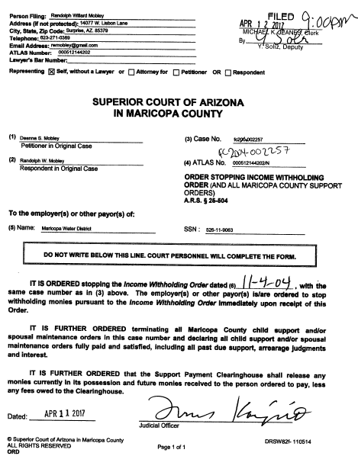

**Termination of IWO created and completed by FSS:**

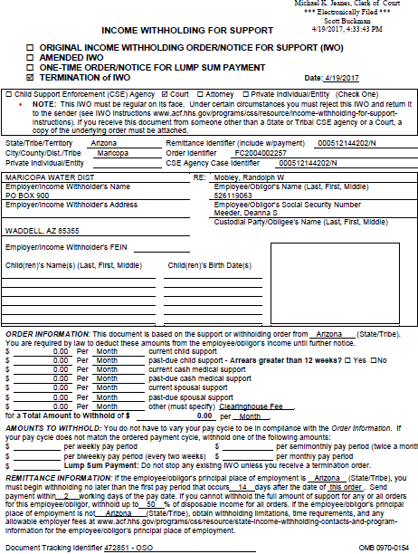

**Review of SOA – Stip Stop/Modify OOA IWO or in some instances, a Petition to Stop Income Withholding**. The Agreement to Stop Income Withholding Order will state that the parties agree to the IWO in place to stop and as to why. The Judicial officer will sign off on Stop per their agreement.

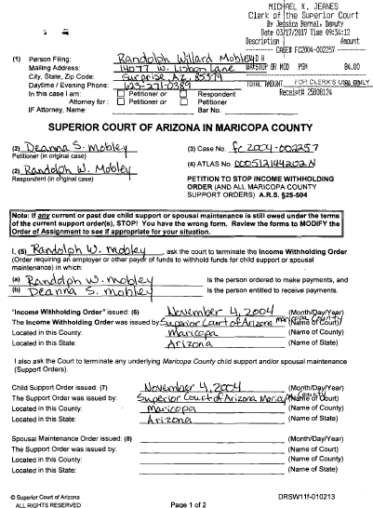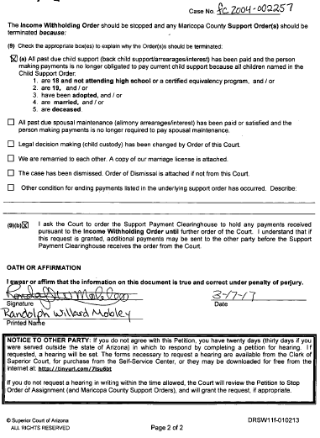

**A Petition to Stop Income Withholding Order is typically filed by the NCP/Obligor but can be filed by CP/Obligee**.

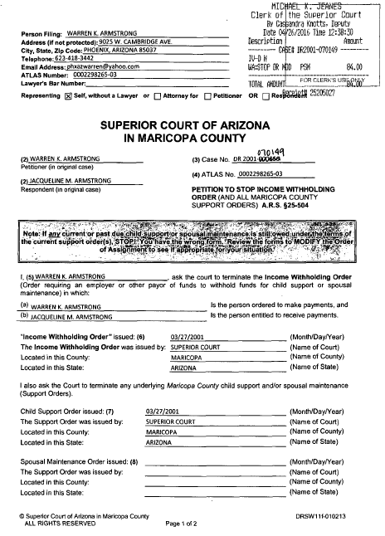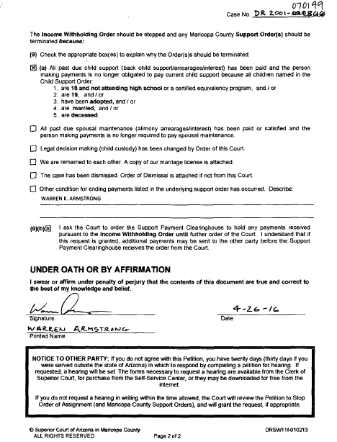

The petition to stop IWO includes a request to hold monies (page 2, 9B box) until further order of the court.

Verbiage of box 9B:



If the 9B box has been checked, an SNCA R narrative will be created on case to hold monies. The Petitions to Stop IWO are received by way of the FSS’s Petition to Stop Queue and are created from daily review by the person assigned to suspense; an R narrative is created on ATLAS case.

Example of initial SNCAR Narrative created from Petition to Stop IWO:

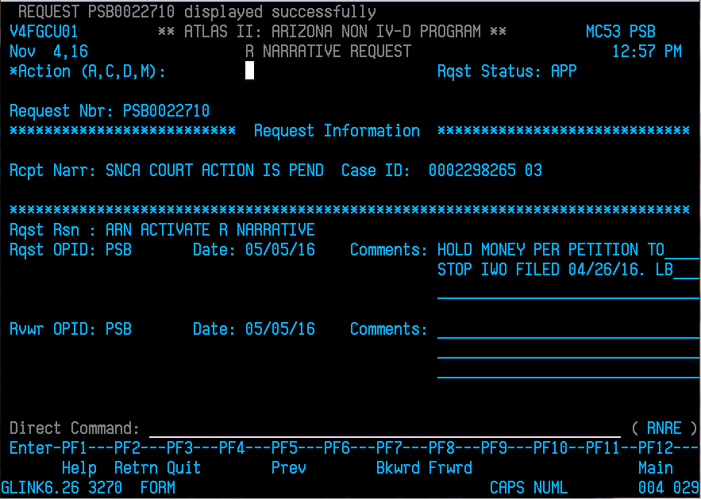

In these instances unless otherwise notated by the Judicial Officer, all monies being held in suspense will be refunded to NCP/Obligor per the verbiage of Order Stopping Income Withholding Order signed by Judicial Officer:

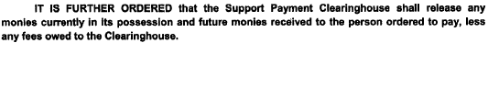

Or if only one obligation of either child support or spousal is being requested to stop (see example of Petition to Stop IWO, Page 2) an SNSD R narrative will be created to ensure release of continued obligation (see example below).

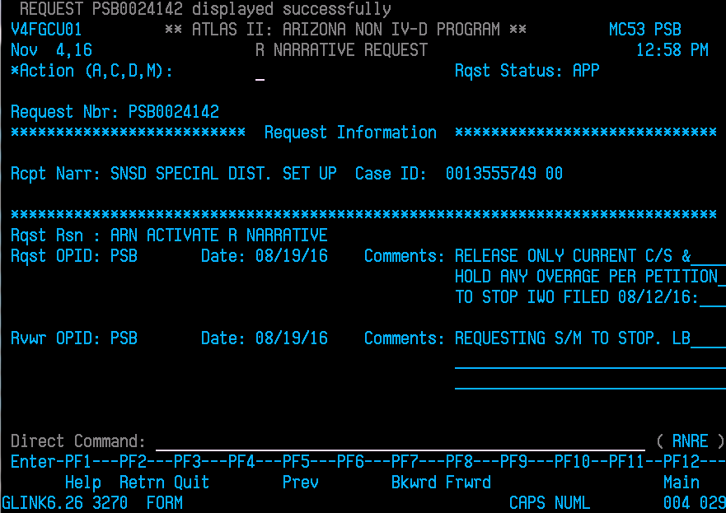

Example of Petition to Stop IWO, Page 2 with spousal support requested to stop:

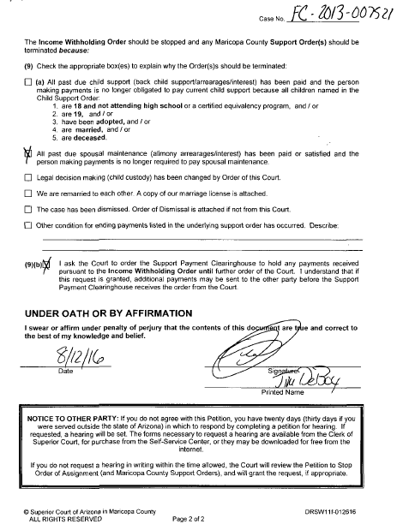

**Creating Authorization to Release Monies**

Authorizations to Release Monies are the coversheets created when monies are in suspense and need to be refunded to NCPs or obligors in the case. The staff member who researches the daily suspense list will create the coversheet to include all the pertinent information that needs to be reviewed before initiating the actual refund on the ATLAS system. When the coversheet is completed, it will need to be saved as a Word document and titled with the Father’s name on the case and the court case number (Fait, James FC2009-000288) and digitally signed by the preparing staff member. The Word document/coversheets created for the day will be saved in the Suspense folder under **1 New Suspense** and another staff member, Lead, Supervisor or Family Support Services Manager will be alerted to review and digitally sign as well. If all the information on the coversheet is correct, the reviewing staff needs to digitally sign on the approval signature line provided. Authorizations to Release Monies will then be moved to **2 Signed** Suspense for the staff member to initiate refunds in ATLAS which are called PAARs (Payment Adjustment Request). After the PAARs are entered, the Authorizations to Release Monies are moved to **3 Review** for review. Once payments are reviewed in ATLAS, the Authorizations to Release Monies are then moved **4 CH Approval Pending**.

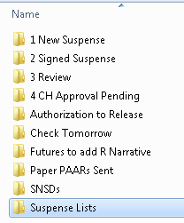

Example of Authorization to Release Monies:

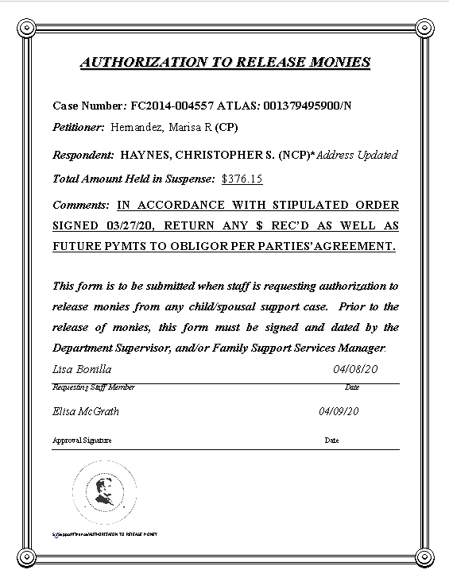

The pertinent information to be included on the Authorization to Release Monies is the Case Number, Petitioner, Respondent, Total Amount Held in Suspense and Comments. Under Comments, the order giving direction to refund and why needs to be included. In the example below, the Stipulated Order signed 03/27/20 is the order and per parties’ agreement is why. Other examples of why money is being refunded are child emancipation, CP death or spousal obligation met.

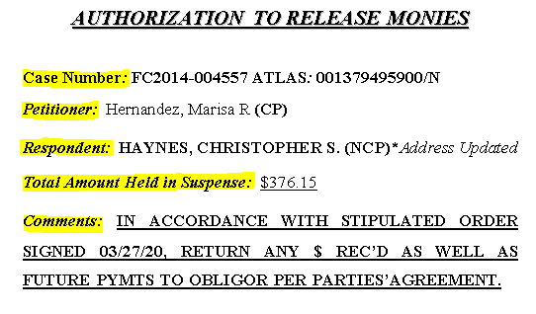

**To Save the Authorization to Release Monies as a Word document**

Click on File, then Save As, then Browse, select the S drive, Fin_Svc, FSS Staff, Document Storage, Suspense, 1 New Suspense.



Title as Father’s name on the case and the court case number: Fait, James FC2009-000288, if Father is CP on case, title as Fait, James (CP) FC2009-000288.

**Initiating Refund on ATLAS/PAARs (Payment Adjustment Requests)**

In ATLAS, Type in PALC (Payment List By Case) on the Direct Command line and enter. Then type in the ATLAS case in Case: ______ and enter. This will pull up the payment listing for the payments. Press F11 to view the payment or payments in suspense. In the Actn line next to the payment that needs to be refunded, type a D and hit enter.

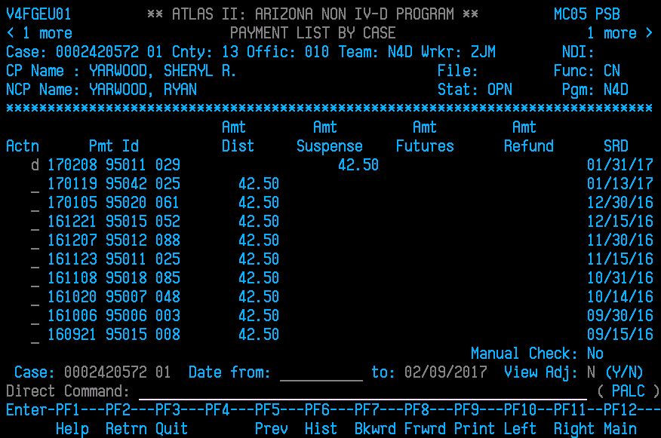

This will take you to payment detail screen. On the Direct Command line, Type PAAR and enter.

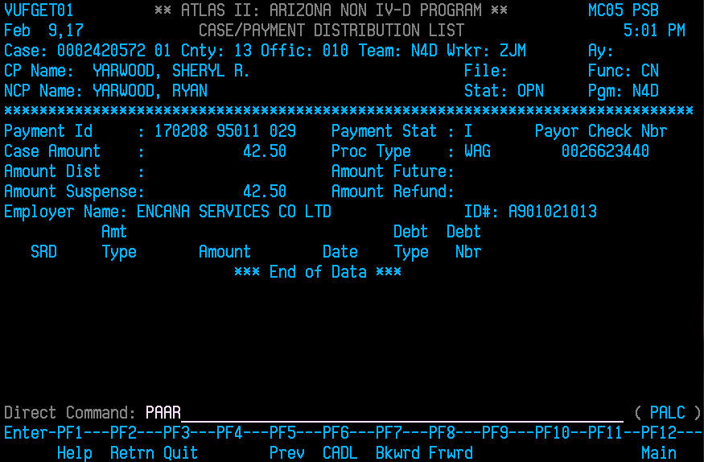

In the PAAR (Payment Adjustment Screen), this will continue to give the detail of the payment. It is in this screen the ATLAS number and Comments as to why payment should be refunded.

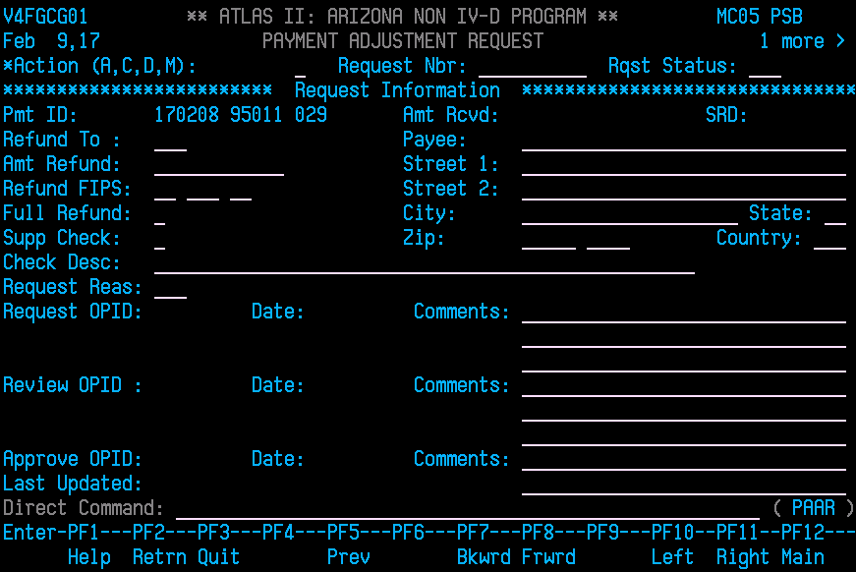

The cursor automatically defaults to the top of the PAAR screen at the Action line; Type in an **A** (for add);

Then the cursor will move to the Rqst Status: ______; type in **PEN** which stands for Pending;

Next tab down to Refund To: ______ and type **NCP**.

Tab to Amt Refund: __________ and type in amount of payment (do not include dollar sign);

Tab next to the Full Refund: and type in **Y**;

Next tab to Check Desc: ___________ and Type in the **ATLAS case number (do not include /N)**;

Tab to Request Reas: _____________ and type in **BRF**, which stands for Back out Refund;

Next, tab to Comments: _________ and Enter order info from Authorization to Release Monies with your initials at the end, i.e. **Pymt refunded to Obligor per Stop IWO signed 07/20/16. LB** and enter.

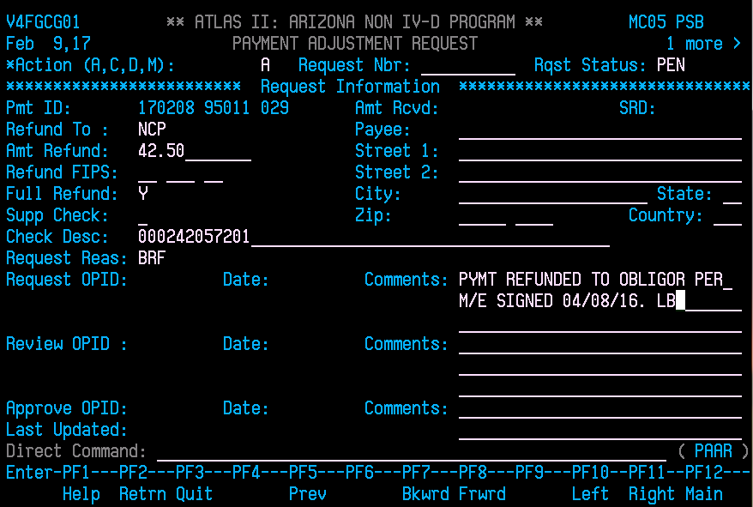

Once all PAARs have been initiated, they will need to be reviewed by another staff member or FSS Lead. You can alert them verbally or by way of email that your PAARs are ready to be reviewed.

**Reviewing PAARs on ATLAS**

On the Direct Command line, type in ATLAS case # and Enter. Press F11 to verify payments are in suspense along with parties’ info on Authorization to Release Monies. Type in RELI (Request Listing) and enter**.**

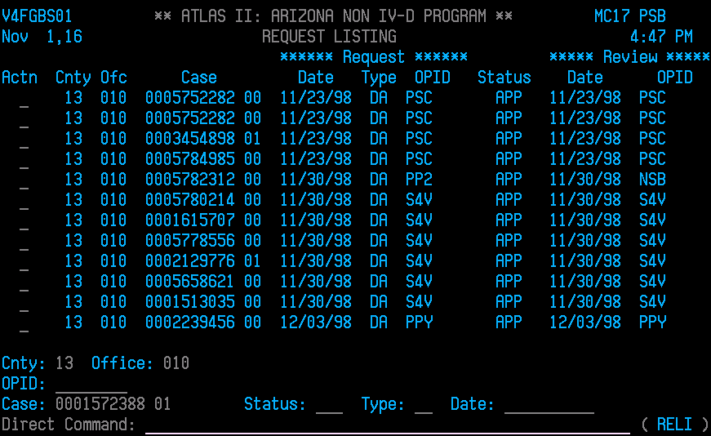

Remove the County and Office and Press Enter. All the payments pending review will appear as status PEN.

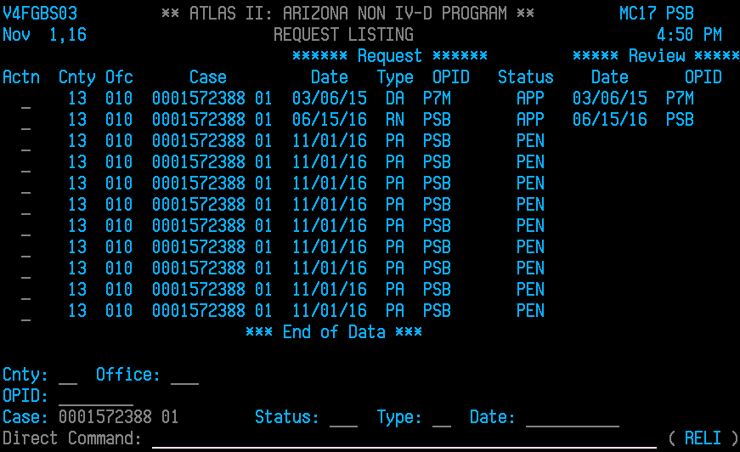

Type in an **S** to select payment in Pending status (PEN)

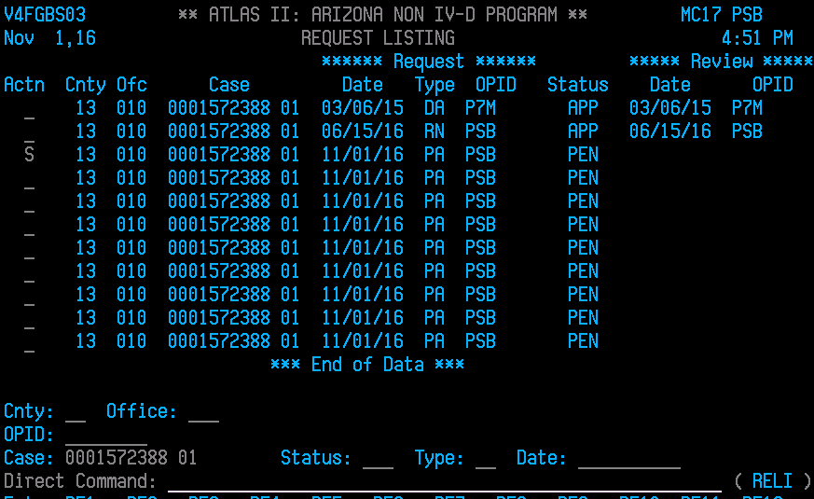

This will take you to PAAR screen for that payment

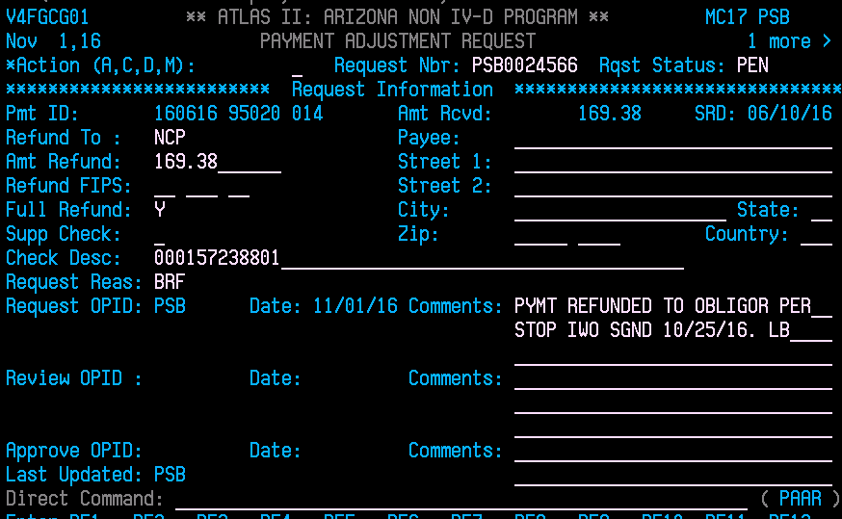

The cursor is at the top on the Action line; Type in an **M** (for modify);

Then the cursor will move to the Rqst Status: _____; type in **RVW** (for review) over the PEN and enter.

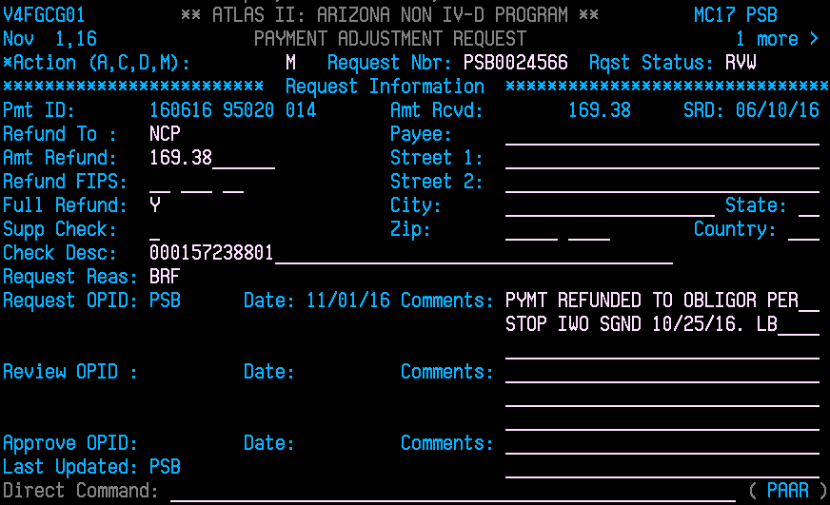

Press F2 and this will return you to the **RELI** screen; from here you can enter the next ATLAS case number. If you have more than one payment on a case that has a refund initiated, you can Type an **S** next to each payment and enter. This will select all payments. After first RVW is completed, Press F2 and this will take you to the next payment to RVW. Once all complete in RELI, continue onto the next ATLAS case by typing in case number and Press Enter.

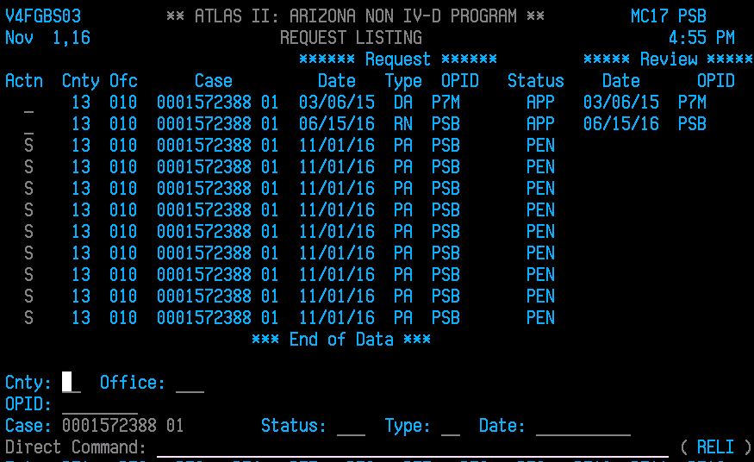

At this point, SDU/Clearinghouse (State Distribution Unit) will complete the final approval of PAAR and a refund check will issue to NCP. Be sure to review NCP’s address for the most current address provided. Final approval from Clearinghouse typically takes 2 -4 business days. Once payments have been refunded, be sure to close case with appropriate reason on the **CAST** screen.

400 DUPLICATE/ERROR CASE PURGE

401 NCP DECEASED

402 CASE DISMISSED BY COURT

403 NCP IN FOREIGN JUDGMENT

405 PLACED ON INACTIVE CALENDAR

410 CP DEATH

411 CASE CONSOLIDATED

416 CHILD EMANCIPATION

421 NO ARREARS OR CHILD DEATH

422 CHANGE OF CUSTODY

The Authorizations to Release Monies are stored by Father’s last name in the Authorization to Release folder in the FSS shared folder. After 60 days have passed and payments have not been refunded, the Authorizations are purged to the folder titled Authorization No Longer Needed within the Authorization to Release.



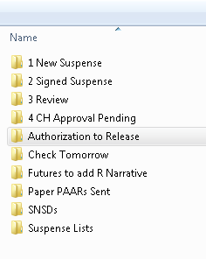 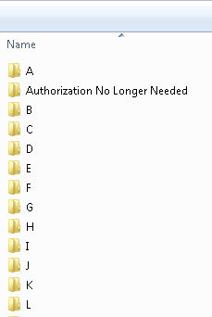

**For SURE/SULI PROCEDURE to release funds to CP, refer to SNSD procedure**

**SDBT** Suspense Code

The payments are in suspense due to debts being closed on an ATLAS case. An **SDBT** suspense code is automatically generated by the ATLAS system when debts are closed on a case. After reviewing PALC for payments in suspense, go to the CAAL notes to review if debts were closed due to a pending Stop IWO. If an E9640 CAAL note (Order of Assignment Stopped Reason) is located, monies will remain in suspense until a Judicial Officer signs off the Stop. This can be determined by a review of iCIS for Order Stopping IWO signed by Judicial Officer. If a Stop IWO has been processed and all debts have been closed with monies are in suspense, the CHF debt should not be deactivated until any past due Clearinghouse fees have been paid. All other debts should be deactivated. The CHF debt will need to be reopened at this point. See SNCA Suspense code for stops to collect fees and the example under **SNSD** R Narrative to Spit Monies per Stop Order with a Paper PAAR Request. Otherwise, steps to complete an Authorization to Release Monies will be taken.

If no E9640 CAAL note is located, a review of **DELN** (Debt Listing) and/or **SUOD** (Support Detail) will determine if debts are closed due to a future effective date of an obligation. In these instances, monies will remain in suspense until the effective date commences and then automatically released to CP. If monies are sent in by an employer too early, monies will be refunded to NCP. Steps to complete an Authorization to Release Monies will be taken. See example of Authorization to Release below:

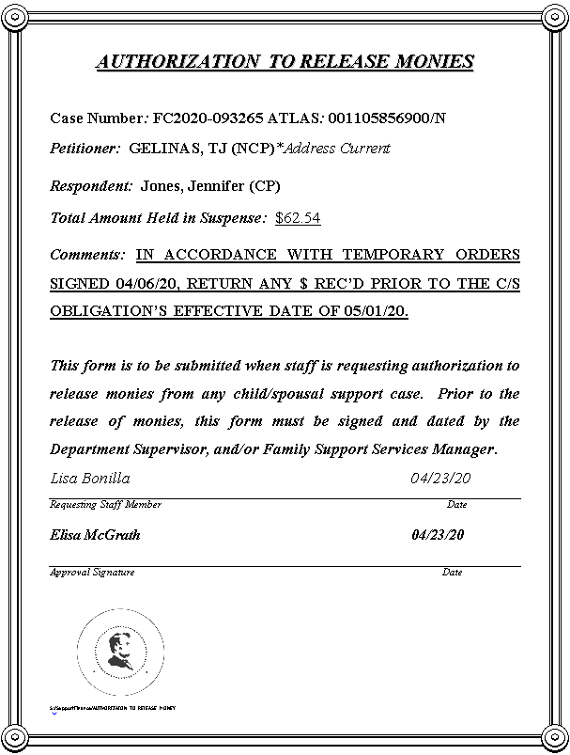

Note: If the CHF debt has been deactivated for a long period of time and it shows Inactive for the month fees need collected, it will need to be rebuilt so payments can apply accordingly.

**SNCA** Suspense Code

An **SNCA** (Court Action Is Pending) is an R narrative that is manually created by FSS when a Petition to Stop an Income Withholding Order is filed. A review of iCIS is completed using the court case number for payment. The court case number can be located on **SUOD** and/or on **DELN**. If only a Petition to Stop IWO is located in iCIS, monies will remain in suspense until a Judicial Officer signs off the Stop. If the Stop IWO and any underlying order are located in iCIS, a review of how the Judicial Officer orders monies to be disbursed is done and the proper steps to complete order are taken.

If monies in suspense are due to an SNCA R narrative and the Judicial Officer orders all monies to be released to CP, the **SNCA** R narrative can be deactivated to release all funds. Be sure that the debts on ATLAS case are opened as well, to ensure there is no delay in releasing funds to CP. If a Judicial Officer orders monies in suspense to be split between CP and NCP, a **SNSD** R narrative will need to be created on ATLAS case and the **SNCA** R narrative will need to be deactivated. This will cause monies to fall under the **SNSD** suspense code and the proper steps will need to be taken the next business day; see **SNSD** suspense procedures.

Example of initial **SNCA** R Narrative created from Petition to Stop IWO:

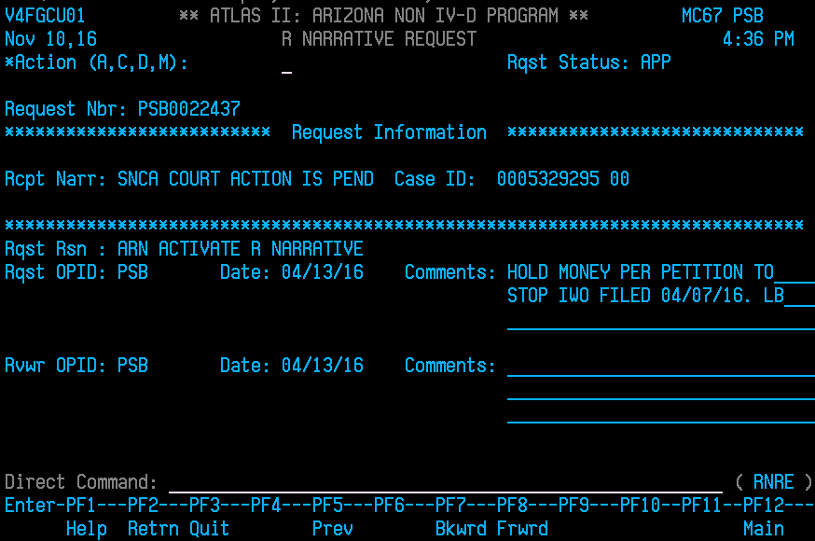

**SNSD** R Narrative created from Modification to Split Monies:

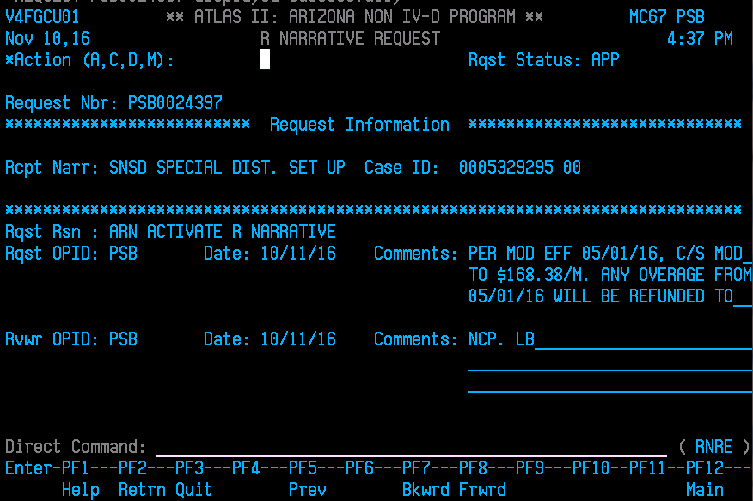

Removal of **SNCA** R Narrative after **SNSD** has been created:

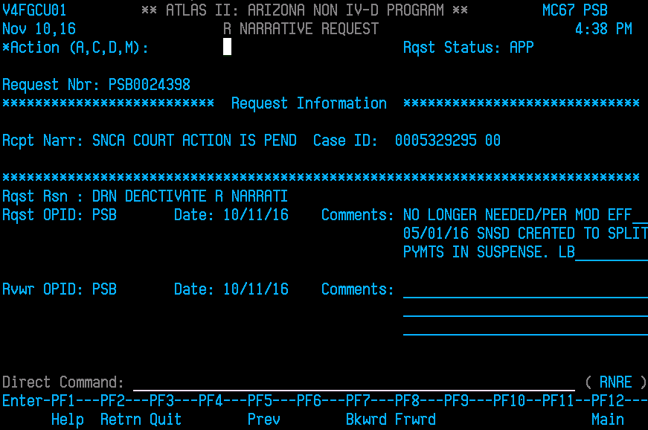

**SNSD** **Suspense Code**

An **SNSD** (Special Distribution) is an R Narrative that is manually created by FSS staff to review payment for special instructions by a court order or to monitor payments for appropriate distribution. After reviewing PALC for payment (s) in suspense, go to RELI to review the comments under the SNSD R Narrative. This will give instruction as to how funds should be disbursed; whether funds will need to be released, refunded or split among parties. A Word document can be created and saved in the **Check Tomorrow** folder under the FSS shared folder to save information for the case such as the removal of an SNCA R Narrative and creating an SNSD R Narrative and case notations. Title the Word document the same as the Authorizations to Release Monies as Father’s name on the case and the court case number and SNSD: Contreras, Joe M. DR2000-071407 SNSD. This can be stored under the SNSD folder in the FSS shared folder for Suspense until no longer needed. See example of Word document below:

Example: Word document for Check Tomorrow to remove **SNCA** R Narrative and Create **SNSD** R Narrative

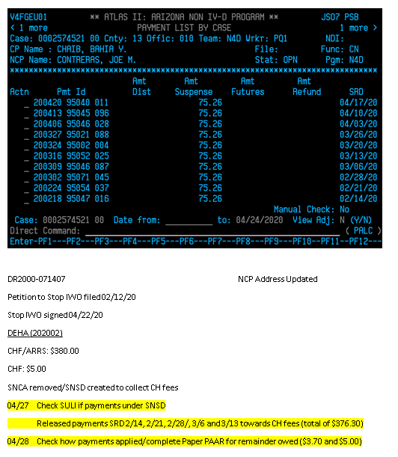

Example: **SNSD** R Narrative to Spit Monies per Stop Order with a Paper PAAR Request (PALC screen)

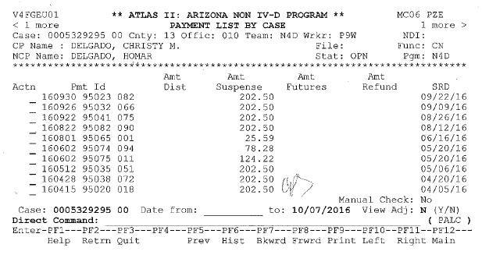

In this example, orders have been signed ordering a modification to child support effective 05/01/16; whereas, monies have been on hold since the Petition to Stop IWO was filed on 04/13/16. All payments have been held until further order of the court which was signed on 10/03/16. Payments will need to be split to accomplish what the Judicial Officer has ordered. An SNSD R Narrative has been created and the SNCA R Narrative hold has been deactivated (see examples under SNSD R Narrative created from Modification to Split Monies and Removal of SNCA R Narrative after SNSD has been created).

Example of **SNSD** R Narrative to split monies:



When payments need to be split, as in this situation and monies will be refunded to NCP, all past due Clearinghouse fees (CHF) will need to be paid before an approval of refunds will be completed by SDU/Clearinghouse. This can be calculated by going to the CHF debt, Type DEHA in the Direct Command line and enter.

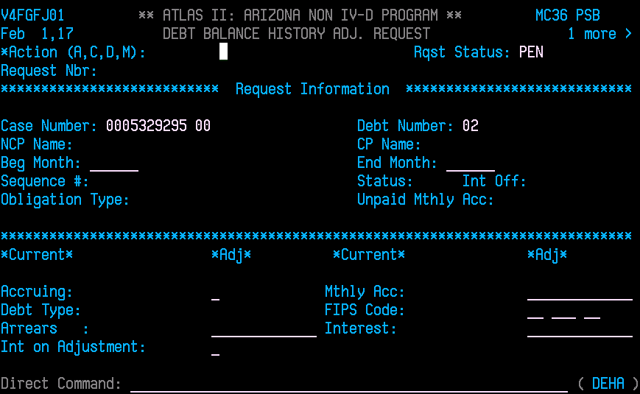

Type D in the Action line, tab down to the Beg Month: and type in the date of the next month from the payment that needs to be split and hit enter. Under the Arrears section, the total amount due for past CHF owed will appear. This amount will be figured in the oldest payment to be split in order for fees to be paid first and then NCP’s refund can be included in the figures on the Paper PAAR Request (see below).

Example of breakdown to split monies (PALC screen)

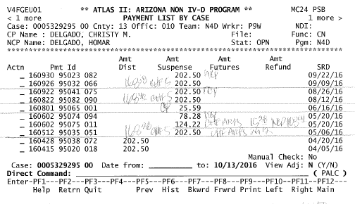

After the payments have fallen under the SNSD R Narrative, the payments prior to 05/01/16 have been issued to CP. The remaining payments will need to be applied towards current child support obligation for the months, current CHF and past due CHF paid and refunds to NCP. The breakdown on the Paper PAAR Request represents these figures.

**Paper PAAR Request (BRP Back out Reapply)**

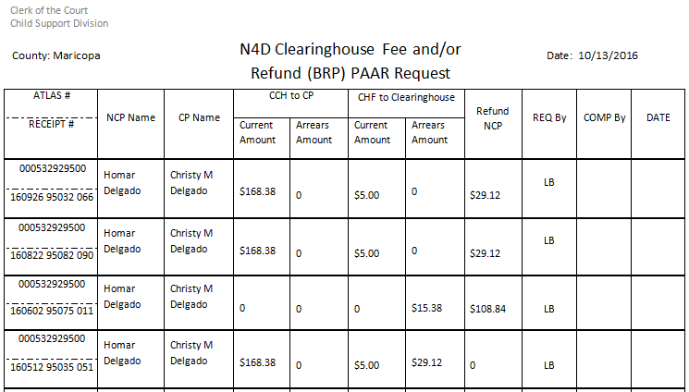

The Paper PAAR Request is attached to email sent to dcsssuspense@ azdes.gov. This email does not need to be copied to FSS Research as this is a suspense task only. A CAAL note will need to be created on ATLAS case as well to notate communication with SDU Suspense Unit for disbursement of funds. Be sure to notate if past CHF owed are being applied as well (see CAAL note example below). This process can take up to 3 business days. SDU will enter a CAAL note once BRP PAAR (s) has been entered.

Example of email for Paper PAAR Request:

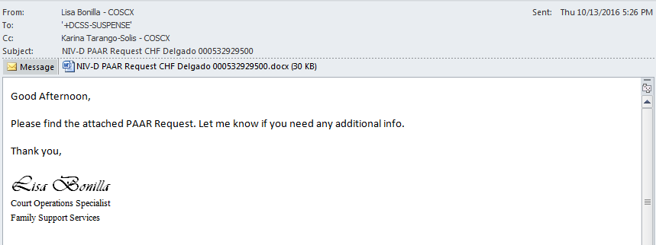

CAAL Note created when BRP PAAR Request has been sent

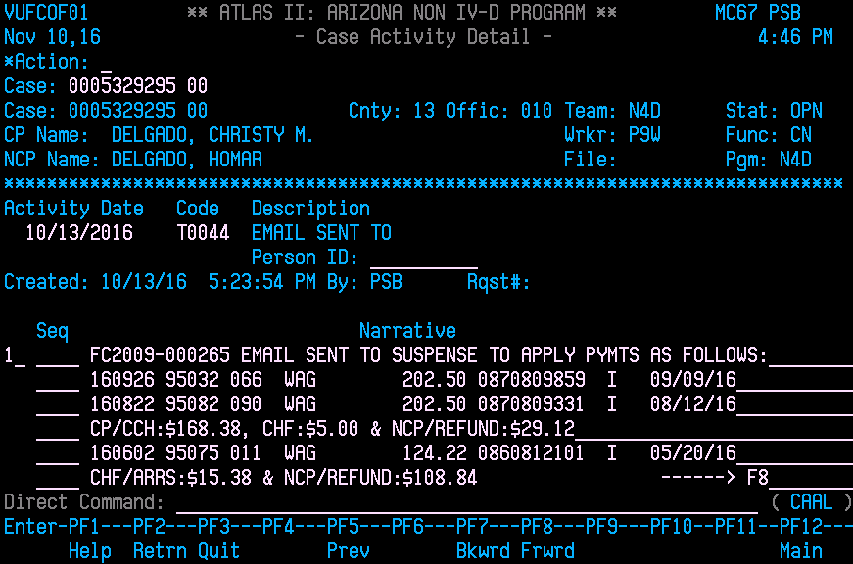

Continuation of CAAL Note for BRP PAAR

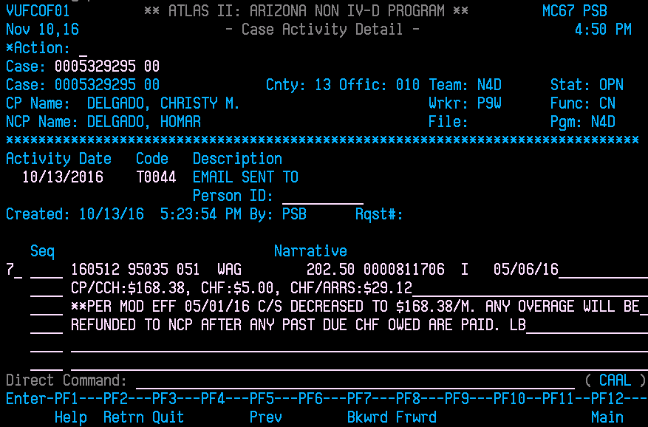

An Authorization to Release Monies needs to be created to initiate refunds on the remaining payments to NCP.

Example: Authorization to Release Monies with **SNSD** hold

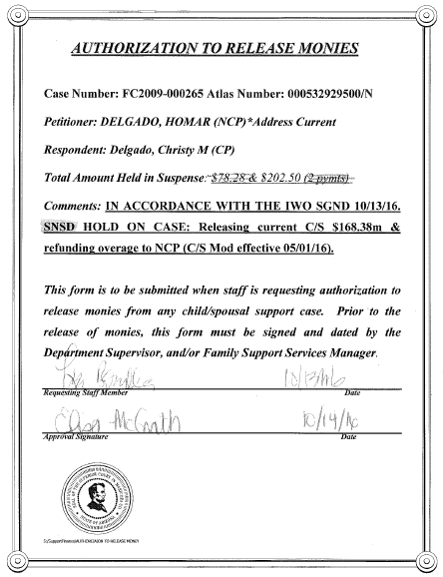

The **SNSD** hold will be removed once the NCP’s employer has made adjustment according to the IWO and not to further delay funds distributing to CPs.

PALC Screen after Paper PAAR splits and PAARs have been completed.

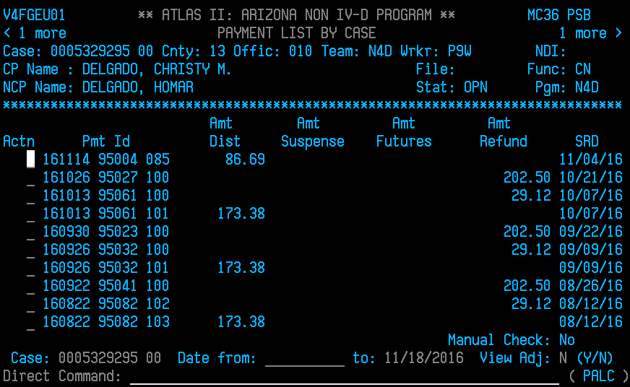

Removal of **SNSD** R Narrative:

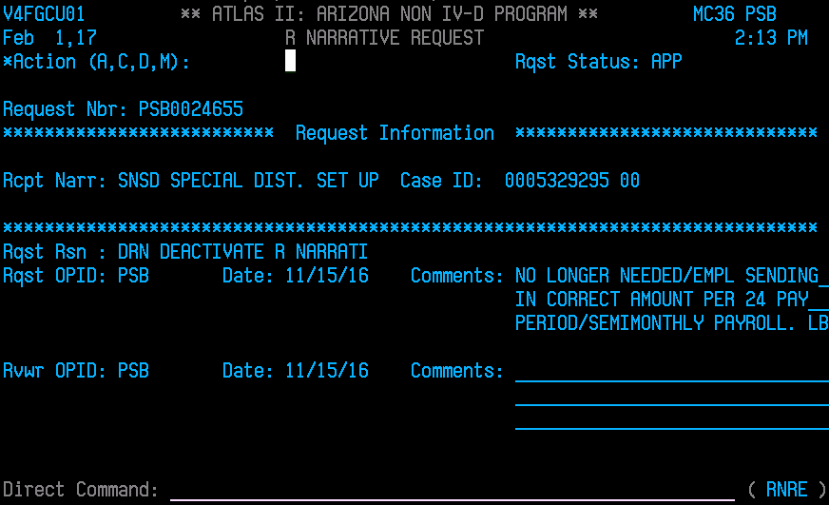

Example of **SNSD** R Narrative Needs to be created to Split Monies per Stop Order (PALC Screens)

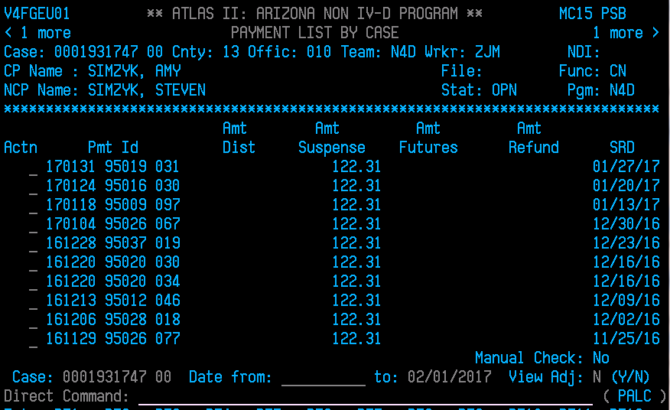

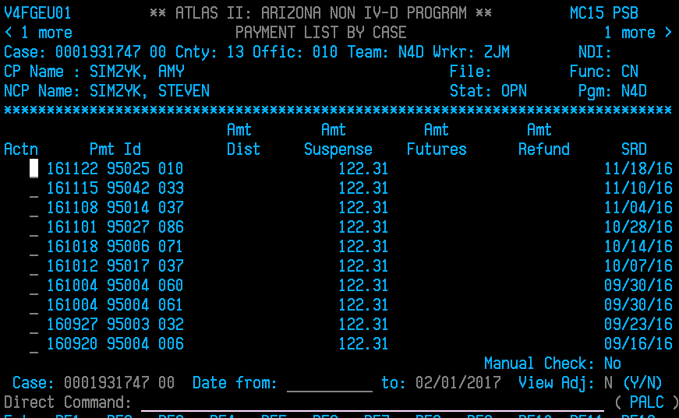

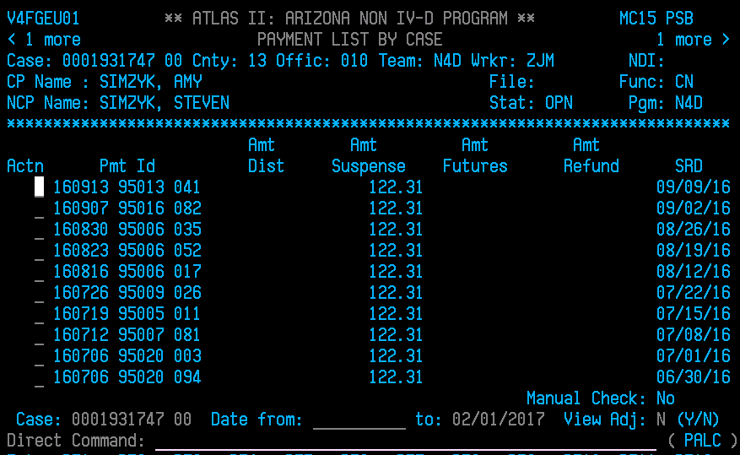

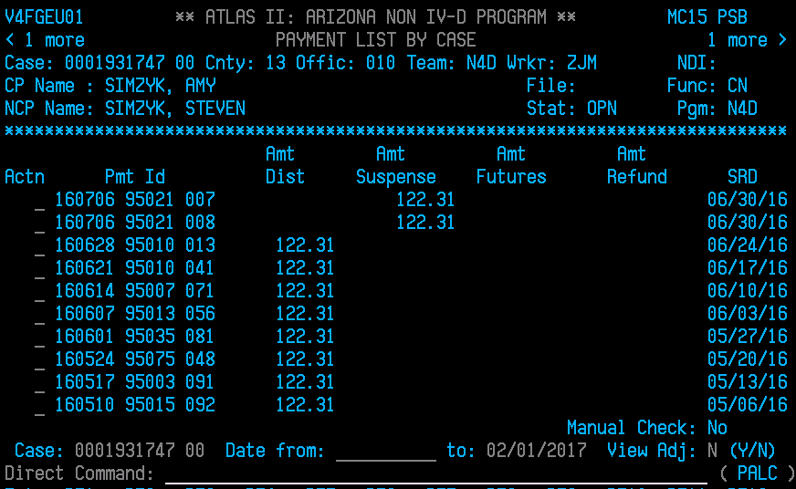

In this example, an Order Stopping IWO has been signed 01/24/17. An SNCA R Narrative was created to hold monies per the Petition to Stop/Modify Wage Assignment filed on 06/26/16 until further order of the court. With the Stop Order that has been signed on 01/24/17 and the effective date of 07/01/16, monies received prior to 07/01/16 will be issued to CP and monies received 07/01/16 on will be refunded to NCP. An SNSD R Narrative will need to be created along with reopening the debts to process monies to CP. Then the SNCA R Narrative will need to be deactivated to allow the payments to fall under the SNSD R Narrative to process monies to parties as ordered. The Authorization to Release Monies to refund monies to NCP can be created as well to have ready once the SNSD R Narrative is in effect.

Order Stopping Income Withholding Order signed 01/24/17

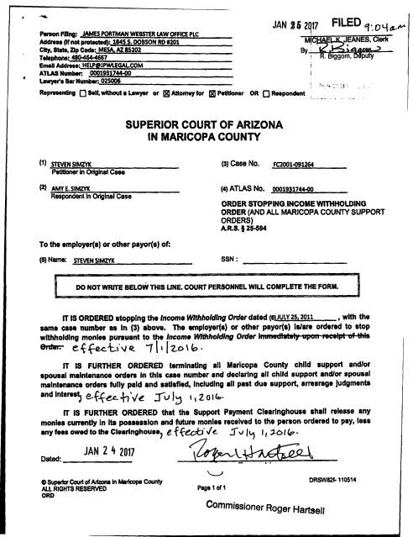

Authorization to Release Monies is created to complete refunds to NCP per Stop IWO signed 01/24/17

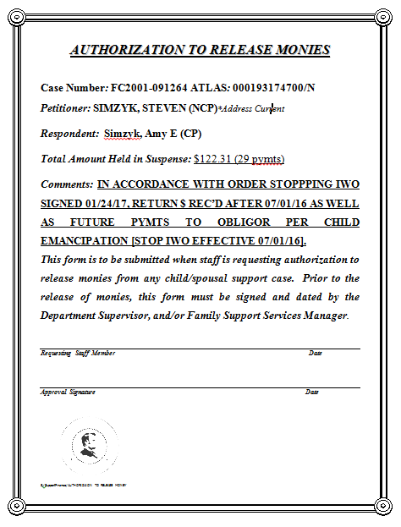

Example of initial **SNCA** R Narrative created from Petition to Stop IWO:

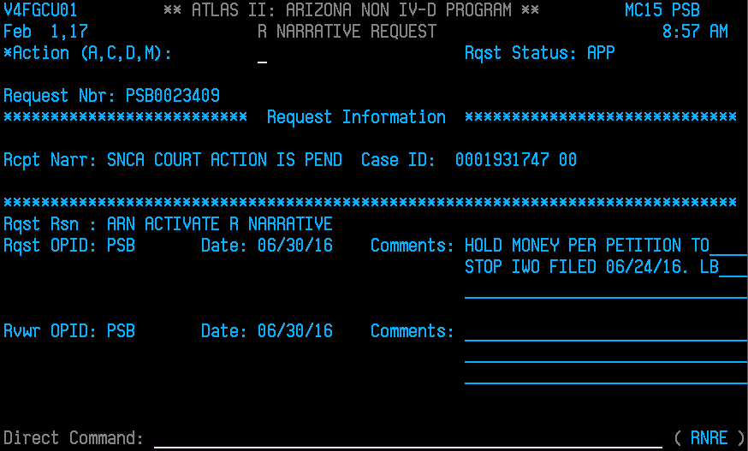

**SNSD** R Narrative created from Stop IWO effective 07/01/16 to Split Monies:

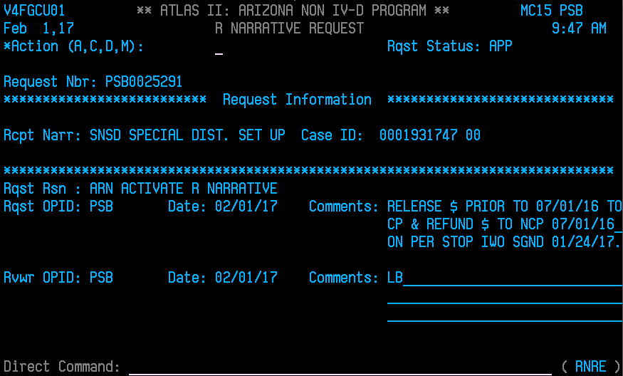

Removal of **SNCA** R Narrative after **SNSD** has been created:

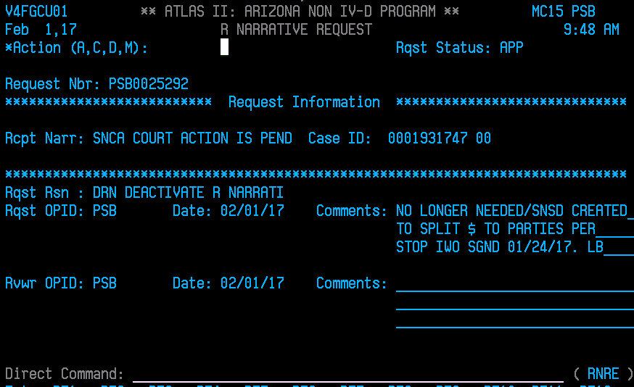

After the payments have fallen under the **SNSD** R Narrative, the payments received prior to 07/01/16 will be issued to CP (using SRD dates which are the 3 payments from 06/30/16) using the **SURE/SULI** process. The refunds to NCP can be initiated for the monies received 07/01/16 on to the NCP (the other 29 payments received to date).

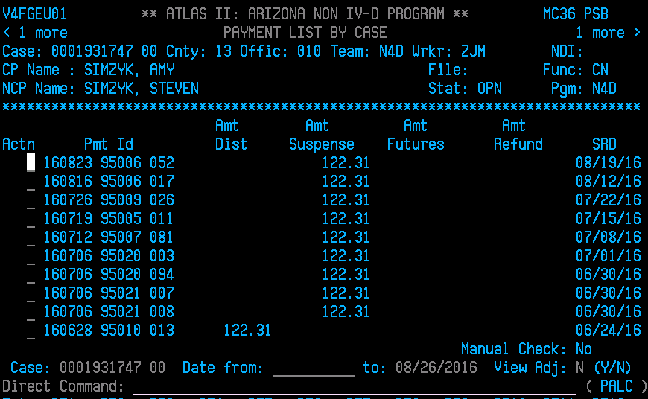

**SURE/SULI Process to release funds to CP**

Type in PALC on Direct Command line and enter. You will need to pull up the payments with SRD 06/30/16**.** Hit F8 until you get to the first payment with SRD 06/30/16 and Press F11. Type a “D” in the Actn line to display payment you want to release to CP and then Press Enter.

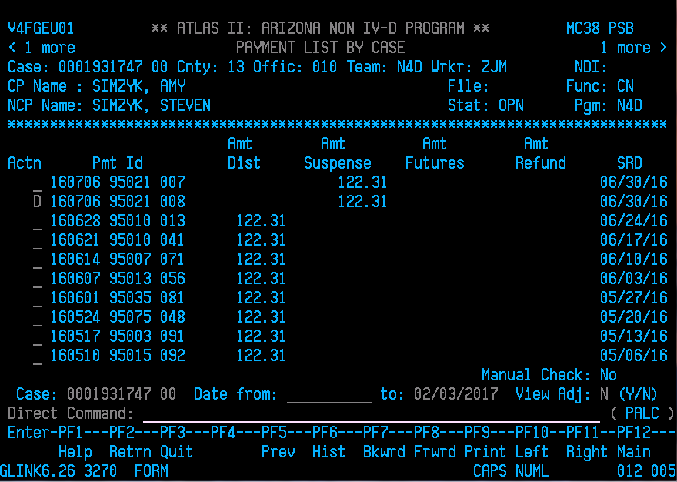

This brings up the detail of the payment you selected. Type in **SURE** on the Direct Command line and then Enter.

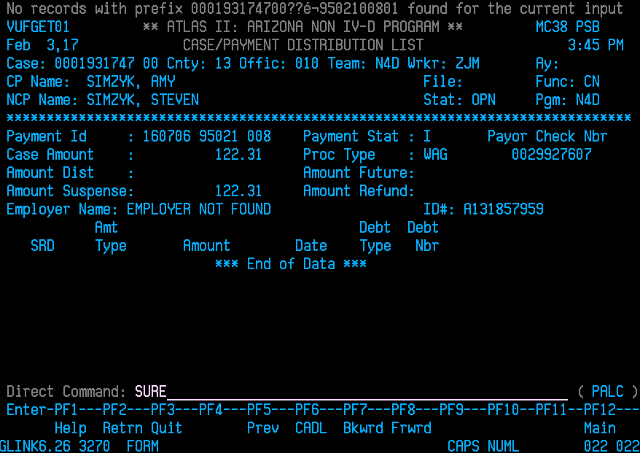

This bring you to the Suspense Request for this payment (SURE screen)

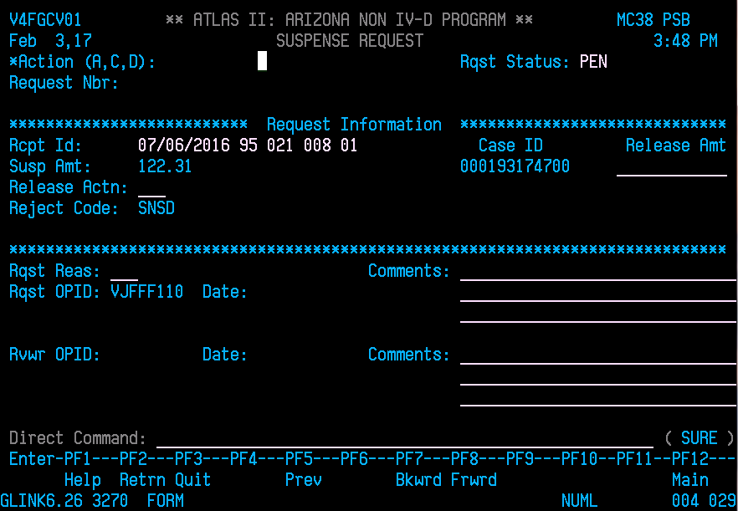

Type an “A” in the Action line. The cursor defaults to the Rqst Status which should stay as PEN;

Tab through to Release Amt and Type in the amount that needs to release to CP;

Tab to Release Actn: ____ and type in AUP (Override R Narrative);

The cursor will go to Rqst Reas: ____, type in ADJ (Adjust);

The cursor will now be at Comments.

Next, Type in a basis description as to why payment is being released followed by your initials.

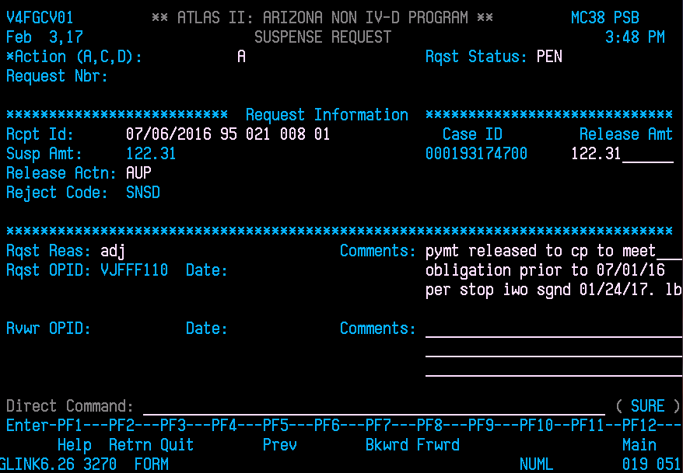

Enter and added successful message will appear at the top the screen.

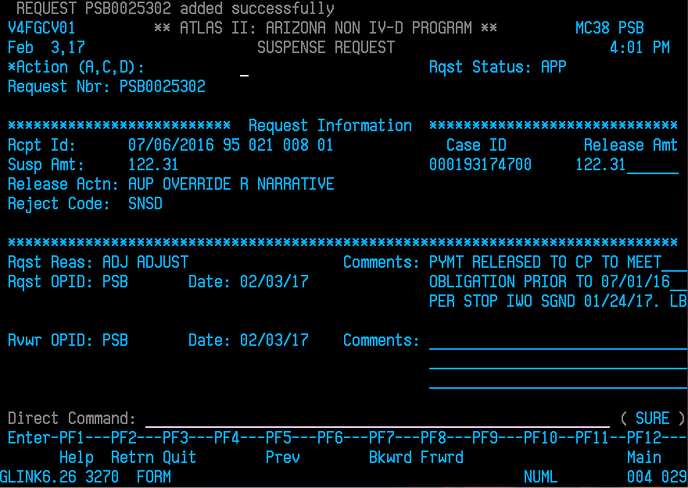

Type in **SULI** in the Direct Command Line and then enter.

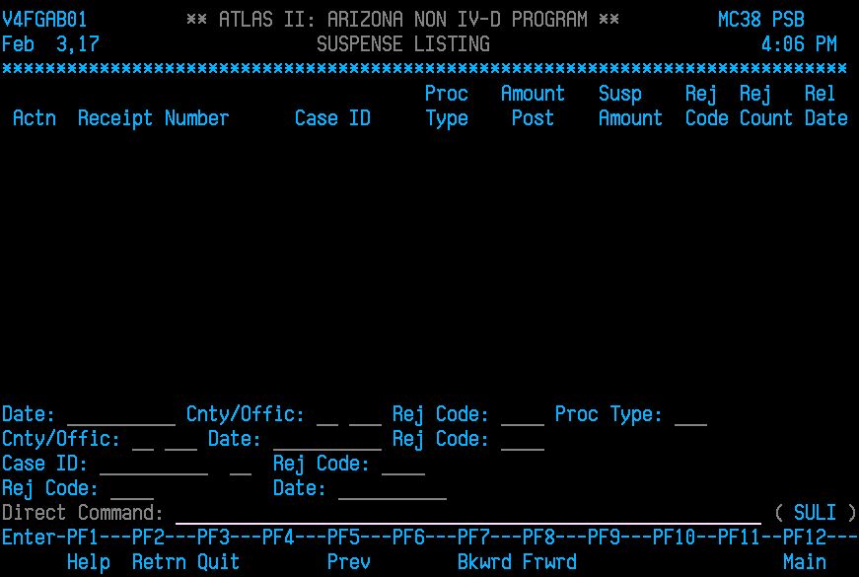

Tab down to Case ID: _______ and type in the ATLAS number then enter. This is the Suspense Listing of all the payments on this ATLAS case. You will need to match the Receipt Number to the Pmt Id of the payment you entered the SURE and type “D” in the Actn line next to the payment and enter.

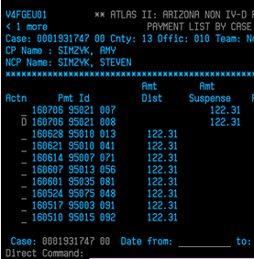 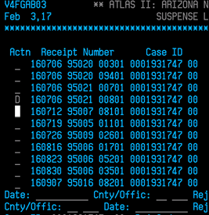

This takes you to the SULI screen to complete the release of the payment to CP.

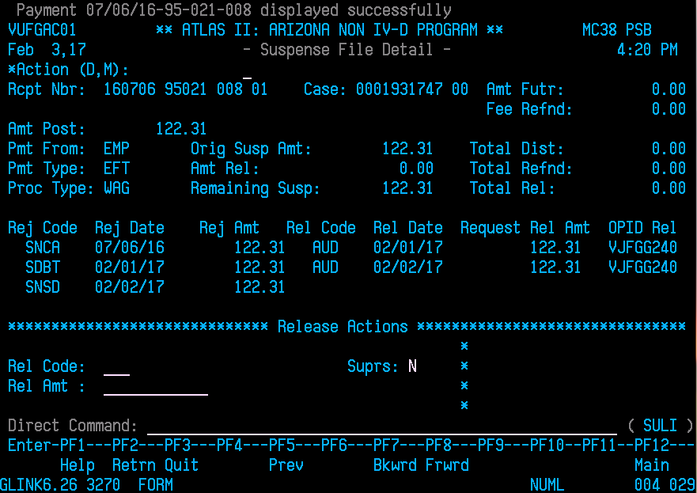

Type an “M” on the Action line. The cursor defaults to the Rel Code: _______ which is the release code.

This will need to be the same as Release Code used on the SURE screen under Release Action.

**Release Code/Action:**

**AUP** Override R Narrative is used when an R Narrative needs to remain on the case such as this case where an SNSD is used to split monies.

**AUD** Release for Auto Distribution is used when an SNSD is inactivated or when releasing payments when debts have been closed and are now reopened.

Next tab through to Rel Amt: ______ and type in the amount that needs to release to CP; which should coincide with payment amount entered on the SURE screen. *Suprs defaults to N.

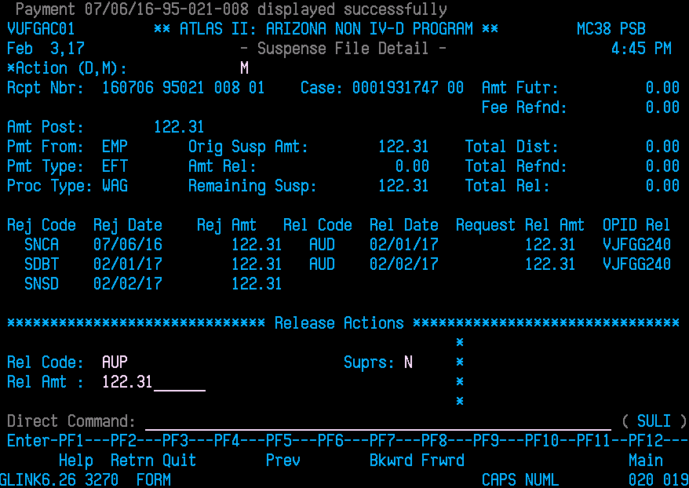

Enter and at the top of the screen it will read modified successfully.

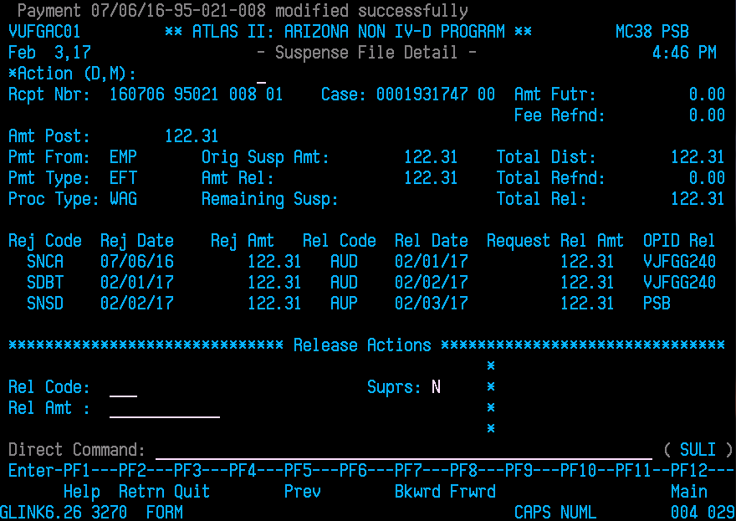

Return to PALC to verify payment has been released. If the payment appears to be “gone” on the PALC screen, it has been completed for release on the next business day.

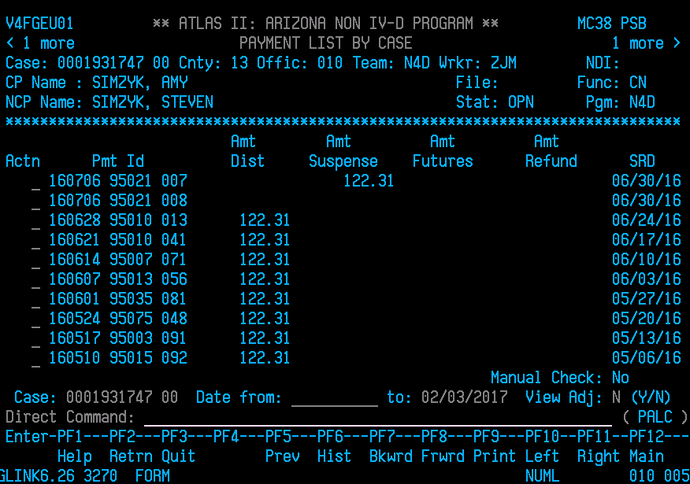

Continue on and complete the remaining payments that are to release to CP. With the SNSD R Narrative in place, the refunds to NCP can be initiated as well. Once all the refunds have been initiated, they will need to be reviewed by another staff member or FSS Lead.

Be sure to check the next business day if payments did in fact issue to CP. The debts can now be closed; however, the case itself will not be able to close until the refunds have issued out NCP. Check on case over the next few business days to ensure all payment s have refunded to NCP and then case can be closed.

**POLICIES / RELATED DOCUMENTS:**

* N/A

**OTHER PARTIES INVOLVED:**

* N/A

**TIME / VOLUME:**

* Varied

**FREQUENCY:**

* Daily

**PERFORMANCE MEASURE:**

* N/A

**SYSTEM ACCESS REQUIRED:**

* Atlas
* On Base Workflow
* iCIS

**REPORTS / FORMS:**

* N/A

**DEFINITIONS:**

* N/A

**APPLICABILITY:**

This procedure applies to all employees of the Clerk of the Court.

**REVISION HISTORY:**

|  |  |  |  |
| --- | --- | --- | --- |
| **Revision Number** | **Revision Author** | **Summary of Changes** | **Approval Date** |
| - |  |  |  |
| A | N/A | Reviewed | 03/05/2019 |
| B | Lisa Bonilla | Reviewed | 5/11/2020 |
| C |  |  |  |