**PURPOSE:**

To provide instructions for loading New Non IV-D cases.

**OBJECTIVE:**

* To ensure ATLAS number is generated and IWO is completed.

**EVENT DRIVER:**

* FSS receives an order Child Support or Spousal maintenance paid through Clearinghouse.

**PROCEDURES:**

**Open a case in OnBase Thin Client Workflow**

When the court orders that child and/or spousal support be paid, (via minute entry, judgment, order, divorce decree, child support order, or stipulation) Family Support Services staff create a new Income Withholding Order (IWO) entry in the Income Withholding Order queue. Once the new IWO entry is created, the case data will then be sent to the OnBase Workflow and an Income Withholding Order (IWO) will be completed.

1. Open OnBase Thin Client.
2. Click on “Main Menu” Bars next to “Document Retrieval” and select open Workflow

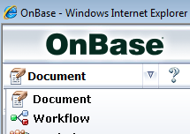

1. A new Workflow window will open.
2. Drop down arrow “COSC Income Withholding Order” Select “IWO New Queue”
3. Highlight the order by clicking on the line item.
4. Click on **Click Here to edit this order.**

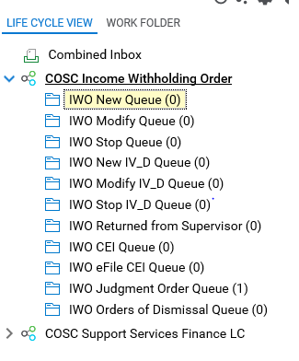 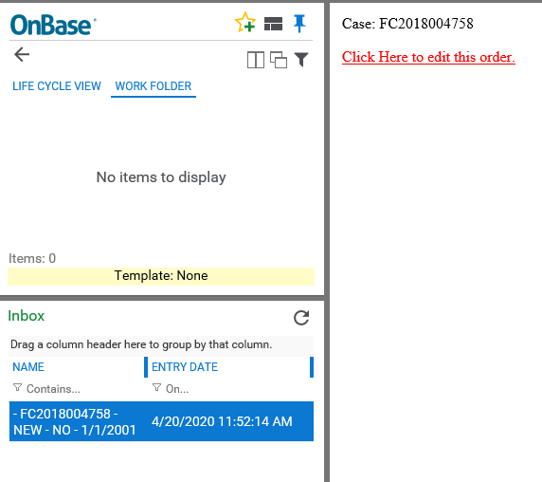

Case selection

1. The **Edit Order/Update OnBase** form window will open.
2. Right click on the screen and select Print Preview.
   1. Select **Custom** size print so the screen can be printed on one page. Roughly 70% will allow the screen to print on one page.
   2. Print the OnBase Form.

**Research case information in iCIS & enter into OnBase form**

Child and spousal support amounts provided in the OnBase form need to match the order entered by the court. Verifying the amounts in the court order against what is entered into the OnBase form ensures there are no discrepancies and the correct support amounts are entered into the ATLAS database.

1. Open the case docket in iCIS.
2. Look for the document that contains the support information; the filing date should be near the Underlying Order date. Possible documents that contain this information are:
   1. Divorcee decree
   2. Child Support Order
   3. Minute Entry
   4. Judgment and Order
   5. Stipulations
   6. Orders

OnBase Form

iCIS Docket

 

1. Confirm the amounts entered into the OnBase queue match the amounts entered in the order/decree/minute entry.
   1. If they do not match, contact the courtroom clerk, courtroom clerk manager, or judicial assistant for further clarification.
      1. If the amount is wrong in the OnBase form and the order in iCIS is correct, correct the OnBase form amount. *If correcting the OnBase form is too time consuming, forward the document to the supervisor queue and have your supervisor delete the event. Inform the courtroom clerk to resubmit the OOA.*
      2. If the OnBase form is correct and iCIS is incorrect, the clerk will file an amended order or nunc pro tunc minute entry.
         1. Go to the OnBase form and click **Save for Later**. This will put the form back in the queue to be processed at a later time.
         2. Select a new IWO to process from the OnBase workflow and start the research process from the beginning.
2. Check start date of the order is the same.
   1. If a date is not provided in the order, make the start date the 1st of the following month after the order was signed.
   2. If they do not match, contact the courtroom clerk, courtroom clerk manager, or judicial assistant for further clarification.
      1. If the amount is wrong in the OnBase form and the document in iCIS is correct, correct the OnBase form amount.
      2. If the OnBase form is correct and iCIS is incorrect, the clerk will file an amended order or nunc pro tunc.
         1. Go to the OnBase form and click **Save for Later**. This will put the form back in the queue to be processed at a later time.
         2. Select a new IWO to process from the OnBase workflow and start the research process from the beginning.
3. Locate the children’s name in the order/decree/minute entry or Sensitive Data Sheet
4. Enter the children’s name and date of birth into the OnBase form.

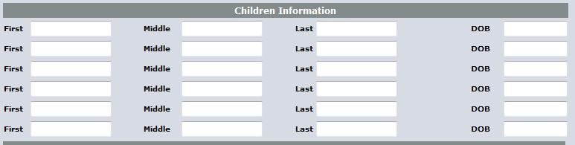

1. Enter termination date for youngest child into the OnBase Form. The termination date can be determined by the parameters below.

|  |  |
| --- | --- |
| **Month Born** | **Month Emancipated** |
| January - May | Use 5/31 of same year |
| June - August | Use same month of that year |
| September - December | Use 5/31 of next year |



1. Open the image of the SDS (Sensitive Data Sheet) in iCIS.
2. Add the employer address of the NCP to the OnBase form.
   1. Type in the name of the company in the Name field. Employers with matching criteria will populate as the name is entered.
   2. Select the matching employer if party already exists.
   3. If the employer does not exist, leave the name field blank, check the **Add New Employer for this Order** box, enter in the employer information, and check the **Address Is an Employer** box.
   4. If the NCP is self-employed, enter the NCP’s name in the Name line and their home address. Do not check the **Address in an Employer** box if the NCP is self-employed.

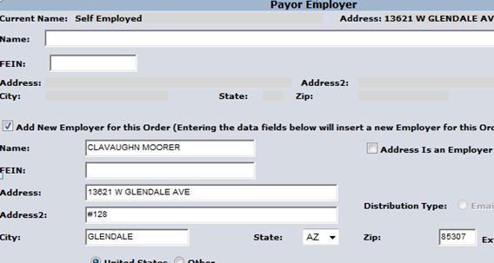

**Check if adding a new employer**

**Do not check if self-employed**

**Log into IV-D and Non IV-D ATLAS**

Family Court Services staff works in two versions of ATLAS; IV-D and Non IV-D. FCS staff will only add and modify cases in the Non IV-D version, but will regularly access the IV-D cases to research existing party information. In order to quickly research cases, staff will open a separate screen for IV-D and Non IV-D.

1. Double click on the ATLAS icon.
2. Enter CICS3 in the first screen and Press Enter.

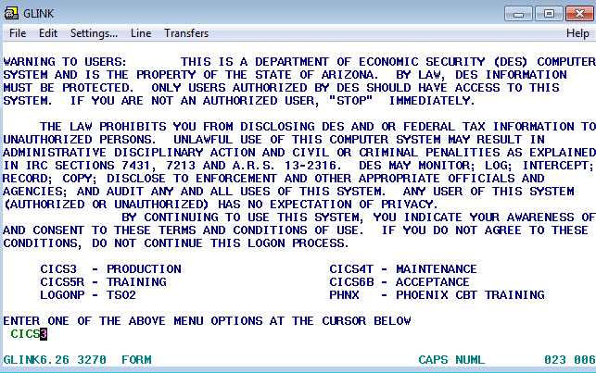

1. Enter login ID and password. The password will not show any alphanumeric as it is entered. Hit Enter.
2. On the next screen type **FCSE** and Press Enter.

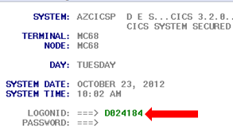 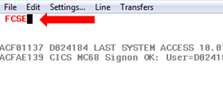

1. Select IV-D or Non IV-D
   1. To open a Non IV-D ATLAS screen, type in **Y** and Press enter.
   2. To open a IV-D ATLAS screen, keep the default **N** and Press enter.



1. Open a second ATLAS screen by following steps 1-5. You will need one screen for IV-D and one screen for Non IV-D. The IV-D and Non IV-D screens are differentiated by the titles on the tops of the screens.





**Research ATLAS for pre-existing ATLAS cases**

Occasionally cases are incorrectly submitted as new Non IV-D cases when in fact they are modifications or a IV-D case. To ensure that cases are not being duplicated or that we are mistakenly doing work that only the State handles, FCS staff research IV-D and Non IV-D ATLAS for existing case information.

1. Check IV-D ATLAS for an existing IV-D case.
2. Search for the NCP by entering their SSN. Type **SSCR** on the Direct Command line. Press Enter.
3. Type in the SSN. Press Enter.

Enter Social

SSN Search

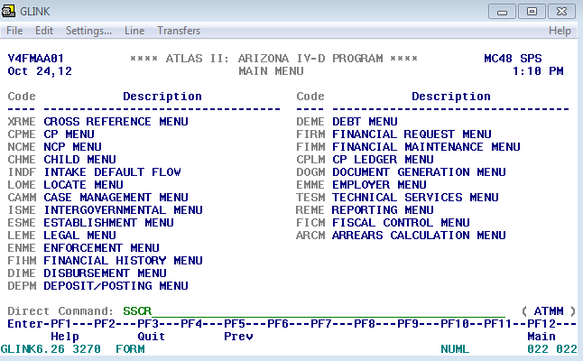 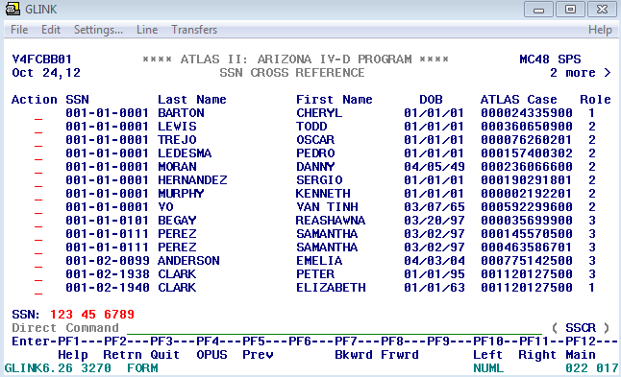

1. If there is not a case found by searching the SSN, search by name by typing **NACR** on the Direct Command line. Press Enter.
   1. Look for a match that has the same date of birth.
   2. If the NCP is listed, Press F11 to pull up the associated party and see if the CP in the existing case matches in the new case.

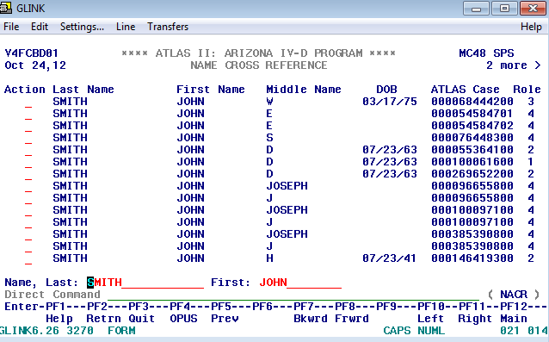

1. If there is an existing IV-D case with the same parties, the case is not a new case and does not need to be loaded. THEN SEE MODIFICATION PROCEDURE AFTER THIS?
   1. On the Direct Command line type **CAAL**.
   2. Press **F6**.
   3. Enter a CAAL note that describes an IWO. Enter the following information:
      1. 1st line - (Case Number) NEW IWO F/$(total payment amount) SIGNED (today’s date)
      2. 2nd line - MAILED TO (employer name address). COC13/INITIALS
   4. Hit Enter.
   5. The cursor will go to the Code line. Enter the following code information based on whether or not there was a work mailing address provided.
   6. Enter **E9644** for Employer Info
   7. Enter **E9663** for no employer info
   8. Press Enter.
2. If there is not an IV-D case, check the Non IV-D ATLAS screen.
   1. Follow the same steps as the IV-D search.
3. If there is an existing Non IV-D case with the same parties, this case is a modification and not a new ATLAS case. Refer to the IWO Modification procedure.If no existing ATLAS cases were found, a new ATLAS case will be loaded.

**Loading a new ATLAS case**

In order

1. In the Non IV-D Atlas screen, on the Direct Command line type **INDF**. This will open the HLCI Inquiry screen.
2. Enter CP’s Social Security Number. Hit enter.
   1. If there is no SSN available, enter the CP’s name, date of birth, and gender.

Match found

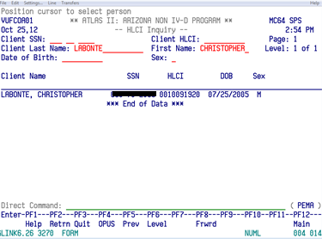

1. Check to see if any matches populate.
   1. If no matches are found, Press F2. The party will need to be added as a new party and added as part of the case.
      1. Fill in the name fields, date of birth, gender and SSN.
      2. Tab to the Action line and type **A** to add party. Press Enter. The new party has been created.
   2. If a match comes back, arrow down so the cursor is on the name and Press Enter.
      1. Verify the name, DOB, gender, and SSN.
      2. If all of the personal information is correct, tab to the Action line and type **A** to add to ATLAS case.
      3. If there is information missing in any of the fields, add the information to the corresponding field. Hit enter. Tab to the Action line and type **A** to add to ATLAS case.
      4. If the person already existed in ATLAS and is attached to an existing Non IV-D case, the party information will be in blue text and the information is not editable. The Non IV-D case will display in the **# of Cases This Person** field. This person can be added to the new ATLAS case, but if any personal information needs to be modified, it will be modified later in the Demographics screen. Tab to the Action line and type **A** to add to the ATLAS case.

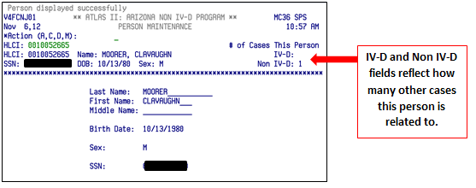

Person Maintenance updated and HLCI # generated

Person Maintenance in edit mode

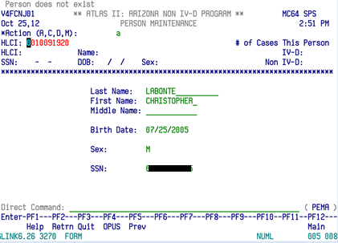 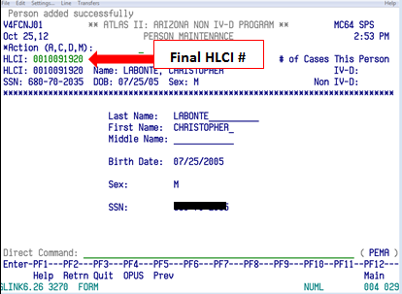

1. If the party already exists in ATLAS and a SSN is provided, check that the SSN is also included in the OnBase form. If it is not included in the OnBase form, add it to the form now.
2. The HLCI number will be generated. Write the HLCI number on the OnBase form printout by the respective parties’ name.
3. Type **INDF** on the Direct Command Line and repeat these steps for each party in the case. Once all of the parties have been added to the case, you should have a HLCI number written down next to each parties name on the printout of the OnBase form.

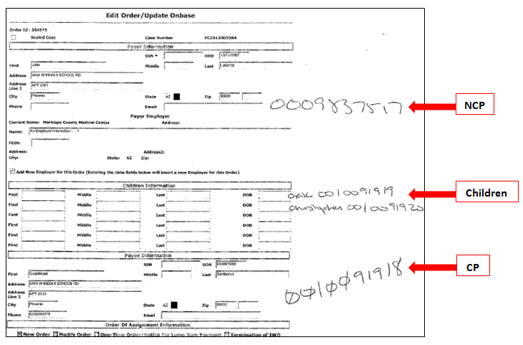

1. When done adding parties, Press F2.
2. On the Case Status screen, add all the parties HLCI numbers starting with CP, then NCP, and then the children by tabbing to the associated fields.
3. Press Enter once they are all entered.
4. Type in **A** on the action code and Press Enter.

HLCI numbers entered

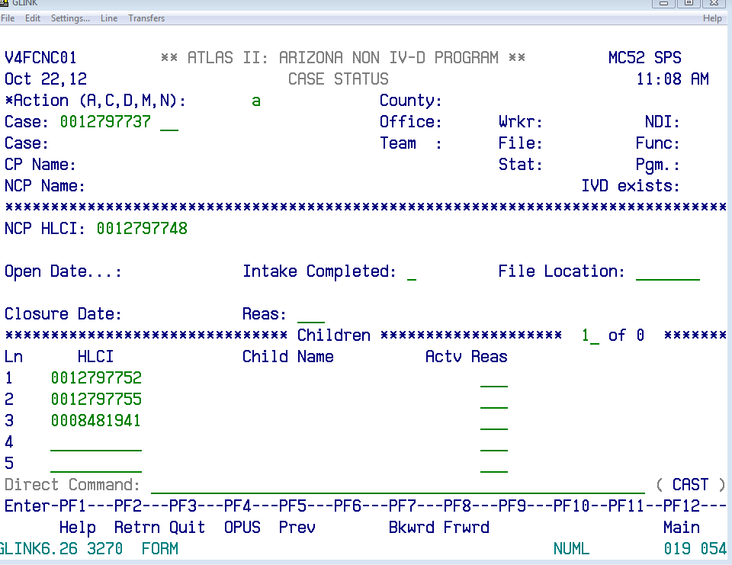

**Children**

**NCP**

**CP**

Blank Screen

1. Check that all the correct names populated. The text will change from green to blue to indicate the save has occurred.
   1. If the wrong HLCI number for the **CP or NCP** was entered, the parties can be corrected by typing over the wrong HLCI number, typing **A** on the Action line, and Press Enter.
   2. If the wrong HLCI number for the child was entered, tab to the reason line and enter **CER** as the reason code. Type in the correct child’s HLCI number on the next available line and enter **M** on the Action line. Press Enter.
      1. If you are uncertain as to the available reason codes, Press F1 on the reason line and the code list will populate. Press F2 to get out of the reason code screen.

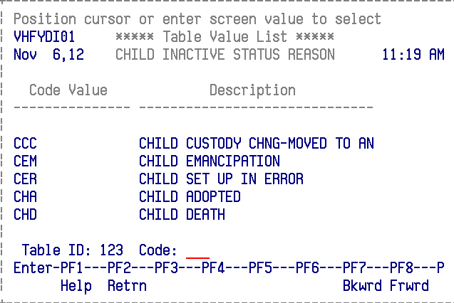

1. The ATLAS number is the case number in green. Write the ATLAS number on the top of the OnBase form print out.

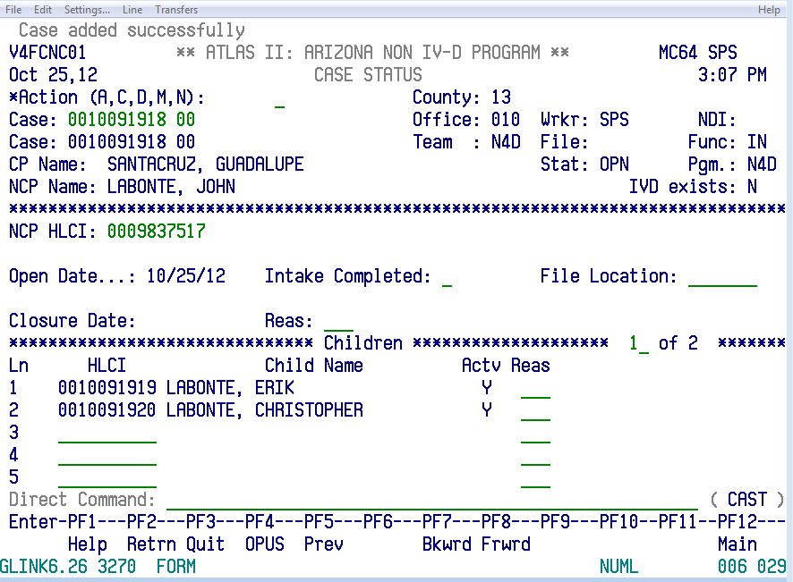

**ATLAS #**

1. Enter ATLAS number into the OnBase workflow screen. Include **N** after the ATLAS number. The N stands for Non IV-D.

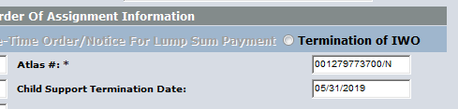

1. Press F2 in ATLAS. The CPDE (Custodial Parent Demographics) screen will open.
2. Modify the address and phone information by entering **M** on the Action line.
3. Enter the address in the following format:
   1. 1st line - Street Address
   2. 2nd line - Suite or Apartment Number
   3. City, State, and Zip in the respective fields
4. Enter the phone number in the phone number field.
5. Press Enter.

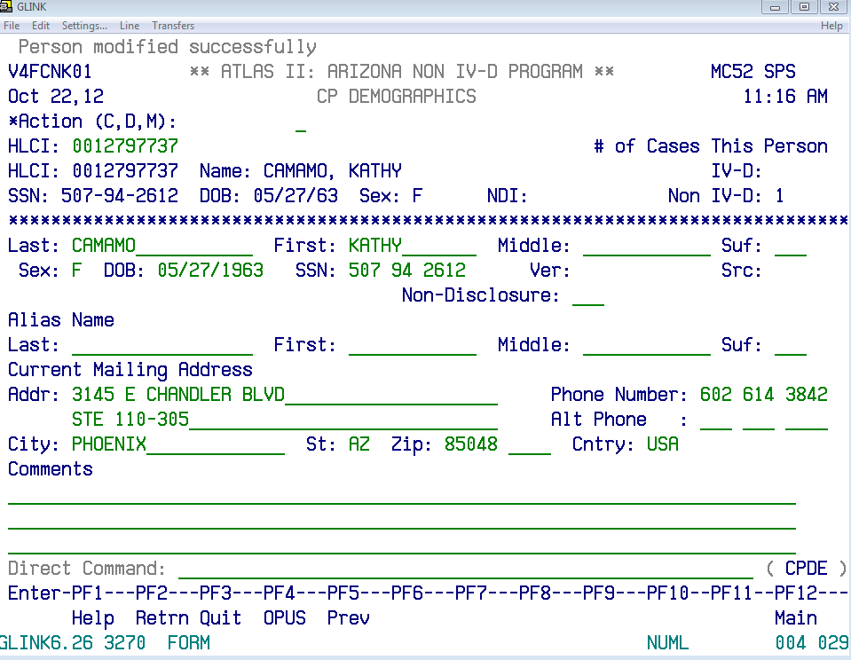

1. The next two screens in ATLAS are not used by the Clerk’s Office. Press F2, three times.
   1. These are the two screens that are passed.
      1. Employer List
      2. Employer Detail

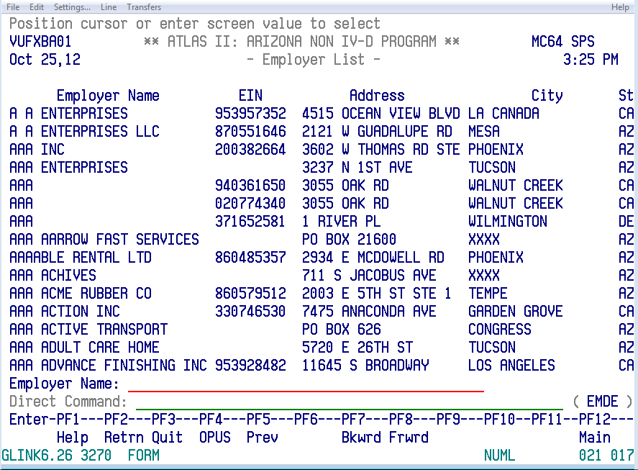

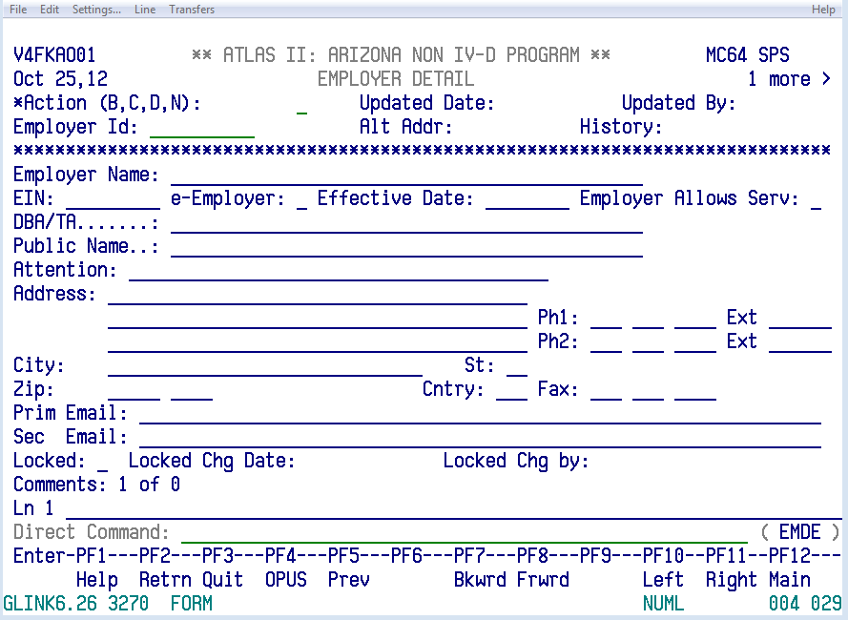

1. The NCDE (Non-Custodial Parent Demographics) screen will open.
2. Modify the address and phone information by entering **M** on the Action line.
3. Enter the Address in the following format:
   1. 1st line - Street Address.
   2. 2nd line - Suite or Apartment Number.
   3. City, State, and Zip in the respective fields.
4. Enter the phone number in the phone number field.
5. Press Enter.
6. The next screen in ATLAS is not used by the Clerk’s Office. Press F2, twice.
   1. This is the screen that is passed.

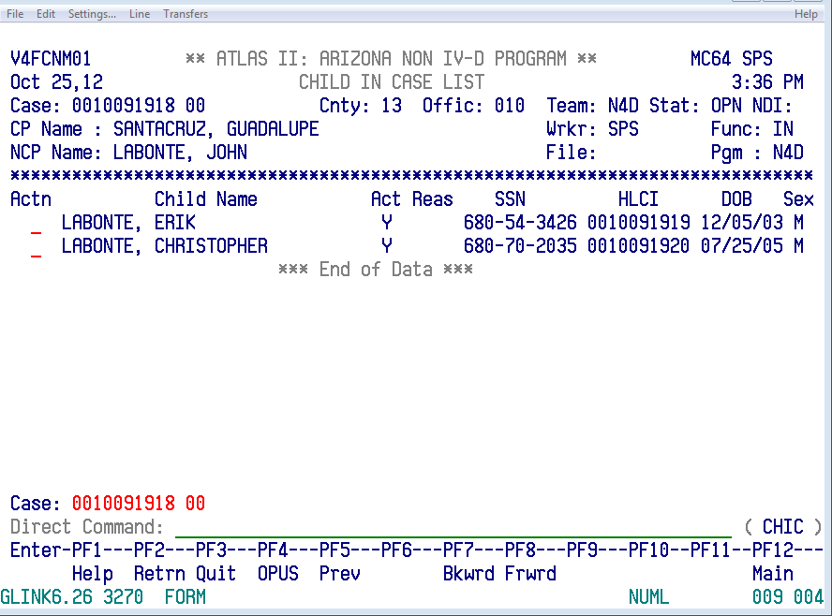

1. SUOD Screen (Support Order Detail) is where the child support information will be entered.

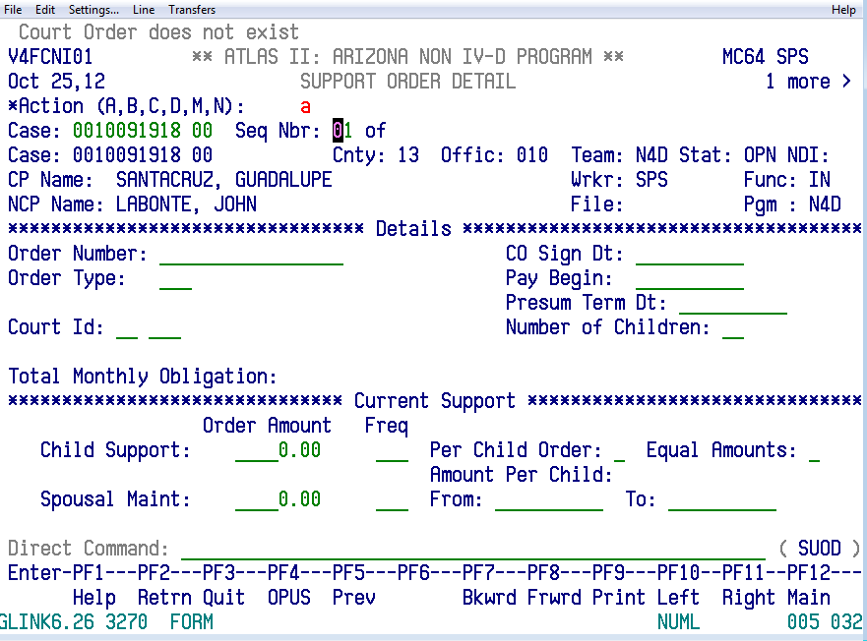

1. Enter the following information in the SUOD screen by tabbing through the fields:
   1. Enter **A** in the Action code.
   2. Delete sequence number (Seq Nbr)
   3. **Order Number** - Type in the FC case number. Do not include the dash.
   4. **Enter CO** **Sign Date -** Enter the underlying order date located in the OnBase form.
   5. **Order Type** - Enter **DIV** (Divorce decree) or **INI** (Initial Order). If both types of orders are in the court docket, always use DIV.
   6. **Pay Begin** - Enter the effective date of the order.
   7. **Persum Term Date** (Presumed Termination Date) - Enter the termination date of youngest child.
   8. **Court ID -** The court ID is always **04 013.**
   9. **Number of Children** - Enter the total number of children listed in the order.
   10. **Child Support** - Enter the total amount of child support. Do not include the dollar sign ($); it will automatically populate when the screen is saved.
   11. **Frequency** – Enter **MON** for monthly
   12. **Per Child Order** - Always enter **N** because the payments are never broken down by child.
   13. **Spousal Maint** – Enter the total amount of Spousal Maint **(if ordered).** Do not include the dollar sign ($); it will automatically populate when the screen is saved.
   14. **Frequency** – Enter **MON** for monthly.
   15. **From & To** – Enter from and to date if ordered.
2. Press F10 and then the Clerk Fee screen will open.

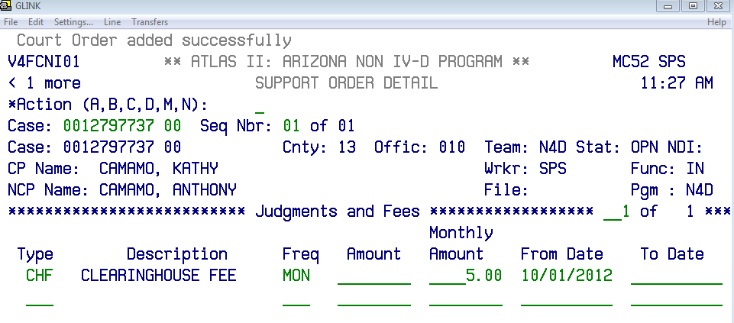

1. Enter the following information in the Clerk Fee screen by tabbing through the fields:
   1. **Type** – **CHF** for Clearing House Fee
   2. **Freq:** - **MON** for monthly
   3. **Monthly Amount** –8.00 as of 4/1/20. The clearinghouse fee is always eight dollars
   4. **From Date** - Enter the current month the fee is being entered, or the future month the order takes effect.
   5. Press Enter.
2. Press F10 to double check that support and fee amounts entered in ATLAS are correct and match the OnBase Form information.
3. Go to Direct Command line and enter **CAST**
4. In **Action** field enter **M**
5. In the **Intake Completed** field type **Y**.
6. Press Enter.
7. Func will change from IN to CN. The top of the screen will also update to say Case modified successfully.

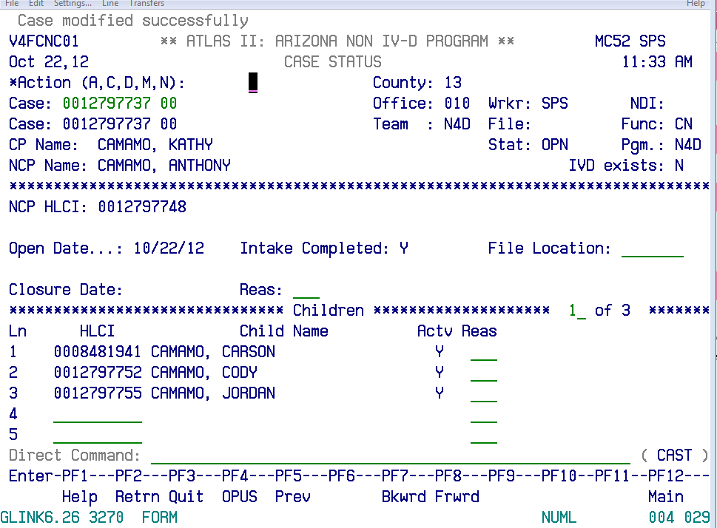

**Case modified successfully**

**Func: changed from IN to CN when saved**

1. Go to Direct Command line and type **DEDN**.Hit Enter. This will open the Debt Screen. First the clearinghouse fees will be added to the debt screen. Enter the following information:
   1. **Action** - Enter **A**.
   2. **Debt Nbr** – Delete the number.
   3. **Type** – **CHF** for the clerk fee.
   4. **Seq No** - **01** so the information entered in the SUOD screen will update into the debt screen.
   5. **Oblig** – **NCF** for NCP fees
   6. **Accruing** – **Y** for yes to accrue monthly.
   7. **Monthly Accrual** - **8.00** for the clearinghouse fees.
   8. **Begin date** – Enter the current month the fee is being entered.
      1. If entering a date that occurs in the future, enter that month and year as the effective date and in the **Deact Reason**, enter **FDS**.
   9. **Oblig Freq** – **M** for monthly.
   10. **Effective Date** – Current month entering.
   11. Press Enter.
   12. The screen will update and show *Debt added successfully* in the top left corner. The case number, jurisdiction, and pay begin date information will be brought over from the SUOD screen.

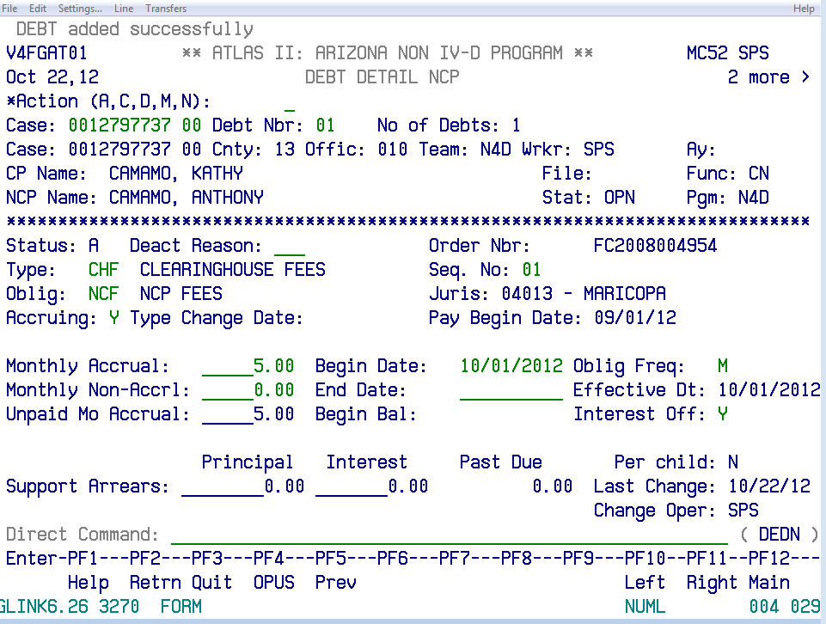

1. The child support amount will now be added to the debt screen. Enter the following information:
   1. **Action Code** - Enter **C**.
   2. **Debt Nbr** - Delete the Number.
   3. Hit enter.
   4. **Action Code** – Enter **A**.
   5. **Type** – **NPI** for Non Public Assistance In
   6. **Seq No.** – **01**
   7. **Oblig** – **CCH** for Current Child Support
   8. **Accruing** –
      1. Enter **Y** if it is child support so that support will continue to accrue if full payment is not received.
      2. Enter **N** If it was a judgment because there would not be an accrual.
   9. **Monthly Accrual** – Enter support amount.
   10. **Begin Date** – Beginning of when payments were due.
   11. **Oblig Freq** – **M** for monthly.
   12. **Effective Date** – Enter the effective date of the child support.
   13. **Interest Off** – **N**
   14. Press Enter.

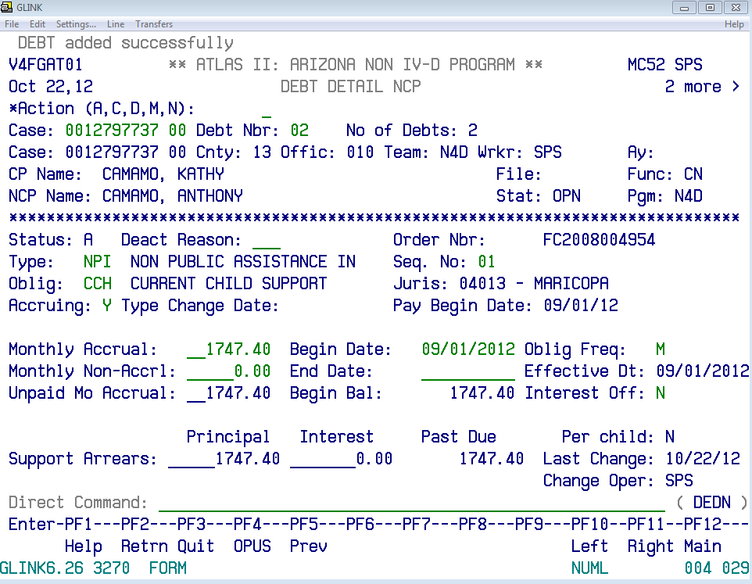

1. If spousal support was ordered, it will now be added to the debt screen. Enter the following information:
   1. **Action Code** - Enter **C**.
   2. **Debt Nbr** - Delete the Number.
   3. Hit enter.
   4. **Action Code** – Enter **A**.
   5. **Type** – NPI for Non Public Assistance
   6. **Seq No.** – **01**
   7. **Oblig** – **CSP** for Spousal Support
   8. **Accruing** –
      1. Enter **Y** so that support will continue to accrue if full payment not made.
      2. Enter **N** If it was a judgment because there would not be an accrual.
   9. **Monthly Accrual** – Enter support amount.
   10. **Begin Date** – bringing of when payments were due.
   11. **Oblig Freq** – **M** for monthly.
   12. **Effective Date** – Enter the effective date of the spousal support.
   13. **Interest Off** – **N**
   14. Press Enter.
2. On the Direct Command line type **DELN**.
3. Check that the clearinghouse fee, child support amounts and the spousal support match the information in the OnBase form.

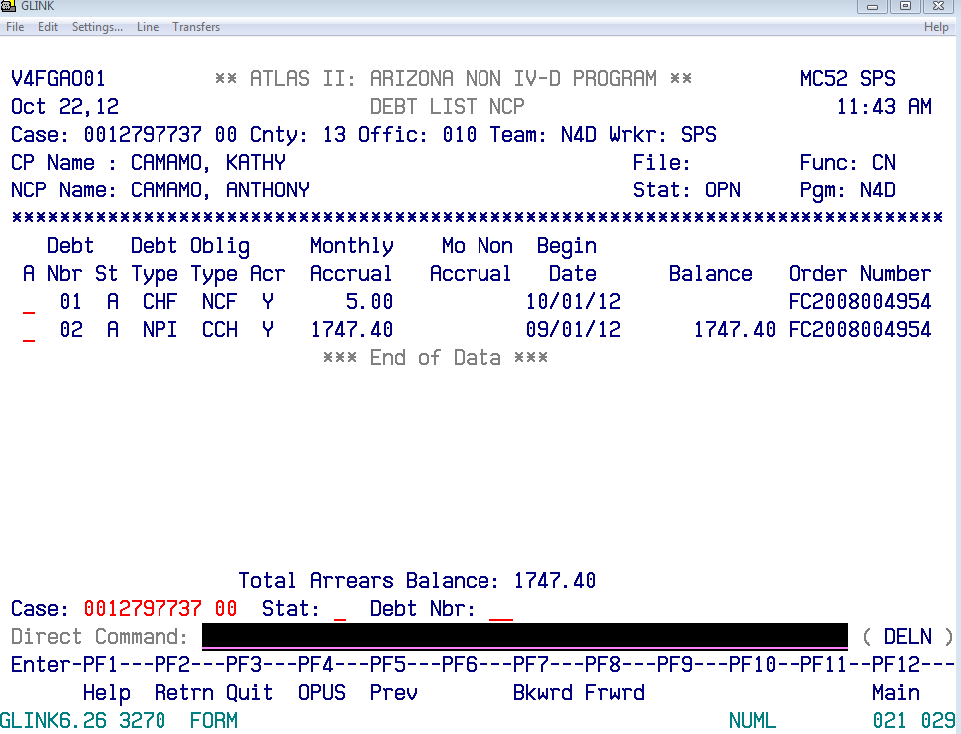

1. On the Direct Command line type **CAAL**.
2. Press F6.
3. Enter a CAAL note that describes where the IWO is being sent. Enter the following information:
   1. 1st line - (Case Number) NEW IWO F/$(total payment amount) SIGNED (today’s date)

2nd line - MAILED TO (employer name address). INITIALS

1. Press Enter.
2. The cursor will go to the Code line. Enter the following code information based on whether or not there was a work mailing address provided.
   1. Enter **E9644** for Employer Info
   2. Enter **E9663** for no employer info
3. Press Enter.

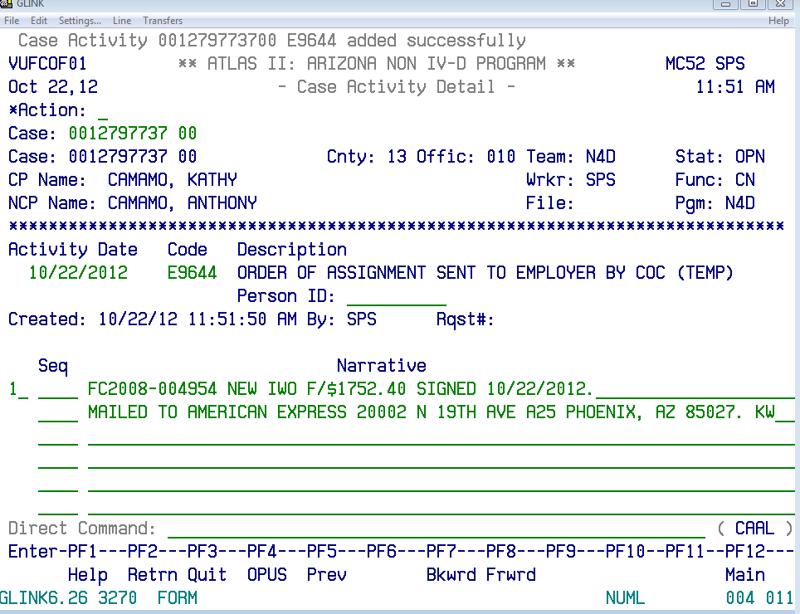

1. If there is an employer for the NCP and the employer information already exists in ATLAS, the employer information will be added to the case.
   1. Type **EMPL** on the direct command line. Hit enter.
   2. Type the employer’s name on the **Employee Name** line. Press Enter.
   3. If the employer is in system, place the cursor on the name. Press Enter.
   4. Type **NCDE** on the Direct Command line.
   5. Employer info will populate.
   6. Enter the start date as the day the IWO will be mailed (the following day the IWO is completed). Press Enter.

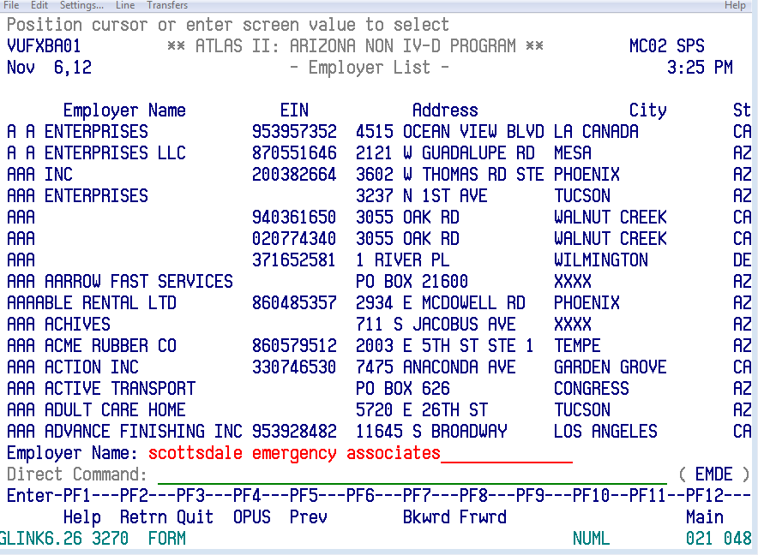

1. The new ATLAS case upload is complete.

**Completing the OnBase Form**

1. Double check that all of the information in the OnBase form has been correctly added.
   1. Names
   2. SSN
   3. Employer information
   4. Children’s name
   5. Termination Dates
   6. Order Dates
   7. ATLAS number added.
2. Once all the information has been confirmed, Click **Complete Order** on the bottom of the OnBase Form.
3. Click **Close**.

**POLICIES / RELATED DOCUMENTS:**

* N/A

**OTHER PARTIES INVOLVED:**

* N/A

**TIME / VOLUME:**

* Varied

**FREQUENCY:**

* Daily

**PERFORMANCE MEASURE:**

* N/A

**SYSTEM ACCESS REQUIRED:**

* ATLAS
* OnBase Workflow
* iCIS

**REPORTS / FORMS:**

* *Order to process IWO*

**DEFINITIONS:**

* N/A

**APPLICABILITY:**

This procedure applies to all employees of the Clerk of the Court.

**REVISION HISTORY:**

|  |  |  |  |
| --- | --- | --- | --- |
| **Revision Number** | **Revision Author** | **Summary of Changes** | **Approval Date** |
| - |  |  |  |
| A | N/A | Reviewed | 03/05/2019 |
| B | N/A | Reviewed | 06/01/2020 |
| C |  |  |  |