**PURPOSE:**

To provide instructions for processing payment history requests.

**OBJECTIVE:**

* To ensure payment history requests are handled accurately and consistently over time.
* To ensure payment history requests are transmitted correctly.

**EVENT DRIVER:**

* A request for a payment history is received.

**PROCEDURES:**

1. **Payment History Requests**
   1. Payment History requests can be received via fax, email, US Mail, phone and in person at the filing counters.
   2. There is a fee to request a payment history. If it is to be mailed an additional charge will apply for postage.
   3. Fees do not apply for other government agencies, i.e. Public Housing, Department of Child Support Services (DCSS) or Social Security Administration.
2. **N4D: Printing and Processing a Payment History**
   1. Requests will have either an Atlas #, Case #, or Social Security #.
3. If Atlas # is provided go to **SUOD** and enter **D** on the **Action** line, see figure 1.
4. Enter the Atlas # on the **Case** line and select the enter key
5. If Case # is provided go to **SUOC** and enter Case # on **Support Order Number** line, see figure 2.
6. If the Case # shows up at the top enter an **S Action** line next to the Case # and enter **Cast** on the **Direct Command** line, select the enter key
7. If the social security number is provided, go to **SSCR** and enter Social Security # on the **SSN** line, see figure 3.
8. If Social Security # appears above enter an **S** on the **Action** line and enter **Cast** on the **Direct Command** line, select the enter key
9. If no numbers are provided, search by name on the NACR screen, enter the last name then first name and select the enter key
10. By the name, enter an **S** on the **Action** line and **Cast** on **Direct Command** line, and select the enter key.

**Figure 1 (Step II.A.a.)**

**Atlas Search - SUOD Screen**

**Figure 2: (Step II.A.c.)**

**Case Number Search - SUOC Screen**

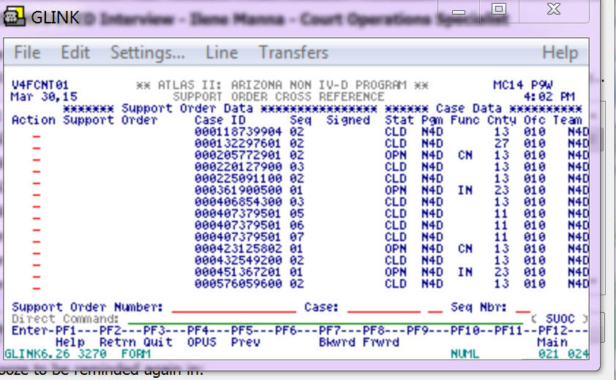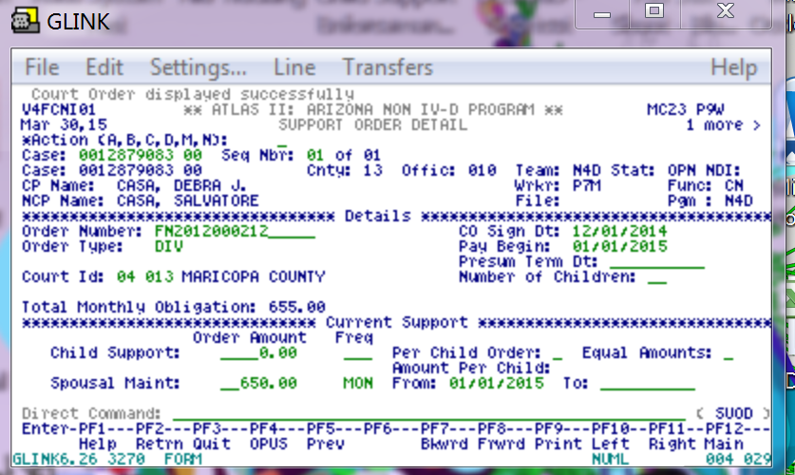

**Figure 3: (Step II.A.e.)**

**Social Security Number Search - SSCR Screen**

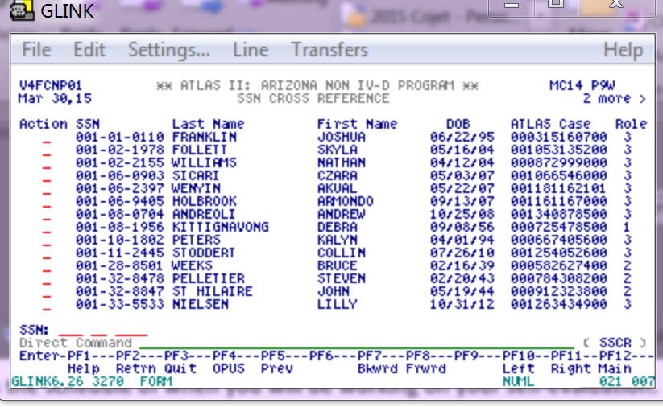

* 1. Verify the case is assigned to Maricopa County. Next to “**County**”, it should state “**13**” for Maricopa.

1. If the case is not Maricopa (13), reject the request. Notate it is not a Maricopa County case and the correct county the case is held in for the party to contact.
   1. Go to the PALC screen
2. General Public Request: print the payment history from the beginning of the case.
3. Tab to “**View ADJ**” and type a “Y”, select the **F6** key to print
4. Hardcopy device will be AUP9L, select the enter key
5. Certify the last page of the payment history
6. Public Housing Request: print one year’s worth of payments
7. Tab to “**DATE FROM**” and enter the correct date range
8. Tab to “**VIEW ADJ**” and type “Y”, select the **F6** to print.
9. Hardcopy device will be AUP9L, select the enter key
10. Fill out the verification form with your name, title, and office phone number (602) 372-5375
    1. Go to the CAAL Screen
    2. Select the F6 key to add a new note
    3. Notate the payment history was sent/processed to a paying customer (B0210).
    4. Tab 8 times to “NARRATIVE” and type the following: “Case number: Payment History sent to (name of requestor and housing department, fax number or address), and your initials.
    5. Select the enter key to save
    6. Tab to CODE and type T0035
11. If the payment history is being faxed, make sure a confirmation of successful transmission is received
12. If the request was received by email, send an email to the requestor letting them know the payment history is completed and is being mailed.
13. **4D: Printing and Processing a Payment History**
    1. Log into Atlas and type **FPUB** (instead of FCSE)**.**
    2. Enter Atlas # or the SSN#
    3. Change the BEG DATE per housing request. (One year from date of printing), otherwise leave begin start as is, and select enter.
    4. Verify party name
    5. Tab to printer and enter AUP9L, select the y key to print
    6. Change Y to P on CP only
14. **Pay History 1988 and Prior**
15. The **ACS or RDS** application is pay histories for 1988 and prior are found
16. Click on Icon for ACS to get this display in figure 4.

**Figure 4: (Step IV.B.)**

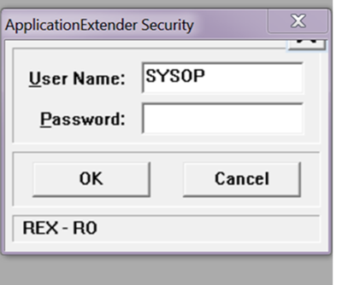

1. Enter the Password **OTG** and click **OK,** the box below is displayed in figure 5.

**Figure 5: (Step IV.C.)**

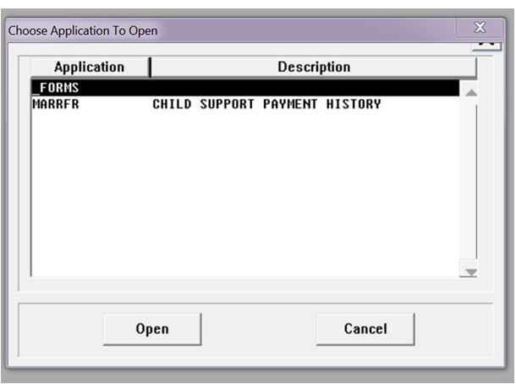

1. Select “MARRFR”, and click Open, the following screen will be displayed in figure 5.

**Figure 5: (Step IV.D.)**

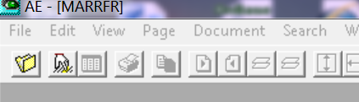

1. Click on the tab that looks like a hand, the following screen will be displayed in figure 6.

**Figure 6: (Step IV.E.)**

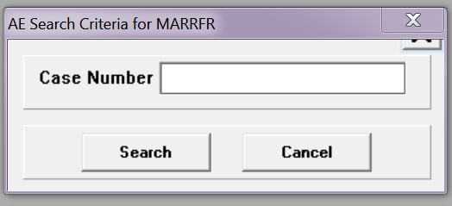

1. Cases numbers may have to be entered several ways to find the case, i.e. DR1990-013023 can be tried as:

* DR-9013023
* DR*9013023
* DR90-013023
* DR90-13023.

If the case number is not found, the message in figure 7 will be displayed.

**Figure 7: (Step IV.F.)**

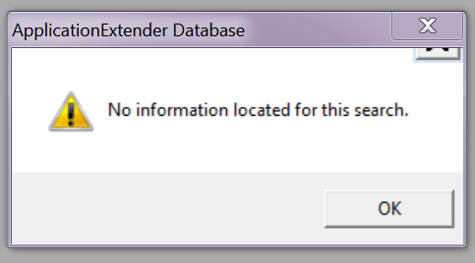

**POLICIES / RELATED DOCUMENTS:**

* N/A

**OTHER PARTIES INVOLVED:**

* N/A

**TIME / VOLUME:**

* Varied

**FREQUENCY:**

* Daily

**PERFORMANCE MEASURE:**

* N/A

**SYSTEM ACCESS REQUIRED:**

* Atlas
* MS Outlook
* ACS or RDS Application

**REPORTS / FORMS:**

* N/A

**DEFINITIONS:**

* N/A

**APPLICABILITY:**

This procedure applies to all employees of the Clerk of the Court.

**REVISION HISTORY:**

|  |  |  |  |
| --- | --- | --- | --- |
| **Revision Number** | **Revision Author** | **Summary of Changes** | **Approval Date** |
| A | Diana Hoover | Document Origination | 10/28/2016 |
| B | N/A | Reviewed | 03/05/2019 |
| C | N/A | Reviewed | 04/20/2020 |