PURPOSE:

To provide instructions for entering direct deposit information for support or spousal payments into the Atlas system.

OBJECTIVE:

- To ensure direct deposit requests are handled accurately and consistently over time.

EVENT DRIVER:

- A request for direct deposit for support or spousal payments is received.

PROCEDURES:
- Direct Deposit Requests
  - A direct deposit request can be submitted by the custodial parent in person at the filing counter, through the US Mail or via fax. Or, requests may be submitted by the Arizona Clearinghouse on the behalf of the custodial parent.
  - The form must be filled out in its entirety with the custodial parent’s information being legible. The form may be accepted without a case number or Atlas number. If the form is accepted without a case number or Atlas number, the custodial parent’s DOB or SSN must be verified.
  - The form must be submitted with one of the following bank account verification documents:
- A copy of a voided check with CP’s name on it.
- A statement from the bank, on bank letterhead listing the routing number account number with CP’s name on it.

- Rejecting New Direct Deposit Requests
- Direct Deposit requests must be rejected for any of the following reasons:
- The case has an active SEEN screen in Atlas.
- The case is IV-D. ( Interoffice to DCSS)
- The application is incomplete and/or missing a signature.
- The application was not accompanied with supporting bank account verification documents.
- If the custodial parent’s name is not listed on the account. Under NO circumstances will direct deposits be made into an account that is not the custodial parent’s.
- On each Direct Deposit that is rejected, put initials and date rejected, on the lower right corner of the form, i.e. “Rejected JQ 11/01/16”.
- Enter a CAAL note on the custodial parent’s Atlas case using code F1028 stating that the direct deposit was not initiated and the reason why it was rejected.
- Entering New Direct Deposit Requests
  - Log into Non IV-D Atlas.
  - Go to the DELN screen and enter the Atlas number on the Case line and press Enter.
  - Verify the following information: (See Figure 1)
    - Custodial parent’s name matches the request form
    - The case is for Maricopa County (13)
Figure 1
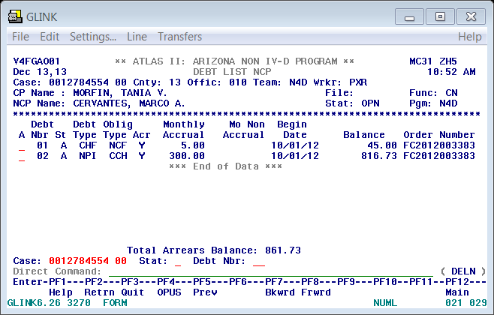

  - Once verified, go to the CPDE screen and update the demographic information, if necessary.
- For name changes, update the name appropriately
- Update the address if different
  - Double check the information entered into the CPDE screen for accuracy. (See Figure 2)
Figure 2
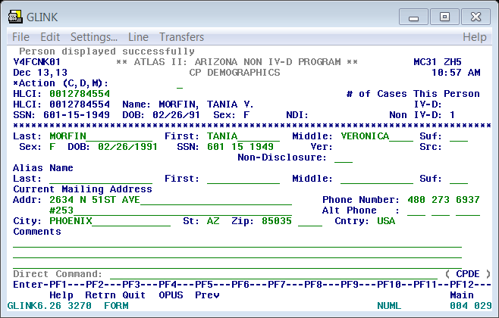

- Next, go to the CPDD screen to enter the direct deposit information from the request form. (See Figure 3)
Figure 3
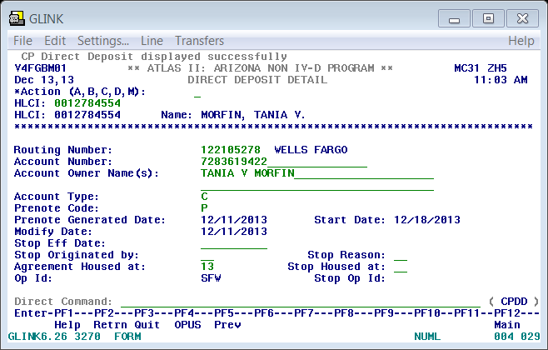

- Enter A on the Action line to add.
- Tab to the ‘Routing Number’ line. Press F1
- Enter the routing number of the financial institution
- Select the Enter key.
- A list of financial institutions will appear. (See Figure 4) Scroll to find and select the institution listed on the form.
Figure 4
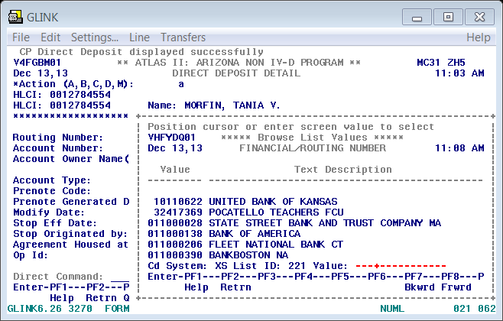

- If the routing number of the financial institution is not in Atlas, email the AZ State help desk for assistance at (DCSS-SAA-HD@azdes.gov)
- Tab to ‘Account Number’ and enter the account number.
- Tab to ‘Account Owner Name(s) and enter the account owner’s (custodial parent’s) name as it appears on the supporting bank documents. If there are two people listed on the account, enter both names first line will always be CP name and second line will be the other party name listed on supporting document.
- Tab to ‘Account Type’ and enter a C if the account is a checking account or S if it is a savings account.
- Tab to ‘Prenote Code’ and enter a Y. Note: this will change to a ‘P’ once the direct deposit information is in effect.
- Tab to ‘Agreement Housed at’ and enter the county code for Maricopa County: 13.
- Double check the information entered into the CPDE screen for accuracy
- Press Enter to save the new direct deposit information.
- On the lower right corner of the form put initial’s and date completed, i.e. “Completed JQ 11/01/16”.
- After the request is entered into Atlas, place the direct deposit form into the Completed folder.

- View Account History
- On the CPDL screen, arrow up to the line of the desired information.
- Select enter to view the account history.
- Scan completed direct deposit requests to the FSS Staff folder daily. Scan Direct Deposits by selecting Folder and FSS Scan. Go to FSS Staff folder, click on Document Storage, click on Direct Deposit then click on Direct Deposit Scan from Ricoh. Scanned Direct Deposit will appear as a PDF document, drag to year. Click on the year, and then drag the Scan to the Month. Add new folder and name it the date of scanning.
- Modifying Direct Deposit Requests
The following steps are important as they serve to enter a stop date for the current information in effect and create a history for the account:
- The custodial parent will have to submit the same verification documents as listed in Step I.1 through 3 to modify direct deposit information.
- Log into Non IV-D Atlas.
- Once verified, go to the CPDE screen and update the demographic information, if necessary.
- For name changes, update the name appropriately
- Update the address if different
- Double check the information entered into the CPDE screen for accuracy.
- Next, go to the CPDD screen to stop the previous direct deposit in effect:
    - Enter M on the Action line to modify
    - Tab to “Stop Eff Date” and enter today’s date.
    - Tab to “Stop Originated by” and enter “CP”
    - Tab to “Stop Reason” and enter “CP”
    - Stop Housed at: 13 (Maricopa County)
    - Double check the information entered into the CPDE screen for accuracy
    - Select Enter key to modify the previous direct deposit.
- Stay on the CPDD screen to clear and enter the new direct deposit information:
- Enter C on the Action line and select enter to clear the screen.
- Enter A on the Action line to add.
- Tab to the ‘Routing Number’ line. Press F1
- Enter the routing number of the financial institution
- Select the Enter key.
- A list of institutions will appear, scroll to find and select the institution listed on the form.
- If the routing number of the financial institution is not in Atlas, email the help desk for assistance at (DCSS-SAA-HD@azdes.gov)
- Tab to ‘Account Number’ and enter the account number.
- Tab to ‘Account Owner Name(s) and enter the account owner’s (custodial parent’s) name as it appears on the supporting bank documents. If there are two people listed on the account, enter both names starting with CP name on the first line.
- Tab to ‘Account Type’ and enter a C if the account is a checking account or S if it is a savings account.
- Tab to ‘Prenote Code’ and enter a Y. Note: this will change to a ‘P’ once the direct deposit information is in effect.
- Tab to ‘Agreement Housed at’ and enter the county code for Maricopa County: 13.
- Double check the information entered into the CPDD screen for accuracy
- Press Enter to save the new direct deposit information.
- On the lower right corner of the form put initial’s and date completed, i.e. “Completed JQ 11/01/16”.
- After the request is entered into Atlas, place the direct deposit form into the ‘Completed’ folder and scan at the end of the day.

- Stopping Direct Deposits
The following steps serve to enter a stop date to stop direct deposit altogether:
- The custodial parent will need to submit an Authorization to Stop Direct Deposits form.
- For the request to be processed, the form must be:
- Filled out in its entirety by the custodial parent.
- It must be legible.
- Signed by the custodial parent.
Note: If the above criteria are not met, reject the form and do not process the request.
- Log into Non IV-D Atlas and go to the CPDD screen:
    - Enter M on the Action line to modify
    - Tab to “Stop Eff Date” and enter today’s date.
    - Tab to “Stop Originated by” and enter “CP”
    - Tab to “Stop Reason” and enter “CP”
    - Stop Housed at: 13 (Maricopa County)
    - Double check the information entered into the CPDD screen for accuracy
    - Select Enter key to stop the previous direct deposit.
- Once verified, go to the CPDE screen and update the demographic information, if necessary:
- For name changes, update the name appropriately.
- Update the address if different.
- Double check the information entered into the CPDE screen for accuracy.
- On the lower right corner of the form put initial’s and date completed, i.e. “Completed JQ 11/01/16”.
- After the request is entered into Atlas, place the form into the ‘Completed’ folder and scan at the end of the day.

POLICIES / RELATED DOCUMENTS:

- N/A

OTHER PARTIES INVOLVED:

- N/A
TIME / VOLUME:

- Varied

FREQUENCY:

- Daily

PERFORMANCE MEASURE:

- N/A

SYSTEM ACCESS REQUIRED:

- Atlas
- Share Drive: FCS Staff Folder

REPORTS / FORMS:

- Authorization to Stop Direct Deposits

DEFINITIONS:

- N/A

APPLICABILITY:

This procedure applies to all employees of the Clerk of the Court.

REVISION HISTORY:

Revision Number | Revision Author | Summary of Changes | Approval Date
- | Diana Hoover | Document Origination | 10/26/2016
A | N/A | Reviewed | 03/05/2019
B | N/A | Reviewed | 04/20/2020
C

