PURPOSE:

To provide instructions for entering Acknowledgement and Termination notices from Employers (Acks & Terms) into ATLAS.

OBJECTIVE:

- To provide the necessary direction to ensure that Acks and Terms are correctly and accurately completed.
- To ensure consistent handling of Acks and Terms over time.
- To provide the necessary direction for entering CAAL notes in ATLAS.

PROCEDURES:
- Sorting the Acks and Terms
  - The Acks and Terms are notices that are received back from the employer stating if the NCP is working there and when the garnishments will begin or if the employee has terminated employment and when the termination occurred.
  - Look at the ATLAS numbers and sort between Non IV-D and IV-D Cases.
    - Non IV-D Cases will have an ATLAS number ending in /N.
    - IV-D Cases will have an ATLAS number ending in /000 (three digits).

- ACKs
  - For each Acknowledgement (ACK) received, pull up the case on the correct ATLAS side so that a CAAL note can be put on the account.
  - CAAL Note:
    - Go to the CAAL Screen by entering CAAL on the Direct Command line and then press Enter.
    - Press F6 to enter a new CAAL note.
    - Enter the following note and then press Enter. See Figure 1.
- Non IV-D: [Case Number] Rec’d ACK from Employer. [initials]
- IV-D: [Case Number] Rec’d ACK from Employer. [COC13/initials]

Figure 1, Non IV-D ACK Example
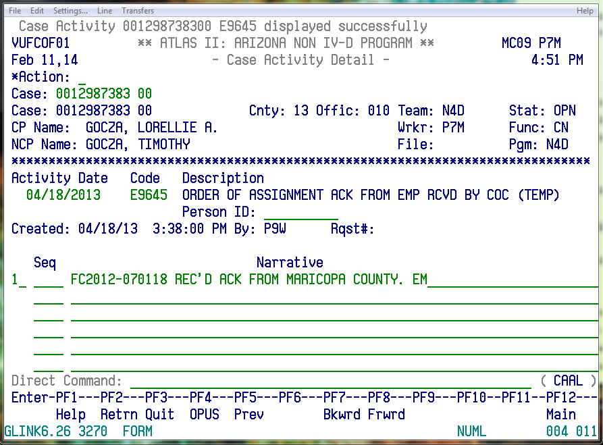

    - Enter E9645 in the Code field and then press Enter to save the CAAL note.

- Terms
  - For each Termination (Term) received, pull up the case on the correct ATLAS side so that a CAAL note can be put on the account.
  - CAAL Note
    - Go to the CAAL Screen by entering CAAL on the Direct Command line and then press Enter.
    - Press F6 to enter a new CAAL note.
    - Enter the following note and then press Enter. See Figure 2.
      - Non IV-D: [Case Number] Rec’d Term Notice from Employer Name. NCP term’d on date. [initials]
- IV-D: [Case Number] Rec’d Term Notice from Employer Name. NCP term’d on date. [COC13/initials]

Figure 2, IV-D Term Example

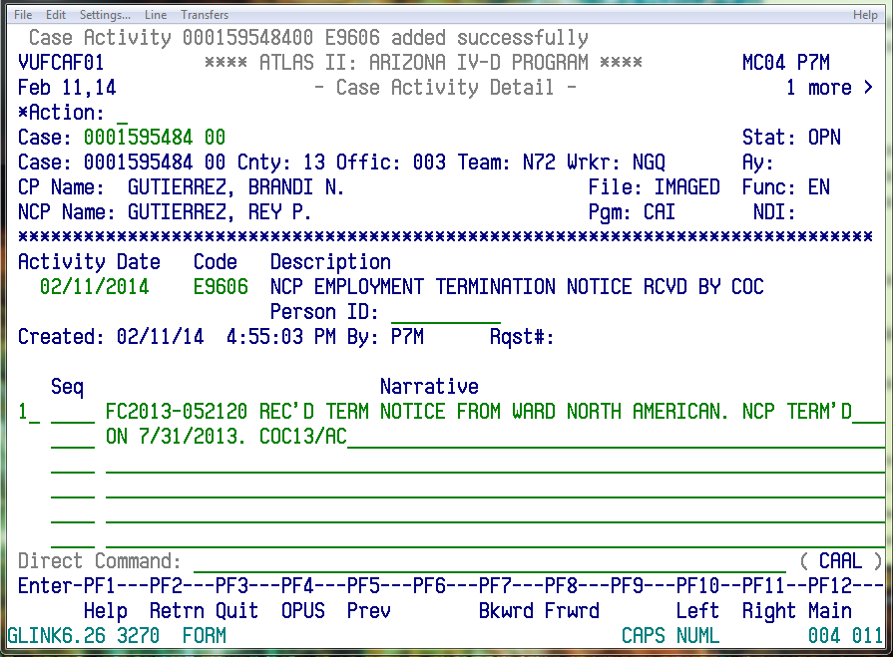

    - Enter E9606 on the Code line and then press Enter to save the CAAL note.

- Completing ACKs & Terms
  - After entering the CAAL note, save the ACKs and Terms for a month in case any of the information needs reviewed.
  - Once a month has passed, discard the ACKs and Terms in the purge document bin.

POLICIES / RELATED DOCUMENTS:

- N/A

OTHER PARTIES INVOLVED:

- N/A

TIME / VOLUME:

- Varied

FREQUENCY:

- Varied

PERFORMANCE MEASURE:

- N/A

SYSTEM ACCESS REQUIRED:

- OnBase
- iCIS
- ATLAS

REPORTS / FORMS:

- N/A

DEFINITIONS:

- ACKs: Acknowledgements
- CP: Custodial Parent
- NCP: Non-Custodial Parent
- TERMs: Terminations

APPLICABILITY:

This procedure applies to all employees of the Clerk of the Court.

REVISION HISTORY:

Revision Number | Revision Author | Summary of Changes | Approval Date
A | N/A | Document Origination | 03/27/2014
B | N/A | Reviewed | 03/05/2019
C | N/A | Reviewed | 04/21/2020

