PURPOSE:

To provide instruction for using the Power Scan 3000 for reproducing copies of filmed cases.

OBJECTIVE:

- To provide the necessary guidance for using the Power Scan 3000 for reproducing copies of filmed cases.

GENERAL INFORMATION:

Pursuant to A.R.S. §12-283 the Clerk of the Court shall maintain and provide access to court records in accordance with applicable law. This procedure refers to utilizing the Scan Pro for reproducing copies of filmed cases.

EVENT DRIVER:

- Reproducing copies of filmed cases is required.

PROCEDURES:
- Start up instructions and printing individual pages from microfilm:
- Control-Alt-Delete to log on.
- Log in as you would in the morning: mcaz.maricopa.gov\
- Select devices and printers from the Start menu and set it to default printer (HP LaserJet P3010 Series UPD PCL6), close screen.
- Select the Power Scan 3000 icon on your desktop – double click to open.
- Select 16 mm roll film sample.
- Select Adjust – you will see everything that you will need to make copies.
- Load film – pull out the carrier all the way and it will show you how to load the film; when loaded correctly, both of the wheels will spin to the right. Push carrier back in.
- Select Fast-forward to load or move the film.
- If the film is mirrored, adjust it by clicking the R mirror
- Find the frame #:
  - Click auto crop on the image.
  - You can manually straighten to adjust the page if it’s crooked.
  - You can grab the green box and align it over the page.
  - Click auto crop again.
  - Select printer to print.
- Select Next on the left to go to the next image:
  - Click auto crop again.
  - Select printer.
  - Select Next.
  - Continue until you have made all the copies you want.
- To rewind the film:
  - Pull out film slider tray completely (green light will come on).
  - Double click Rewind.
- Select Switch User or Log Off to exit the program – do not do a Shut Down or Restart.

NOTE: You will probably use other buttons, such as: rotate 90 degrees, auto straighten, fast-forward, contrast (to make the page lighter), film orientation, mirror.

- To image and print an entire file from microfilm:
- Follow the Start up procedures of step I. above to set up the film.
- In your personal H drive, create a “New Folder”; the images that you will be saving will go to this folder. See Figure 1.
Figure 1
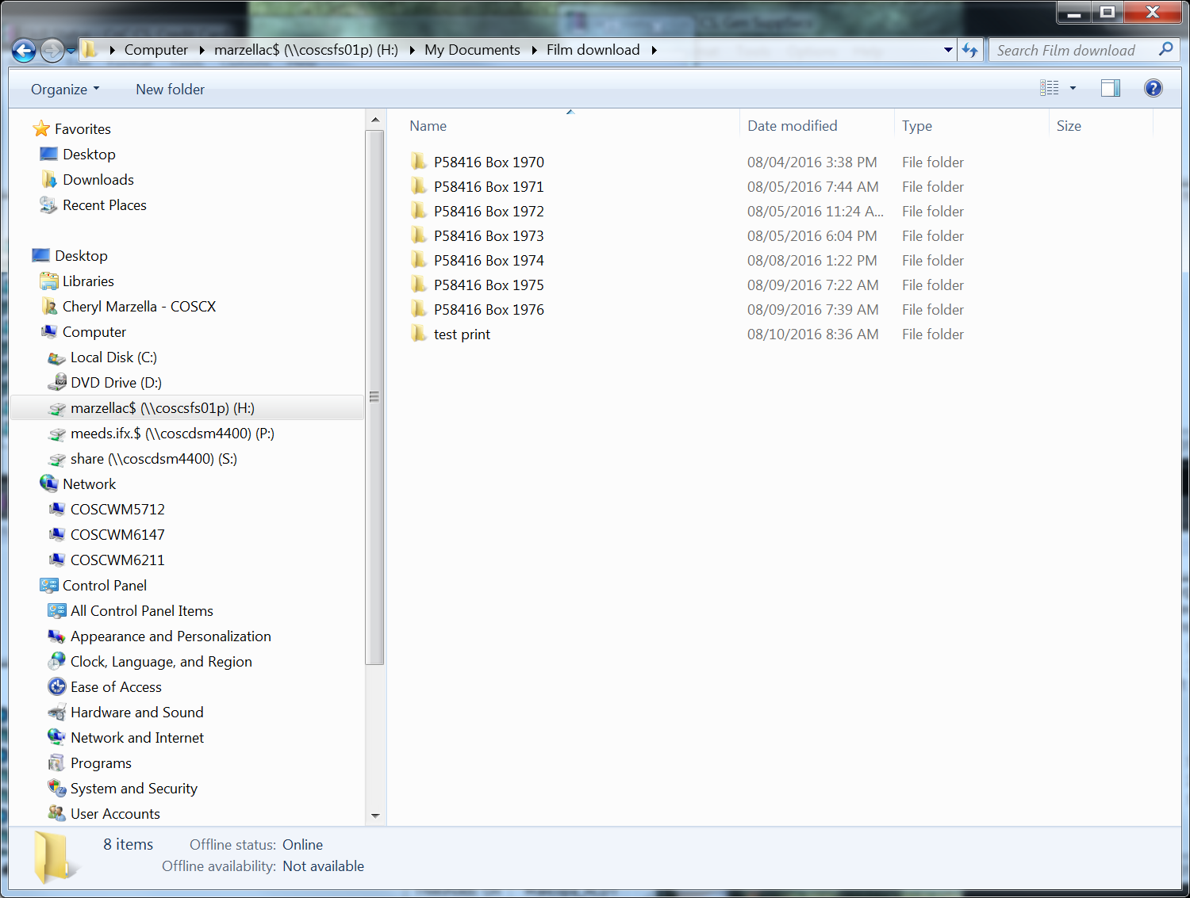

- In Power Scan 3000, select Output
- Select Automatic Scanning:
  - Under file path, select Browse to select the folder in your H drive that you previously created. An example folder is titled Film Download.
  - Under File Prefix, select Auto Scan.
  - Under File Suffix#, leave blank, do not enter anything.
  - Under # of Scans, enter the # of pages in the file or you can guess; overestimate the number of pages if you are guessing. The machine will stop printing when it no longer can read a page.
  - Under File Type, select JPEG.
  - Check the Straighten/Crop button.
  - Select Forward button.
  - Select Start.
- Once the images have copied to your personal folder, open up that folder to verify the images are present. Highlight all items or Right click and copy on the folder itself. See Figure 2.
Figure 2
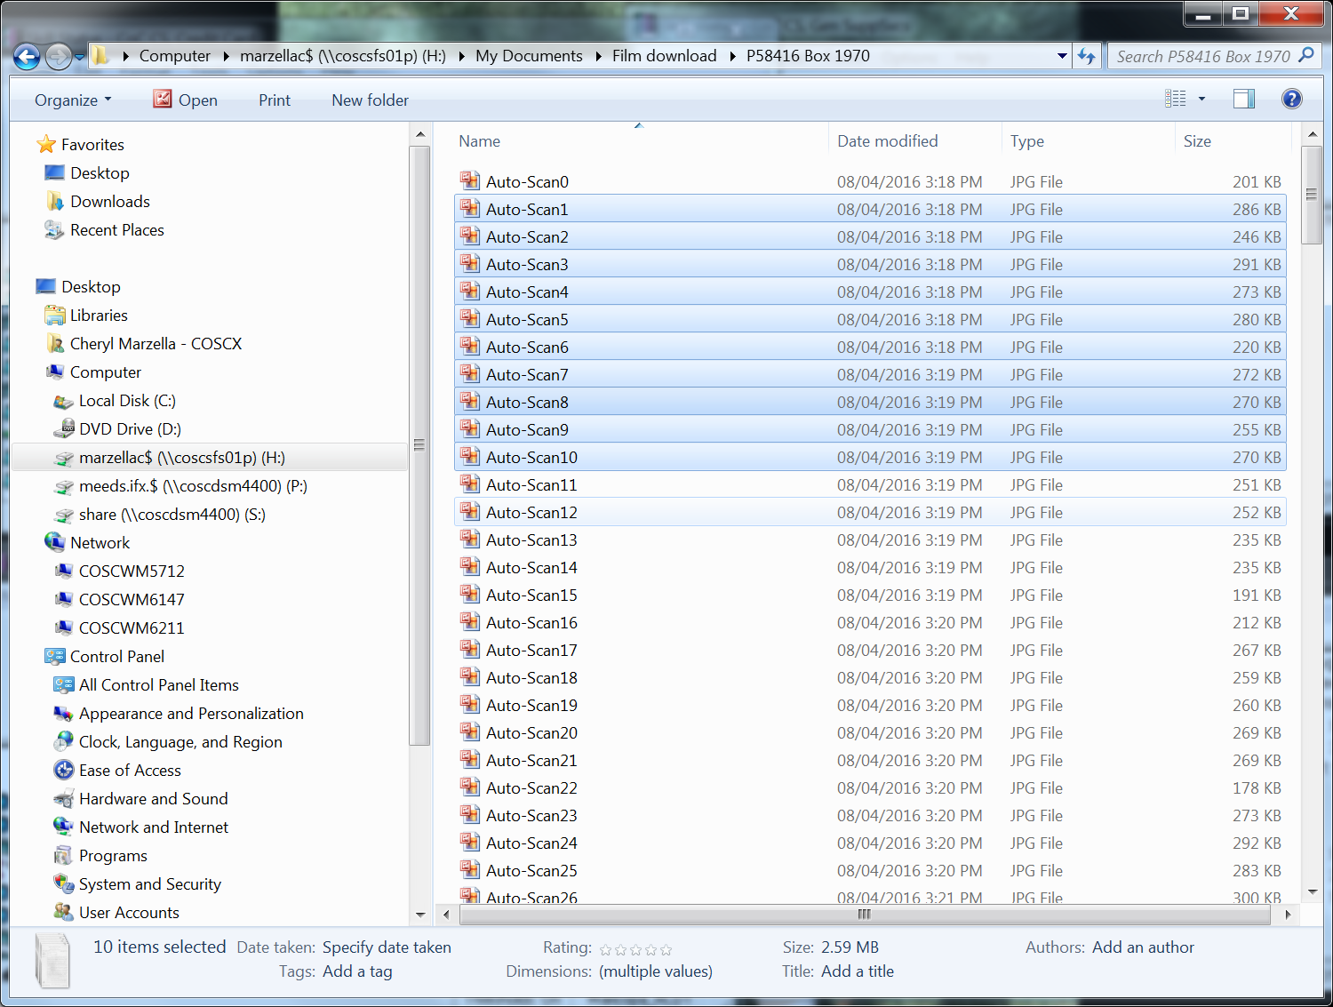

- At this point, if you’ve highlighted all of the documents, you can right click and print them. Be sure you have selected the correct printer, HP LaserJet P3010 Series UPD. Make sure the paper tray is full. The documents will print and you can walk away at this time until it is completed.

- To burn the images to a CD:
- Select “Start”, “Computer” and DVD Drive (D:)
- Insert a CD or DVD disk.
- At the “How do you want to burn a disk?” screen:
  - Disc title – enter the name of the folder that you saved the images to. Example: P58416 Box 1970.
  - Select With a CD/DVD player.
  - Click Next.
- Open your H drive and locate the folder:
  - Right click, select Copy.
  - Return to the DVD Drive (D:)
  - Right click and paste to the CD/DVD.
- At the top in the menu bar, select Burn to Disk:
  - At the Prepare the Disk prompt, select Rec. Speed 24X.
  - Select Next; the images will begin to download.
  - When done, select Finish.
- The CD is complete at this time. Review the CD prior to giving to a customer to make sure the images can be viewed.

POLICIES / RELATED DOCUMENTS:

- A.R.S. 12-283: Powers and duties

OTHER PARTIES INVOLVED:

- N/A

TIME / VOLUME:

- Varied

FREQUENCY:

- Daily

PERFORMANCE MEASURE:

- N/A

SYSTEM ACCESS REQUIRED:

- Scan Pro

REPORTS / FORMS:

- N/A

DEFINITIONS:

- N/A

APPLICABILITY:

This procedure applies to all employees of the Clerk of the Court.

REVISION HISTORY:

Revision Number | Revision Author | Summary of Changes | Approval Date
- | N/A | Document Origination | 08/11/2016
A | Larry Urewicz | Reformatted for the CDI | 01/06/2017
B | Ken Shipley | Procedural Contents Updated | 12/31/2020
C

