PURPOSE:

To provide instructions for the process of taking FC eFile payments though the eFile help desk.

OBJECTIVE:

- To process an over-the-phone payment for FC eFiled documents.

EVENT DRIVER:

- A customer would like to pay for FC eFiled documents over-the-phone.

PROCEDURES:
- In Clerk Review, locate the document/case number that payment is to be made for (typically found in FC hold queue). Click on the Notes tab to obtain the clerk note that provides detailed payment information. See Figure 1.

Figure 1
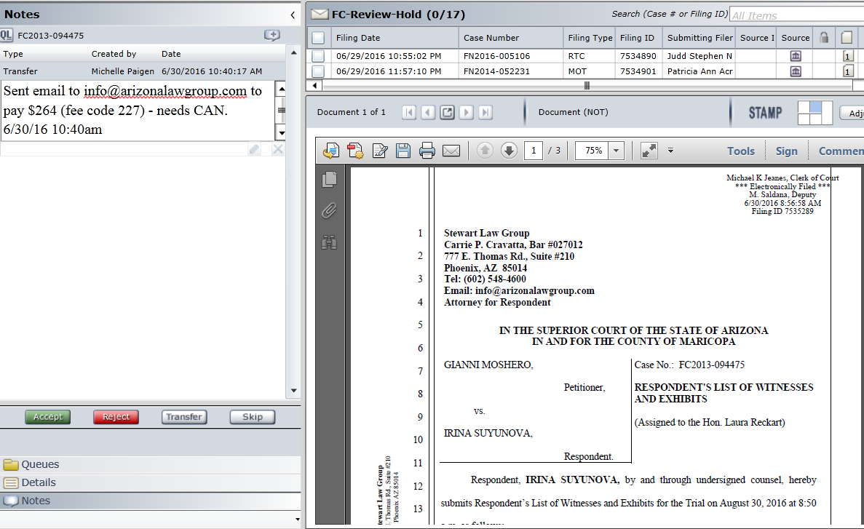

- In COSC Receipting (see Figure 2), click on Cashiering tab and click on Receipt Entry in the drop down to open up a new entry (refer to the cash receipting procedures if needed).
Figure 2
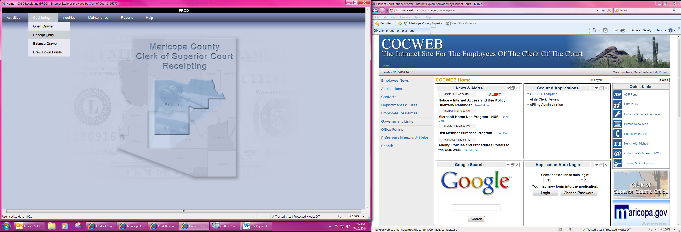

- The Receipt Entry screen will open. Enter the case number in the Case # field and tab to Service Code field. See Figure 3.

Figure 3
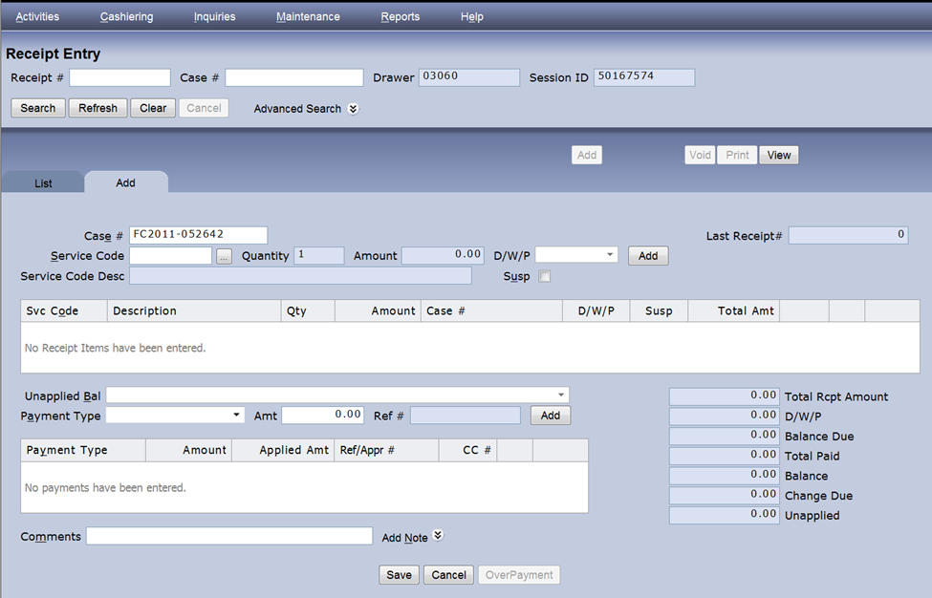
- In the Service Code field enter the 3 digit code that corresponds with the type of funds being receipted. See Figure 4.

Figure 4
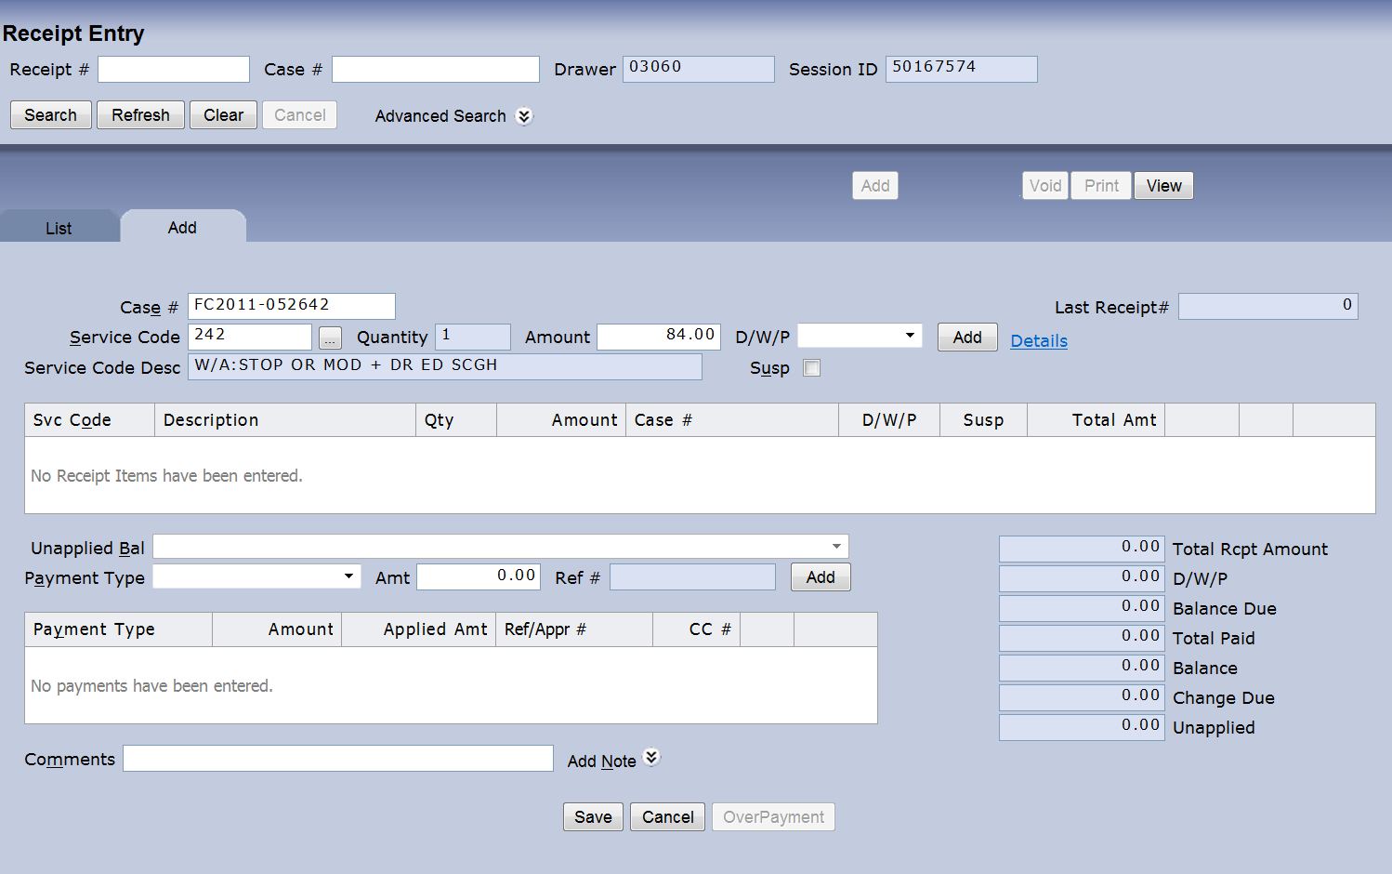

- Tab over and click the ADD button to auto populate payment information. See Figure 5.

Figure 5

- Receipt Item Detail screen will open. See Figure 6.

Figure 6
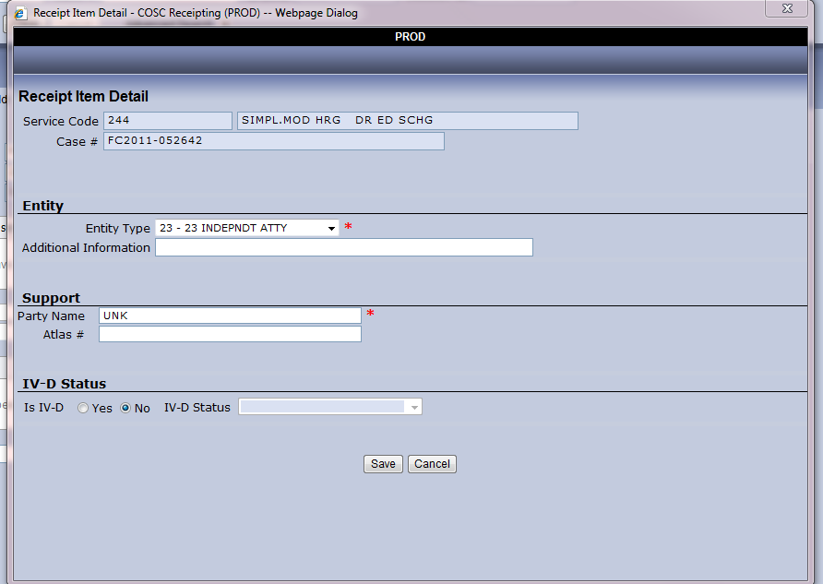

- In the Entity Type field, enter 23 for Independent Attorney if the document being filed is from an attorney, or if being filed by Pro Per, enter 02 Pro-Per.
- Leave the Additional Information field blank.
- In the Support section the Party Name field, input UNK.
- Leave the Atlas # field number blank.
- Leave IV-D Status blank.
- Click Save - the Receipt Item Detail screen will automatically close.
- At the bottom of the Receipt Entry screen (Figure 3) in the Comments field enter paying party information attorney or pro per/ who they are/will be representing/ name on the credit card/ and billing address. Note: If additional room for comments is needed, click on Add Note next to the comments field and select General Note. See Figure 7.
Figure 7
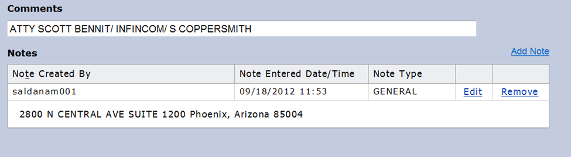
- In the Payment Type field, use the drop down arrow and select the card type and click the ADD button to the right of the Payment Type field. See Figure 8.

Figure 8
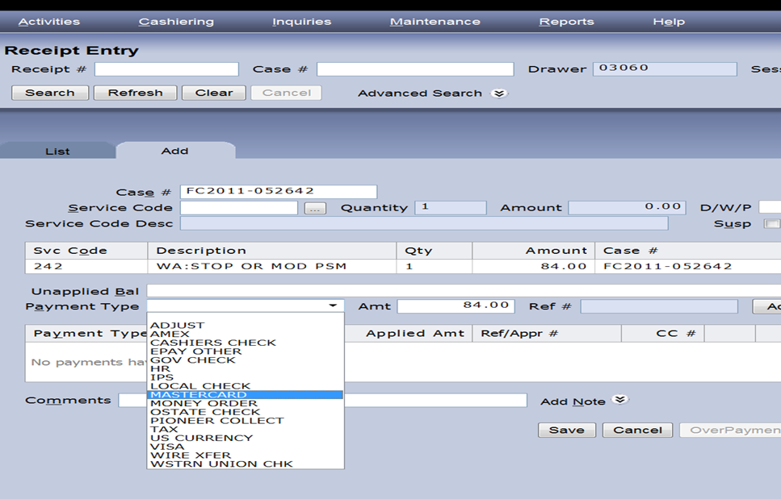

- A Credit Card Processing pop up window will appear. See Figure 9. Manually enter the Credit Card Number (no dashes), card Expiration Date, card Security Code, the Billing Zip Code. Click Submit for credit card authorization.

Figure 9
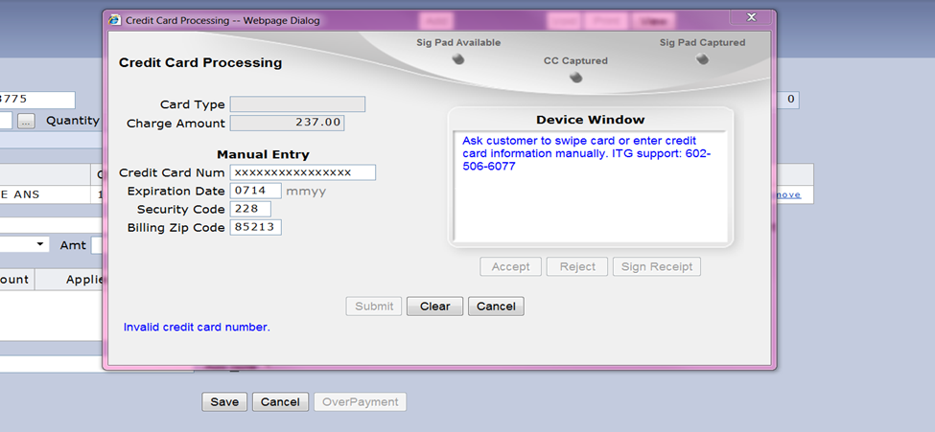

- Once the credit card has been authorized, the Credit Card Processing window will automatically close. After the processing window closes, click the Save button located at the bottom of the Receipt Entry screen to save the entry. See Figure 10.

Figure 10


- The payment has been processed; if you are trained in FC eFile, continue with normal processing procedures which may include creating a credit memo and processing of the document. If not, add additional note in the Notes section in Clerk Review (see Figure 11) to include payment amount and receipt number (located at top right of Receipt Entry screen in Last Receipt # field). Send an email to the FC Operations Specialist (s) assigned to FC eFile to notify them of the payment received.

Figure 11
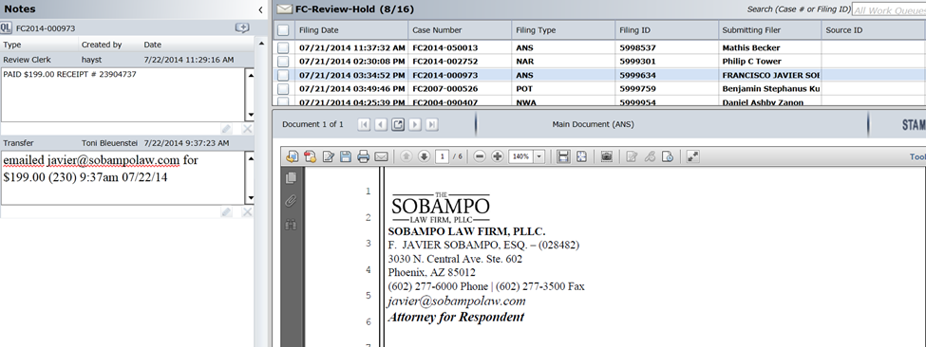

POLICIES / RELATED DOCUMENTS:

- N/A

OTHER PARTIES INVOLVED:

- FC Operations Specialist(s) assigned to FC eFile

TIME / VOLUME:

- Varied

FREQUENCY:

- Varied

PERFORMANCE MEASURE:

- N/A

SYSTEM ACCESS REQUIRED:

- Clerk Review
- COSC Receipting
- Email

REPORTS / FORMS:

- N/A

DEFINITIONS:

- N/A

APPLICABILITY:

This procedure applies to all employees of the Clerk of the Court.

REVISION HISTORY:

Revision Number | Revision Author | Summary of Changes | Approval Date
- | Michelle Figueroa | Document Origination | 07/21/2016
A
B
C

