PURPOSE:

To provide instructions for importing a new PDF document into OnBase.

OBJECTIVE:

- To provide the necessary direction to ensure that documents are correctly imported into OnBase.

EVENT DRIVER:

- A request that a new PDF document be imported into OnBase.

PROCEDURES:
- Open OnBase Thick Client
- Right click and drag the PDF document onto OnBase Thick Client.
- The Import Document dialog box will open (See Figure 1).
Figure 1
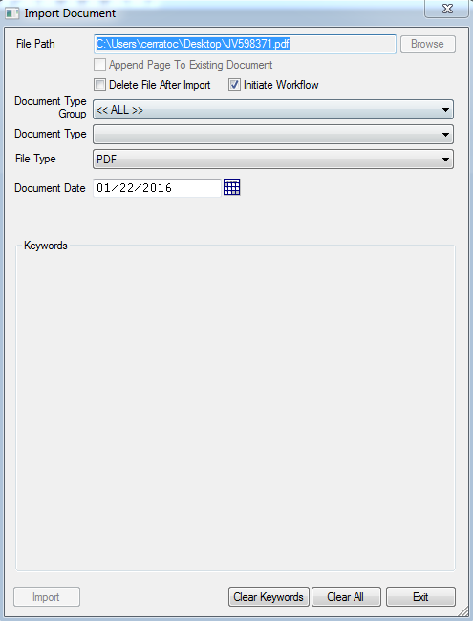

- Select the Document Type Group and Document Type.
- Fill in the following keyword fields using the data from the docket entry in iCIS.
- Case #
- Filing Date
- Docket Code
- Docket Entry ID
- Batch Name – use JUV IMPORT followed by today’s date
- Security
- Point of Entry
- Priority
- Scanned By – use your initials (See Figure 2)
Figure 2
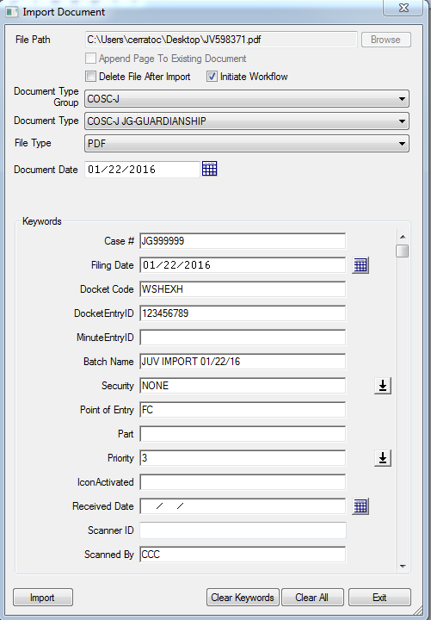
- Select Import
- Workflow starts automatically

POLICIES / RELATED DOCUMENTS:

- None

OTHER PARTIES INVOLVED:

- None

TIME / VOLUME:

- 1 minute for each import, assuming that the docket event and the PDF document have already been created.

FREQUENCY:

- Daily

PERFORMANCE MEASURE:

- N/A

SYSTEM ACCESS REQUIRED:

- iCIS
- OnBase
- Adobe PDF

REPORTS / FORMS:

- N/A

DEFINITIONS:

- N/A

APPLICABILITY:

This procedure applies to all employees of the Clerk of the Court.

REVISION HISTORY:

Revision Number | Revision Author | Summary of Changes | Approval Date
- | Chris Cerrato | Document Origination | 01/22/2016
A | Eileen Fenner | Reviewed | 03/05/2019
B
C

