PURPOSE:

To provide instructions for creating a new document from an existing document.

OBJECTIVE:

- To provide the necessary direction to ensure that new documents are created correctly from existing documents.

EVENT DRIVER:

- A request that a new document be created from an existing document.

PROCEDURES:
- Use Send to and Create New Document:
- Right click on the document for a menu. Select Send To, then Create New Document. (See Figure 1)
Figure 1
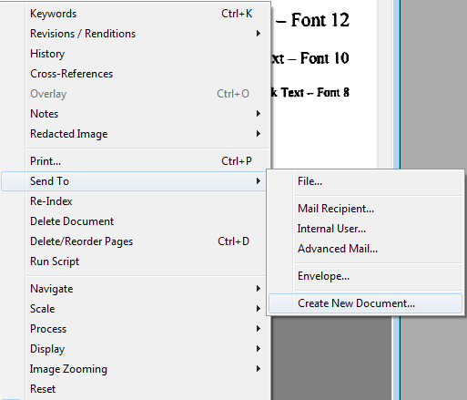

- The Create new document from existing screen opens. Enter the pages that will be copied to the new image in the Create from pages field. Enter the document keywords that the new image should have. (See Figure 2)
Figure 2
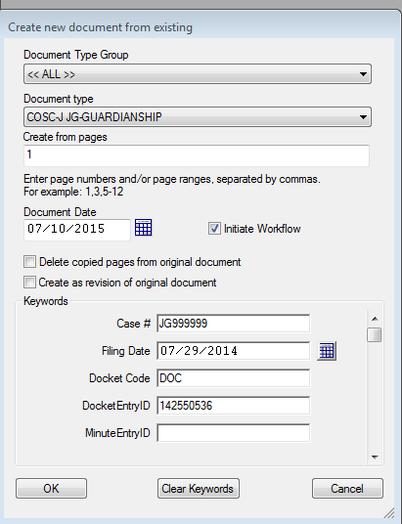

- Un-check the box Delete copied pages from original document
- When the Create as revision of original document box appears, leave it unchecked.
- Select OK.

POLICIES / RELATED DOCUMENTS:

- None

OTHER PARTIES INVOLVED:

- None

TIME / VOLUME:

- Time for each correction varies from 1 to 5 minutes, depending on the size of images and complexity of changes to be made
- Volume varies

FREQUENCY:

- Daily

PERFORMANCE MEASURE:

- N/A

SYSTEM ACCESS REQUIRED:

- iCIS
- OnBase
- Adobe PDF

REPORTS / FORMS:

- N/A

DEFINITIONS:

- N/A

APPLICABILITY:

This procedure applies to all employees of the Clerk of the Court.

REVISION HISTORY:

Revision Number | Revision Author | Summary of Changes | Approval Date
- | Chris Cerrato | Document Origination | 07/10/2015
A | Eileen Fenner | Reviewed | 03/05/2019
B
C

