PURPOSE:

To provide instructions for scanning, reviewing, and auditing Target Test Batches.

OBJECTIVE:

- To provide the necessary direction to ensure that Target Test Batches are scanned correctly, reviewed, and audited on a daily basis.

EVENT DRIVER:

- A Target Test Batch is scanned each day prior to beginning scanning documents

PROCEDURES:
Each Target Test Batch consists of the following items:
- Generic barcode
- Two target sheets stamped with Back Page Content stamp on the back
- Multifeed test sheet
- Legal test sheet

- Scanning Staff Procedure
- Create a batch in Kofax using the default batch name.
- Scan the test batch for the scanner being used.
- If stray lines are seen on the target sheet, clean the glass and scan the test sheets again. If stray lines are still seen, contact COC Scanner Issues.
- The multifeed sheet should cause the scanner to stop:
- When it stops, resolve the multifeed so the image of the sheet is retained.
- If it does not stop, restart the scanner and pc, and scan the batch again.
- If it still does not stop, contact COC Scanner Issues. Do not scan until the multifeed issue is resolved.
- The top and bottom lines on the legal sized test sheet should be completely visible on the image.
- If both sets of lines are not completely visible, restart the scanner and pc, and scan the batch again.
- If both sets of lines are still not completely visible, contact COC Scanner Issues.
- When finished scanning, close the batch. Do not delete the batch.

- EDM QC Procedure
1. Check all target test batches that were scanned the previous business day and today using the following sequence of searches in OnBase (see Figure 1 - 4).
2. Confirm that each test batch has the correct sequence of images (see Figure 5).
3. If pages are missing, or the batch was scanned incorrectly, email the operator to rescan the test batch, and copy their supervisor.
4. If a batch is consistently missing the back page of the first target sheet, ITG may need to lower the back page threshold or perform maintenance.
5. Send an email to the EDM QC Manager and EDM QC Leads after the target test batches have been checked. Note any discrepancies you have found, or if there are no discrepancies (see Figure 6).

Figure 1
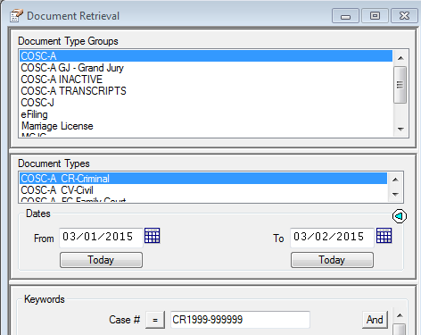

Figure 2
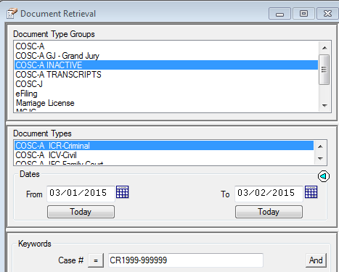

Figure 3
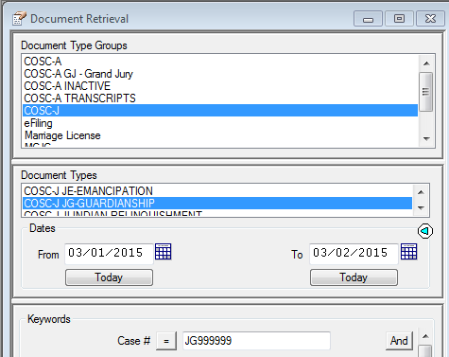

Figure 4
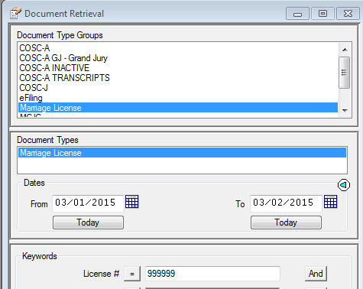

Figure 5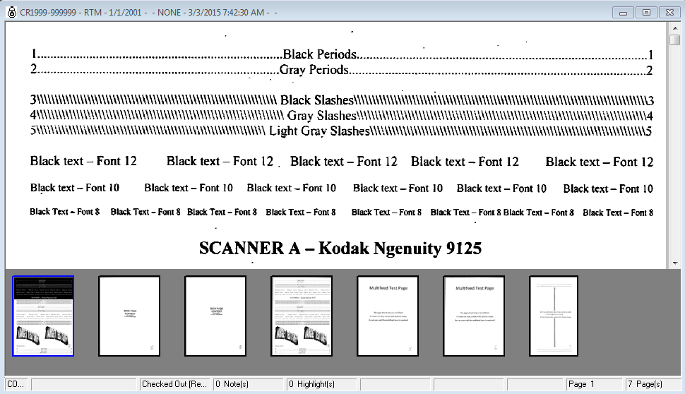

Figure 6
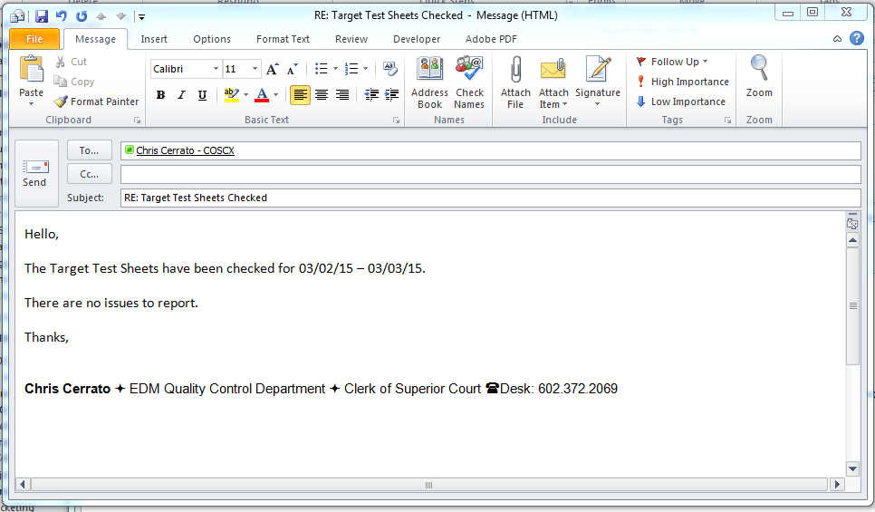

POLICIES / RELATED DOCUMENTS:

- REFDOC-EDMQC-1004: What to Look for in the Target Test Batch

OTHER PARTIES INVOLVED:

- None

TIME / VOLUME:

- Performed every day of the month; 10 minutes each day.

FREQUENCY:

- Daily

PERFORMANCE MEASURE:

- N/A

SYSTEM ACCESS REQUIRED:

- OnBase, Kofax

REPORTS / FORMS:

- N/A

DEFINITIONS:

- (enter appropriate info)

APPLICABILITY:

This procedure applies to all employees of the Clerk of the Court.

REVISION HISTORY:

Revision Number | Revision Author | Summary of Changes | Approval Date
- | Chris Cerrato | Document Origination | 03/05/2015
A | Eileen Fenner | Reviewed | 03/05/2019
B
C

