PURPOSE:

Provide instructions for changing the Kofax properties when scanning sealed sentencing minute entries.

OBJECTIVE:

- To provide the necessary direction to ensure that sealed sentencing minute entries are scanned with the correct properties.

EVENT DRIVER:

- A sealed sentencing minute entry is presented to EDM QC for scanning.

PROCEDURES:
- Select Sealed Document Batch Scan batch class.
- Create a batch and select OK (not Scan)
- On the Properties screen, select Resolution = 300, Color Mode = Grayscale, Sides = Single-sided (see Figure 1)

Figure 1
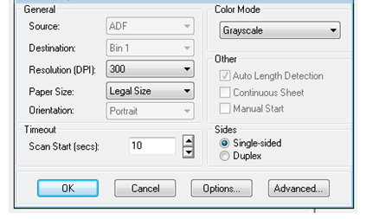
- Select OK
- Scan the batch with these settings
- Create a new batch.

- Confirm that the Properties screen has returned to the following settings with the new batch: Resolution = 200, Color Mode = Black & White, Sides = Duplex (see Figure 2)
Figure 2
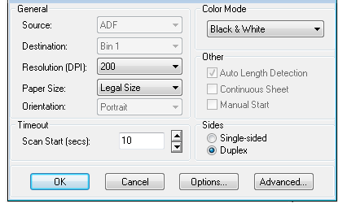

POLICIES / RELATED DOCUMENTS:

- N/A

OTHER PARTIES INVOLVED:

- N/A

TIME / VOLUME:

- 30 seconds to change settings for each batch.

FREQUENCY:

- Frequency depends upon number of sealed sentencing minute entries scanned each month.

PERFORMANCE MEASURE:

- N/A

SYSTEM ACCESS REQUIRED:

- Kofax

REPORTS / FORMS:

- N/A

DEFINITIONS:

- N/A

APPLICABILITY:

This procedure applies to all EDM QC employees of the Clerk of the Court.

REVISION HISTORY:

Revision Number | Revision Author | Summary of Changes | Approval Date
- | Chris Cerrato | Document Origination | 12/10/2014
A | Eileen Fenner | Reviewed | 03/05/2019
B
C

