PURPOSE:

To provide instructions for creating a new document from an existing document.

OBJECTIVE:

- To provide the necessary direction to ensure that new documents are created correctly from existing documents.

EVENT DRIVER:

- A request that pages from a document be removed and used to create another document.

PROCEDURES:
There are three different methods for creating a document from an existing one – Drag and Drop, Send To / Create New Document, and Extracting Pages.
- Drag and Drop:
  - Determine which page should be the first page of the new document. Right click, hold, and drag the thumbnail page from the document into the area in OnBase outside the document. (See Figure 1)

Figure 1
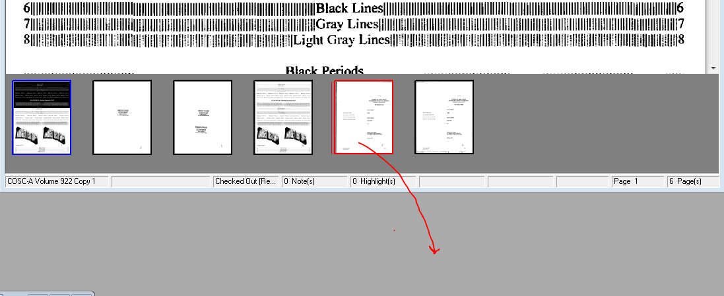

  - Create a new document which starts with this page. (See Figure 2)

Figure 2
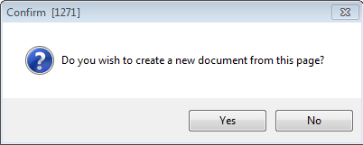

  - Save the page as a new document. (See Figure 3)

Figure 3
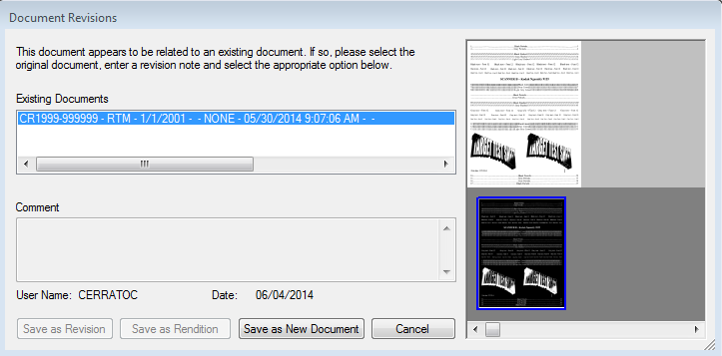

  - Delete the page from the original document. (See Figure 4)

Figure 4
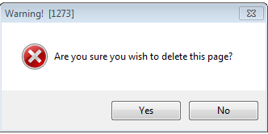
  - Select Save as Revision to revise the original document so it will no longer have the page you dragged from it. (See Figure 5)
Note: If you wish to create a copy of the original document that does not have the page you dragged from it in addition to the original document, select Save as New Document.

Figure 5
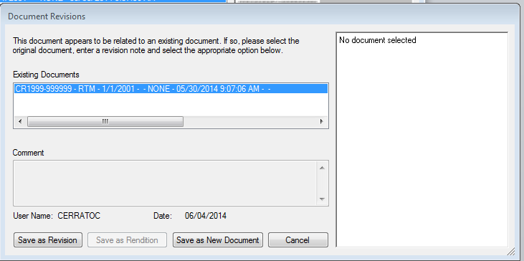

  - Continue dragging pages from the original document to the new document. Each time, select Save as Revision to move the pages from the original document to the new document. (See Figure 6)

Figure 6
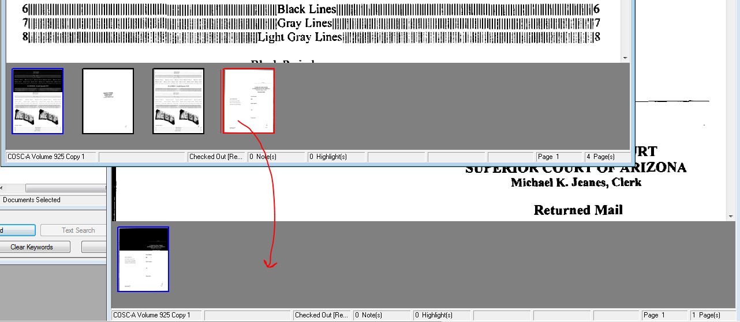
- Use Send to and Create New Document:
- Right click on the document for a menu. Select Send To, then Create New Document. (See Figure 7)
Figure 7
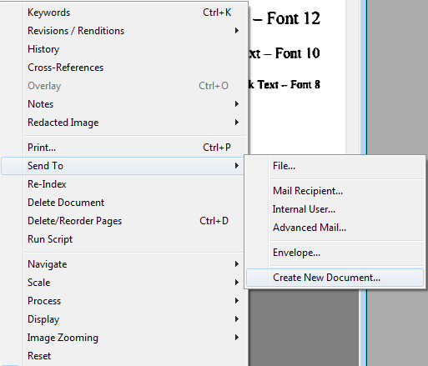

- The Create new document from existing screen opens. Enter the pages that will be removed from the current image in the Create from pages field. Enter the document keywords that the new image should have. (See Figure 8)

Figure 8
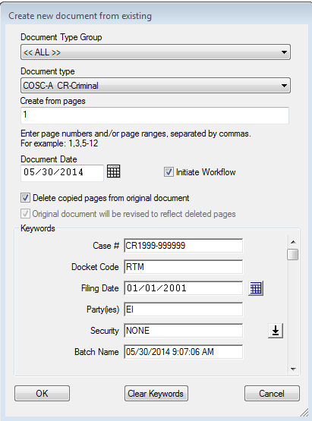

- Select OK.

- Extract Pages (PDF Only):
- Print the image to Adobe PDF.
- Save as a PDF file outside OnBase.
- Open the PDF file you have just saved.
- Select Tools, then Extract. (See Figure 8)

Figure 8
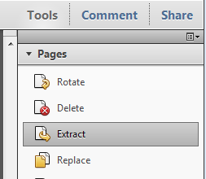

  - In the From and To fields, enter the pages that will be extracted from the current image to create a new image.
    - Select Delete Pages After Extracting if you want these pages deleted from the original image.
    - Select Extract Pages As Separate Files if appropriate. (See Figure 9)

Figure 9
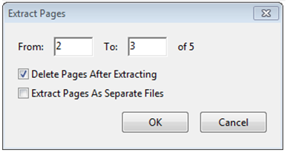

  - Save the pages which have been extracted using a new file name. (See Figure 10)

Figure 10
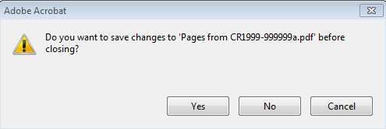

  - Save the changes to the original document before closing. (See Figure 11)

Figure 11
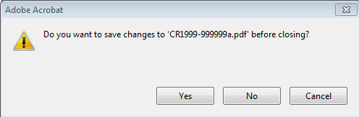

  - Re-import both documents into OnBase assigning the appropriate keywords.

POLICIES / RELATED DOCUMENTS:

- None

OTHER PARTIES INVOLVED:

- None

TIME / VOLUME:

- Time for each correction varies from 1 to 5 minutes, depending on the size of images and complexity of changes to be made
- Volume varies

FREQUENCY:

- Daily

PERFORMANCE MEASURE:

- N/A

SYSTEM ACCESS REQUIRED:

- iCIS
- OnBase
- Adobe PDF

REPORTS / FORMS:

- N/A

DEFINITIONS:

- N/A

APPLICABILITY:

This procedure applies to all employees of the Clerk of the Court.

REVISION HISTORY:

Revision Number | Revision Author | Summary of Changes | Approval Date
- | Chris Cerrato | Document Origination | 06/06/2014
A | Eileen Fenner | Reviewed | 03/05/2019
B
C

