PURPOSE:

To provide instructions for auditing trusted outside agency OnBase accounts with Virtual Private Network (VPN) connections.

OBJECTIVE:

- To provide the necessary direction to ensure that all OnBase accounts that depend on a VPN connection are valid accounts which belong to active employees of the designated agency

EVENT DRIVER:

- This audit will occur every March and September

PROCEDURES:
- Enter the Report Services module in OnBase using your User Name and Password. (see Figure 1)

Figure 1
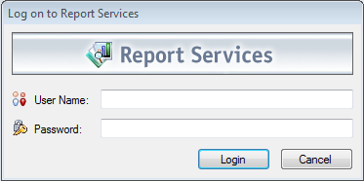

- Under Report, select OnBase Groups and Their Users. Enter “M” in the Report Parameters. Scroll through the list of groups beginning with “M” until you find the correct group. Currently, only the FBI is being audited – Group Name = MC1 FBI. (See Figure 2)

Figure 2
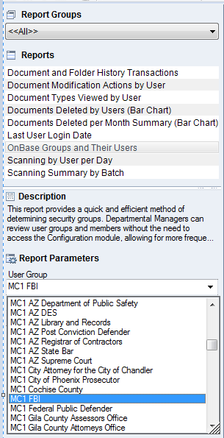

- Select Create (F5) from the bottom of the screen. The users in the group will be listed in a report.

- Audit the accounts by sending an email to the Agency Contact person listed on Table-EDMQC-1001 in the Document Control Index at S:\Document Control\Controlled Document Index.xls - Shortcut. In the email, include all the Real Names that are listed on the User Group report. Do not include the User Names. Request that the Agency Contact person verify the employment of all the names on the report.
- If anyone on the report is no longer employed by the agency, confirm with the Agency Contact person that their OnBase account will be deleted. Determine from the Agency Contact person if the VPN device will be returned or reassigned to a different user.
- Submit requests to delete accounts to the ITG Help Desk. Relay information regarding VPN devices to the ITG Help Desk.
- Forward the email correspondence with the Agency Contact person and the ITG Help desk to the EDM QC Manager, the Court Operations Administrator, and the EDM Program Manager.
- Save the email correspondence with the Agency Contact person and the ITG Help desk in S:\Doc_Management\EDM Quality Control\EDM QC Procedures\Outside Agencies\Audits of VPN Accounts

POLICIES / RELATED DOCUMENTS:

- TABLE-EDMQC-1001: Agency Contact Information Table

OTHER PARTIES INVOLVED:

- Trusted Outside Agency Contact person
- ITG Help Desk

TIME / VOLUME:

- Performed twice each year, in March and September. Approximately 30 minutes each time, not including time spent waiting for the Agency Contact Person or the ITG Help Desk to respond to messages

FREQUENCY:

- Performed every six months, in March and September

PERFORMANCE MEASURE:

- N/A

SYSTEM ACCESS REQUIRED:

- OnBase Report Services
- Microsoft Outlook
- S:\Doc_Management\EDM Quality Control\EDM QC Procedures\Outside Agencies\ Audits of VPN Accounts

REPORTS / FORMS:

- N/A

DEFINITIONS:

- VPN accounts – Virtual Private Network accounts extend a secure portal to agencies that cannot access the Maricopa County network directly. These accounts are achieved through use of a hand held device, for which the Clerk’s Office is charged a monthly fee.

APPLICABILITY:

This procedure applies to all employees of the Clerk of the Court.

REVISION HISTORY:

Revision Number | Revision Author | Summary of Changes | Approval Date
- | Chris Cerrato | Document Origination | 03/21/2014
A | Eileen Fenner | Reviewed | 3/5/2019
B
C

