PURPOSE:

To provide instructions for processing images sent to the COSC KEYWORDS QC QUEUE in the COSC Adult Courts Indexing Lifecycle in OnBase.

OBJECTIVE:

- To provide the direction to ensure that the missing keywords on images are properly updated.

EVENT DRIVER:

- Images from with missing or incomplete keywords are sent to the COSC KEYWORDS QC QUEUE by the OnBase application.

PROCEDURES:
  - To access the QC Queue Priority Workflow Queue in OnBase, click on the Workflow button on the OnBase Tool Bar. (See Figure 1)

Figure 1


- Select COSC Adult Courts Indexing LC from the Life Cycle View list. (See Figure 2)

Figure 2
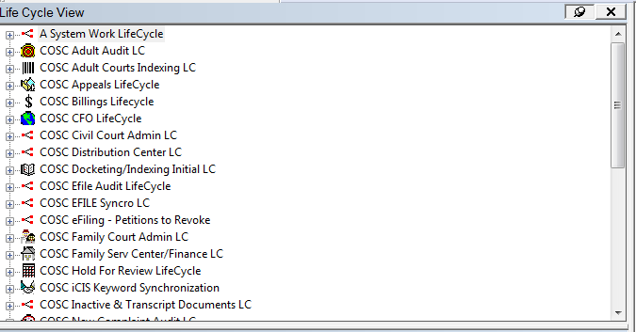

- Select COSC KEYWORDS QC QUEUE. (See Figure 3)

Figure 3
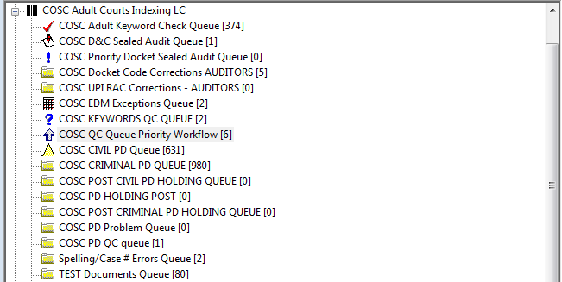

- Images with case numbers, docket codes, file dates, or docket entry IDs that are missing or incomplete appear in the queue. (See Figure 4)

Figure 4
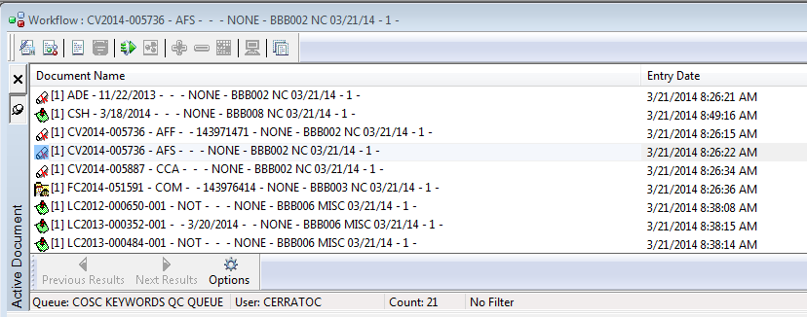

- If the case number keyword is missing or incomplete, check the parties in iCIS to determine the correct case number.

- To fix an image that was scanned with an iCIS barcode, access the keywords by right clicking on the image and select Keywords option. You may see blank keyword fields, keywords that have populated the wrong keyword fields, or incomplete keyword fields. (See Figure 5.)

Figure 5
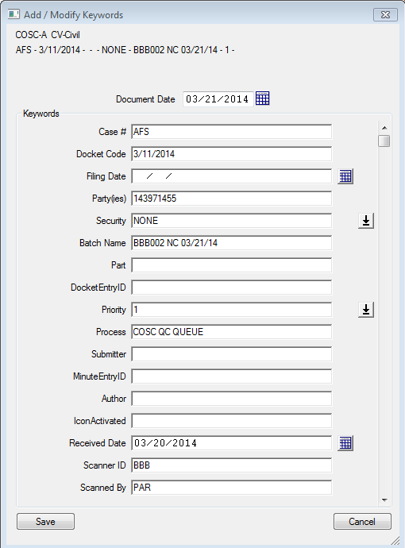

- Correct each keyword field manually so that the proper keyword is in the proper keyword field. (See Figure 6)

Figure 6
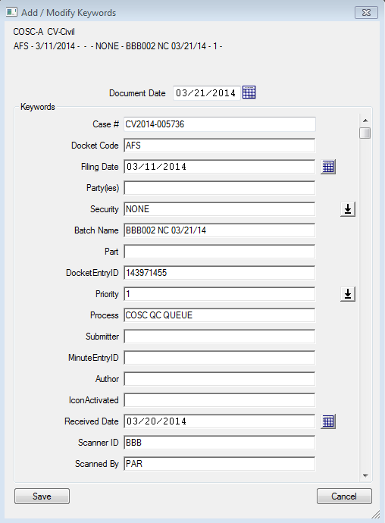

- If necessary, select View iCIS Key Words from the iCIS docket entry screen to find the correct keywords. (See Figure 7)

Figure 7
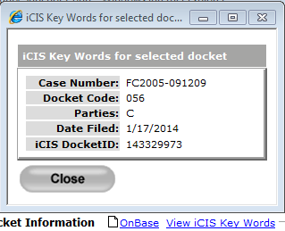

- When the corrected keywords have been saved, click on the Restart Workflow button to move the image out of the queue. (See Figure 8)

Figure 8
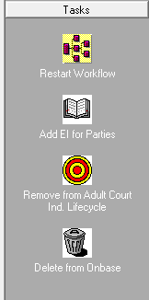

- To fix an image that was scanned with an Express Index barcode, access the keywords by right clicking on the image and select Keywords option.
A. If only the Party(ies) keyword of EI is missing, simply click on the Add EI for Parties button (See Figure 8)
B. If the docket code is missing, sometimes the batch name will show what the docket should be; otherwise, pull up the entire batch and see what docket codes were being used on other documents in the batch.
- When the corrected keywords have been added, click on the Restart Workflow button to move the image out of the queue. (See Figure 8)

POLICIES / RELATED DOCUMENTS:

- None

OTHER PARTIES INVOLVED:

- Barcoders
- Scanning staff
- ITG Staff

TIME / VOLUME:

- Time and volume vary, but can range from 5 per day (approximately one minute each to fix) to several hundred per day (could take several hours to fix). When several hundred per day are entering the queue, the barcodes need to be examined for print quality issues.

FREQUENCY:

- Daily

PERFORMANCE MEASURE:

- N/A

SYSTEM ACCESS REQUIRED:

- OnBase
- iCIS

REPORTS / FORMS:

- N/A

DEFINITIONS:

- N/A

APPLICABILITY:

This procedure applies to all employees of the Clerk of the Court.

REVISION HISTORY:

Revision Number | Revision Author | Summary of Changes | Approval Date
- | Chris Cerrato | Document Origination | 03/21/2014
A | Eileen Fenner | Reviewed | 03/05/2019
B
C

