PURPOSE:

To provide instructions for making electronic corrections using the TrueSign application.

OBJECTIVE:

- To provide the necessary direction to ensure that electronic corrections using the TrueSign application are properly done.

EVENT DRIVER:
Documents need to be electronically corrected.

OVERVIEW:
- As of 1/19/07, approval was given to correct documents electronically, for those documents that only exist electronically. Approval was later expanded to include electronic corrections and image changes on documents filed prior to 01/01/07.
- Electronic Corrections: The following items may be corrected electronically:
  - Case Numbers
    - Incorrect case numbers are identified during the docketing process or in the Stage 3 audits.
  - File Stamps
    - File stamps are corrected when they are illegible, incorrect, such as “future” file dates, or missing.
  - Docket Codes on Minute Entries
    - These are usually requested by a courtroom clerk or a courtroom services manager.
  - Court-Ordered Corrections
    - These court orders are usually minute entries which endorse EDM QC. Examples: Changes to the text of a plea agreement or other document.
PROCEDURES:
- Use Core-Based, OnBase thick client for setting up the TrueSign software:
  - Click on the User option on the main menu bar in OnBase Thick Client. (See Figure 1.)

Figure 1
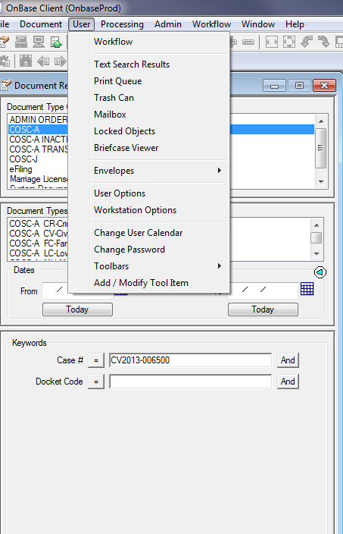

- Select Workstation Options on the drop down menu.
- Select Workflow Display Options tab. (See Figure 2.)

Figure 2
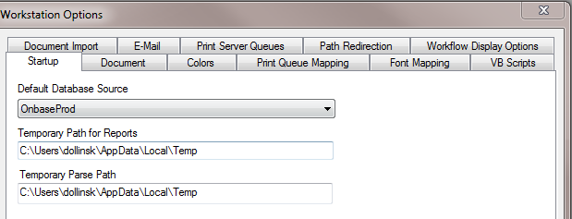

- Select Core-based in the User Interface drop down menu and click the Save button. (See Figure 3.)
Figure 3
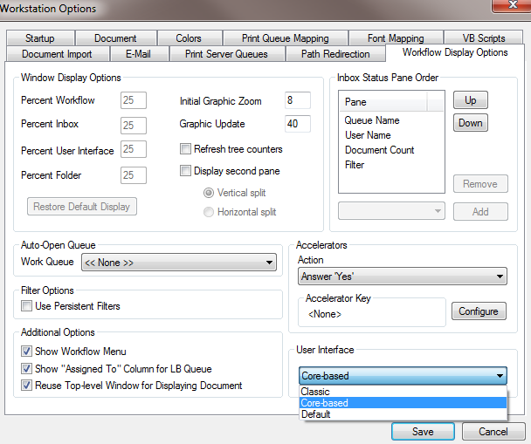

- To activate the Core-based user interface, go to the File option on the main menu bar and select the Re-launch Client option on the drop down menu. TrueSign is now available. (See Figure 4.)
Figure 4
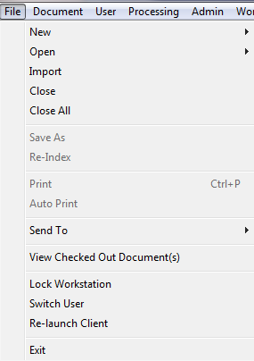

- Correcting a document image:
- Select a document image to correct.
- Click on the Send to Correction button. (See Figure 5.)

Figure 5
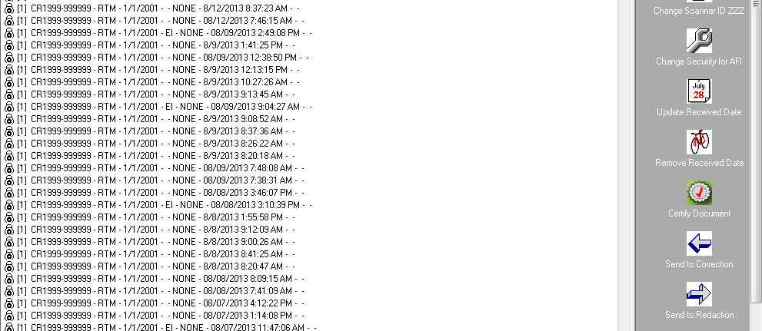

- Click on the Workflow icon on the Main Menu in OnBase thick client and scroll down to the TrueSign option. (See Figure 6.)

Figure 6
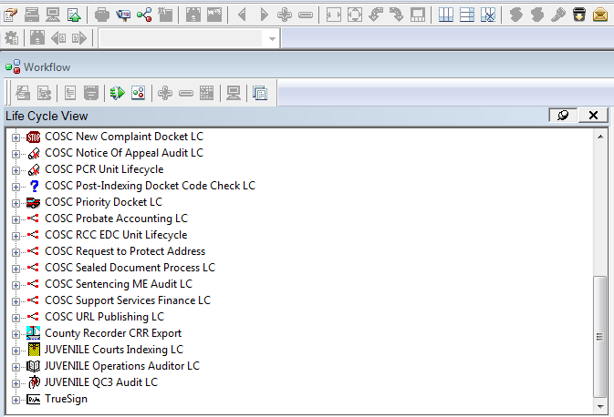

- TrueSign has a Correction queue and a Redaction queue.
  - The Correction queue is load-balanced, so you will see only the images that you sent to the queue. (If necessary, images can be re-assigned to other EDM QC staff.)
  - Select the document image you wish to correct and click on the Launch TrueSign button. (See Figure 7.)

Figure 7
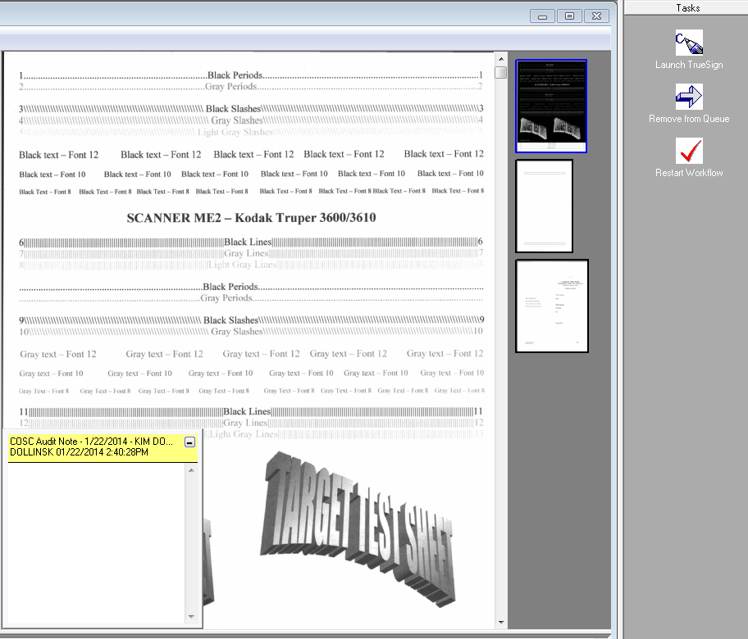

- TrueSign will launch (it may take a minute or two). (See Figure 8.)

Figure 8
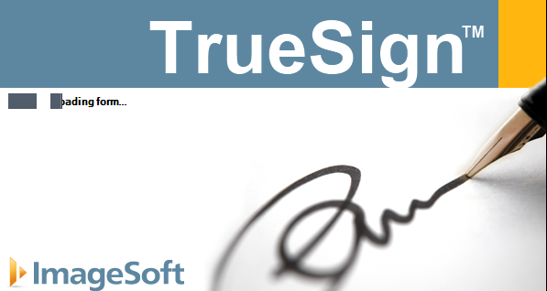

- You will see two options on the top menu bar: Sign and Stamp/Markup. Select Stamp/Markup option. (See Figure 9.)

Figure 9
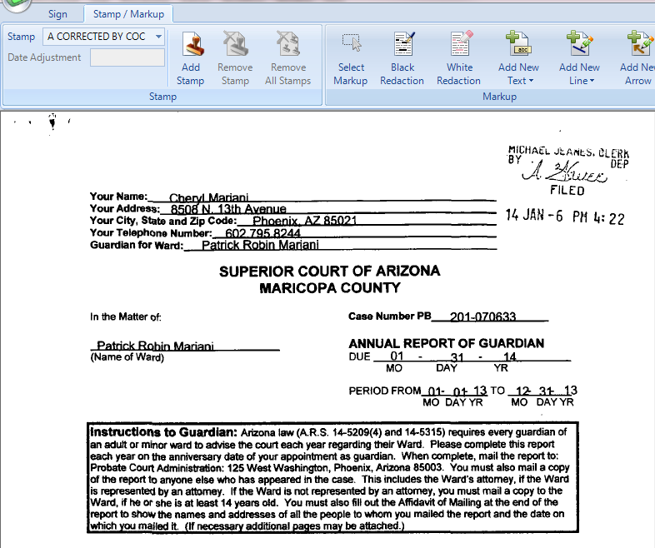

- Select your stamp from the drop-down Stamp menu. Click on Add Stamp. (See Figure 10).
Figure 10
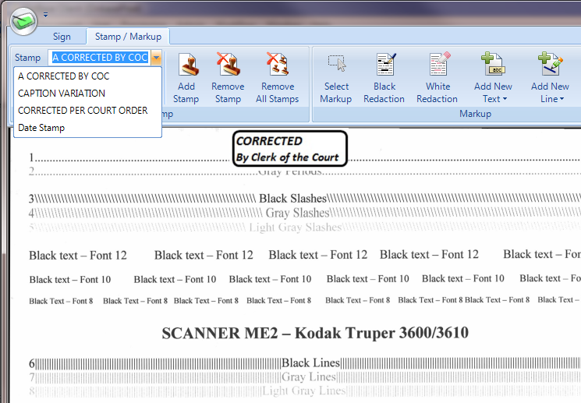

- Double click and place the stamp in the center of the top of the page. If it is not possible, place the stamp wherever there is enough blank space so it will not cover any text.
- If the caption is not correct but the case number is, use the Caption Variation stamp.
- If the Court has ordered the correction, use the Corrected Per Court Order stamp.
- If the correction is from one of the QC Queues, use the Corrected by COC stamp.

- If the correction needs to be made on a page other than the first page, to reach the page, click on the Sign option and click on Next Page option. (See Figure 11.)

Figure 11
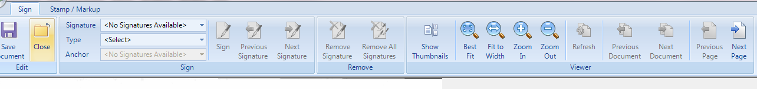

- There are several mark-up tools that can be used to make corrections.
  - The Add New Line option is used to draw a line through text on the image. (See Figure 12.)

Figure 12
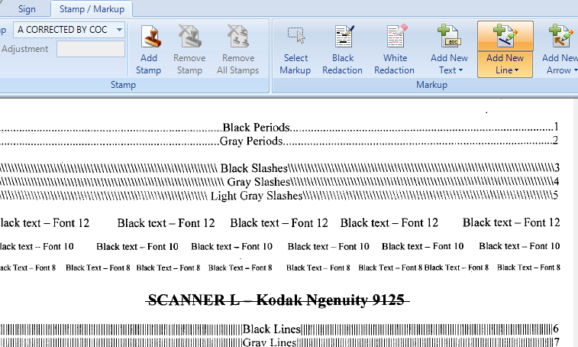

- The Add New Text option is used to add corrections to text on the image.
    - Click on Add New Text (defaults to 12 point font, but there are options for 10 point and 8 point font).
    - Draw a box on the image.
    - Enter text.
    - Box can be sized, moved or deleted. (See Figure 13)

Figure 13
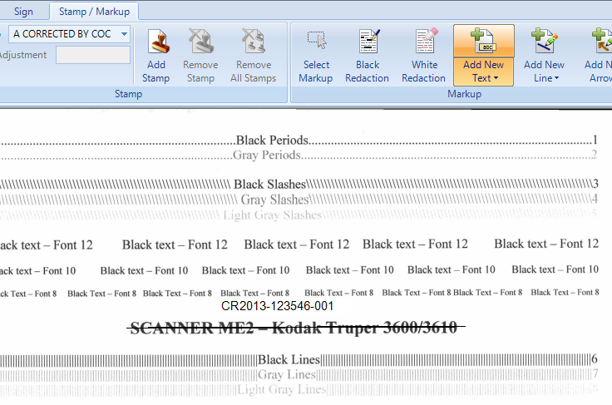

- To delete, cut or copy a text box or line.
    - Click on Select Markup.
    - Click on the markup you wish to delete, cut, copy, move or re-size.
    - Right click for a menu.
    - Select the option you wish to do to the markup. (See Figure 14)

Figure 14
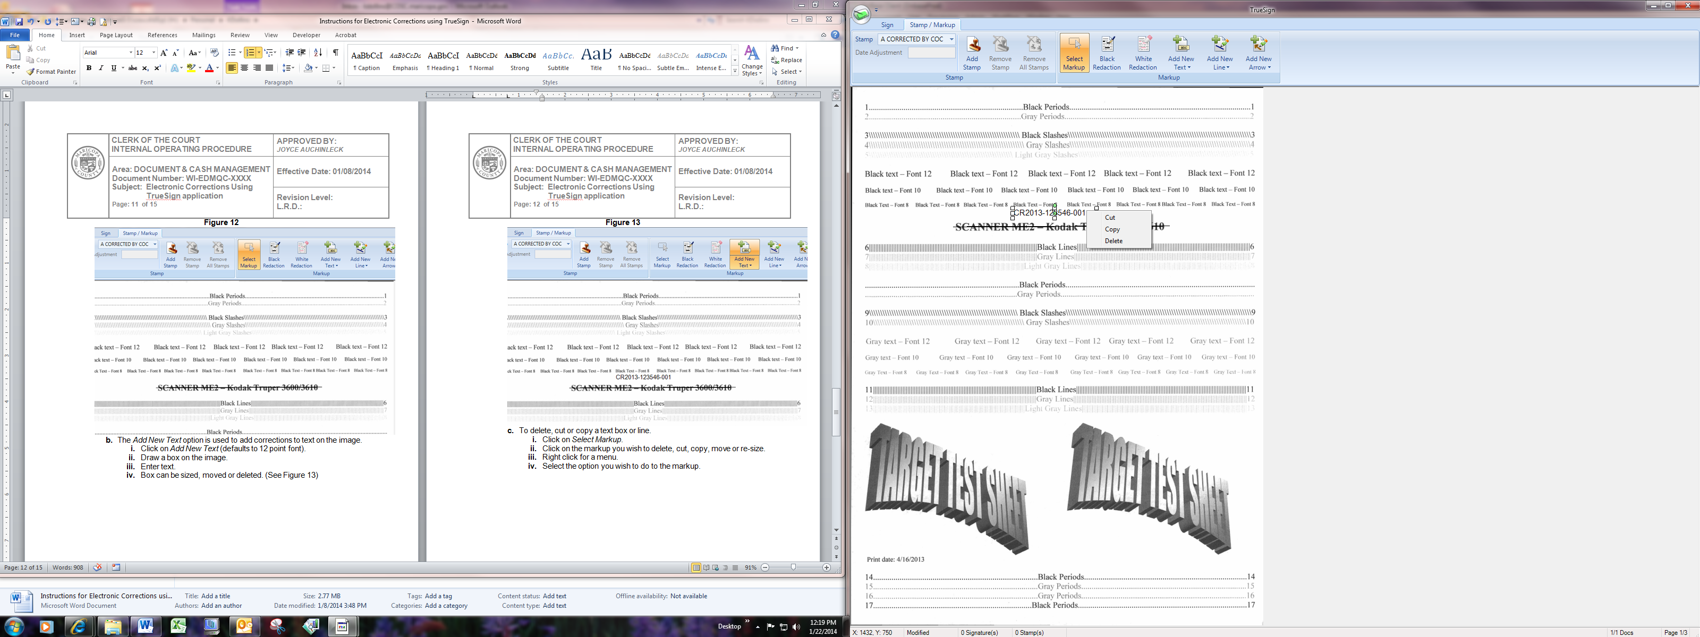

- To save the correction once it has been made, select the Sign option and click on the Save Document button. (See Figure 15.)

Figure 15
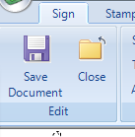

- The corrected document will appear. If necessary, update the keyword fields with the correct case number or file date and update the docket ID.
- The TrueSign note will be automatically deleted when the image is sent out of the queue.

      - To move the corrected image out of the Correction Queue, select either Remove from Queue or Restart Workflow buttons.
- If the corrected image has not yet been docketed, the Restart Workflow button will send it to the correct queue so that the image can be docketed.
- If the corrected image has been docketed, then the Remove from Queue button will send the image out of the Corrections queue and the original QC queue.
- The green icon in the top left hand corner of the TrueSign screen allows access to a drop down menu that includes the options of Save Document, Close, Preferences and Configuration. (See Figure 16)

Figure 156
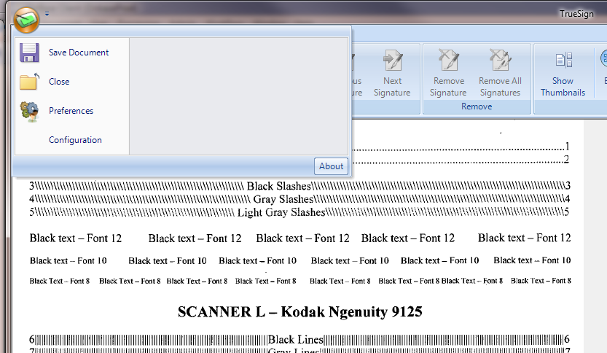

- Save Document and Close options are also available on the Sign menu bar.
- If instructed to do so, setting changes can be made using the Preferences and/or Configuration options. DO NOT change the settings in the Preferences screens without specific instructions from your supervisor.
- See Figure 17 for recommended User settings. The Configuration screens are grayed out and can only be changed by ITG.

Figure 167
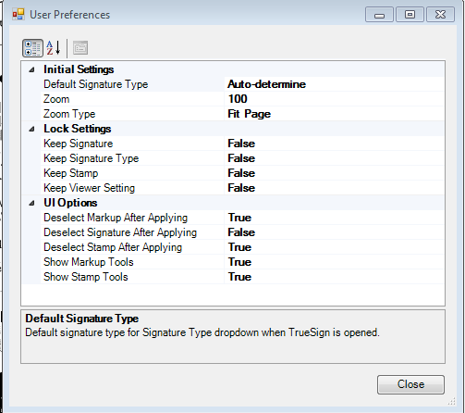

POLICIES / RELATED DOCUMENTS:

- None

OTHER PARTIES INVOLVED:

- None

TIME / VOLUME:

- At least 10 to 20 times daily. Approximately 1.5 minutes.

FREQUENCY:

- Hourly

PERFORMANCE MEASURE:

- N/A

SYSTEM ACCESS REQUIRED:

- OnBase
- TrueSign

REPORTS / FORMS:

- N/A

DEFINITIONS:

- N/A

APPLICABILITY:

This procedure applies to all employees of the Clerk of the Court.

REVISION HISTORY:

Revision Number | Revision Author | Summary of Changes | Approval Date
- | Chris Cerrato | Document Origination | 01/24/2014
A | Eileen Fenner | Reviewed | 03/05/2019
B
C

