PURPOSE:

Provide instructions for changing the Ngenuity 9125 scanner from landscape to portrait orientation.

OBJECTIVE:

- To provide the necessary direction to ensure that legal sized documents are imaged completely in portrait settings on Ngenuity 9125 scanners.

EVENT DRIVER:

- A legal sized document is presented for scanning on an Ngenuity 9125 scanner that is set to scan in landscape orientation.

PROCEDURES:
- Create a batch and select OK (not Scan)
- Select Scan / Properties
- Select Paper Size = Maximum, Orientation = Portrait (see Figure 1)

Figure 1
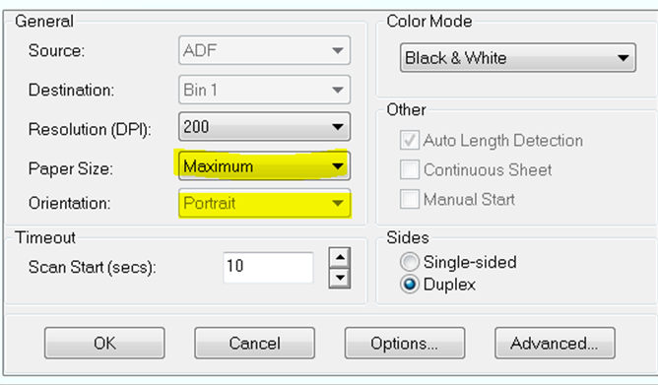
- Select Options
- Select Front Rotation = 180, and Back Rotation = 180 (see Figure 2)

Figure 2
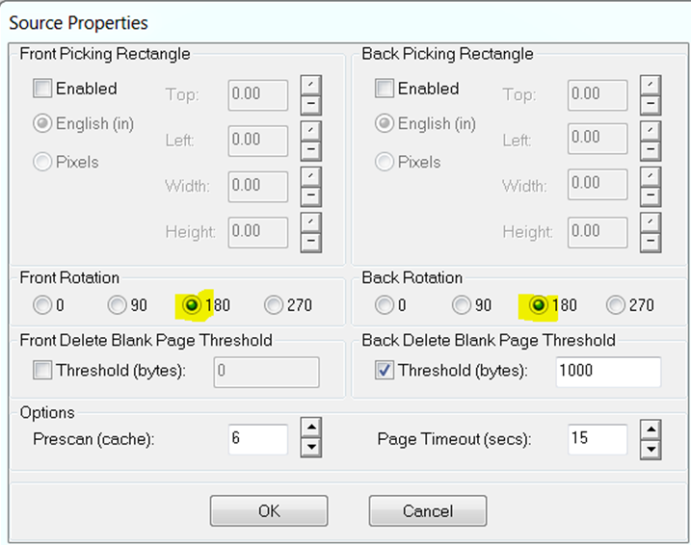

- Select OK
- Select OK
- The settings will return to Landscape orientation when you open your next batch. If they do not, change them manually using the same steps as above, with these selections:
- Paper Size = Letter
- Orientation = Landscape
- Front Rotation = 90, Back Rotation = 90

POLICIES / RELATED DOCUMENTS:

- N/A

OTHER PARTIES INVOLVED:

- N/A

TIME / VOLUME:

- 30 seconds / Volume depends on how many legal sized documents are filed each month.

FREQUENCY:

- Frequency depends upon how frequently legal sized documents are filed each month.

PERFORMANCE MEASURE:

- N/A

SYSTEM ACCESS REQUIRED:

- Kofax

REPORTS / FORMS:

- N/A

DEFINITIONS:

- N/A

APPLICABILITY:

This procedure applies to all employees of the Clerk of the Court.

REVISION HISTORY:

Revision Number | Revision Author | Summary of Changes | Approval Date
- | Chris Cerrato | Document Origination | 01/08/2014
A
B
C

