PURPOSE:

To provide instructions for EDM QC staff to search for unfinished electronic work on a weekly basis.

OBJECTIVE:

- To ensure that documents that have not been processed correctly or timely (“exception documents”) are identified and fixed promptly.

EVENT DRIVER:

- These procedures are carried out weekly, preferably each Friday.

BACKGROUND:

The following procedures will be completed weekly, and are of critical importance. They are the final look through the OnBase database to check for unfinished electronic work (which is similar to a paper document being misplaced), and keyword problems.

The various searches outlined below will identify the following items:
- Missing keywords
- Garbled keywords
- Invalid docket codes
- Incorrect Security keywords
- Undocketed items
- Unprocessed and unfinished work
- Images that need reindexing into the correct document type

These searches may be done more frequently than weekly, but the final search must be done after the completion of the work for the period being checked.

- Example: If there are predockets or priority workflow documents with scan dates of 12/15/13, the check can only be done up to 12/14/13 for that particular case type.

Sweeps Audit Log: After the sweeps have been done, update the sweeps audit log on the S drive at \\COSCDSM4400\share\Doc_Management\EDM Quality Control\EDM .

PROCEDURES:
QC Procedures/Sweeps.
- Garbled Case Number Keywords: (Example: PB201Z-Z02330)
- Garbled Keywords are most often caused by a system error, a printer error, or poor quality barcodes (can be a user error if toner is too light).
- In OnBase, perform a search in Custom Query: EDM QC – Garbled Case Number Keywords for the period being audited. (See Figure 1)

Figure 1
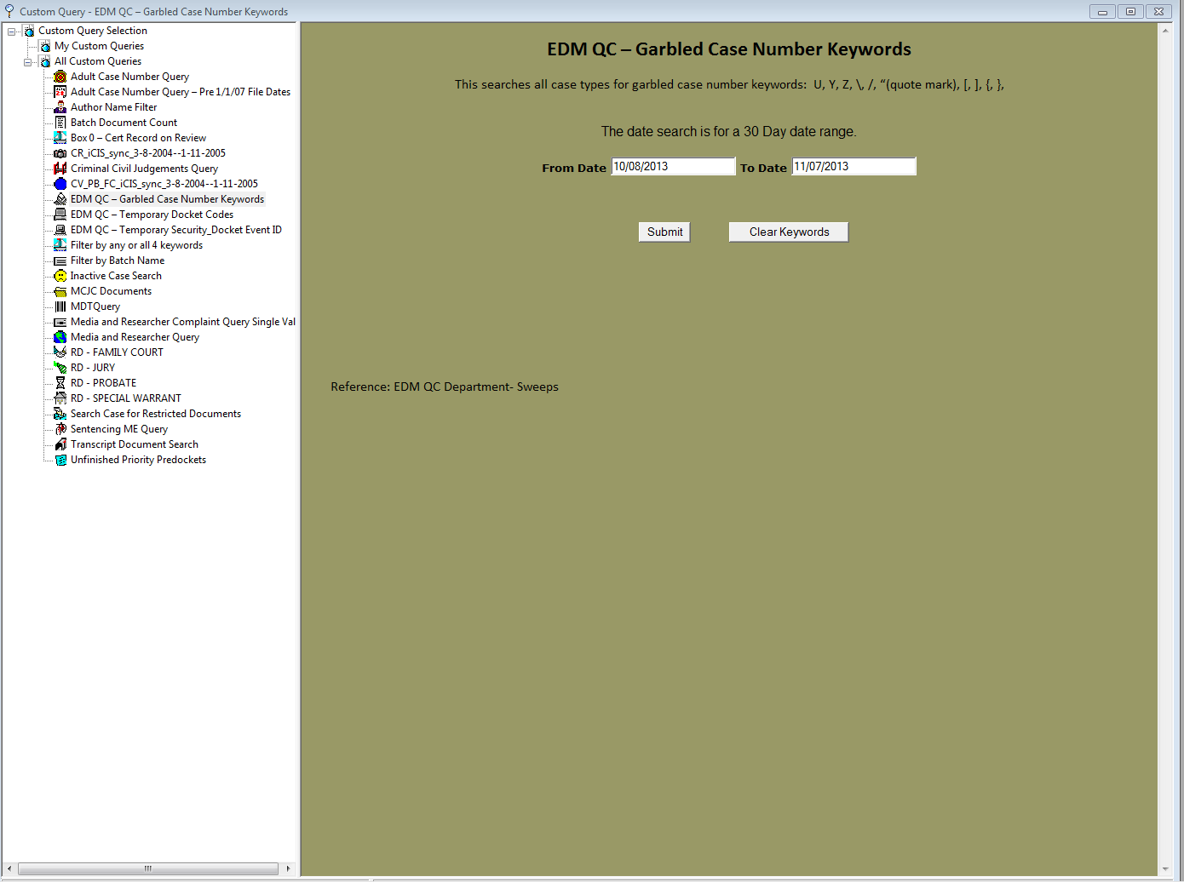

- Garbled keywords can be audited up to the previous day. Today’s work might still be in the QC Queue – so leave that for the person working the QC Queue. If today is November 7, 2013 the audit period is 60 days (from September 6, 2013 to November 6, 2013).
- Run the iCIS Sync script to update keywords on images with a Docket Event ID keyword.
- A minimal number of garbled keywords can be expected; if a larger problem is seen, it needs to be investigated and addressed. Bring to EDM QC manager’s attention. (See Figure 2)

Figure 2
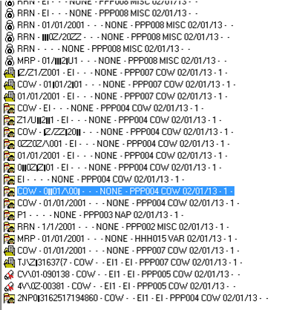

- Temporary Docket Codes (an indicator of incomplete work):
- Determine period to audit: Check predockets and priority dockets to determine the oldest work still pending.
  - Example: If today is November 7, 2013, and it is found that predockets are current to 10/29/13 and priority dockets are current to 10/26/13, the search period is 8/27/13 to 10/26/13, 60 days.
- For the period being audited, run a search using Custom Query: EDM QC – Temporary Docket Codes (See Figure 3). Look at the history and see where the problem occurred.
Figure 3
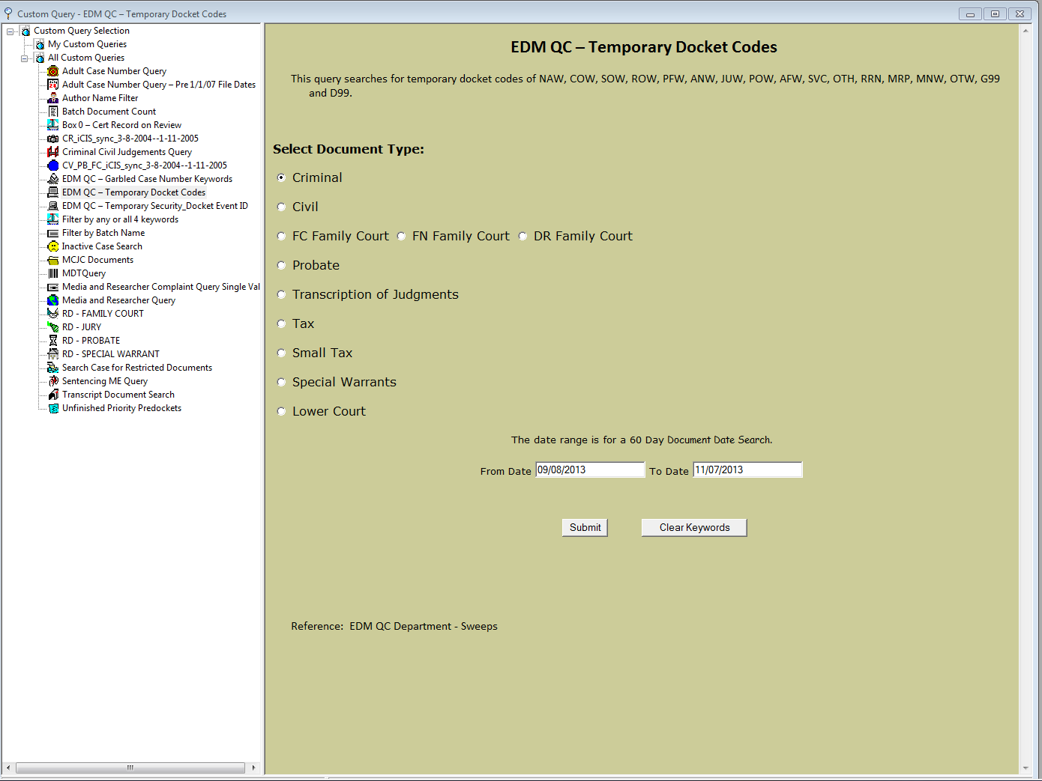

- If it was a user error (usually this is EDM QC staff) sends the user an email and screen print, and copy EDM QC Manager.
- If it was a system error or an unexplained error, email the EDM QC Manager.
- If the document is “buried” in a workflow, move it to the supervisor queue for faster processing.
- Correct as necessary. Any unfinished work should be processed ASAP. Request assistance from the auditors when necessary. Move documents into the OnBase Sweeps envelope (see section VII Sweeps Envelope below) and monitor daily to ensure completion. When document keywords are updated and complete, remove from the folder. See Figure 4.
Figure 4
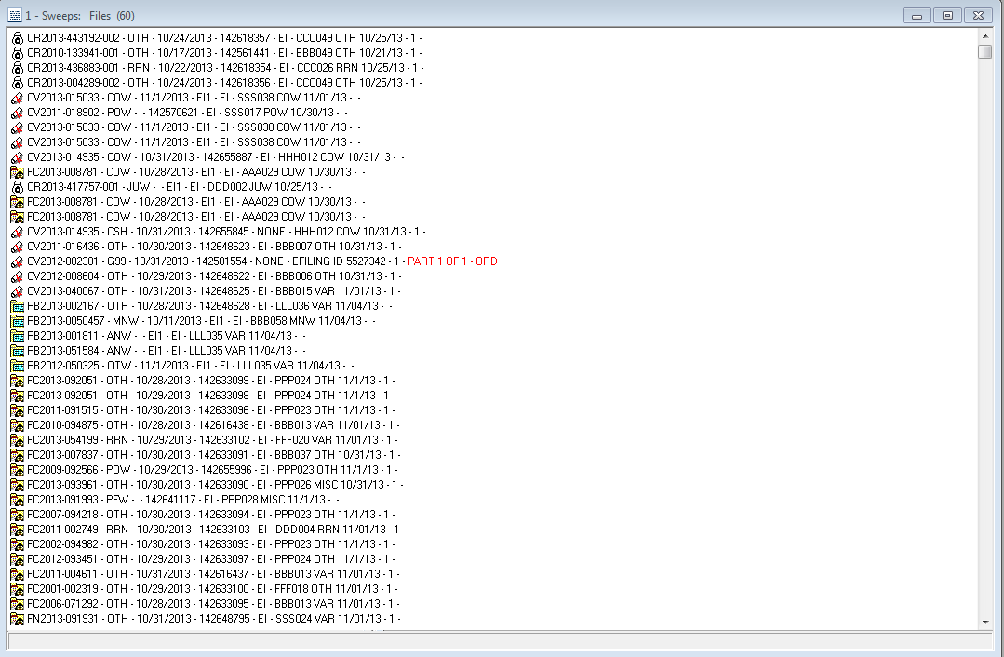

  - Note: If after 7 days, the keywords on the image remain unfinished, ask for a status update and enter it on a note on the image.

Current List of Temporary Docket Code Keywords

NAW COW SOW
ROW PFW ANW
JUW POW AFW
SVC OTH RRN
MRP MNW OTW

- Temporary Security(EI) ; Temporary Docket Event ID(EI1); Temporary Parties (EI):
- The following searches will locate incomplete work or system errors. Use Custom Query: EDM QC – Temporary Security/Docket Event ID. (See Figure 5)
Figure 5
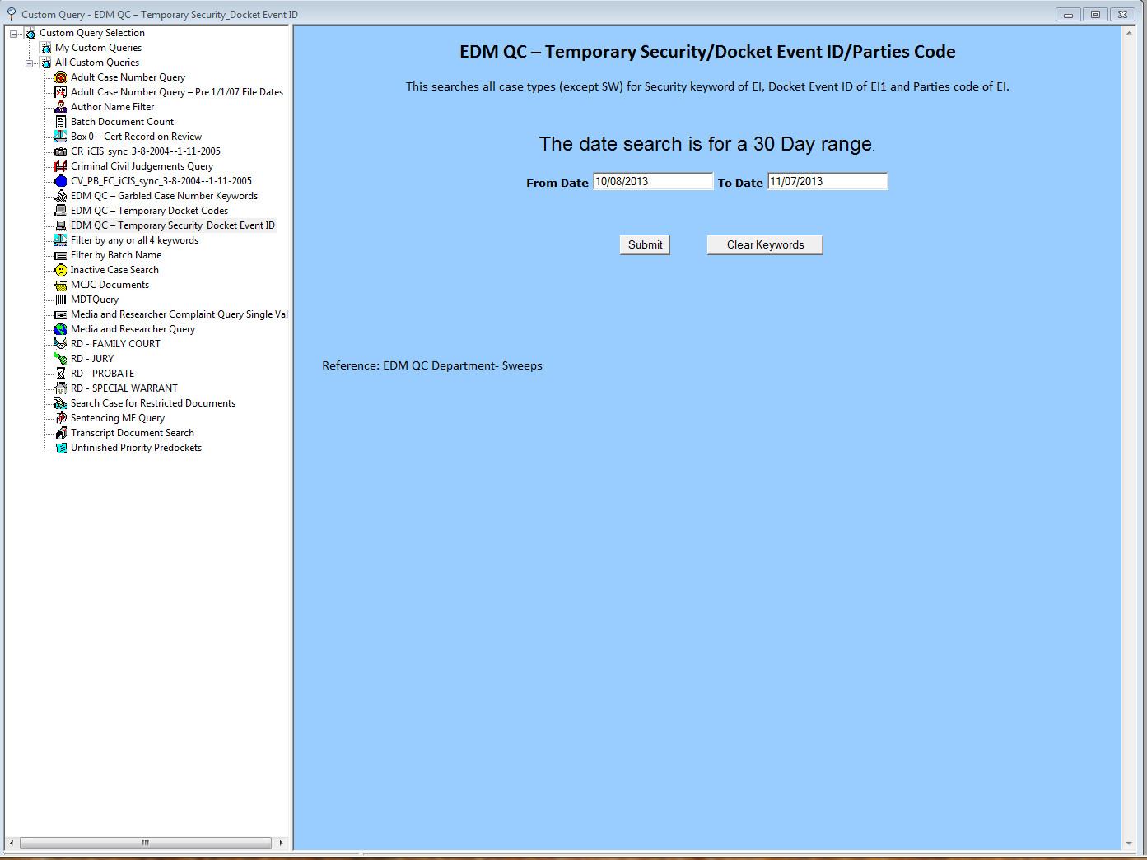

- Period to Audit: Same as for Temporary Docket Codes.
- Any incomplete work should be processed ASAP. Request assistance from the auditors when necessary. Move the images into the OnBase Sweeps envelope; add notes if necessary to indicate status.

- Incorrect Security Keyword:
- Period to Audit: These can be audited up to the previous day. Today’s work might still be in the processor. If today is November 7, 2013, the audit period is September 6, 2013 to November 6, 2013.
- Run the Restricted Document – Security Search query (See Figure 6).

Figure 6
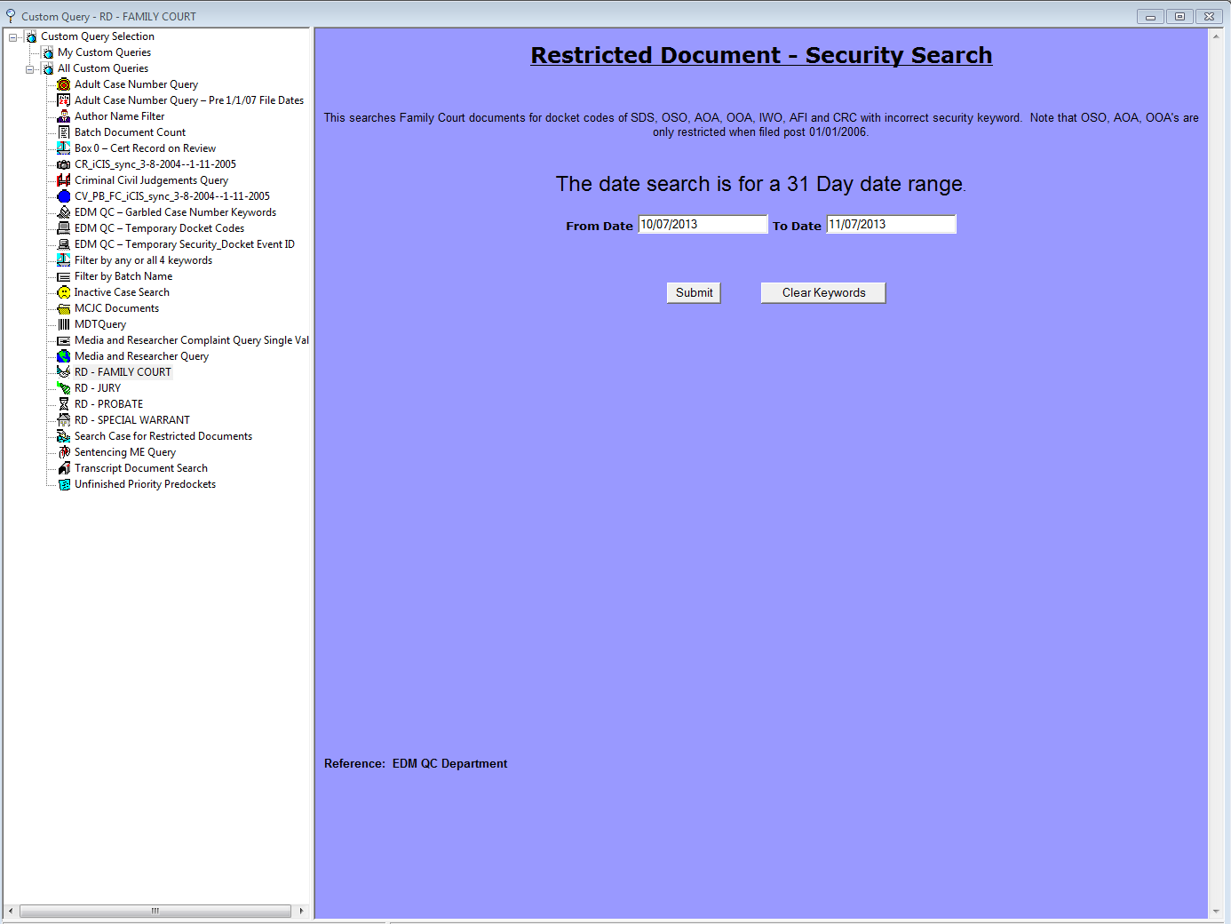

- There is a Restricted Document Security Search query for RD-Family Court,
RD – Jury, RD-Probate, and RD –SWW. The RD-SWW searches for Search Warrant cases. This query may bring up work that is being processed today even though it was scanned some time ago. The work may not have been through the Synchro queue yet. To ensure that is the case, run the iCIS Synch script on the resulting documents, then re-run the query. If something comes up, check to see why.
- If it was caused by user error (usually this is EDM QC staff) sends user an email and screen print, and copy EDM QC Manager. If it was caused by system error, email to the EDM QC Manager.

- Missing Keywords Report (an indicator of incomplete work):
- For the period being audited, run the missing keywords report on the EDM web site (one month at a time).
- Research the documents.
- Resolve each issue returned on the report; only sealed documents on unsealed cases will remain with missing keywords.
- If it was a user error (usually this is EDM QC staff) sends the user an email and screen print, and copy EDM QC Manager.
- Place anything that you can’t immediately resolve in the Sweeps envelope in OnBase, and place a note on the document indicating what action is being taken.
  - Example: “Emailed _____ to assist in locating a case number”

- Incorrect Document Types – when time permits:
- This search identifies images that are in the incorrect document type. For example: A CV image that is in the TJ document type. When image is located, reindex it to the proper case type.
- This search is not critical, but for consistency of the database, it should be done monthly.
- Period to Audit: See the audit log and select a range that has not been audited. You can audit up to the present date.
- For the period being audited, run the following searches in OnBase:

      - CR_____ Case number <> CR????-??????*
      - CV_____ Case number <> CV????-??????
      - LC_____ Case number <> LC????-??????*
      - MH_____ Case number <> MH????-??????
      - MS_____ Case number <> MS????-??????
      - PB_____ Case number <> PB????-??????
      - ST_____ Case number <> ST????-??????
      - SW_____ Case number <> SW????-??????
      - TJ_____ Case number <> TJ????-??????
      - TX_____ Case number <> TX????-??????

      - For FC cases, see Figure 7:

Figure 7
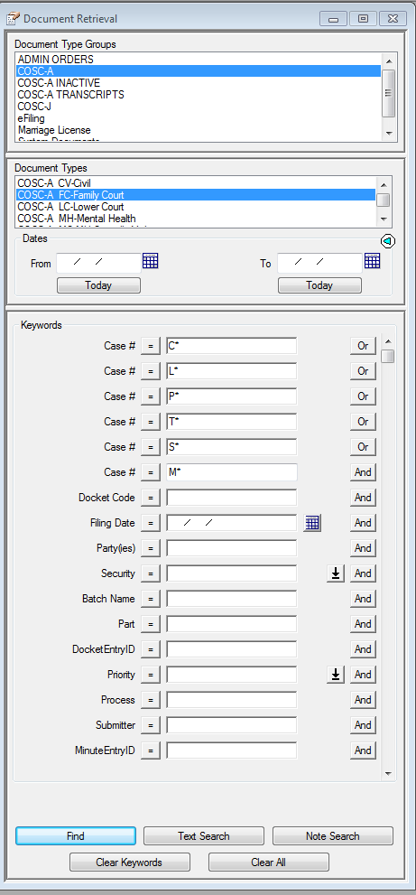

- Sweeps Envelope:
- To access the Sweeps envelope, click on the User option on the OnBase menu bar. A drop down menu appears. (See Figure 8)

Figure 8
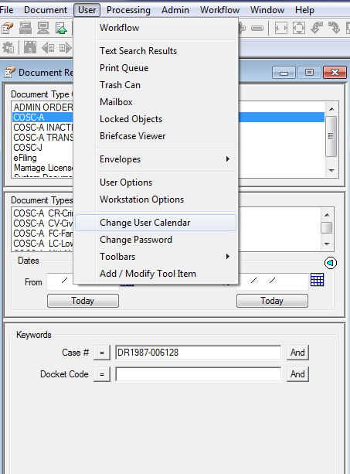

- Select the Envelopes option. Select Open Envelope option. (See Figure 9)

Figure 9
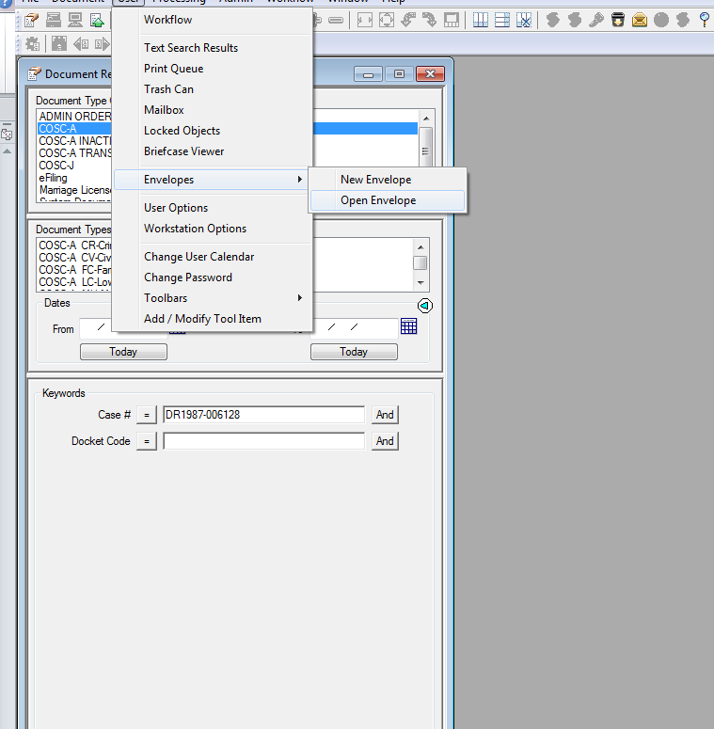

- Select Sweeps option. (See Figure 10)

Figure 10
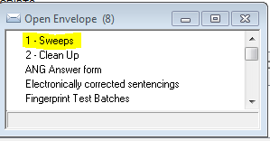
- Highlight the images that need to be sent to the Sweeps envelope. Left click and select Send To option on the dropdown menu. Select Envelope option. Select Sweeps. (See Figure 11)

Figure 11
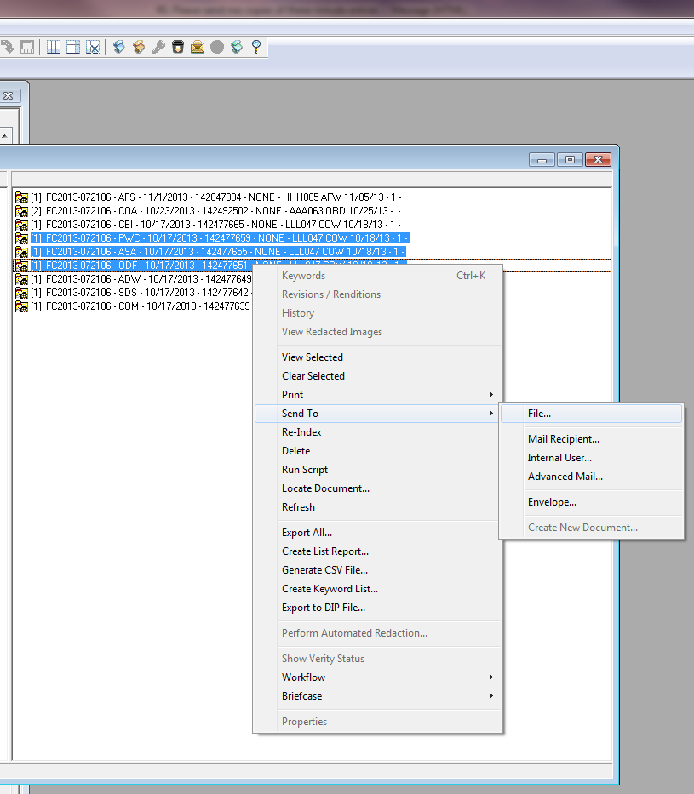

POLICIES / RELATED DOCUMENTS:

- None

OTHER PARTIES INVOLVED:

- Case type auditors

TIME / VOLUME:

- Time to complete the process depend on the number of exception documents found, which is usually 20 to 30 documents.

FREQUENCY:

Sweeps are completed by the assigned EDM QC lead each Friday (or Thursday if the lead is out on Friday). After moving documents into the Sweeps envelope, monitor daily and remove anything that is complete. Anything that has not been handled by the end of the week needs to be brought to a supervisor/auditor’s attention.

PERFORMANCE MEASURE:

- N/A

SYSTEM ACCESS REQUIRED:

- OnBase
- Sweeps Envelope

REPORTS / FORMS:

- N/A

DEFINITIONS:

- N/A

APPLICABILITY:

This procedure applies to all employees of the Clerk of the Court.

REVISION HISTORY:

Revision Number | Revision Author | Summary of Changes | Approval Date
- | Chris Cerrato | Document Origination | 11/07/2013
A | Eileen Fenner | Reviewed | 03/05/2019
B
C

