PURPOSE:

To provide instructions for resolving all documents and minute entries on the monthly Unlinked Documents Report (Stage 4 List) of iCIS docket events with no images.

OBJECTIVE:

- To provide the necessary direction to ensure that all docket events without images have been resolved.

EVENT DRIVER:

- The unlinked documents report (Stage 4 List) is generated by CTS on the 1st and 15th of each month.

PROCEDURES:

- The Unlinked Documents Report (Stage 4 List) is generated on the 1st and the 15th of each month. It is an Excel document located on the U: drive to obtain access to this folder, contact ITG. The list(s) are named as follows:
  - UnlinkedDocuments1stofeachmonthCOC [date generated]
  - UnlinkedDocuments15thofeachmonthCOC [date generated]
- Format the list generated on the 1st as follows:
  - Sort the list by the Docket Date.
  - Highlight and copy the documents listed from the top through roughly the 19th of the month.
  - Paste the copied cells in the template located on the S:\Doc_Management\EDM Quality Control\EDM QC Procedures\Stage 4 Audit.
  - Sort by docket code and place the documents on one of the following tabs: Documents (alpha docket codes), Minute Entries (numeric docket codes), or Court Admin (COA, ERC, NLS, NIC, OLP, OLS, OPH, 047, 070, 322, 323, 399, 435, and 473).
  - Sort the documents on the individual tabs by case type.
  - Sort each case type by case number in descending order.
  - Save the list in S:\Doc_Management\EDM Quality Control\EDM QC Procedures\Stage 4 Audit as [Month] – First List
- Format the list generated on the 15th as follows:
  - Sort the list by the Docket Date.
  - Highlight and copy the documents from the day following the date selected in step 2B above, through the end of the month.
  - Follow steps 2C - 2F above.
  - Save the list in S:\Doc_Management\EDM Quality Control\EDM QC Procedures\Stage 4 Audit as [Month] – Second List.
- On the Minute Entry tab, determine if the docket event is a duplicate docket event.
  - If it is determined the docket event is a duplicate, record the name of the person who docketed it and a note stating “duplicate deleted”. Example: M. Monick – duplicate deleted.
  - Delete the duplicate docket event.
  - If it was determined the docket event is not a duplicate, continue on to the next step.
- Search the case number in OnBase and view the documents filed around the same time as the document being searched.
  - If the image is located, update the keywords, activate the icon, and restart workflow if necessary.
  - If the image was not located, continue on to the next search.
- Search for the file date and docket code in OnBase.
  - View all the results to see if it was scanned under the wrong case number or attached to another document.
  - If the image is located, update the keywords, activate the icon, and restart workflow if necessary.
  - If the image was not located, continue on to the next search.
- Search in OnBase for the batch number that the document might have been scanned into.
  - If the image is located, update the keywords, activate the icon, and restart workflow if necessary.
  - If the image was not located, continue on to the next step.
- Send the list of missing minute entries to the Courtroom Services Managers requesting the original or duplicate original.
- Continue to monitor the list until all minute entries are accounted for.
- After two weeks, send a reminder to the Courtroom Services Managers with a revised list of minute entries that are still missing.
- On the Court Admin tab, follow steps 4, 5, 6, and 7.
  - If a Court Admin notice is not located:
    - For Probate, generate a duplicate original in iCIS on the Reports tab using option 16 or 17. See Figure 1.
Figure 1
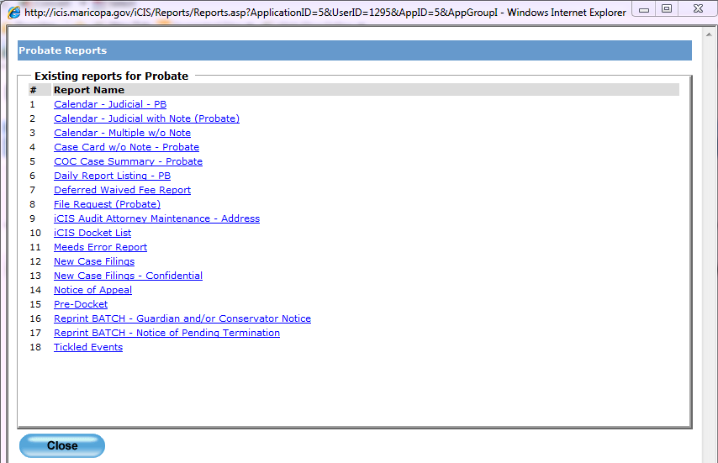
- For other case types, contact Court Administration personnel as follows:
      - Civil Court Administration Supervisor
      - Family Court Administration Management:
        - OPH – Family Court Supervisor
        - COA – Family Court Supervisor
        - 070 – Alternative Dispute Resolution Program Coordinator
        - All Other FC – Family Court Deputy Administrator
  - When a response has been received, either delete the docket event or import the duplicate image sent by Court Admin.
    - To delete COA docket events, email the ITG Help Desk and copy the Document Management Administrator and the Family Court Administrator.
- On the Documents tab, follow steps 4, 6, 7 and 8 (A).
  - If the document in not found, determine what batch the document should have been scanned into and request the paper batch(s) from Fileroom CSC.
  - If the document is not found, refer to Public Records Manager and EDM QC Supervisor for further direction.

POLICIES / RELATED DOCUMENTS:

- N/A

OTHER PARTIES INVOLVED:

- Document Management Administrators
- Courtroom Service Administrators
- Court Administration Personnel
- Public Records Manager
- Court Operations Manager (Auditors)
- Court Operations Supervisor (Auditors)
- EDM QC Supervisor

TIME / VOLUME:

- Time varies. Average 275 entries a month.

FREQUENCY:

- Unlinked Documents (Stage 4 List) is generated by CTS twice a month.

PERFORMANCE MEASURE:

- N/A

SYSTEM ACCESS REQUIRED:

- iCIS
- OnBase
- Batch Log
- MEEDS
- U: drive

REPORTS / FORMS:

- N/A

DEFINITIONS:

- N/A

APPLICABILITY:

This procedure applies to all employees of the Clerk of the Court.

REVISION HISTORY:

Revision Number | Revision Author | Summary of Changes | Approval Date
- | Chris Cerrato | Document Origination | 11/06/2013
A | Chris Cerrato | Numerous changes and updates to the procedure to reflect current processes. | 08/14/2017
B | Eileen Fenner | Reviewed | 03/01/2019
C

