PURPOSE:

To provide instructions for understanding document history screens in OnBase for the purpose of researching case documents.

OBJECTIVE:

- To provide the necessary documentation to ensure that staff can read, understand and use the document history screens as needed for their document correction activities.

EVENT DRIVER:

- A document exception occurs: A document fails to process in OnBase correctly.

PROCEDURES:

- Open a document in OnBase.
- Right click on the document for a menu, and then select History (you may also put an icon on your OnBase toolbar).
- Document History Screen Appears (see Figure 1).
Figure 1
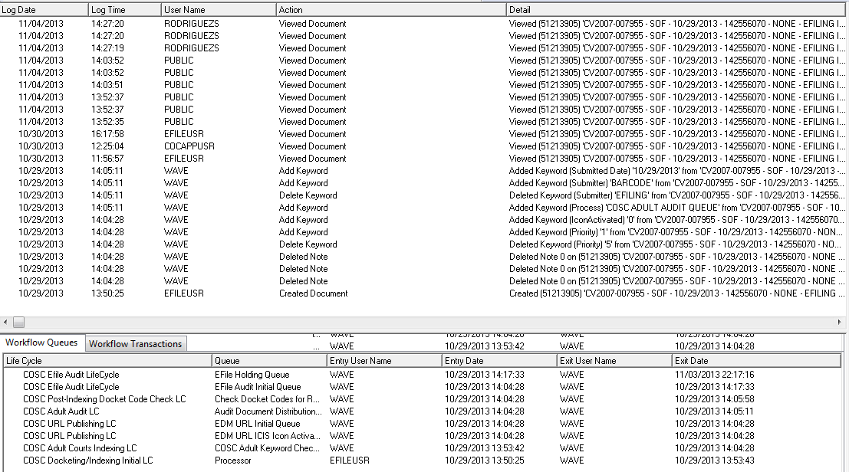

- The upper portion of the screen (Figure 2) shows each user who interacted with the document to:
- Create the document
- View
- Print
- Delete
- Change keywords
- Etc.
Figure 2
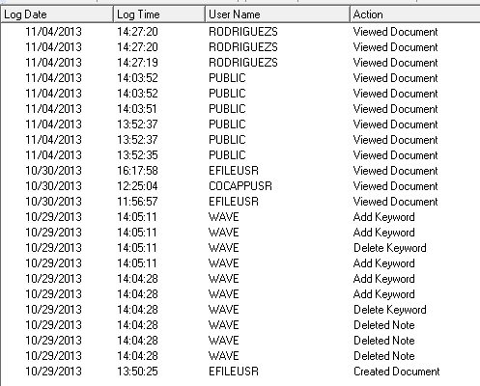

- The lower portion of the document history screen (Figure 3) shows:
- Each lifecycle and workflow queue the document has passed through (or is still in).
- The time of entry and exit from each queue.
- The user responsible for sending to a queue or removing from a queue.

Figure 3
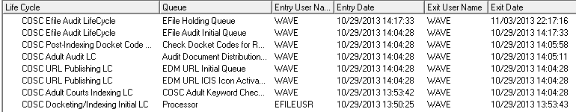

POLICIES / RELATED DOCUMENTS:

- None

OTHER PARTIES INVOLVED:

- None

TIME / VOLUME:

- 5-20 times per day; time spent depends upon the difficulty of determining the information needed from the screen.

FREQUENCY:

- Document history is used on a daily basis by EDM QC department staff.

PERFORMANCE MEASURE:

- N/A

SYSTEM ACCESS REQUIRED:

- OnBase

REPORTS / FORMS:

- N/A

DEFINITIONS:

- N/A

APPLICABILITY:

This procedure applies to all employees of the Clerk of the Court.

REVISION HISTORY:

Revision Number | Revision Author | Summary of Changes | Approval Date
- | Chris Cerrato | Document Origination | 11/05/2013
A | Eileen Fenner | Reviewed | 03/01/2019
B
C

