PURPOSE:

To provide instructions for electronically correcting sentencing minute entries.

OBJECTIVE:

- To provide the necessary direction to ensure that sentencing minute entries are electronically corrected and the integrity of the thumbprint is not lost.

EVENT DRIVER:

- Detecting an error on a sentencing minute entry.

PROCEDURES:
- Save the sentencing minute entry as a PDF document using the Save As option in the File menu on the menu bar in OnBase. (See Figure 1)

Figure 1
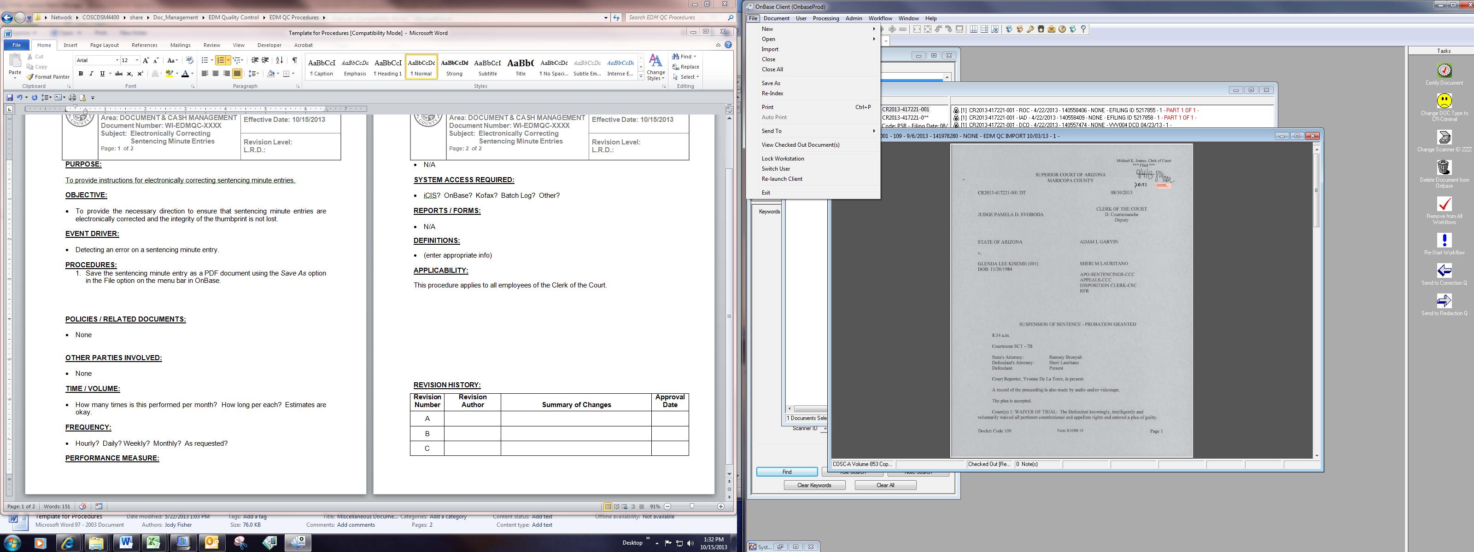

- The Save As dialog box opens. Select PDF from the drop down menu and click the Save button. (See Figure 2)

Figure 2
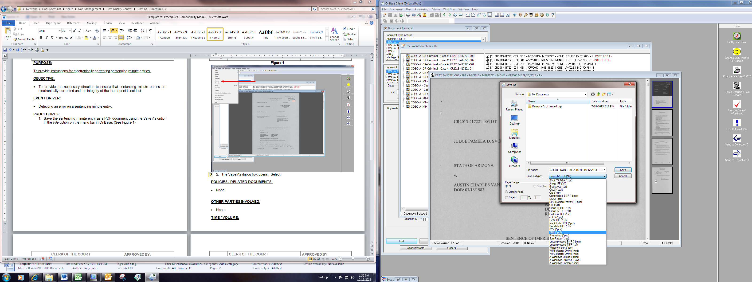

- Open the document and select the Extract Page button. (See Figure 3)

Figure 3
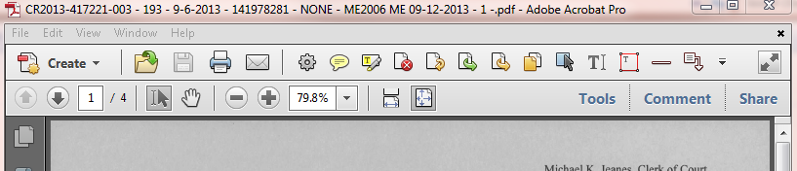

- Select the page number you wish to extract and then click the delete page option. DO NOT extract the fingerprint page. If a change is requested to the fingerprint page, refer to the EDM QC Manager. (See Figure 4)

Figure 4
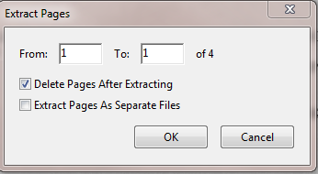

- A dialog box appears asking for confirmation of the page deletion. Click Yes. (See Figure 5)
Figure 5

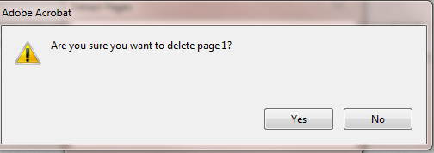

- Using the Adobe markup tools, make the needed correction to the file date, the hearing date, the docket code, or the case number. Add the correction stamp to the correction. (See Figure 6)
Figure 6
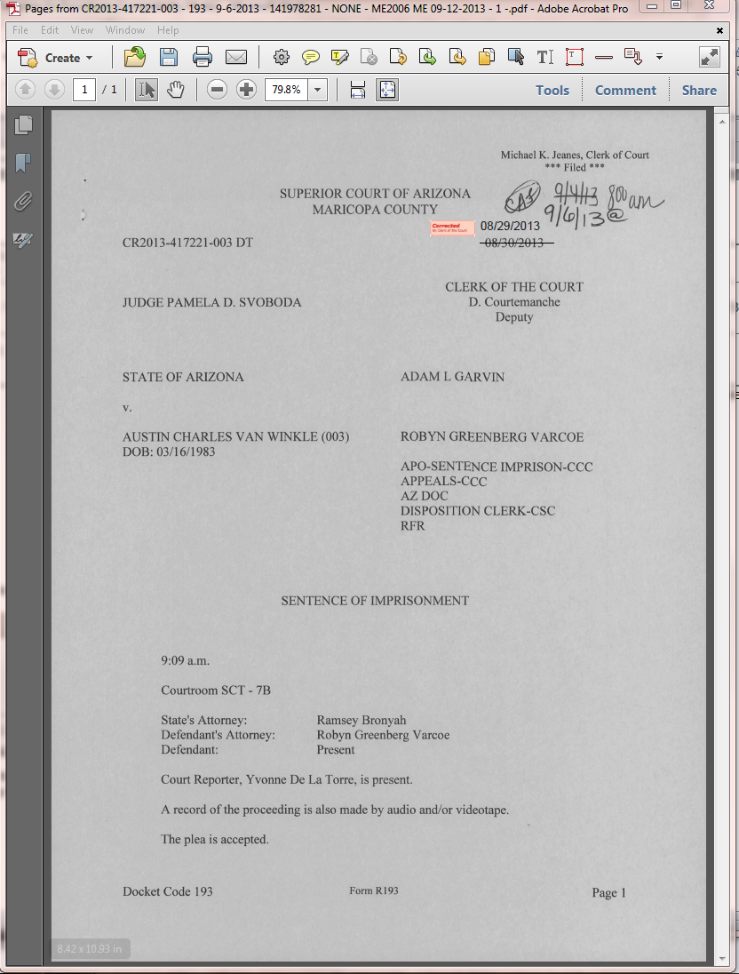

- Select the Print option on the tool bar and select Adobe PDF as the Printer and click on the Print button. (See Figure 7) Name the corrected page and save to the desktop.
Figure 7
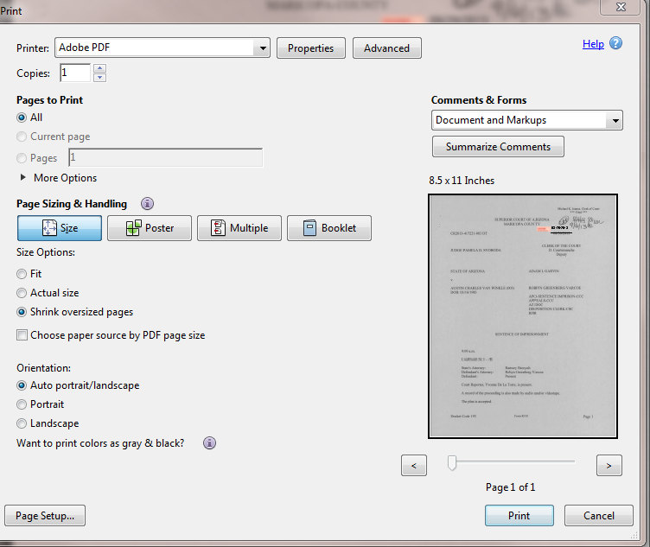

- Click on the original Adobe document and select the Insert Page option. (See Figure 8).

Figure 8

- The location where you printed and saved the corrected page will open. Highlight the the corrected page and click the Select button. (See Figure 9)

Figure 9
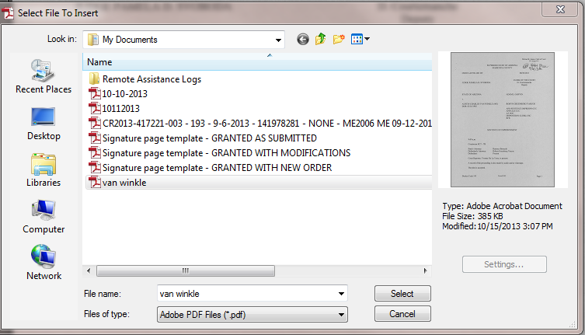

- A dialog box opens asking where the page should be inserted. Click either the Before or After button, depending upon where the page should be located in the document. (Generally, the first page is the one being corrected, so to insert it properly, select Before. (See Figure 10)

Figure 10
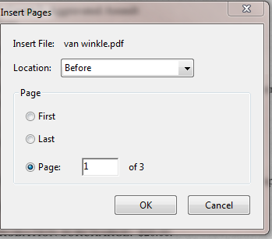

- Click on the Save option in the Adobe Menu Bar (see Figure 11). Import the Adobe document into OnBase using the keywords from the original image. Delete the original image in OnBase.

Figure 11
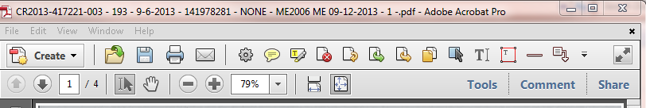

POLICIES / RELATED DOCUMENTS:

- None

OTHER PARTIES INVOLVED:

- None

TIME / VOLUME:

- Four to five times per month. Five minutes per correction.

FREQUENCY:

- As requested

PERFORMANCE MEASURE:

- N/A

SYSTEM ACCESS REQUIRED:

- OnBase
- Adobe Professional

REPORTS / FORMS:

- N/A

DEFINITIONS:

- N/A

APPLICABILITY:

This procedure applies to all employees of the Clerk of the Court.

REVISION HISTORY:

Revision Number | Revision Author | Summary of Changes | Approval Date
- | Chris Cerrato | Document Origination | 10/15/2013
A | Eileen Fenner | Reviewed | 03/01/2019
B
C

