PURPOSE:

To provide instructions for scheduling, completing, and processing the monthly scanning audits.

OBJECTIVE:

- To provide the necessary directions to ensure accurate and consistent monthly scanning audits and audit results.

EVENT DRIVER:

- End of month auditing of scanning staff is required so the results can be used to determine scanning accuracy and manage errors.

PROCEDURE:
- Scheduling the Monthly Audits
- Each following business day before the beginning of the next month, review the EDMS Batch Log to identify all scanner locations that were used to scan that month.
- Use the EDM QC Audit Log located at S:\Doc_Management\EDM Quality Control\Statistics to assign weekly scanner audits to the EDM QC Leads and Specialist.
- Send the Scanner Audit Schedule to the EDM QC specialists and leads, and copy the EDM QC Manager.
- Request the audits be completed no later than the second business day of the month, since the adult and juvenile Scanner Audit Results need to be compiled by the second business day of the month.
- Request that the EDM QC specialists and leads email you and copy the EDM QC Manager when they have completed the audits.

- Completing Individual Audits
- Use the EDM QC Audit Log to create daily audits for each scanner location assigned to be scanned with.
- Generate a monthly Batch Log Report from EDMS Batch Log found in the Secured Applications section on the COCweb for each operator on the list.
- Select a total of 7% of the total documents scanned each day throughout the month. Audit all documents in the batches that have been selected.
  - The document total should be as close to 7% of the total documents as possible, without going under 7%.
  - If less than 7% of documents were scanned for the month, audit 100 percent of the documents that were scanned.
  - Select a variety of document types when possible.
- Use OnBase Thick Client to retrieve each batch listed on the Scanner Audit Log. Copy the batch name from the EDMS Batch Log, paste it into the batch name field in OnBase, and select Find.
- Maximize the first document in the batch. Review each document individually, and then close by clicking the X in the upper right corner of the document.
  - Review each document for the following items:
    - Complete case number.
    - Complete file stamp.
    - Overlapping pages.
    - Upside down pages.
    - Back pages not deleted.
  - Additional errors are noted in REFDOC-EDMQC-1002: Guidelines for Auditing the Scanners.
- Use REFDOC-EDMQC-1002: Guidelines for Auditing the Scanners to determine the validity and point value of each scanning and document processing error.
- Prepare scanning errors (See Figure 1) for operators to be added to the Scanning Audit Forms Folder; save the scanning errors to the monthly Scanner Errors folder.

Figure 1
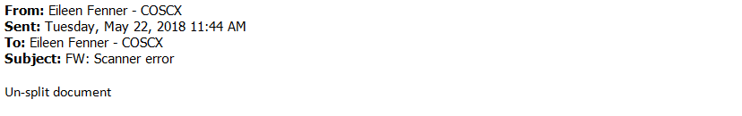
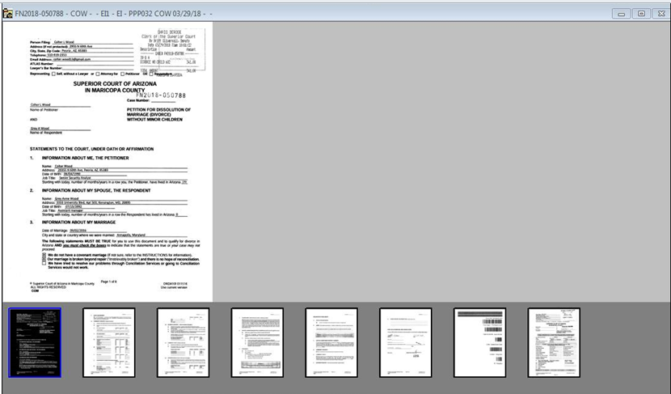
- Prepare document processing error emails for preppers save the document processing errors to the monthly Scanner Audits Errors folder.

- Processing the Audits
- Review the Scanner Audit Log, Scanner Error emails, and the Document Processing Error emails for accuracy and legibility:
  - Check the spelling of each name.
  - Confirm the supervisors are correct.
  - Check that each error belongs to the individual being audited.
  - Confirm that each screen shot clearly indicates the error.
- Create folders for each operator in the Scanner Audits folder at S:\Doc_Management\ EDM Quality Control\EDM QC Procedures\Scanner Audit Forms\ for the year and month being audited. See Figure 2.

Figure 2
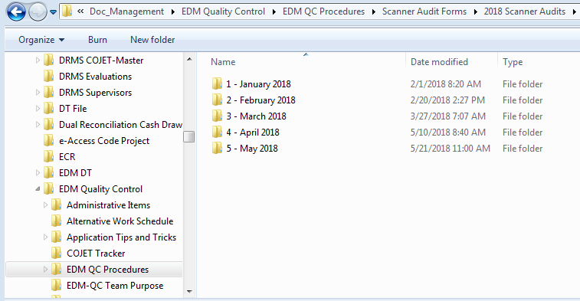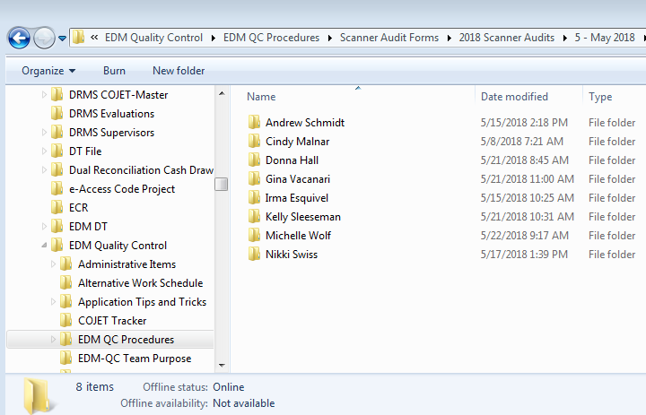

  - Add the: Scanner Audit errors for each operator to each individual operator folder.
  - Group the individual operator folders into supervisor folders.
- Create folders for each individual who has a document processing error for the month being audited in the folder. See Figure 2.
  - Group the individual folders into supervisor folders.
- Complete the Adult Scanner Audit Results charts located at S:\Doc_Management\Scanner Audits for EDM Supervisors\EDM QC AUDIT LOG
  - Enter the number of documents audited, number of pages audited, # of errors, and number of Metric errors for each operator

    - # Of Errors = the weighted error total. For example, if the operator missed a file stamp, the # of Errors would be 1.
    - Metric Actual Errors = the amount of errors without weights, not including procedural errors. For example, if the operator missed a first page, the Metric Actual Errors would be 1. If the operator did not enter the page and document counts in the batch log, that would not be counted because it is a procedural error.
  - Enter the auditor initials.
  - Check the formulas to be sure they capture the correct values.
- Copy the All Scanner Audits folder and save to S:/Doc_Mgmt/Scanner Audits for EDM Supervisors [Month, Year].
- Send the Scanning Audits message to all scanning supervisors and managers, copying the document management administrators and the deputy director. The message format can be found in Standard Language for EDM QC Messages at S:\Doc_Management\EDM Quality Control\EDM QC Procedures\Miscellaneous.
- Send each operator their scanner errors, and copy their supervisor. Use the Scanning Audits and Document Processing Errors from Standard Language for EDM QC Messages.
- Send each staff person their document processing errors, and copy their supervisor. Use the Standard Language for EDM QC Messages.

POLICIES / RELATED DOCUMENTS:

- REFDOC-EDMQC-1002: Guidelines for Auditing the Scanners
- Standard Language for EDM QC Messages

OTHER PARTIES INVOLVED:

- Document Processing Area Supervisors and Auditors

TIME / VOLUME:

- Varied

FREQUENCY:

- Daily

PERFORMANCE MEASURE:

- N/A

SYSTEM ACCESS REQUIRED:

- COCweb>Secured Applications>EDMS Batch Log
- iCIS
- OnBase Thick Client
- Microsoft Word
- Microsoft Excel

REPORTS / FORMS:

- Scanner Audit Log
- Adult Scanner Audit Results chart
- Juvenile Scanner Audit Results chart

DEFINITIONS:

- N/A

APPLICABILITY:

This procedure applies to all EDM QC staff of the Clerk of the Court.

REVISION HISTORY:

Revision Number | Revision Author | Summary of Changes | Approval Date
- | Chris Cerrato | Document Origination | 06/26/2013
A | Chris Cerrato | Updated reference numbers that occur in body of work instructions. | 06/18/2014
B | Eileen Fenner | Included screenshots and updated work procedures | 05/23/2018

