PURPOSE:

To provide instructions for monitoring the OnBase processing queues.

OBJECTIVE:

- To provide the necessary direction to ensure that the OnBase processing queues are monitored to see that they are processing normally and timely.

EVENT DRIVER:

- The OnBase processing queues are set on timers to run periodically throughout the day. Occasionally, the timer may not run, or a document may get caught in the queue without being processed. EDM QC staff monitors the queues daily at 10:00 a.m., 11:30 a.m., 1:00 p.m. and 3:30 p.m. to look for these issues and either resolve them or alert ITG to take action.

PROCEDURES:
- Open OnBase Thin Client in COCWeb screen. See Figure 1.

Figure 1
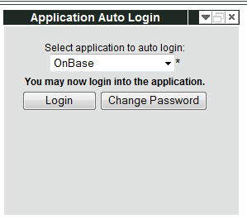

- Select Document option on the menu. A drop down menu appears. See Figure 2.

Figure 2
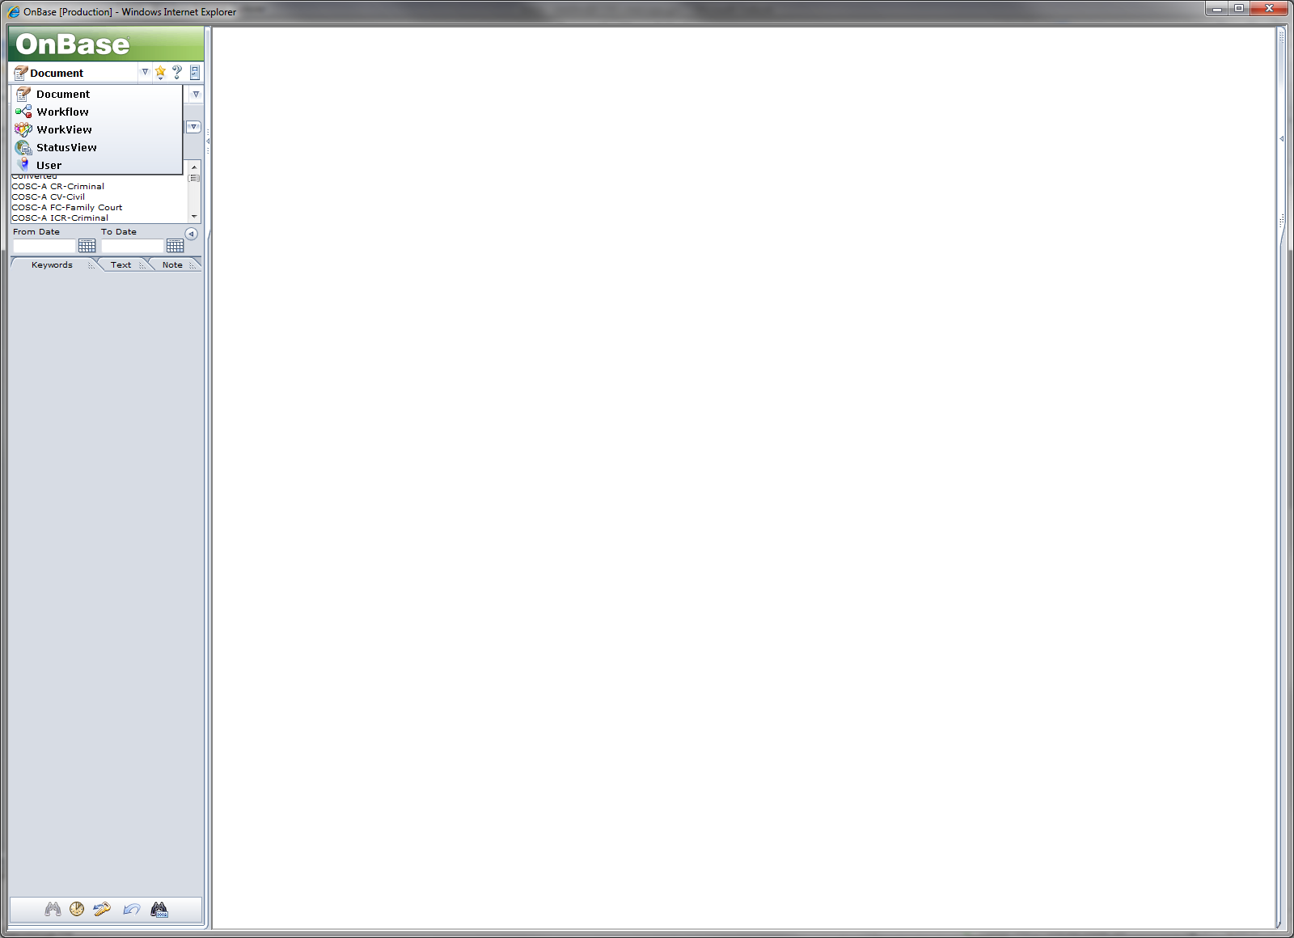

- Select the Status View option. See Figure 3.

Figure 3
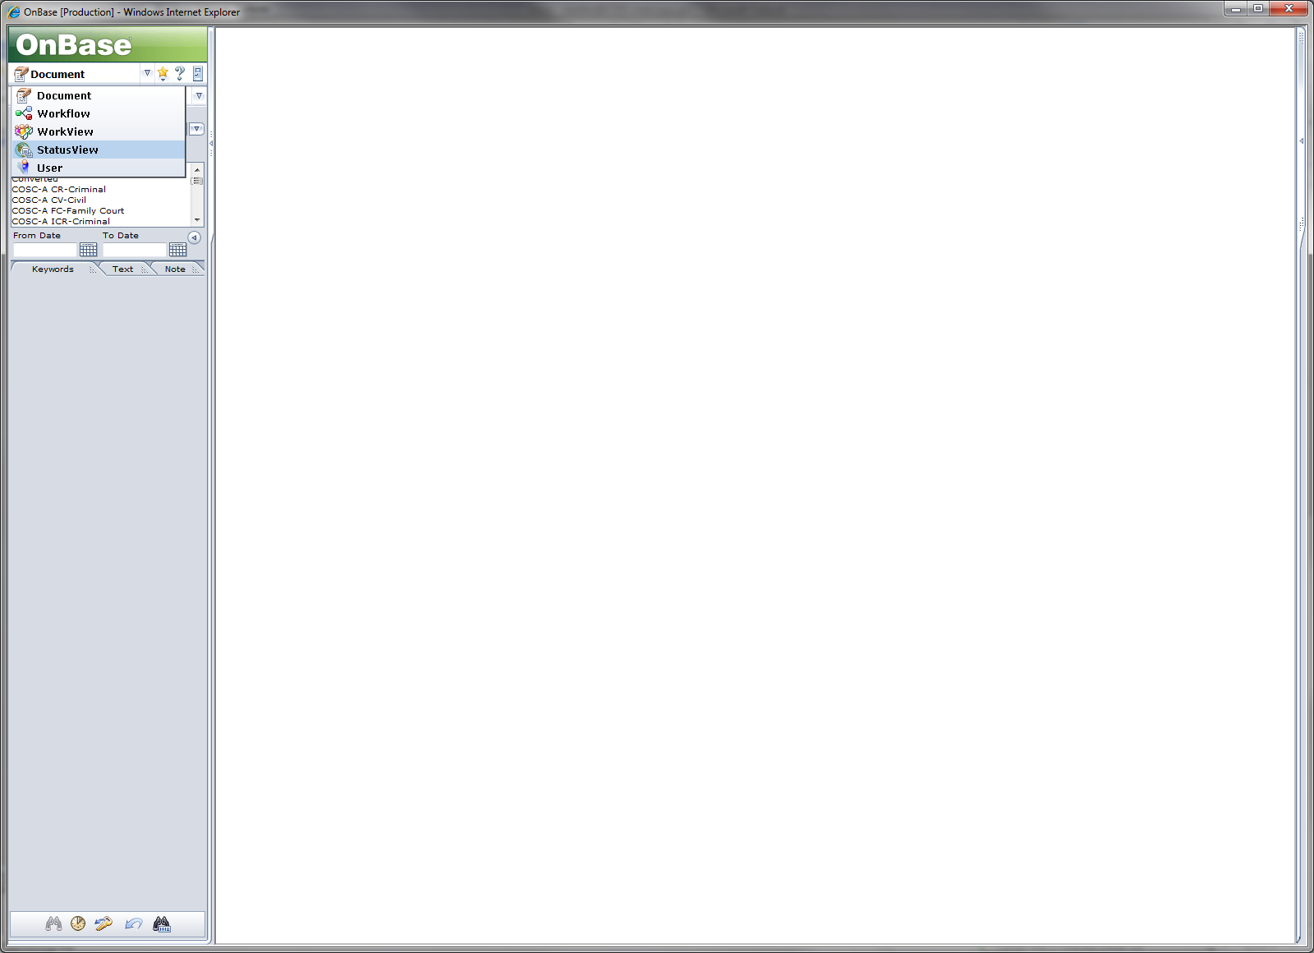

- The Juvenile System Portlet will open as the default screen. See Figure 4.

Figure 4
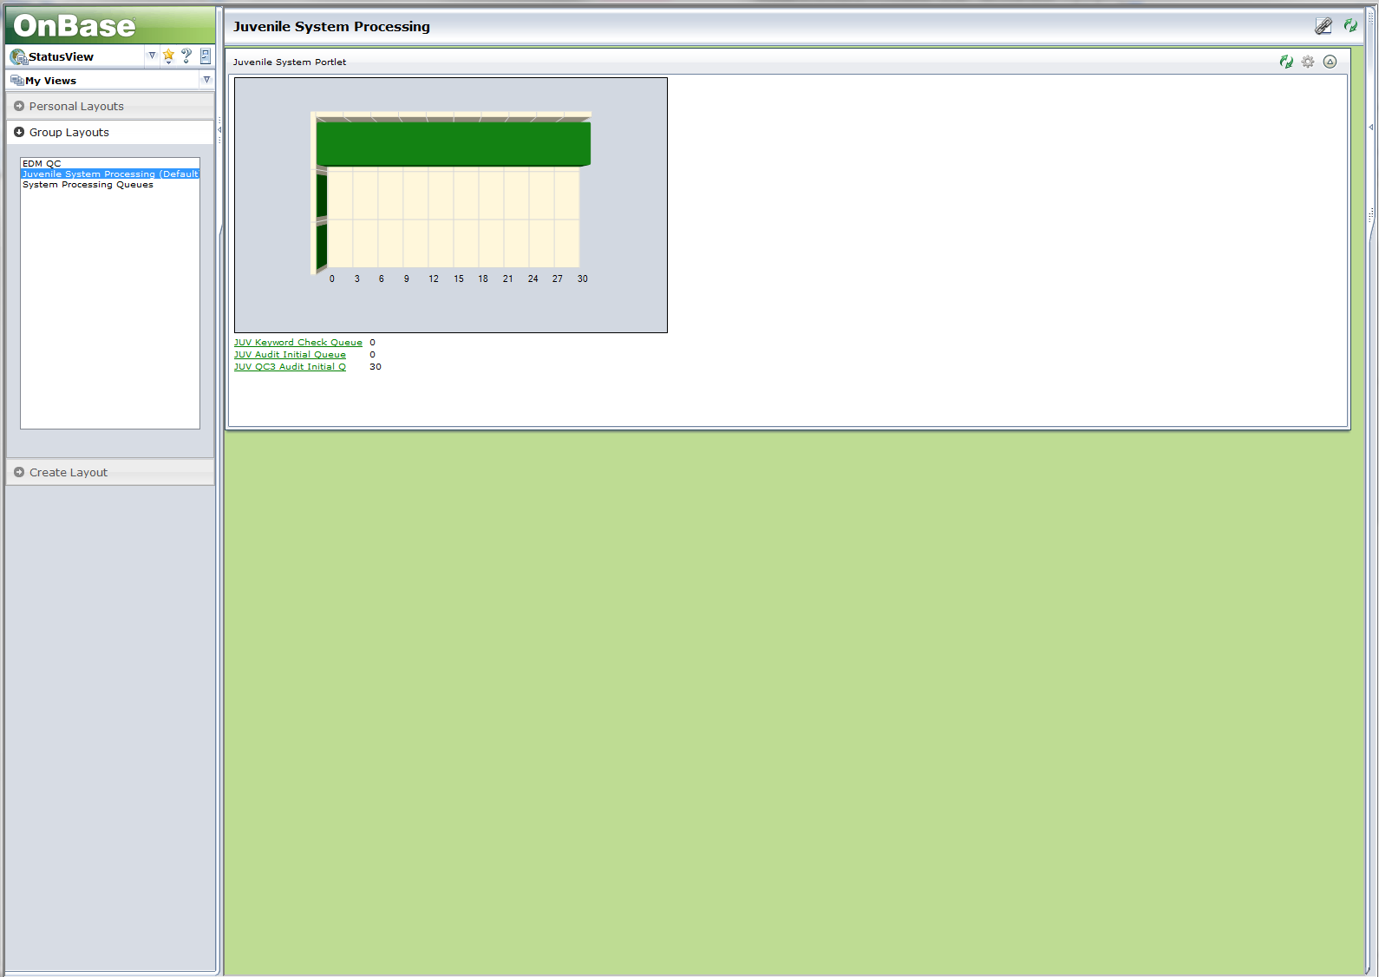

- Select System Processing Queues option. A screen showing graphs of the various OnBase processing queues will open. See Figure 5.

Figure 5
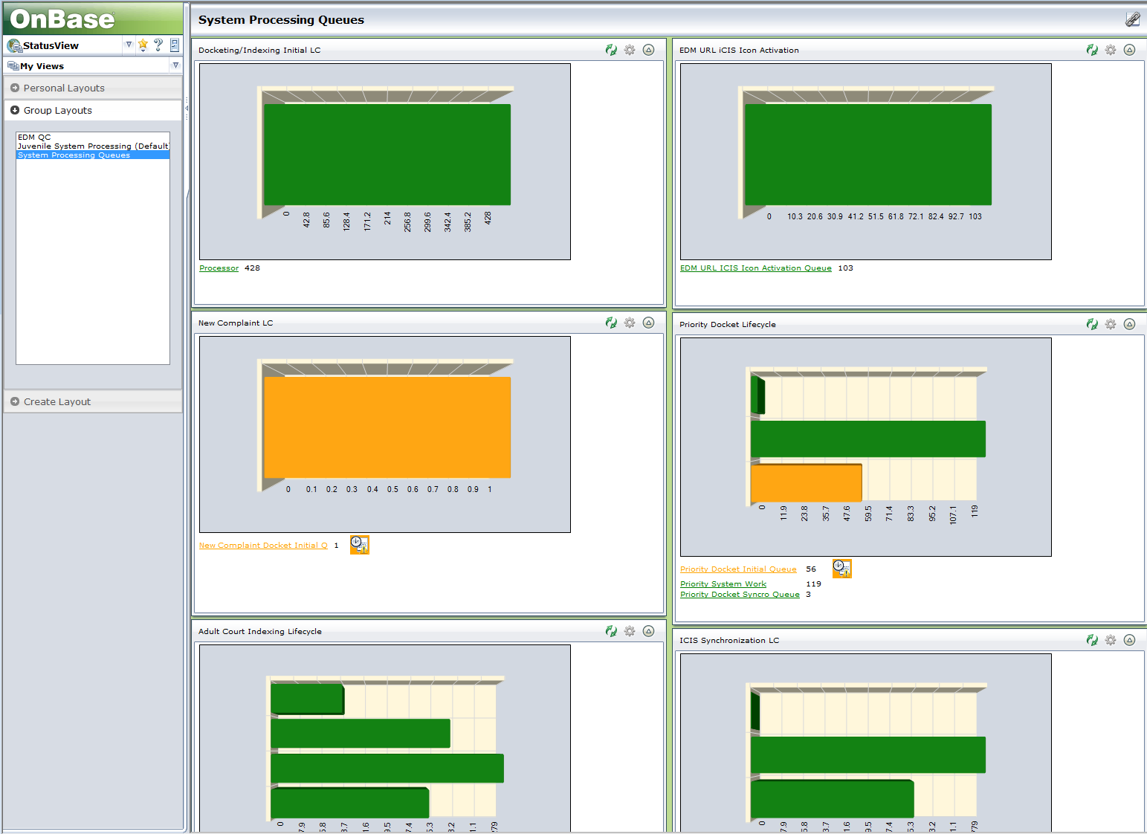

- Green indicates that the processing queue is running normally.
- Orange indicates that some document images in the queue are approaching the time limit for moving out.
- Red indicates that the limit has been reached for some/all documents in the queue.
  - If one document is caught in the queue, resolve it if you can:
  - Check for document locks
  - Check for scanner keyword (might be QQQ instead of AAA, BBB, etc.)
  - If you cannot resolve, send an email to ITG Help desk (not the whole distribution list noted below).
  - If there are more than one but fewer than 25 document images over 30 minutes, watch the queue and refresh your screen after five minutes to see if the documents have processed. The lag may be the queue trying to catch up.
  - If the message indicates there are more than 25 document images that have been in the processing queue for more than 30 minutes, take a screen print of the graph and send an email to COC OnBase Workflow Issues. Construct the email using information from the matrices (Figures 6 – 8) and the sample email (Figure 9) below.
  - Send a follow up email to COC OnBase Workflow Issues when the problem is resolved: “All queues are back to normal.”
  - If the problem is not resolved in an hour, send a follow up email to COC OnBase Workflow Issues: “The issue is still unresolved.” It is not necessary to send a follow up email if the issue is a widespread problem with OnBase.
Figure 6
Three Main (URGENT) OnBase Processing Queues
NAME | RANKING  1= Critical  2 = Important  3 = Medium | IMPACT | EDM QC ACTIONS | Comments
Processor | 1 | - Documents are not moving into any ADULT or JUVENILE workflow queues  - Icons in ADULT and JUVENILE iCIS are not being activated  - Notifications are not going out (JV) | Send email to distribution list: COC OnBase Workflow Issues  (1)Subject Line:  Urgent – OnBase Processing Queue Stoppage  (2) Body of Email:  State if this affects Adult, Juvenile or both; Include impacts of queues (shown at left);  Include screen shot of queue(s)
Adult Keyword Check Queue | 1 | - Documents are not moving into any ADULT workflow queues  - Icons in ADULT iCIS are not being activated
JUV Keyword Check Queue | 1 | - Documents are not moving into any JUVENILE workflow queues  - Icons in JUVENILE iCIS are not being activated  - Notifications are not going out
Figure 7
Queues Affecting Juvenile Documents Only

NAME | RANKING  1 = Critical  2 = Important 3 = Medium | IMPACT | EDM QC ACTIONS
JUV Audit Initial Queue | 2 | - Documents are not moving into Juvenile Operations Auditor Lifecycle | Send email to distribution list: COC OnBase Workflow Issues  (1)Subject Line:  OnBase Processing Queue Stoppage  (2) Body of Email:  State that this affects Juvenile only ; Include impacts shown at left;  Include screen shot of queue(s)
Juv QC3 Audit Initial Queue | 3 | - Documents are not moving into: Juvenile QC3 Audit Lifecycle

Figure 8
Queues Affecting Adult Documents Only

NAME | RANKING  1 = Critical  2 = Important 3 = Medium | IMPACT | EDM QC ACTIONS | Comments
New Complaint Docket Initial Q | 2 | COW documents are not moving into new complaint workflow for docketing. | Send email to distribution list: COC OnBase Workflow Issues  (1)Subject Line:  OnBase Processing Queue Stoppage  (2) Body of Email:  State that this affects Adult Court only ;  Include impacts shown at left;  Include screen shot of queue(s)
NC Priority System Work | 2 | Keywords on completed COW documents are not being updated; images not subsequently routed.
Priority Docket Initial Queue | 2 | Documents are not moving into Priority workflow for docketing.
Priority System Work | 3 | Keywords not being updated on completed priority documents; images not subsequently routed.
Priority Docket Synchro Queue | 3 | Keywords not being updated on completed priority documents; images not subsequently routed.
EDM URL ICIS Icon Activation Queue | 3 | Icons are not being activated in iCIS.
Civil PD Queue | 3 | Predockets were not created (CV, PB, FC, etc.).
Criminal PD Queue | 3 | Predockets were not created (CR).
Docket Creation Queue | 3 | Auto dockets (AOA, GJT, RTM, etc.) were not created.
Initial Synchro Queue (ICIS Synchro LC) | 3 | Keywords not updated on completed predockets; images not subsequently routed.
ICIS Synchro – Older than 7 Days (ICIS Synchro LC) | 3 | Keywords not updated on completed predockets; images not subsequently routed.

Figure 9
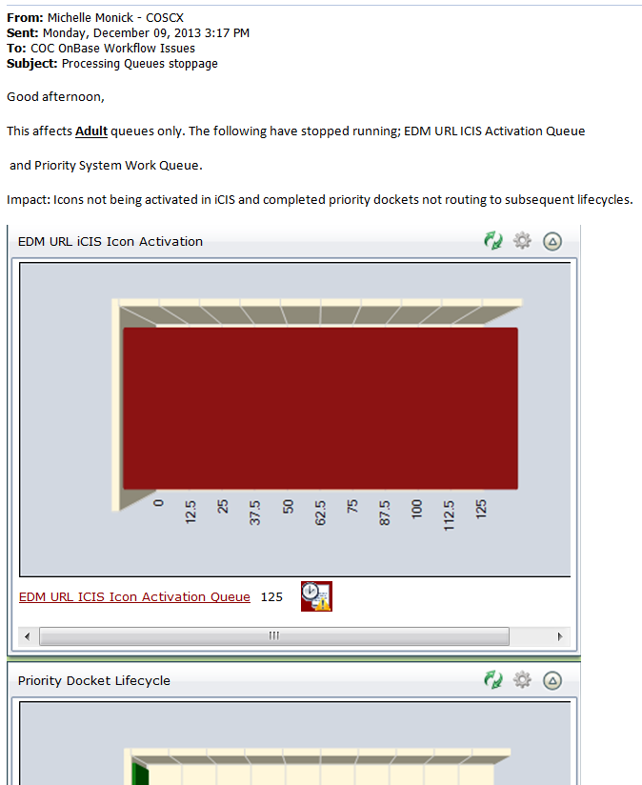

POLICIES / RELATED DOCUMENTS:

- None

OTHER PARTIES INVOLVED:

- None

TIME / VOLUME:

- Four times each work day of the month. Approximately 30 seconds per check.

FREQUENCY:

- Four times per day.

PERFORMANCE MEASURE:

- N/A

SYSTEM ACCESS REQUIRED:

- COCWeb, OnBase thin client

REPORTS / FORMS:

- N/A

DEFINITIONS:

- N/A

APPLICABILITY:

This procedure applies to all employees of the Clerk of the Court.

REVISION HISTORY:

Revision Number | Revision Author | Summary of Changes | Approval Date
- | Chris Cerrato | Document Origination | 06/06/2013
A | Chris Cerrato | Step 8 – Some language changes, but mostly the addition of the tables and sample email, Figures 6 through 9. | 12/20/2013
B | Eileen Fenner | Reviewed | 03/01/2019
C

