PURPOSE:

To provide instructions for EDM QC to assist Appeals with preparing the electronic court record to be transmitted electronically to the Court of Appeals using C2C (Court to Court) software.

OBJECTIVE:

- To provide the necessary direction to ensure that EDM QC staff are aware of how to assist Appeals staff.

EVENT DRIVER:

- Staff from the Appeals Department submits a request for assistance.

PROCEDURES:

- Unfinished pre-dockets
  - EDM QC leads complete all unfinished pre-dockets in iCIS. An alternative is to contact the docket supervisor and request assistance in completing the pre-dockets.
  - Synchronize the keywords on the OnBase image.
  - Change the security keyword from EI to NONE.
  - Email Appeals that the pre-dockets have been completed.
- Unfinished Priority docket images
  - If there are unfinished Priority docket images, the EDM QC leads go into the corresponding Priority Docket queue.
  - Locate the document in the queue.
  - Either docket the image or send it to the Supervisor queue and request that the auditor complete it ASAP.
  - Email Appeals that the priority dockets have been completed.
- Unscanned Documents
  - Appeals will bring batch(es) to the EDM QC area for scanning.
  - Scan the batch or batches using the appropriate batch name. (See PRO-EDMQC-1018: Scanning.)
- Microfilmed Case
  - Appeals will print out the micro-filmed documents and barcode them from the iCIS docket event.
  - Appeals staff will bring the batch(es) to an EDM QC lead.
  - The Batch Slip will be labeled MICROFILM.

  - The EDM QC lead will have the batch scanned into OnBase. The lead retains the batch after it is scanned and immediately removes the images from workflow.
  - Notify Appeals the batch has been scanned.
  - EDM QC will delete the images after the C2C transmission has been successful.
  - The paper batch is returned to the Appeals Department.
- Reindexing
- Appeals will email the ECR Hotline requesting the images be moved from the Inactive document type group in OnBase to the COSC-A document type group in OnBase. The images also need to be linked to the docket events in iCIS.
- Retrieve the images in the Inactive document type group using the case number. (See Figure 1.)
Figure 1
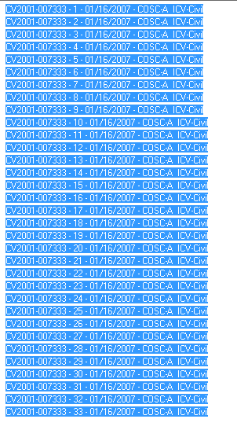

- Re-index each image to the appropriate case type in COSC-A .
- Link the image to the iCIS docket event. Use QQQ for the Scanner ID keyword and your initials for Scanned By keyword.
- Ensure that the security keyword is correct on the image. (E.G., NONE, SDS, SDSOA, etc.)
- Activate the icons in iCIS.
- Delete any duplicate images. When choosing which image to delete, select the best image and if both are equally good, delete the image from the Inactive.
- Splitting Large Documents
- Appeals will contact EDM QC if they are unable to upload a document due to file size.
- EDM QC will split the document into two or more parts as needed to reduce the file size. (See PRO-EDMQC-1003: Splitting a Document Image in OnBase.)

- Supplemental Documents From a Related Case
- The Court of Appeals may order the COC to supplement the record with documents from another case.
  - It is not necessary to docket and link the documents in question to the case on appeal.
  - EDM QC Lead will simply add a second case number keyword to the documents in question, enabling the C2C to pick them up.
  - After the Appeal or Supplement has been transmitted, the keyword will be removed.

POLICIES / RELATED DOCUMENTS:

- PRO-EDMQC-1003: Splitting a Document Image in OnBase
- PRO-EDMQC-1018: Scanning

OTHER PARTIES INVOLVED:

- Appeals Department staff

TIME / VOLUME:

- The volume of work and time involved can vary greatly, depending upon the issue being addressed.

FREQUENCY:

- As requested; usually once a week.

PERFORMANCE MEASURE:

- N/A

SYSTEM ACCESS REQUIRED:

- iCIS
- OnBase

REPORTS / FORMS:

- N/A

DEFINITIONS:

- C2C: Software that transmits Maricopa County Superior Court case records to the Arizona Court of Appeals.

APPLICABILITY:

This procedure applies to all employees of the Clerk of the Court.

REVISION HISTORY:

Revision Number | Revision Author | Summary of Changes | Approval Date
- | Chris Cerrato | Document Origination | 02/07/2014
A | Eileen Fenner | Reviewed | 03/01/2019
B
C

