PURPOSE:

To provide instructions for completing the EDMS Batch Log.

OBJECTIVE:

- To provide the necessary direction to ensure that the EDMS Batch Log is filled out with all necessary information.

EVENT DRIVER:

- Receiving batches of documents for scanning.

PROCEDURES:

- Completing the EDMS Batch Log
- The EDMS Batch Log is located on the COC Website. It contains a record of all batches scanned at each scan location each day.
- Create a New Batch Log each day for each scan location.
- Each day, begin numbering batches with “001”.
- Click on New Batch Log. Select your Scan Location. Leave Scan Time blank. Click on Submit. See Figure 1.
Figure 1

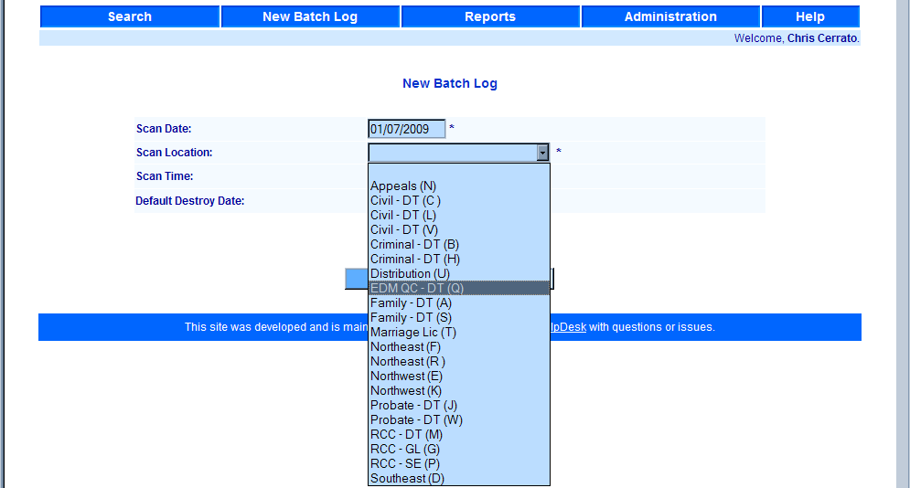

- The View/Edit Batch Log screen opens. Click Add Entry. See Figure 2.

Figure 2
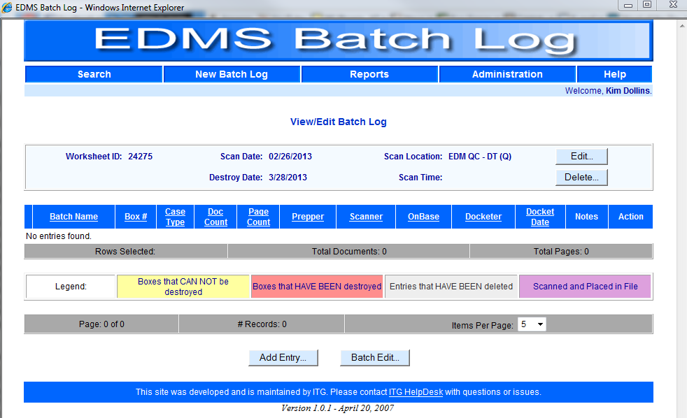

- Enter your batch information on the Add New Batch Log Entry screen. See Figure 3.
Figure 3
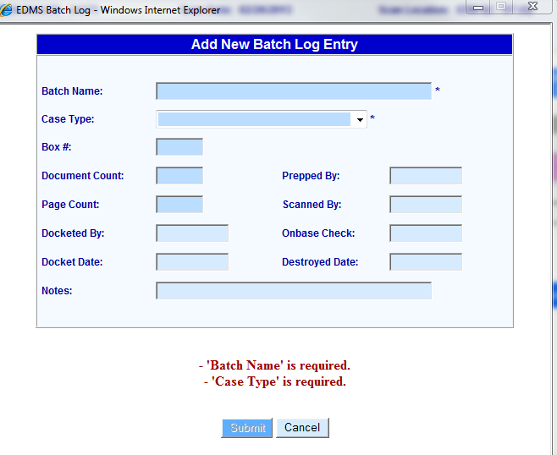

- Fill in the Batch Name: field using the batch naming convention below. See Figure 4.
Figure 4
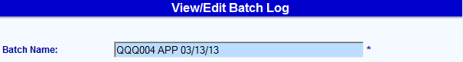

Note: The batch name always uses the scanner machine initials, the batch number, the batch type (copied from the batch slip), and the date.
- Select the Case Type: from the drop down list. See Figure 5.
Figure 5
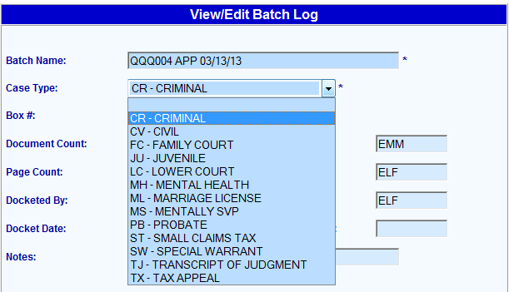

- The completed batch log entry includes the Box #, the Document Count, the Page Count, Docketed By, Docket Date, Prepped By, Scanned By, and Onbase Check. See Figure 6.
Figure 6
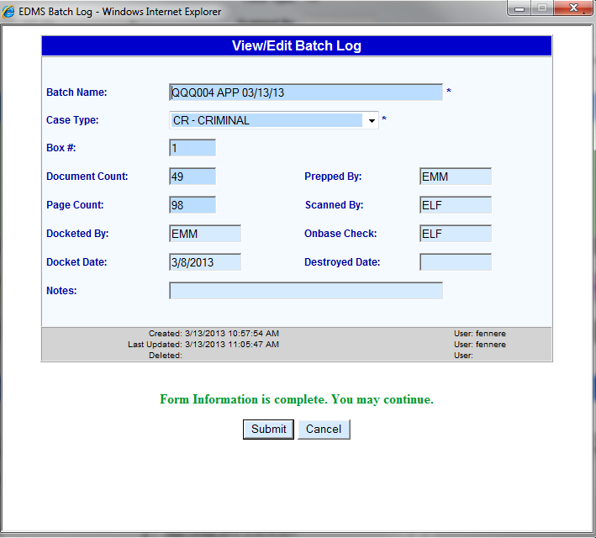

- Click on Submit.
- Click on Add Entry to open the View/Edit Batch Log screen to enter the next batch information.
- If you have closed the Batch Log and need to add more batches later in the day, open the Batch Log in Cocweb. Click on the Search option on the menu bar. See Figure 7.
Figure 7
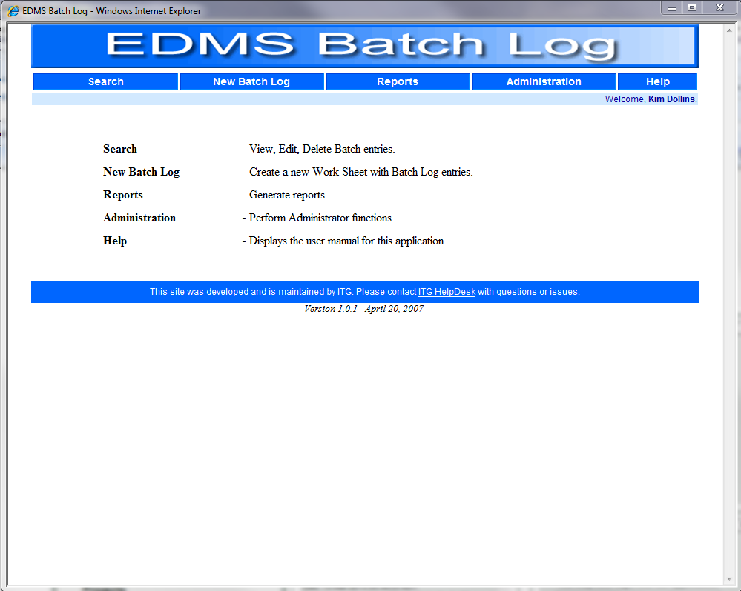

- The Search screen opens. Enter today’s date in the Scan Date and To fields. Select the Scan Location from the drop down list. See Figure 8.

Figure 8
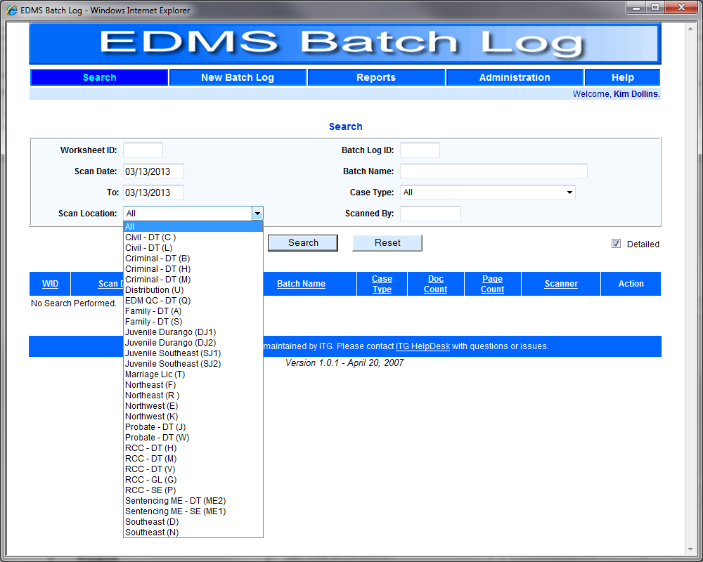

- The View/Edit Batch Log screen will appear. To activate the Add Entry button, click on the last number in the *WID column. See Figure 9.

Figure 9
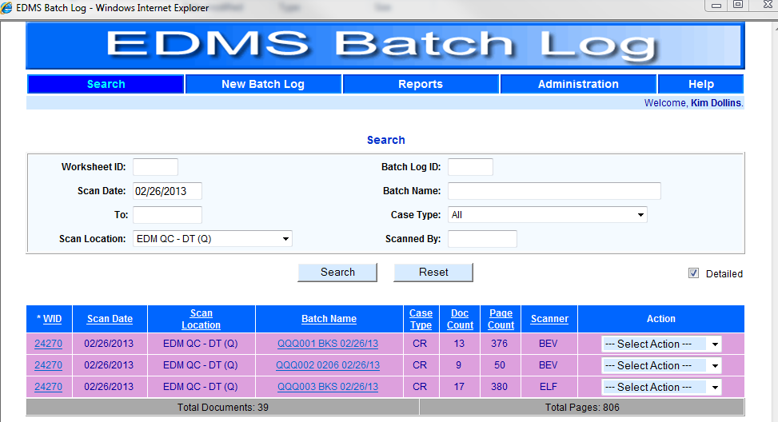

- Click on the Add Entry button and the Add New Batch Log Entry screen will appear.
- Add the new batch information using I. Steps 5 through 9. See Figure 10.

Figure 10
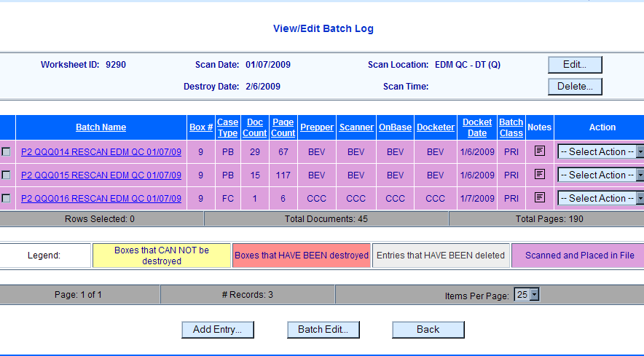

POLICIES / RELATED DOCUMENTS:

- PRO-EDMQC-1018: Scanning

OTHER PARTIES INVOLVED:

- N/A

TIME / VOLUME:

- Every business day. Volume depends upon how many batches are scanned per each scanner.

FREQUENCY:

- Daily

PERFORMANCE MEASURE:

- N/A

SYSTEM ACCESS REQUIRED:

- Cocweb
- EDMS Batch Log Application

REPORTS / FORMS:

- N/A

DEFINITIONS:

- N/A

APPLICABILITY:

This procedure applies to all employees of the Clerk of the Court.

REVISION HISTORY:

Revision Number | Revision Author | Summary of Changes | Approval Date
A | Eileen Fenner | Reviewed | 03/01/2019
B
C

