PURPOSE:

To provide instructions for the daily monitoring of the Batch Manager module in Kofax Capture Software, and resolving issues.

OBJECTIVE:

- To provide the necessary direction to ensure proper processing of scanned batches that fail to release timely or correctly.

EVENT DRIVER:

- Scanned batches that fail to process correctly or timely are stored temporarily in Batch Manager.

BACKGROUND INFORMATION:

- A scanned batch takes a predictable path through Batch Manager, by entering various queues where actions take place. When the action is concluded, the batch moves on to the next queue. The batches are routed to the various queues automatically by the software as follows:
- Adult & Juvenile Court Documents:
Scan (manual) →Quality Control (auto+manual) → Recognition (auto)→ Release (auto)
- Marriage Licenses:
Scan (manual) → Recognition (auto) →Validation (manual)→ Release (auto)
- If the program encounters a document that has been rejected, or other types of errors have occurred in the batch, the release will stop and the batch will be sent to the Quality Control queue with an “Error” status code.

PROCEDURES:

- Resolving Batches in the Quality Control Status:
- Open the Batch Manager module of Kofax Capture Software. See Figure 1. All batches in progress, from scan to release are visible in Batch Manager.

Figure 1
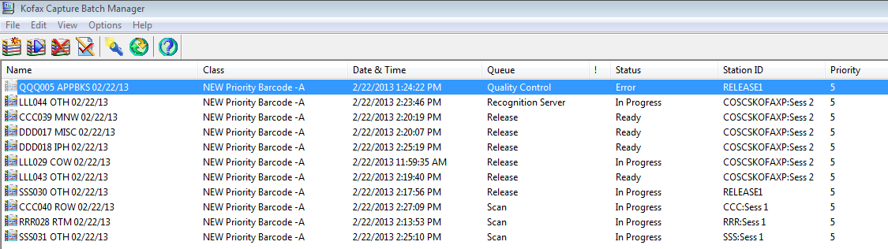

- Click on any batch in Quality Control status to highlight it, and then click the Process Batch button on the toolbar. See Figure 2.

Figure 2


- The batch will open and the contents will be displayed. See Figure 3.

Figure 3
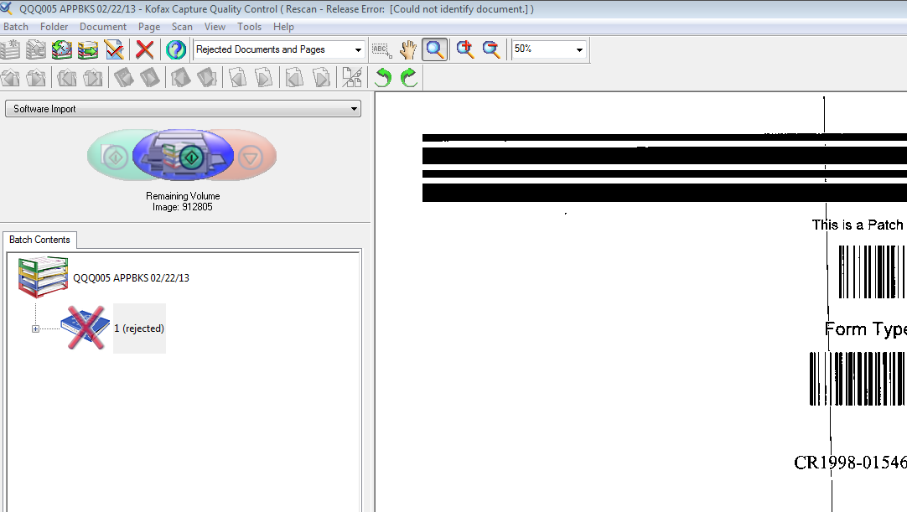

- If the page displayed is a barcode, take the following steps:
- Click on rejected to highlight, then right click and select unreject. See Figure 3.
- Click on the blue book icon to highlight, then right click and select the corresponding document type (see the barcode for document type). See Figure 4.

Figure 4

- Once the document has been unrejected and the correct document type selected, click on Batch (located on the toolbar), then Close. See Figure 5
- If the page displayed is a barcode sheet with no pages attached, right click and select delete. Then select close batch. See Figure 5.

Figure 5
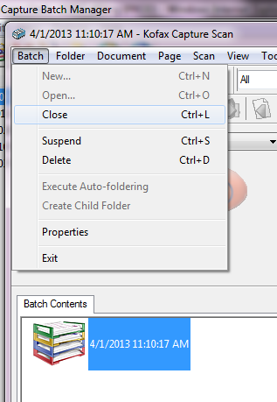
- If the page displayed is not a barcode, take the following steps:
  - Send an email to the scanner and copy their supervisor asking them to rescan the document that erroneously split. The email to the scanner should include the following:
    - Subject Line: The batch name
    - Screen shot of the split image.
    - Ask the scanner to provide a case number, docket code and file date of the document that erroneously split.
  - Once an email has been sent to the scanner and their supervisor the image can be can be deleted. Click on the red X to highlight, then select delete. The following message will appear: Are you sure you want to delete? Select Yes.
  - Click on “Batch” (located on the toolbar), then select “Close”.
  - The part of the image that released in OnBase will need to be deleted as well. As requested, the Scanner will have provided the case number, docket code, and file date of the document. Locate the image in OnBase and delete.

- Procedures for Large Number of Batches in the Release Status:
- Open Kofax Capture Batch Manger. If more than 10 batches are in the Release Status Queue take the following steps:

  - Send an email to the ITG Help Desk to let them know batches are releasing slowly.
  - Send an email to the COC EDM Scanners to let the Scanners know batches are releasing slowly.
    - Use the following language: Subject line: Batch Release – Slow

Batches are releasing, but slowly. Please continue scanning. If you are not able to find your batches in OnBase at this time, please check later today. (Or first thing tomorrow morning) if the message is being sent late in the day.)

    - Use this language if batches are not releasing at all: Subject Line: Batch Release – Stopped
Batches are not releasing at this time. Please continue scanning. If you are not able to find your batches in OnBase, please check later today.
  - Continue to monitor Kofax Capture Batch Manager. Once the batches have caught up to normal status send a follow-up email to the COC EDM Scanners.
    - Use the following language: Subject line: Batches have been released to OnBase

All batches have now been released to OnBase. You may now check them in OnBase.

- Validating Marriage License Test Batch:
- Open Kofax Capture Batch Manager.
- If there is a Marriage License test batch listed, highlight the batch. See Figure 6.

Figure 6
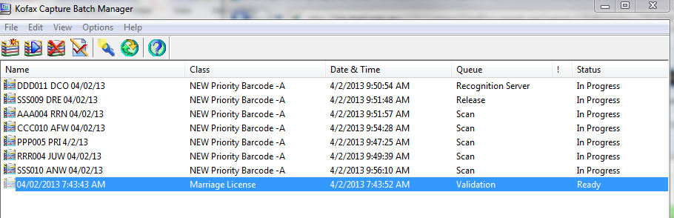

- Click on the Process Batch icon. See Figure 7.

Figure 7

- The Kofax Capture Validation screen opens. See Figure 8.

Figure 8
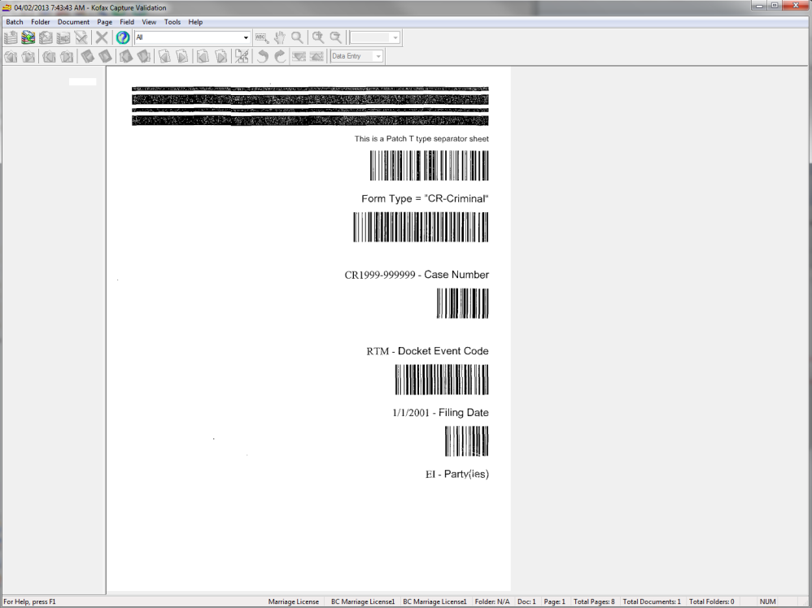

- After a few minutes, the Database Validation Error dialog box appears. Click on OK. See Figure 9.
Figure 9
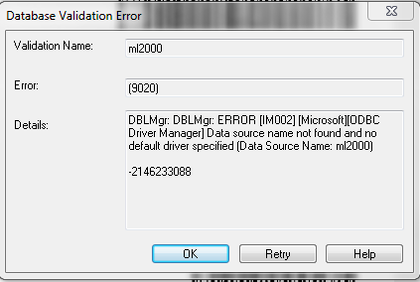

- Enter 999999 in the License # field. Tab to the Groom Last Name: field and enter TEST. Tab to the Groom First Name: field and enter TEST. Tab to the Bride Last Name: field and enter TEST. Tab to the Bride First Name: field and enter TEST. Tab and enter today’s date in the Marriage Date: and the Recording Date: fields using MM/DD/YYYY, then tab again. The Kofax Capture Validation dialog box appears. Click Yes. See Figure 10.
Figure 10
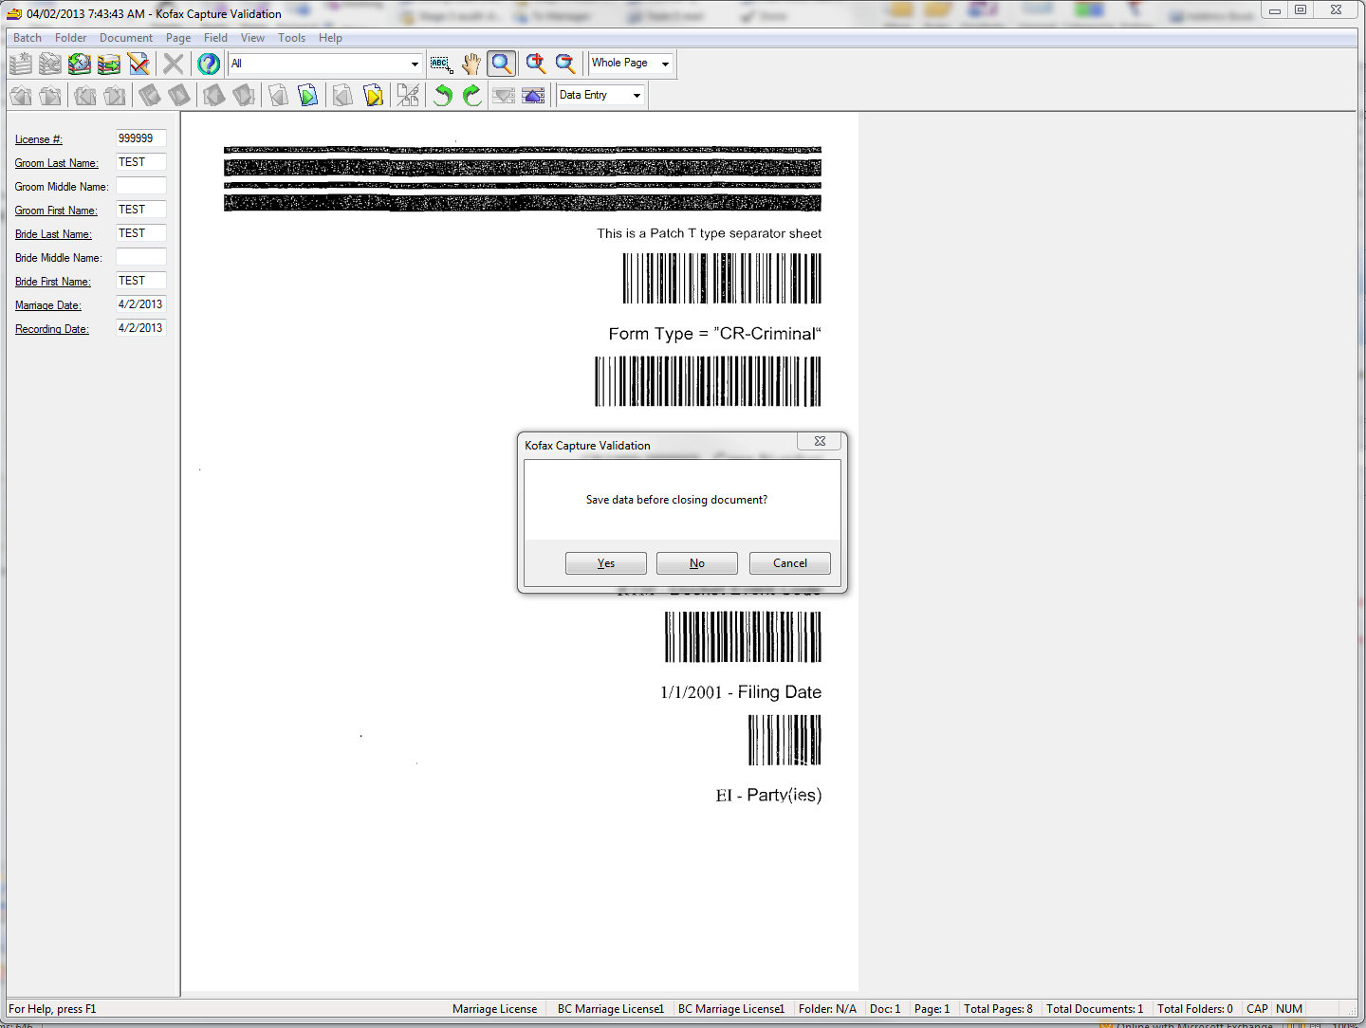
- A second Kofax Capture Validation dialog box appears. Click Yes. See Figure 11.

Figure 11
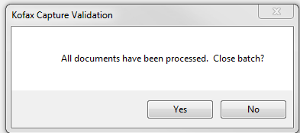

POLICIES / RELATED DOCUMENTS:

- None

OTHER PARTIES INVOLVED:

- EDM Scanners
- EDM Supervisors
- Document Management Managers
- Document Management Administrators
- ITG staff

TIME / VOLUME:

- Average volume is ten batches per week in quality control status; one batch per month in suspended status. An occurrence of a large number of batches in release status occurs about once per month or every six weeks. Monitoring batch manager takes about 15 to 30 minutes per day. If a system event occurs, which happens every few months, time and volume can go up steeply.

FREQUENCY:

- Monitor hourly.

PERFORMANCE MEASURE:

- N/A

SYSTEM ACCESS REQUIRED:

- Kofax Ascent Capture: Batch Manager Module

REPORTS / FORMS:

- N/A

DEFINITIONS:

- Kofax Capture 8.0: Software program used to scan documents which are then released into the OnBase repository.

APPLICABILITY:

This procedure applies to all employees of the Clerk of the Court.

REVISION HISTORY:

Revision Number | Revision Author | Summary of Changes | Approval Date
- | N/A | Document Origination | 04/16/2013
A | Eileen Fenner | Reviewed | 03/01/2019
B
C

