PURPOSE:

To provide instructions for correcting eFiled documents received in Courtroom Clerk Review.

OBJECTIVE:

- To provide the necessary direction to ensure that eFiling corrections are completed and accurately updated in the eFile Foundation program and in the Electronic Court Record.

EVENT DRIVER:

- An efiled document is sent to the Courtroom Clerk Review QC Queue in eFile Foundation with a note indicating what correction is needed.

PROCEDURES:

- Correcting General Errors:
- Click on the eFile Court Clerk Review link found on Cocweb. See Figure 1.

Figure 1


- Click on Courtroom Clerk, then Special Queues and then on the EDM QC folder. If there is a correction request, it will show under the EDM QC folder as (1/1 or 2/2, etc.). See Figure 2.

Figure 2
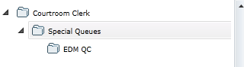

- Click on the eFile Clerk Review link in Cocweb and bring up the EDM QC folder. See Figure 3.
Figure 3
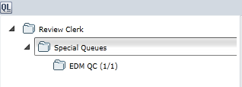

- Go to the Search field at the top of the screen and using the drop down list, select All Items. See Figure 4.

Figure 4
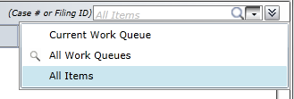
- Enter the eFiling ID number for the Court Clerk Review error and click on the search option. See Figure 5.

Figure 5

- The eFiled Order will appear and can then be corrected.
- Right click on the EDM QC folder entry. See Figure 6.

Figure 6
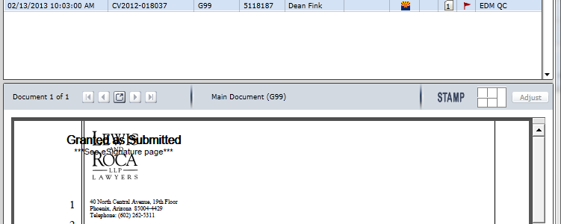

- A drop down menu appears. Select Document Replace option. See Figure 7.
Figure 7
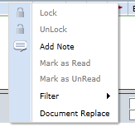
- A dialog box appears. To open the converted copy of the eFiling, click on the Open button. See Figure 8.
Figure 8
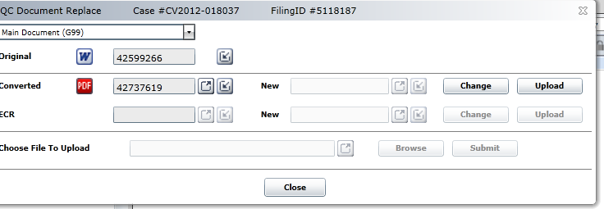

- Print the eFiling to Adobe and make the correction using PRO-EDMQC-1008: Electronically Correcting or Changing Images.
- Select the Upload option. See Figure 8.
- The Browse button will be activated. Click Browse (see Figure 9) and select the corrected eFiling. Click Open and the corrected eFiling will be uploaded.

Figure 9
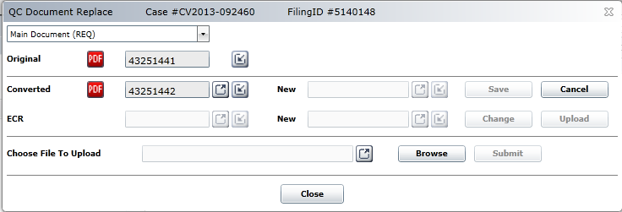

- Click Submit. See Figure 10.

Figure 10
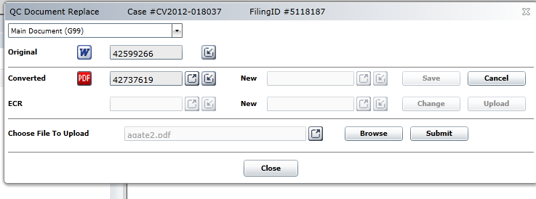
- The Save button will be activated. Click Save. See Figure 11.

Figure 11
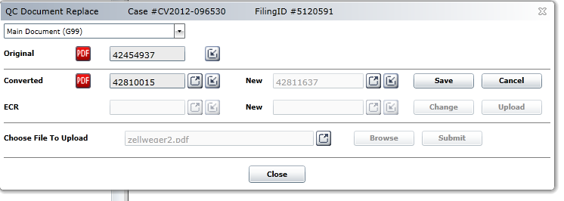

- A dialog box will appear. See Figure 12. Click OK.

Figure 12
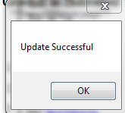

- Click Close.
- Return to Courtroom Clerk Review and bring up the eFiled Order. Click Transfer. Select the Judicial Officer from the drop down list (see Figure 13). Add a note that the error has been fixed.

Figure 13
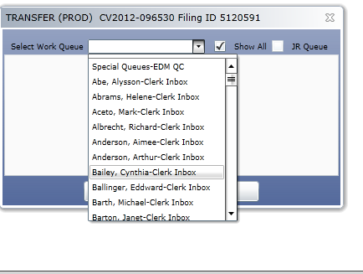

- Enter OnBase. Select eFiling Document Type Group.
- Enter the eFiling ID. Click on the original converted version of the eFiled document and delete it.
- Enter the correction information in the eFiling Corrections Tracking Log.

- Correcting a landscaped Order:
- Follow Steps I.2. through 10. referred to above.
- In the saved Adobe document, remove the horizontal Banner using the Text removal tool from the Adobe menu bar. See Figure 14.
Figure 14
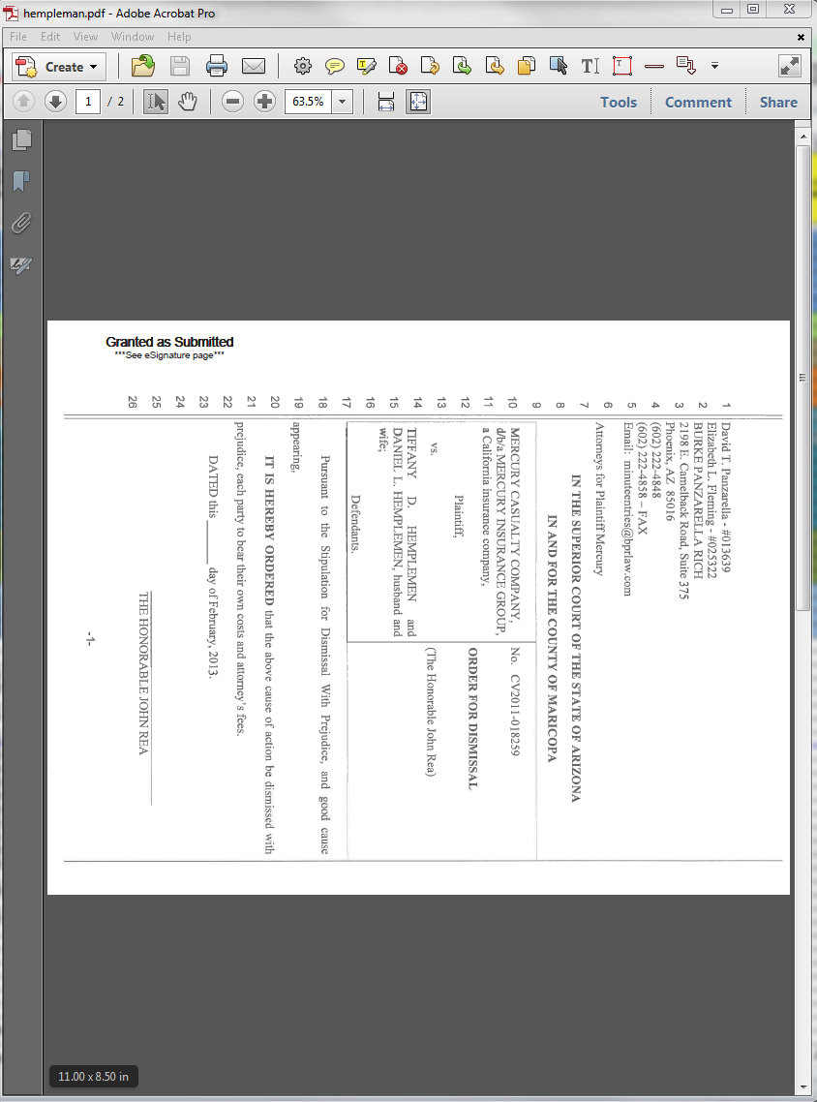

- Flip the first page or pages of the Order to portrait using the Rotation tool on the Adobe Tool Bar. Leave the signature page in landscape. See Figure 15.

Figure 15

- Copy the banner template that applies and apply it in the upper left corner of the document. See Figure 16.

Figure 16
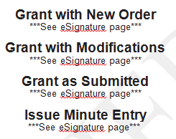

- Extract the signature page from the document and choose the delete after extraction option. See Figure 17.
Figure 17
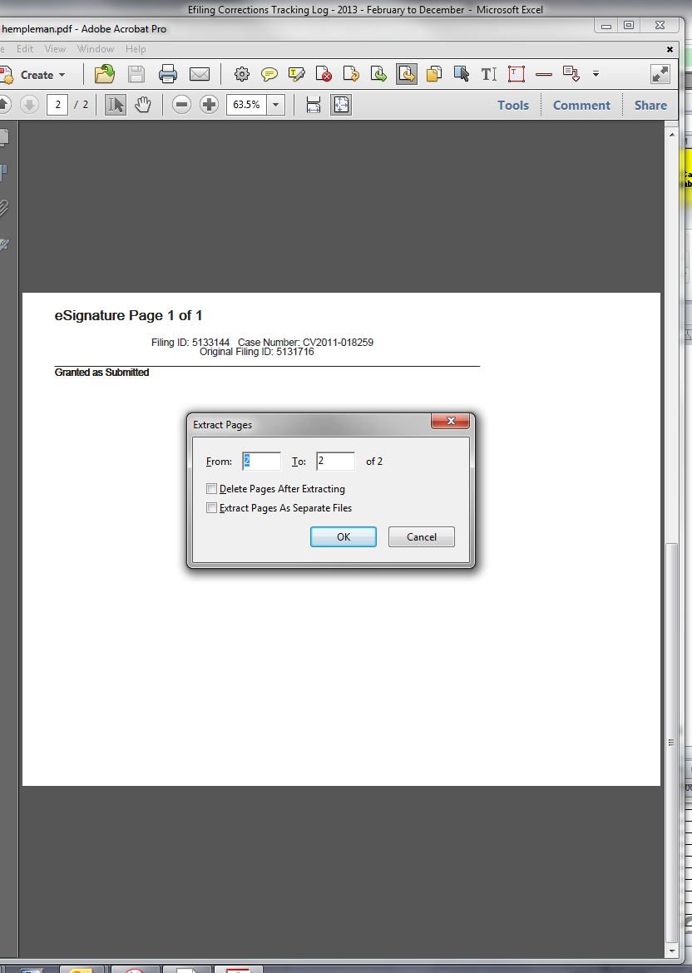

- Open the signature page template: S:\ Doc_Management \EDM Quality Control\Efiling Audits and Procedures\Efiling Procedures\ Efiling Correction Procedure - Courtroom Clerk Review.docx. See Figure 18.

Figure 18
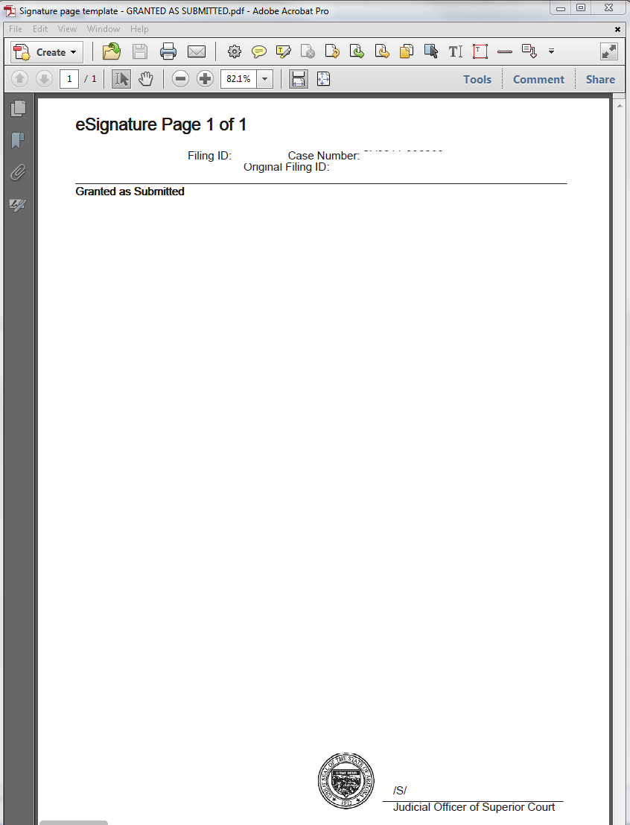

- Copy the Filing ID, case number and prior Filing ID from the landscaped signature page. See Figure 19.

Figure 19
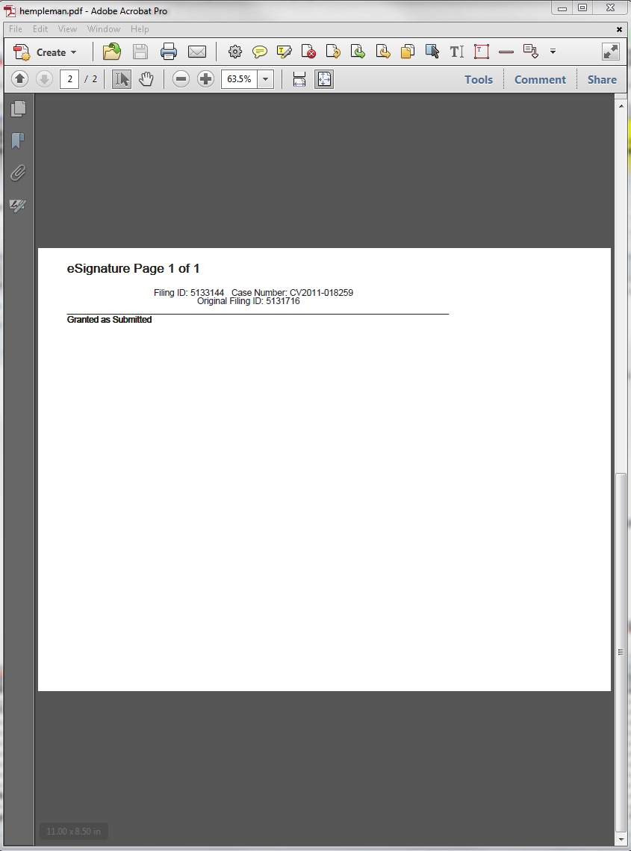

- Look for the Judicial Officer’s name and the date in the Clerk Review menu line and add that on the signature line.
- Import the corrected signature page into the Order.
- Re-print the corrected Order in Adobe.
- Upload the corrected Order as outlined in Steps I.11. through 20. above.

POLICIES / RELATED DOCUMENTS:

- PRO-EDMQC-1008: Electronically Correcting or Changing Images
- PRO-EDMQC-1011: Clerk Review eFiling Corrections
- PRO-EDMQC-1013: eFiling Corrections from eFile Audit QC Mailbox

OTHER PARTIES INVOLVED:

- Courtroom Clerks

TIME / VOLUME:

- Average of ten minutes per correction.

FREQUENCY:

- Average of 1 to 5 corrections per day.

PERFORMANCE MEASURE:

- N/A

SYSTEM ACCESS REQUIRED:

- OnBase
- eFiling Foundation software application
- Adobe Professional software application
- S:\ Doc_Management \EDM Quality Control\Efiling Audits and Procedures\Efiling Procedures\ Efiling Correction Procedure - Courtroom Clerk Review.docx

REPORTS / FORMS:

- eFiling Corrections Tracking Log

DEFINITIONS:

- None

APPLICABILITY:

This procedure applies to all employees of the Clerk of the Court.

REVISION HISTORY:

Revision Number | Revision Author | Summary of Changes | Approval Date
- | N/A | Document Origination | 03/08/2013
A
B
C

