PURPOSE:

To provide instructions for correcting eFiled document errors received in the eFile Audit QC Mailbox.

OBJECTIVE:

- To provide the necessary direction to ensure that eFiling corrections are completed and accurately updated in the eFile Foundation program and in the Electronic Court Record.

EVENT DRIVER:

- Emailed correction request is sent to the Efile Audit QC mailbox.

PROCEDURES:
- General Error Corrections
- Access the eFile Audit QC Mailbox in Outlook by selecting Public Folders> Departmental Discussions>Clerk of the Court>Efile Audit QC. See Figure 1.

Figure 1
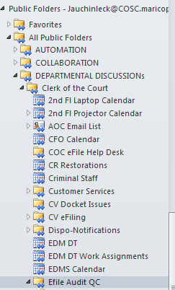

- Open the email request. See Figure 2.

Figure 2
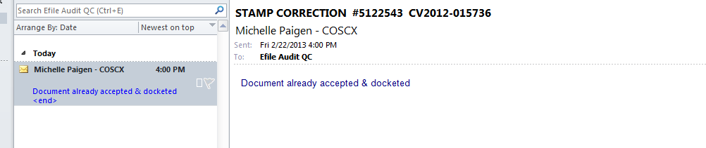

- Click on Review Clerk>Special Queues>EDM QC. See Figure 3.

Figure 3
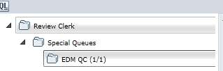

- Enter the Filing ID number in the search field. See Figure 4.

Figure 4
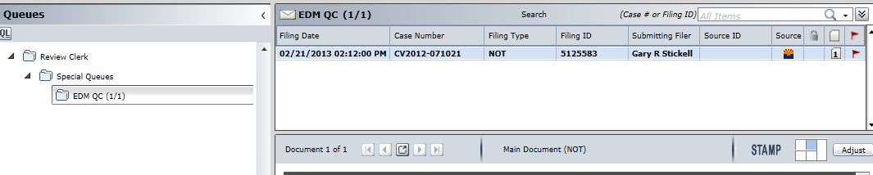

- Right click on the blue menu bar. See Figure 5.

Figure 5
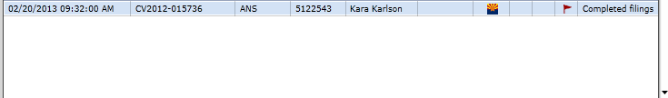

- The drop down menu appears. Select Document Replace option. See Figure 6.
Figure 6
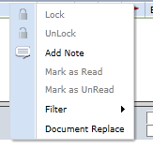
- A dialog box appears. To open the ECR copy of the eFiling, click on the open button. See Figure 7.
Figure 7
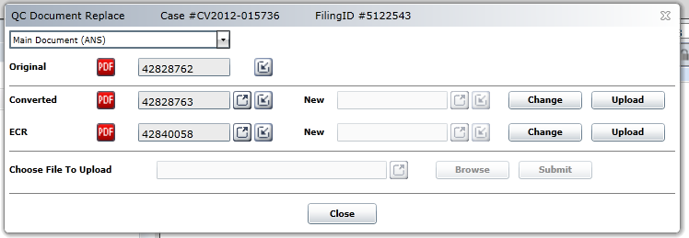

- Print the eFiling to Adobe and make the correction using PRO-EDMQC-1008: Electronically Correcting or Changing Images.

- Click Upload. See Figure 8.
Figure 8

- The Browse button will be activated. Click Browse (see Figure 9) and select the corrected eFiling. Click Open and the corrected eFiling will be uploaded.

Figure 9
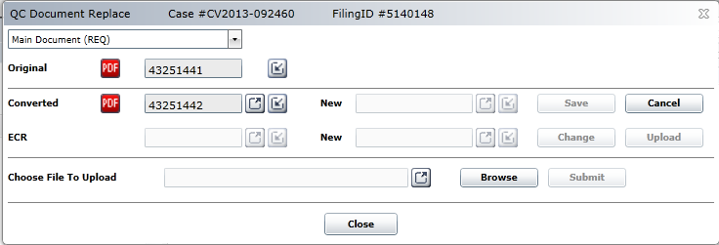

- Click Submit. See Figure 10.

Figure 10
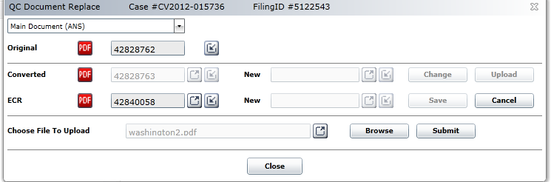

- The Save button will be activated. Click Save. See Figure 11.
Figure 11 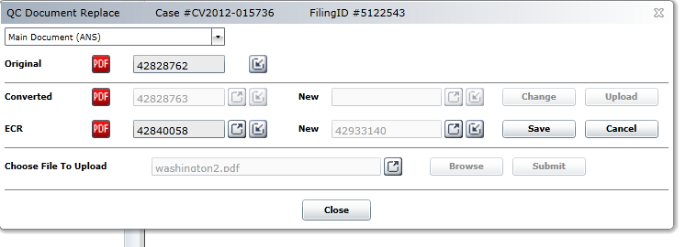

- A dialog box will appear. See Figure 12. Click OK.
Figure 12
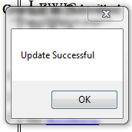
- Click Close.
- Open OnBase. Select COSC-A Document Type Group.
- Enter the eFiling ID. Click on the original ECR version of the eFiled document and delete it.
- Send a reply email that the error has been corrected.
- Enter the correction information in the eFiling Corrections Tracking Log.

POLICIES / RELATED DOCUMENTS:

- PRO-EDMQC-1008: Electronically Correcting or Changing Images
- PRO-EDMQC-1011: eFiling Corrections – Clerk Review
- PRO-EDMQC-1014: eFiling Corrections – Courtroom Clerk Review

OTHER PARTIES INVOLVED:

- eFile Review Clerks; Case Type Auditors

TIME / VOLUME:

- Average of ten minutes per correction.

FREQUENCY:

- Average of 1 to 10 corrections per day.

PERFORMANCE MEASURE:

- N/A

SYSTEM ACCESS REQUIRED:

- OnBase
- eFiling Foundation
- Adobe Professional
- Outlook

REPORTS / FORMS:

- eFiling Corrections Tracking Log

DEFINITIONS:

- ECR: Electronic Court Record (the version of the eFiling in the Active database in OnBase that is linked to the docket event in iCIS).
- iCIS: Superior Court docket application (Integrated Court Information System)

APPLICABILITY:

This procedure applies to all employees of the Clerk of the Court.

REVISION HISTORY:

Revision Number | Revision Author | Summary of Changes | Approval Date
- | N/A | Document Origination | 03/11/2013
A | Eileen Fenner | Reviewed | 03/01/2019
B
C

